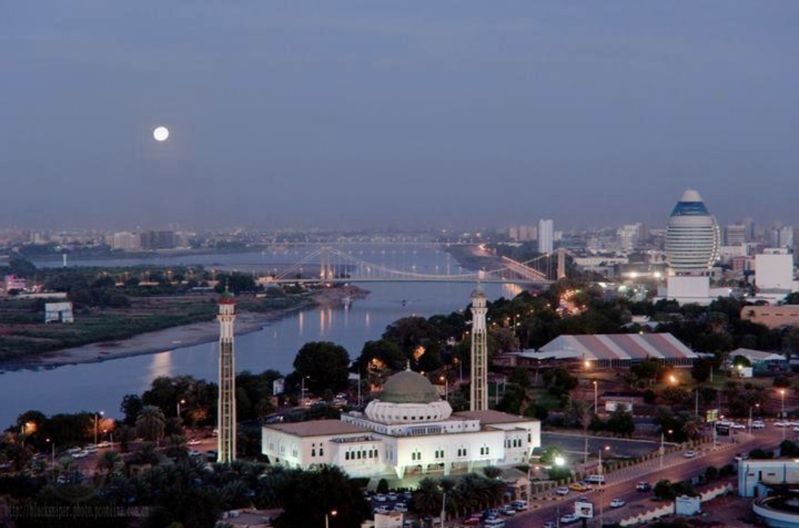
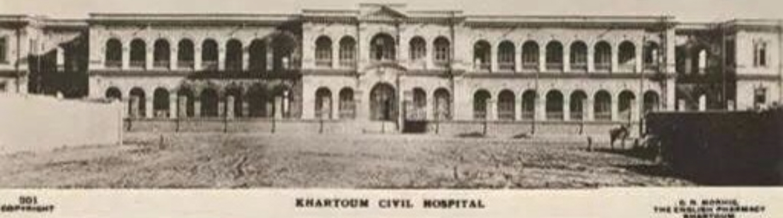

Sudan’s Alternative Health Policy Conference 6th-7th April 2019

Venue: Holiday Inn London - Brentford Lock
Commerce Road
Brentford, Middlesex
London
TW8 8GA
United Kingdom

Day 1: Fund raising event that includes a plenary session on Sustainable Development followed by dinner with Sudanese poetry and music.
Day 2: Healthcare Delivery: Policy, Politics & Power. {3 CPD points}
Full details of what will be covered can be found on our website and in the programme that will be sent out shortly

Conference Registration:
Tickets for non-members for fundraising event (Sudanese cultural event)
Bronze £40, Silver £50, Gold £60

Member registration for two days £100
Registration Link:
https://eu.jotform.com/build/90792423943362
Limited places are available so book today to avoid missing out!
We hope you will be able to join us for this most important conference
Please Note that the last day for booking hotel rooms at a discounted rate is 27th March 2019 @ 11:00.
Hotel Booking Bedrooms Direct no.
020 8232 2004 (Ali) M-F 09:00 -17:00

