Article Title [Times New Roman size14 point, centered paragraph]

Autherª, Auther^{b*}
ª Department , Affiliation, Country
^{b,} Department , Affiliation, Country
Corresponding Email Address of Corresponding Author:

Abstract
It should be an explicit summary of your presentation that states the problem, the methods used, and the major results and conclusions. Do not include scientific symbols, acronyms, numbers, bullets or lists in the abstract. It should be single-spaced in 12-point Times New Roman. [Background/ Objectives and Goals]: This section should be the shortest part of the abstract and should very briefly outline the following information: What is already known about the subject, related to the paper in question? What is not known about the subject and hence what the study intended to examine or what the paper seeks to present. In most cases, the background can be framed in just 2–3 sentences, with each sentence describing a different aspect of the information referred to above. The purpose of the background, as the word itself indicates, is to provide the reader with a background to the study, and hence to smoothly lead into a description of the methods employed in the investigation. [Method s]: The methods section is usually the second-longest section in the abstract. It should contain enough information to enable the reader to understand what was done, and important questions to which the methods section should provide brief answers. [Expected Results/ Conclusion/ Contribution]: The results section is the most important part of the abstract and nothing should compromise its range and quality. The results section should therefore be the longest part of the abstract and should contain as much detail about the findings as the journal word count permits. The abstracts will be peer reviewed and authors will be informed about acceptance for presentation via email.

Keywords: Maximum 4 Key words

- This research presented on XXX International Conference: City/Country, DD-MM-YY
- Fonts
Font size is Times New Roman typeface in 12 point pitch.
- Page Margins
Set the paper size to A4 with 254 mm margins on all sides
- Line Space
Use single-line spacing and leave a line gap between paragraphs
- Paper Length Limit
The paper length limit is 12 pages maximum, including figures, tables, references, and appendices.
- Paragraphing:
Leave a blank line between paragraphs without indent. And Text should be left and right justified across whole page width, providing a vertical margin on both sides.
- Formula and Equation
Equations must be typeset with the same word processor. You may also type the equation in Mathtype (which is available at www.mathtype.com , with 30 days free trial), and use its default setting. All equations must be numbered and appeared in the following format (font type must be TIMES NEW ROMAN):
x + y = z (1)
- Figures
Upon submission of an article, authors are supposed to include all figures and tables in the Word file of the manuscript. Figures and tables should be placed in suitable spaces. All figures should be cited in the paper in a consecutive order. Figures should be supplied in either vector art formats (Illustrator, EPS, WMF, FreeHand, CorelDraw, PowerPoint, Excel, etc.) or bitmap formats (Photoshop, TIFF, GIF, JPEG, etc.). Bitmap images should be of 300 dpi resolution at least unless the resolution is intentionally set to a lower level for scientific reasons.
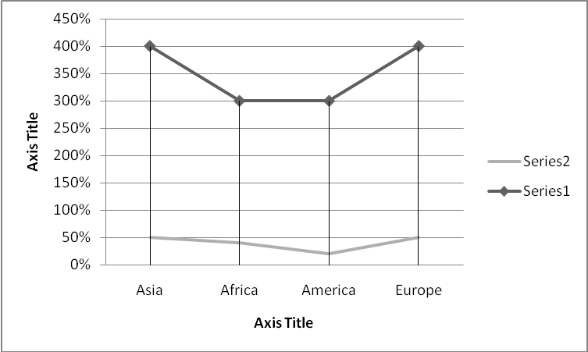
Figure 1: Sample of figure
- Tables
Tables should be cited consecutively in the text. Every table must have a descriptive title and if numerical measurements are given, the units should be included in the column heading. Vertical rules should not be used. These should clarify or supplement the manuscript text, not duplicate the text. They should be sized as this page as illustrated as follows.
Table 1: Description of the samples

Table 1: Sample of Table
 |  | Numbers of respondents (NR) | Percentage of NR to number of TR* | Number of online banking (NOB) | Percentage of NOB to number of TA** | Percentage of NOB to NR
Sex | Male | 434 | 50.35% | 131 | 48.34% | 30.18%
 | female | 428 | 49.65% | 140 | 51.16% | 32.71%
Salary | 20000 ≦ | 84 | 10.21% | 12 | 4.43% | 13.64%
 | 20001-30000 | 44 | 5.10% | 4 | 1.48% | 9.09%
 | 30001-40000 | 240 | 27.84% | 85 | 31.37% | 35.42%

* TR denotes total respondents.

- References
Authors are responsible for ensuring that the information in each reference is complete and accurate. All references should be cited within the text; otherwise, these references will be automatically removed.

- Powers, J. M., & Cookson, P. W. Jr.(1999). The politics of school choice research. Educational Policy, 13(1), 104-122.
- Shotton, M. A.(1989). Computer addition? A study of computer dependency. London, England: Taylor & Francis.
- Bruckman, A.(1997). Moose Crossing: Construction, community, and learning in a networked virtual world for kids (Doctoral dissertation, Massachusetts Institute of Technology). Retrieved from http://www.static.cc.gatech.edu/~asb/thesis/

