Bayside Counselling &  Family Therapy |  |  |  | What is Anxiety?  Anxiety is an emotion characterized by feelings of tension, worry, and fear. At least that’s what it is defined as. But let me explain what that really means.  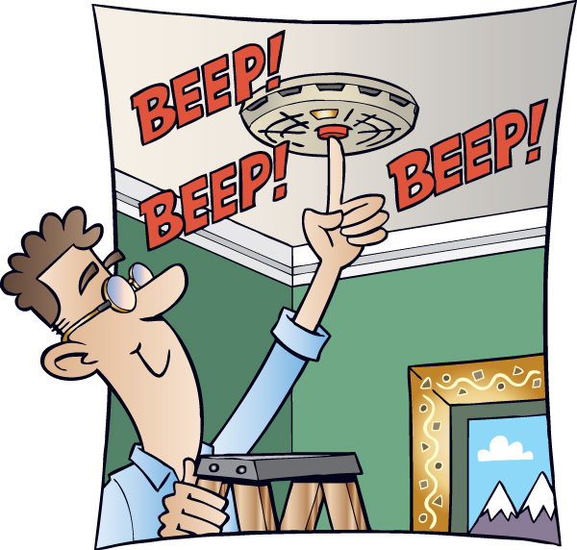  Anxiety can be described as an internal smoke detector. But instead of warning you of only smoke, it warns you of any perceived threats. This “alarm” warns us of any approaching danger so we can protect ourselves.  However, if a smoke detector isn’t calibrated correctly, steam from a shower might falsely trigger the alarm. Similarly, your anxiety may be perceiving danger where none exists.  Once the smoke detector gets triggered, it keeps going until you turn it off. In terms of anxiety, it keeps on going until the threat is relieved, disrupted, or eventually goes away on its own.  Where Does Anxiety Come From?  Now that you understand anxiety is like a smoke detector that alerts you of any perceived danger. You are probably wondering why does it happen and where does it come from?  Anxiety is an evolutionary trait that helps protect us from danger. Let’s look at an example:  Giraffes live in an Immediate-Return Environment which means your actions instantly deliver clear and immediate outcomes.  • the giraffe feels hungry > worries about hunger > searches for food > the worry is relieved.  However, people live in a Delayed Return Environment which means the choices you make today will not benefit you immediately.  • getting a good education today could lead to a better career in the future  The problem with this is that your worries are not relieved immediately.  Our brains are not designed to solve problems in a Delayed Return Environment. This leads to chronic stress and anxiety about perceived threats that are not actual dangers.  What Other People Think Anxiety is Like  Anxiety can be difficult to understand which gives others a negative misconception of the illness. Here are some of the most common myths about anxiety:  1. Anxiety Will Go Away On Its Own  Anxiety symptoms are persistent and will get worse if ignored. The severity of symptoms can fluctuate throughout a person's life based on different situations or stages in their life.  However, this does not mean it is no longer an anxiety disorder. Anxiety disorders are chronic and persistent and if not treated properly, symptoms are likely to return.  2. Anxiety isn’t that Common  Anxiety disorders affect over 18 percent of the US population. This is approximately 40 million Americans every year. Only 37% of those suffering receive any form of treatment.  3. Dismissed as Negative Stereotypes  It is common for people to dismiss anxiety and think it is just laziness, overreacting, it’s all in your head, being too sensitive or emotional, or seeking attention.  These negative stereotypes cause people with anxiety to feel more alone which makes it difficult to share their struggles with others.  4. Just Stop Worrying  If it was as simple as just stop worrying, no one would have an anxiety disorder. It is very difficult to overcome an anxiety disorder without help. There is no magic wand that you can use to just snap out of it or stop worrying.  Overcoming anxiety takes time and effort to challenge irrational thoughts and behaviors so you can reframe those thoughts more rationally.  5. Just Avoid Stressful or Anxious Situations  Anxiety can be triggered by normal day-to-day situations or objects. It can be unrealistic to avoid those stressful situations or objects entirely.  Even if it was possible it would not help the situation. Avoidance only adds fuel to anxiety and can make it worse over time.  6. Social Anxiety is the same as being Introverted or Shy  Introversion, shyness, and social anxiety are actually different and have their own unique characteristics. Introversion is social energy and how someone recharges by being alone where shyness is nervousness or discomfort caused by social interactions.  Social anxiety on the other hand is an anxiety disorder caused by fear or apprehension of social interactions or performance situations.  7. Caused by Childhood Problems  While childhood or developmental problems can be the cause of anxiety for some people it isn’t for everyone. Many people who experience a positive childhood can develop anxiety as an adult.  8. Symptoms are Only Mental  Anxiety isn’t just negative thoughts, emotions, and behaviors. You can experience physical symptoms such as sweating, nausea, racing heart rate, insomnia, and stomach pains.  9. A Sign of Personal Weakness  Anxiety doesn’t discriminate and affects people of all ages. Anxiety is a distressing mental illness that can cause both mental and physical symptoms.  These symptoms can take a toll and make it difficult to focus and be productive, make you feel fatigued, and makes you more at risk of a physical illness.  10. Peace and Quiet is Calming  While it can be nice to get away from everything and have some alone time, this usually doesn’t solve your anxiety.  Your anxiety stems from overthinking anxious thoughts. These worries can spiral out of control when you are alone and feeling isolated.  What Anxiety Looks Like vs What It Actually Is  Anxiety is often misunderstood because many of the symptoms you experience aren’t often visible to those around you.  The Anxiety Iceberg illustrates what anxiety can look like on the outside, but there is so much more going on underneath the surface.  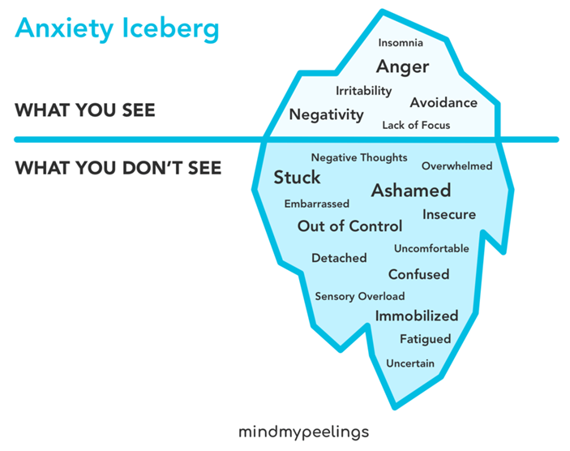  What Happens When You Have Anxiety  Let me explain what this experience is like for someone with anxiety. There is a concept known as the window of tolerance. The window of tolerance is where you can function and deal with daily stress effectively.  To help you understand this, think of your window of tolerance as a river and you are floating down that river. When the river is wide the river flows slowly, it feels calm and safe and your anxiety is under control.  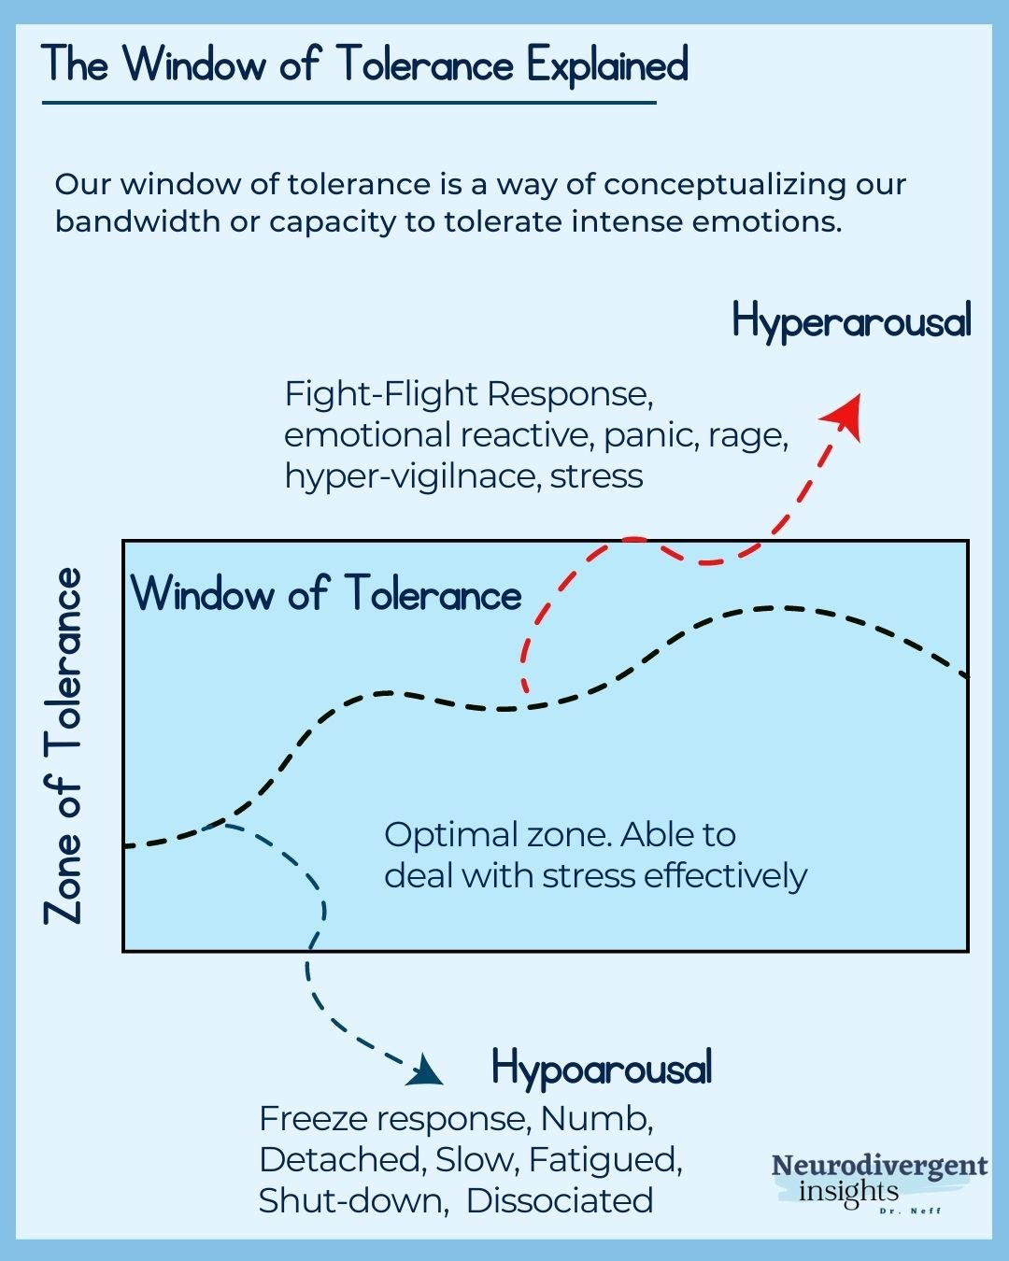  But when you experience stress and anxiety, it causes your window of tolerance to shrink or narrow. When the river begins to narrow it starts to speed up and the waves start pushing you around. You feel unsafe, unable to maintain control, or stay afloat.  What Are You Thinking About (Negative Thoughts)  When the river begins to narrow you feel like you’re going to fall off so you start thinking something bad is going to happen.  You begin thinking of one negative outcome after another. Your thoughts will automatically spiral out of control and become the worst possible scenario.  These distorted thoughts are known as cognitive distortions. They are thoughts that give an irrational and negative perception of reality.  How Do You React When You Have Anxiety (Emotional, Physiological, Behavioral)  When you leave your window of tolerance, your body will automatically respond with fight, flight, or freeze responses.  Going back to the example of you floating down the river. Leaving the window of tolerance is like falling off the floater. You have difficulty getting back on and feel overwhelmed by the waves.  Fight: Confront the threat aggressively or defensively  • shaking  • intense reactions  • feelings of anger or rage  • emotional outbursts  • aggression  Flight: Run or flee from the danger  • feeling trapped  • restlessness or fidgety  • sense of wanting to escape  • tension  • hypervigilance  Freeze: Unable to move or act against the threat  • numbness  • lack of energy  • inability to think or respond  • reduced physical movement  • feeling ashamed  Everyone’s symptoms are unique to them and you may experience a different combination of fight, flight, or freeze responses. You will experience these responses until the anxiety is relieved.  What Anxiety Feels Like  When explaining your anxiety to someone, it is important to share what and how you feel. Since anxiety is unique to each individual there is no single explanation for this, here are a few ways to describe anxiety to someone.  Here are some common examples of how anxiety feels like:  1. It feels like you’re trapped in a loop. You feel the constant back and forth of opposing sensations and emotions. Everything you instinctively try to do to relieve it works against you makes you feel stuck in that cycle.  2. You feel overwhelmed and want to run away from everything. You feel restless and agitated, maybe you have trouble sleeping. It is feeling like a constant tug-of-war with yourself and you just want to escape it all.  3. When under mental distress, it’s difficult to think straight and make rational decisions. The extreme stress and anxiety can cause your brain to shut down and make it difficult to focus, be productive, and perform normal daily tasks.  4. Feels like you have no control over your anxiety. Anxiety isn’t a choice and the negative thoughts, reactions, and symptoms you experience cannot be controlled. They are habitual, automatic, and fleeting.  5. Can feel like everyone is staring and judging you. You experience feelings of humiliation or embarrassment because you are exposed to judgment, scrutiny, or rejection.  6. Constantly being pushed underwater. Anxiety can feel like you are drowning and every time you come up for air it only gives a moment of relief until being thrown back under by another wave.  7. A battle between me, myself, and I. The logical side of your brain realizes what you are thinking or feeling is irrational, but the anxiety takes over with a constant state of panic or self-doubt.  8. It can be physically paralyzing. Anxiety can prevent you from saying or doing something no matter how much you try and force it. It feels like a heavyweight on your chest and can be disabling.  9. Every thought becomes the worst-case scenario. You can’t stop excessively worrying about everything. This causes you to only think in extremes and your worries irrationally spiral out of control.  10. You feel like the world is against you. This creates a perfectionist attitude that cannot be met because you are always doubting and critiquing yourself unfairly.  Help Others Recognize When You Have Anxiety  Explaining what anxiety is and how it feels can help spread awareness and understanding of mental illnesses. However, understanding what anxiety is may not be enough for someone to support you.  Helping others recognize your anxiety will allow them to help prevent triggers, identify when you are experiencing distress, and how you can best cope with those symptoms.  Allow others to ask questions and learn more about your anxiety so it is less likely misunderstandings will occur.  Sometimes it can be difficult to have a conversation about your mental illness. It helps to write it down first which helps process what you want to say.  What Causes Your Anxiety (Triggers)  Anxiety can be triggered due to fear of objects, activities, situations, or performance. Triggers are unique to each individual and without knowing them first it can be difficult for others to help.  You can identify your own triggers by:  • working with a therapist  • keeping a journal  • identifying major life stressors  • reflecting on past experiences  • talking to someone close  • paying attention to any physical signs  Create a list of your triggers and share them with the person you would like to understand your anxiety. Explain each one in detail so they can understand what the triggers are.  What Happens (Symptoms)  Symptoms can include fight, flight, or freeze responses. Create and share a list of symptoms that are categorized by:  • Emotions: Negative emotions or feelings  • Physical: Physical body sensations or signs of distress  • Behavioral: Negative responses or actions  Anxiety provoked responses can often look very negative, unhealthy, and be distressing for others around you.  To help avoid misunderstandings, communicate your symptoms by describing the scenarios that create those conditions or by letting them know when it happens so they can see first-hand what when it occurs.  What Helps (Coping Mechanism)  Everyone responds differently to different coping mechanisms. Talk about what works for you and make a list of some of the techniques you most commonly use to calm or relieve your anxiety.  You may also have a routine or schedule of activities you do regularly to help maintain your mental health or practice self-care. Let them know about these activities and that they are important for you to continue.  Work with them to discuss how they can support you and come up with a list together.  What Doesn’t Help  It is just as important to know what doesn't help as what does help. Be honest and share what doesn’t help when you are experiencing anxiety.  This is just as important because although others may mean well, sometimes their actions can agitate the anxiety further. Discussing these issues can help reduce any unnecessary stress.  How to Describe Anxiety to Someone  In summary, when trying to explain anxiety to someone who doesn’t have it, focus on the cognitive model.  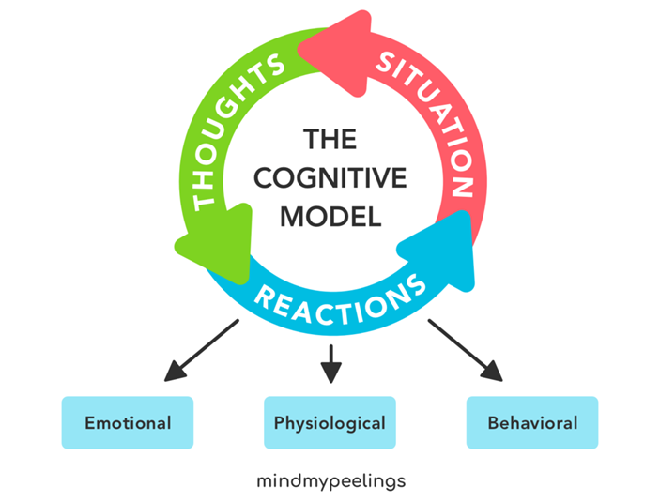  It starts with a distressing situation/trigger → which causes a person to have negative thoughts → this causes negative emotions and physical distress → which leads to negative behaviors.  Identify and describe each aspect of the cognitive model to help explain what your experience with anxiety is like.  