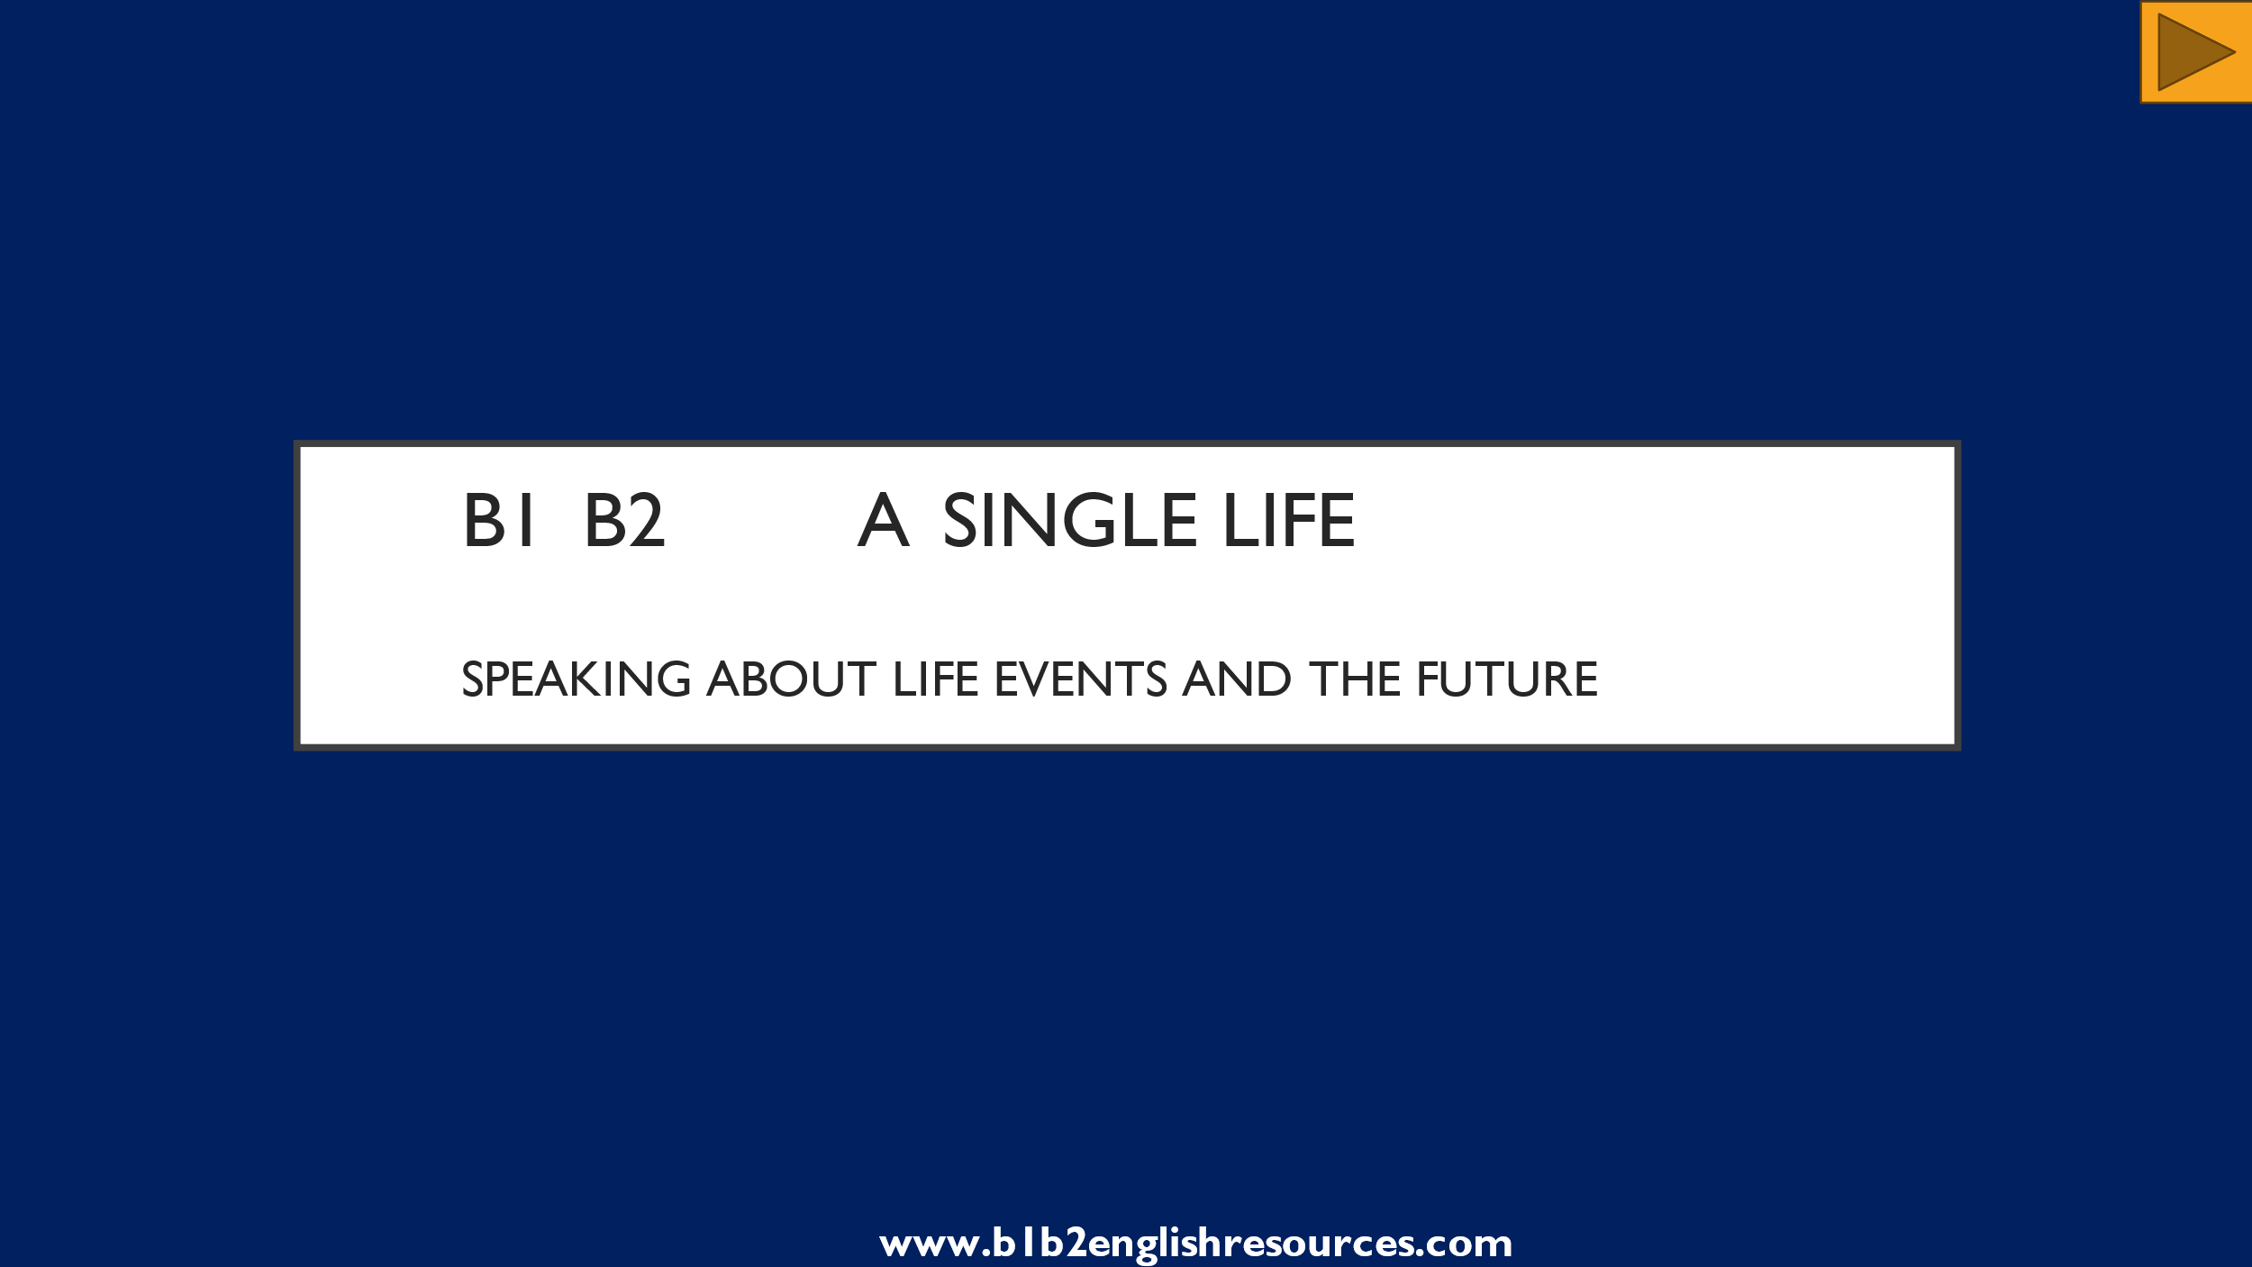

Learning Objectives:
Students will practise:
- Describing events that happened in the past and present, and could happen in the future.
- Talking about milestones in life.
- Describing a room.
- Noticing and describing changes.
- Talking about their own hopes and plans for the future.

Materials:
- PowerPoint presentation.
- One video, 2’30” (YouTube link embedded in the presentation).

Suitable for:
- Intermediate students and above.
- All ages.

Sensitive vocabulary / pictures / ideas:

- None.

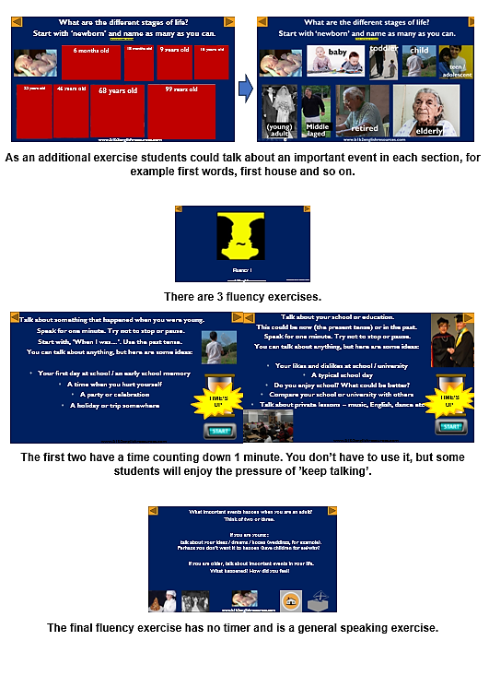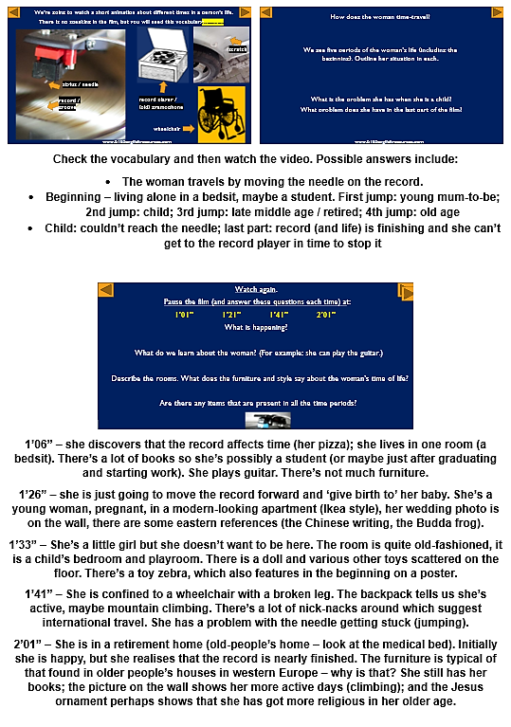

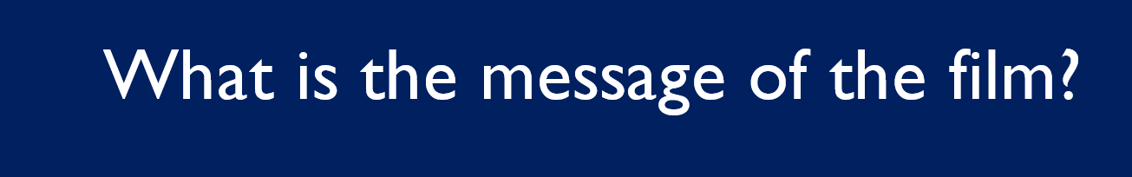
Perhaps the message is that we should live our lives to the full because time is short.

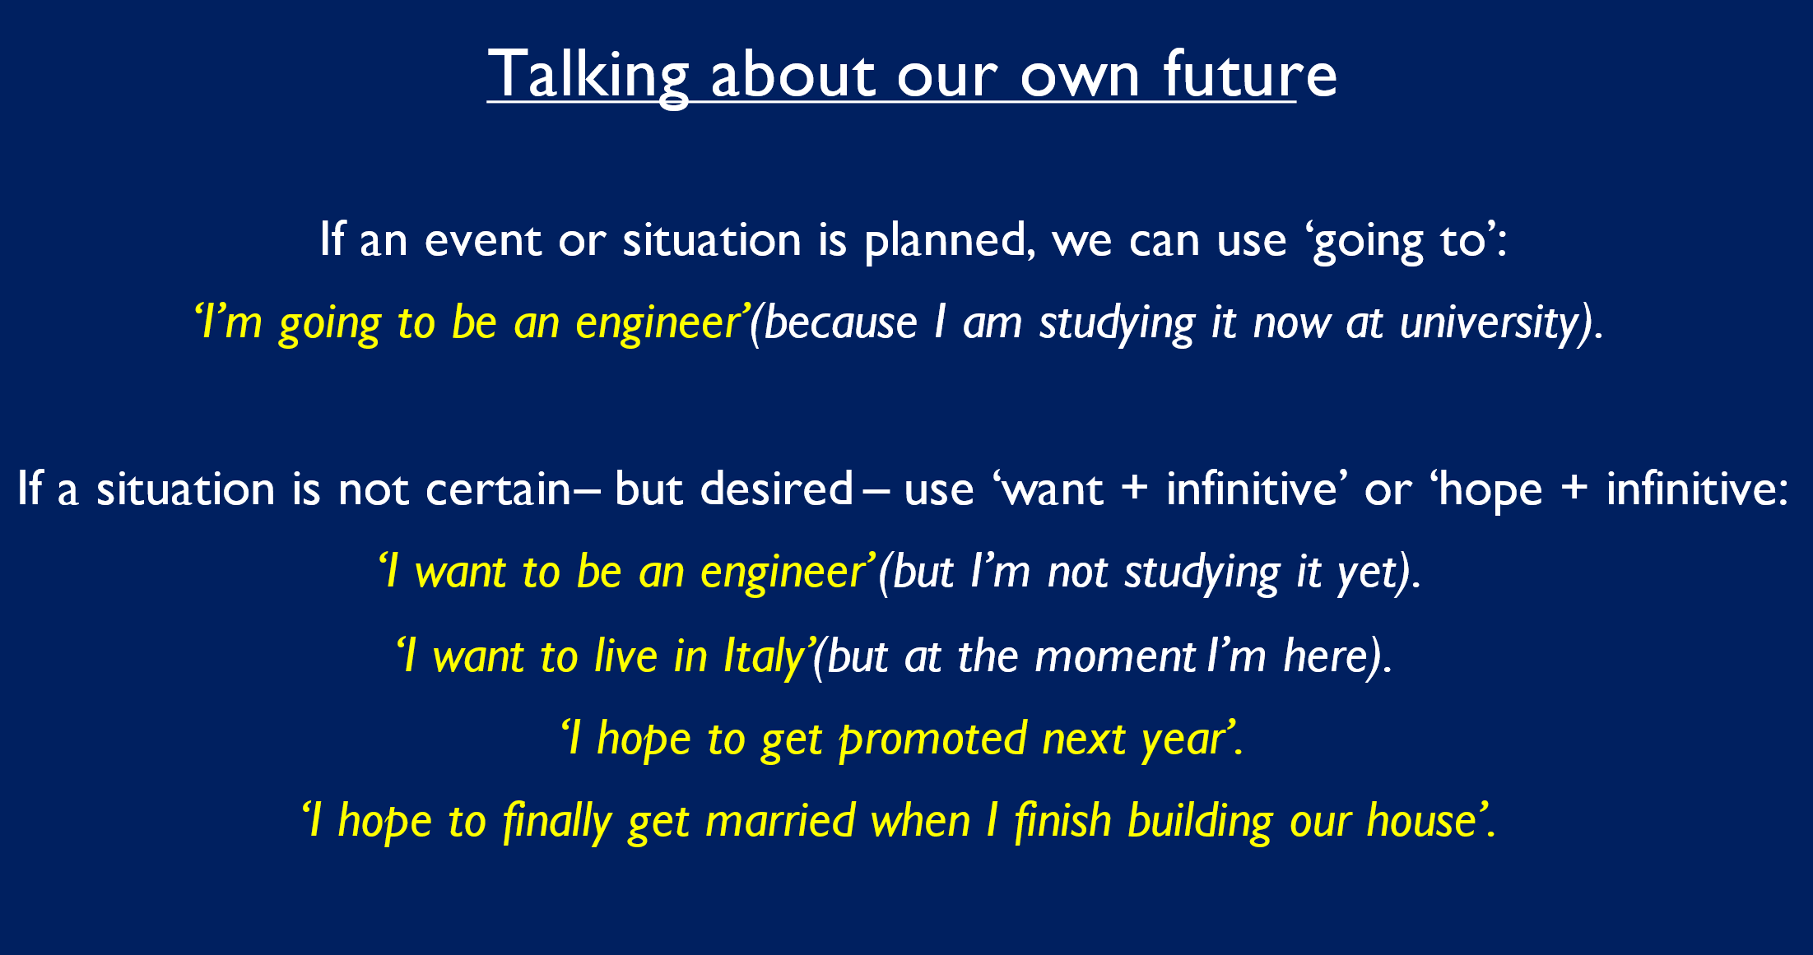
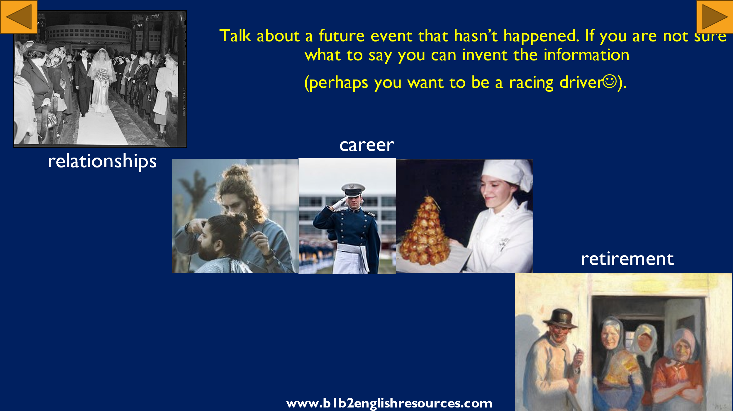
Explain the grammar. Students speak in pairs (or with the teacher).
