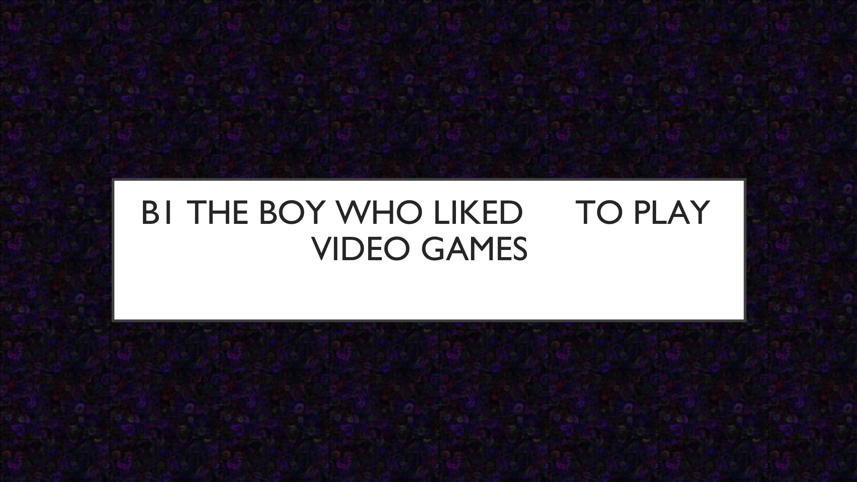

Learning Objectives:
Students will practise:
- Present continuous construction when explaining action in pictures.
- Using stative and dynamic verbs (an introduction).
Students will discuss:
- Gaming and free time activities.
- Action taking place in the video.

Materials:
- PowerPoint presentation.
- One video, 4’00” (YouTube link embedded in the presentation).

Suitable for:
- Intermediate students and above. It could be used with higher beginners (A2) with extra help.
- Adults and children, but the subject matter is probably of interest to teenagers.

Sensitive vocabulary / pictures / ideas:

- The cartoon uses effects to show ‘horror’ as the mother loses her temper with the child. However, nothing is offensive or genuinely scary and the video should be suitable for everyone.

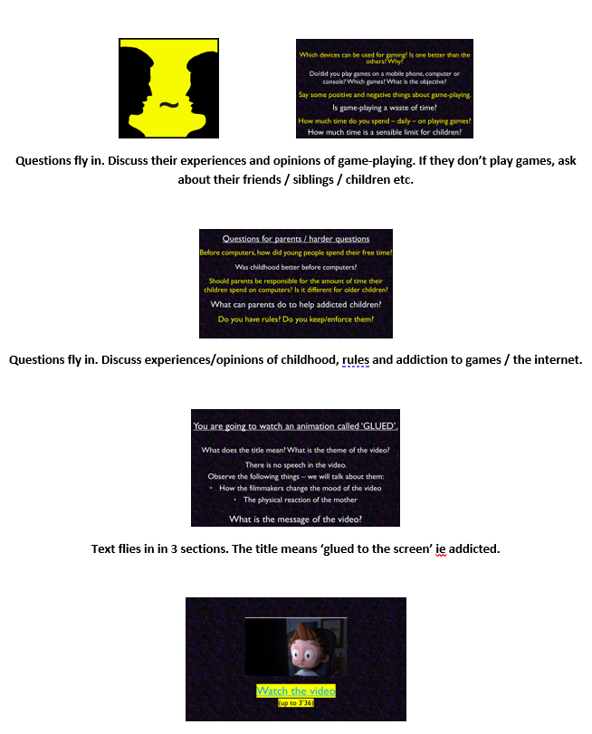
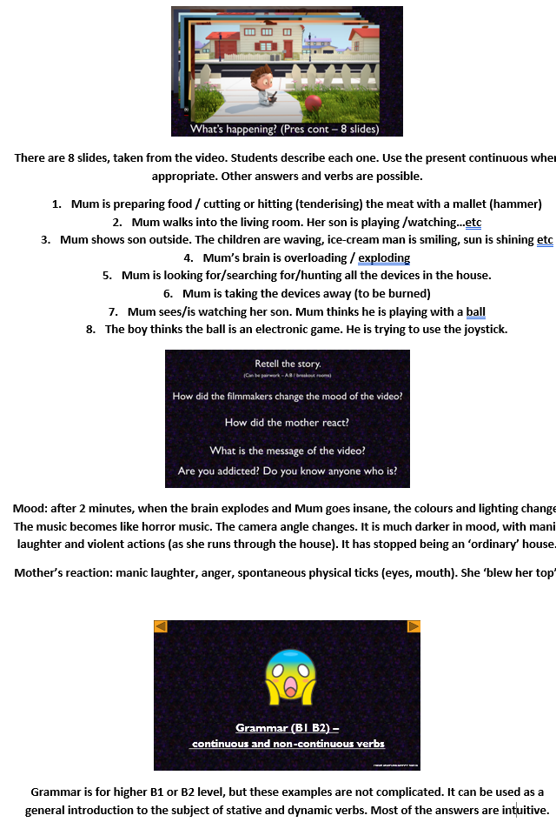
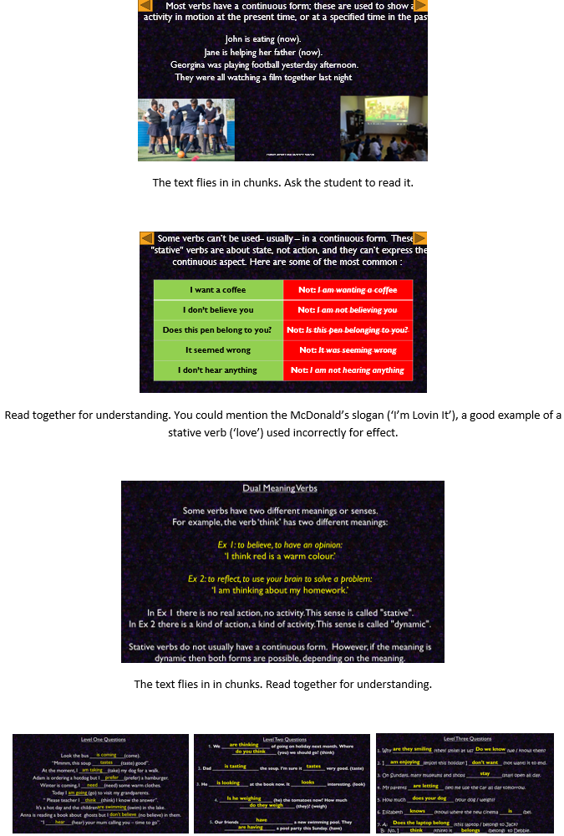
3 levels of questions. Some students will know the answers intuitively. Answers fly in on click.

