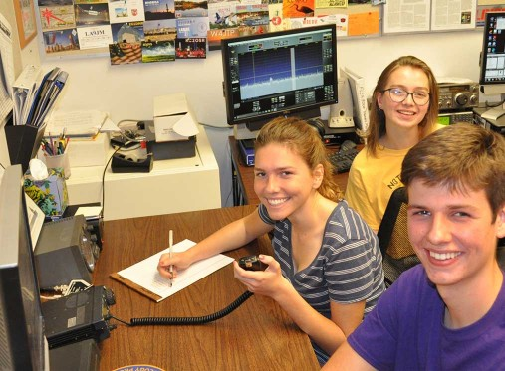
Welcome to Ham Radio!
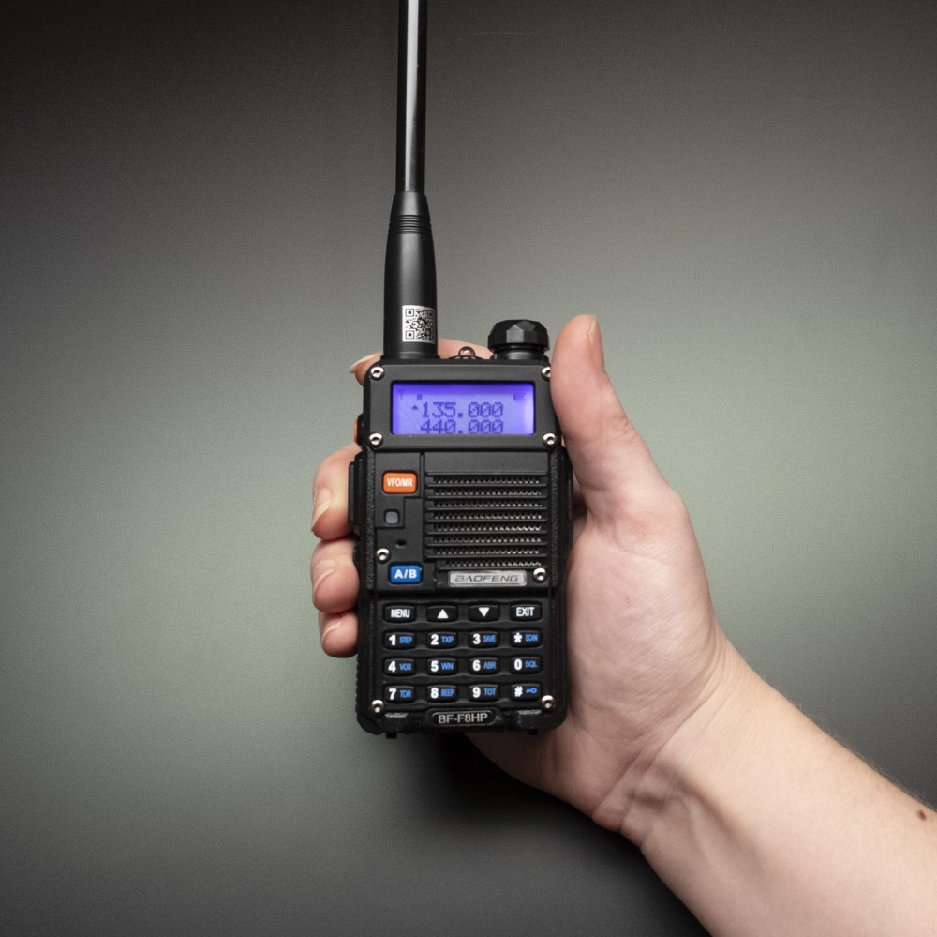
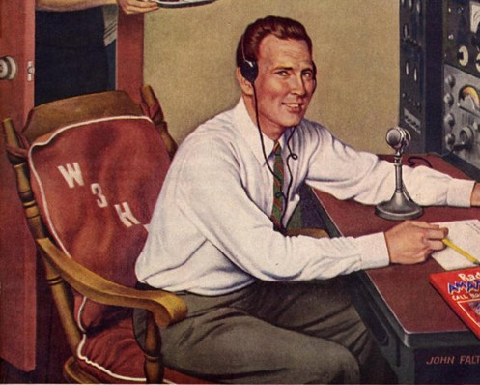
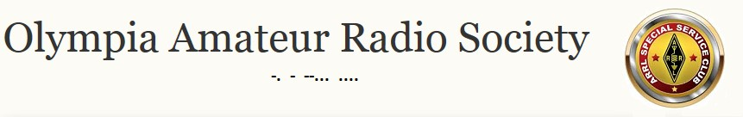

What’s Next?!
A guide to help you get started in the new world of amateur radio …

Dr. Eric S. Messelt, W8ESM

Congratulations!

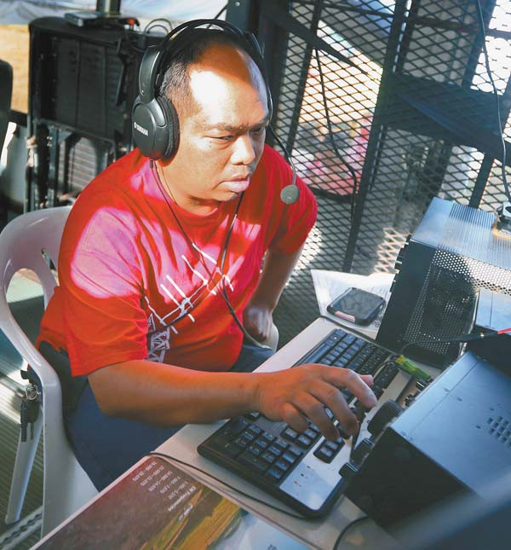
… And Welcome!
You’ve just passed the FCC test allowing you to participate in amateur radio here in the United States. What you have accomplished is significant and valuable! Not only is this privilege valuable to you, but
also your family, your affinity groups, and your community. We welcome you into The Hobby.

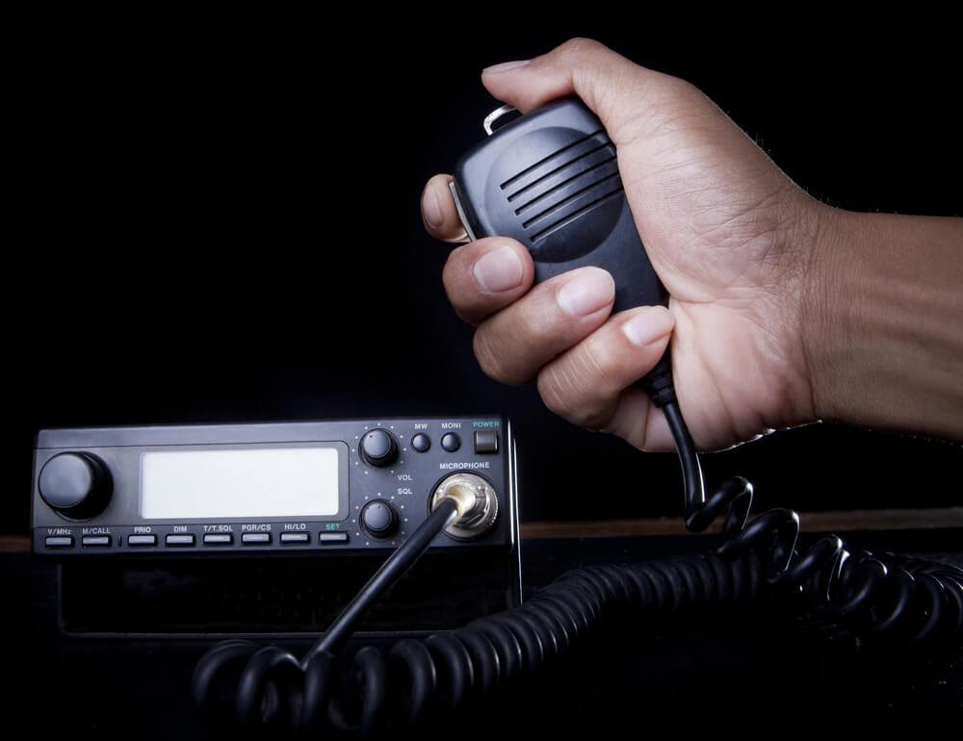
Now What??
But.

The normal, natural, and predictable question that’s formed in your mind is … What’s next? How do I actually get on the air and get the most out of this new license?
That’s what this document is about – helping you get a start. We will outline your basic next steps and make some suggestions based on the accumulated wisdom of over 100 years of amateur radio experience and knowledge. The possibilities are so wide and varied as to be overwhelming. You can get very sophisticated and specialized. Or you can be quite content to be able to help your hiking club stay in touch while on the trail. We’d like to help you take your next best step; but especially to have fun in this new world of Ham radio.

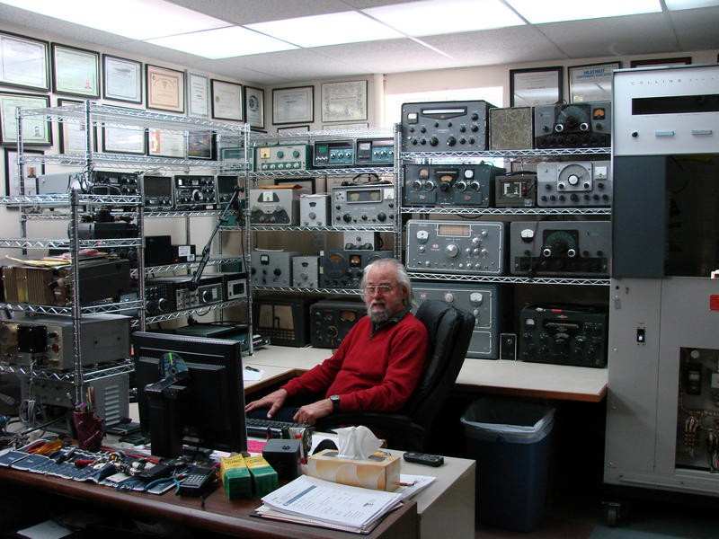
Fluff’n’Stuff
It’s a bit unusual, but that license you just earned is permission by the government of the United States to engage in a hobby. That is the essence of amateur radio. We don’t do all of this under compulsion or for a paycheck; we do this for fun, expanding our personal capabilities, and service for others.
Just in case it hasn’t hit you yet, this is a knowledge and skill-based hobby. You’ve just experienced the knowledge part, but there’s more – much more – that you should know and there are a whole set of skills to be learned and practiced. We are here to help you make a good start. We are excited for you and fascinated to see where you go with this technological pastime!
Sure, OK, yes … we’re a little goofy and maybe even overly excited about the hobby. There are several folks who are in their 70’s and 80’s who started when they were young teenagers – they’ve been at this a long time. There are a few folks who do technology for a living and then get off work to do … more technology for relaxation. Some of us are passionate about certain little nooks and crannies (oh, there are a lot of nooks and crannies in this hobby).
So, yeah; you’ll see some of us as a bit silly at times over what we have come to deeply enjoy. There are skills, knowledge, experiences, war stories, friendships, excitement, and – yep – even some danger. We get pretty jazzed about it all!
But most of that is for later. Right now, this is about you. How can you get a good start? Let’s get past the fluff and into the stuff …

Big Picture of Getting You On The Air

There are some time-tested, practical, and effective things that will get you on the air. Here they are:
- Get connected with the local group of hams.
- Find at least one mentor (in hamspeak, we call that person your “Elmer”).
- Find a frequency in your privilege and listen … a lot.
- After you’ve listened … press the button and talk (well, don’t just blather anything; there are some specific things to say – you will learn those here).
- Join a national organization. That’s pretty easy here in the U.S.: join the ARRL. There’s a lot going on in that organization to support the hobby and get you to go from wherever you are to the next best place – more on that, later.
Now, let’s outline what we will be doing in this document -

- Assumptions we are making.
- How to join a local club.
- Basic Equipment for the new ham.
- What are your privileges, again?
- Understanding the Band Chart.
- How to Get On The Air (“GOTA”).
- Repeater Basics
- Offsets and CTCSS Tones
- How to Make a Basic Call – Script Included!
- Talking to Other Stations – Some Best Practices
- Gaining Experience
- Where do I go from here? Upgrading Your License and Privileges.
- A Word About The ARRL
- A Shout-out to OARS!

And just a word about “amateur.” The word invokes a notion of casualness, carelessness, even sloppiness. This is not the case with Amateur Radio. As you remember, the only reason we have used this word is because we are not allowed to take money for the communications services we do – in only that sense are we not “professional.”
Fact: many in the ‘hobby’ are highly trained, experienced, and dedicated professional-level communicators. But a lot of us prefer the term, “ham radio” as a reminder that we have fun with the hobby.

Assumptions We Are Making
- The vast majority of new hams start by getting the Technician Class license. While it is possible (we’ve seen it) to step into the examination, take and pass the Technician element, then take and pass the General element, and even take and pass the Extra element on the same day; that is rare. The vast majority of us got our first license at the lowest class and upgraded from there. All this means is that we are assuming that you now have a Technician Class license (once it’s in the FCC database) and have not been a ham before. That is, you are starting from the beginning.
- Gender pronouns have been tricky in the last couple of decades. Here, we are just going to make a decision to use the male pronoun for the generic person in this document. This can be unfortunate as the hobby is male dominated and so might reinforce some stereotypes. However, there are a lot of women in the hobby (hamspeak: every female is a “YL,” for Young Lady; wives are “XYL”) and we absolutely encourage everyone to go as far in the hobby as they can. It really is true that Amateur Radio in general, and our local club in particular (“OARS,” more later) do not discriminate. The hobby is open to everyone willing to take on its challenges.
- This document is produced by the Olympia Amateur Radio Society (OARS) and we will be directing specific content that is relevant for amateur radio in Thurston County, Washington.

How To Join A Club
Well, that’s easy! Just fill out the membership form for our club, the Olympia Amateur Radio Society! Next …
OK, hold on – let’s break that out a bit. There are two points we’d like to make about joining a local radio club: 1) you should join a club; and 2) it should be a local club. There are a few radio organizations here in Thurston County, but we want you to join ours, of course!
The hobby is, as we mentioned before, a knowledge and skills-based endeavor and can occasionally get discouraging as you are attempting to master one of the skills or get some recalcitrant piece of equipment to work correctly. Believe it; we’ve all been there. That’s where being part of a club can help. There may be others who have encountered exactly that problem and can provide a solution. Usually, however, there are people who can help you work through to a solution. Developing those relationships is part of why we call our local club a “society,” rather than a group, association,

organization, or even “club.” You’re new to this world and will need some encouragement and guidance to help you get oriented and thrive in the amateur radio environment.
In a nutshell, that is also the basic argument for joining a local club: people near you who can help you get the lay of the radio land, introduce you to leaders in the hobby, provide learning and training experiences to expand your skillset, and so forth. We feel it’s important to develop relationships and friendships to make you more effective as a radio amateur.
Sure, we joke that in the recent COVID-age that ham radio has been practicing social distancing for over a hundred years. Still, these things happen in face-to-face exchanges. Your first radio contact will likely be somebody who is local to you. There is fun in hearing that first voice talking to you over the repeater and then putting face to voice at the local radio club meeting.
We’ll introduce you to our club a bit later.

Basic Equipment For the New Ham
This implies that you’ve waited until you get the license (hamspeak: “ticket”) before you buy any equipment. That is the recommended order – get the ticket, then get equipment.
That being said, you can spend some Serious Money on the hobby. Try to remember – it is just a hobby.
First Radio
You want to get a radio (hamspeak: “rig”). That’s good; there are a lot of options. Generally, there are three classes of radios these days: the hand-held, the mobile rig, and the base station rig.
The hand-held fits in your hand and is meant to be portable and capable (see picture, below); they’ll put out about five watts and only on the VHF/UHF bands. The mobile rig is designed
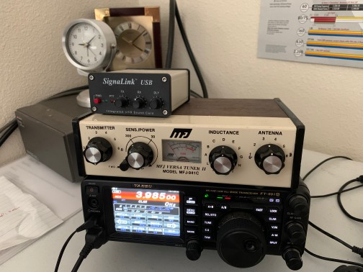
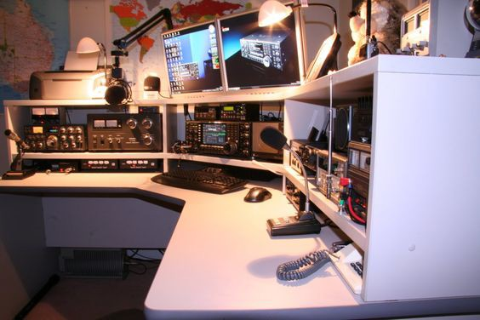
to be mounted in your car, boat, or even (sure, we’ve all got one of these) airplane; but many of us use a mobile rig as our main station at home. Some mobile rigs will cover HF (‘classic’ ham bands) and the VHF/UHF bands, go to a maximum
of about 100 watts, and require an external 13.8v-ish power supply or battery. You can do a lot with a mobile rig but generally (pun intended) need a General Class license to use a mobile rig’s full capabilities. At

the top of the heap is the base station. These rigs sit on a desk or bench, have their own power supplies, can put out 1000+ watts using a separate amplifier, have very sophisticated reception and transmission controls, and really-really pretty lights and dials and knobs and switches and stuff.
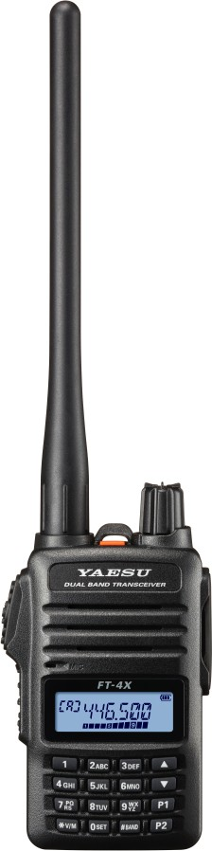
These days, your first radio will likely be a low-power hand-held transceiver (sometimes awkwardly called, “handy-talkie”) for VHF and UHF that will allow you to do a couple of miles simplex (direct, walkie-talkie-like) and usually allow you to get onto the local repeater. There’s a big ol’ debate about what specific radio to get. Most of us would caution you (unless you already really know what you’re doing) against spending a lot of money for your first radio. You should get a basic and (relatively) inexpensive hand-held to learn-
by-doing what features you will later want to pay for … or get gifted. Because nothing says love like a family member giving you a $500+ radio for Christmas…. yeah, that hasn’t happened to me, either.
Moving on … the best apparent value is the selection of inexpensive Chinese radios, including the somewhat notorious Baofeng UV-5R. These do the basics and can be very attractive, price wise. Cost is as low as $25 (in quantity) and usually no more than $40 each. At such a price, you can get a radio that will work and give you months of service. However, the build quality is mixed. These radios don’t do well with rough handling and their signals are usually not clean.
One key thing to look for is that the radio is “FCC Certified,” and some of the cheap radios are not. Look for this logo –

Fortunately, by the time you break that first radio (!), you’ve gotten your ‘radio feet’ wet and are interested in paying for some quality.
Note: In the last couple of years, it has been reported that China has been engaging in serious human rights abuses. There are some folks who have gotten understandably upset and are boycotting Chinese-made products. There are inexpensive non-Chinese options! Yaesu (Japan)

has made a better version of the Baofeng UV-5R with much better build quality (Yaesu FT-4). These radios are about $75.
First ‘Accessory’
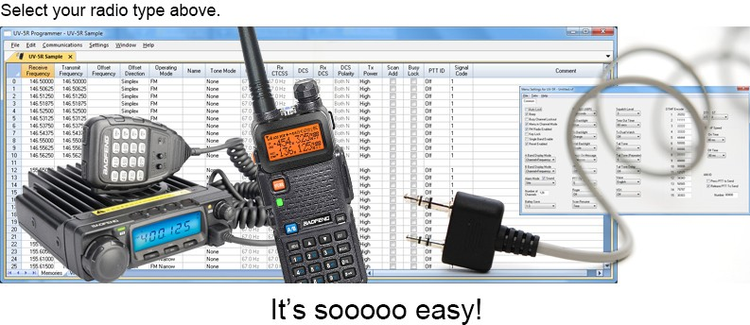
It didn’t take many of us very long with our handhelds to realize that programming in more than a few repeaters was … very … tedious. Getting programming software for your radio makes programming your radio much easier. With
many radios, the free CHIRP program is helpful. CHIRP is clunky and awkward compared to, say, the RT Systems programming packages – but for that first radio, CHIRP is a good addition.
First Upgrade
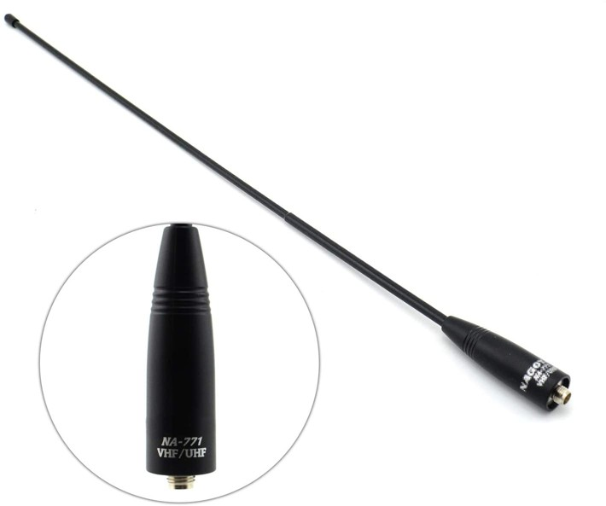
When bought new, these handhelds will include a battery, battery charger, and low-quality antenna. In most cases, your first upgrade will be to get a better antenna. The ones usually packed with the radio (called “rubber ducky” antennas) are not very effective and will be frustrating to you. With the in-the-box antenna, you’ll be able to reach your buddy maybe a mile away. You’ll
want to do better than that and the path forward is a good antenna. As an example, the Diamond SRH999 ($35.89 on Amazon as of mid-2021) would be a good choice. With even a modest antenna upgrade, you’ll probably be able to reach the local repeater and talk with people throughout your county and beyond. Of course, remember that the VHF and UHF bands are Frequency Modulation (FM) and need “line of sight” to wherever you want to be heard.
First Test Equipment

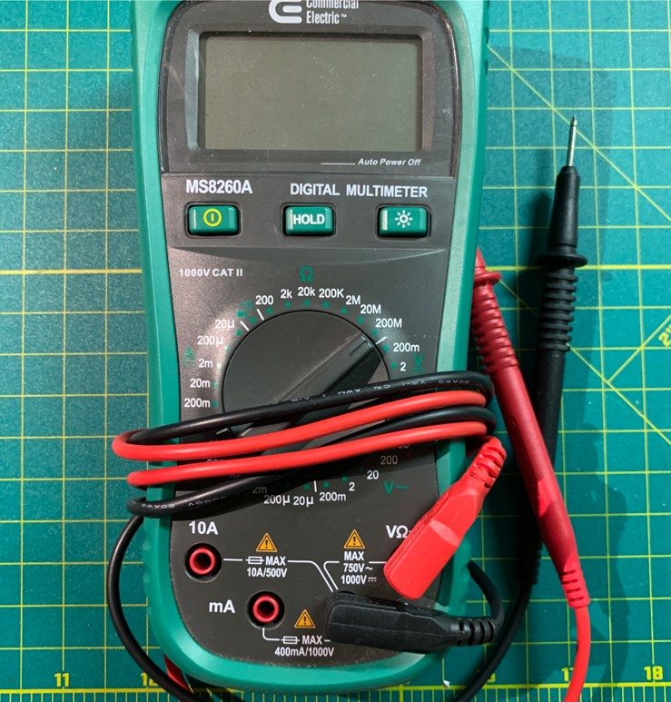
A good VOM (Volt-Ohm-Meter) comes in handy. You may already have one. Try to avoid the cheapest model. It actually takes some expertise to use bad equipment usefully. One the other hand, you don’t need to start with a $150+ device, either. As of 2021,
think in the $15-$30 range. A VOM is useful to get voltage readings (AC and DC), basic continuity, current, and resistance. You can do a lot knowing just those things. This tool will help make Ohm’s Law more
than just numbers and formula – a VOM can show you what’s happening and verify your calculations.

Beyond all these recommendations, there’s a whole eco-system of YouTube, Reddit, Facebook, Discord, and other online resources to help you with specific questions.

What Are Your Privileges, Again?
You have just earned a license to exercise the privilege of using certain parts of the radio spectrum. That license gives you limited privileges – you can’t do everything or go anywhere.
This is like a driver’s license which grants you the privilege of driving a typical automobile on public roads. Yet you can’t operate a motorcycle or commercial tractor rig without ‘endorsements’ which are earned after you demonstrate capability. You are allowed to travel on public roads, but certain roads or lands are restricted to you. If you enter those roads or lands you commit the crime of trespassing. We operate in the a radio spectrum analogy.
So, what can you do with a Technician Class license? Actually, more than you may have realized.
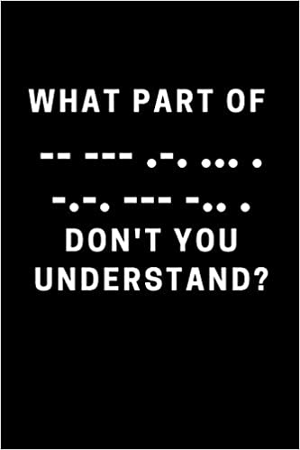
Most people are very aware that they can talk, using FM, on the VHF and UHF parts of the amateur radio bands. Yet there are lots of other ways to communicate –
I’m thinking of the digital modes, including the Granddaddy of all digital modes, Morse Code. That’s right, while nobody really talks about it, you have privileges to use Morse Code (hamspeak: “CW” [“see-double-you”]) in a few of the HF bands (80, 40, 15, and 10m). The Technician Class is not a VHF/UHF-only license! In the typical VHF/UHF world, you have a reach of a few counties (using a repeater). In certain parts of the U.S., you might be able to reach a whole state. But if you develop Morse
Code chops, you are allowed to communicate all over the world, along with the Big Boys.

Additionally, the Technician Class has a part of the 10 meter band for Single Sideband voice (as well as the CW portion mentioned above) and all of the amateur 6 meter band. Frequently neglected is the 1.25 meter (220MHz) band where Technicians have full privileges.
Historically, the “Technician” class license privileges were aimed at the experimenter who wanted to explore and play in the upper frequencies but weren’t really interested in talking across the world in the lower frequency bands. This is reflected in the Technician’s privileges in the 33 cm and 23 cm bands where we start getting into microwave territory, as well as all of the full-on microwave bands available to amateurs.

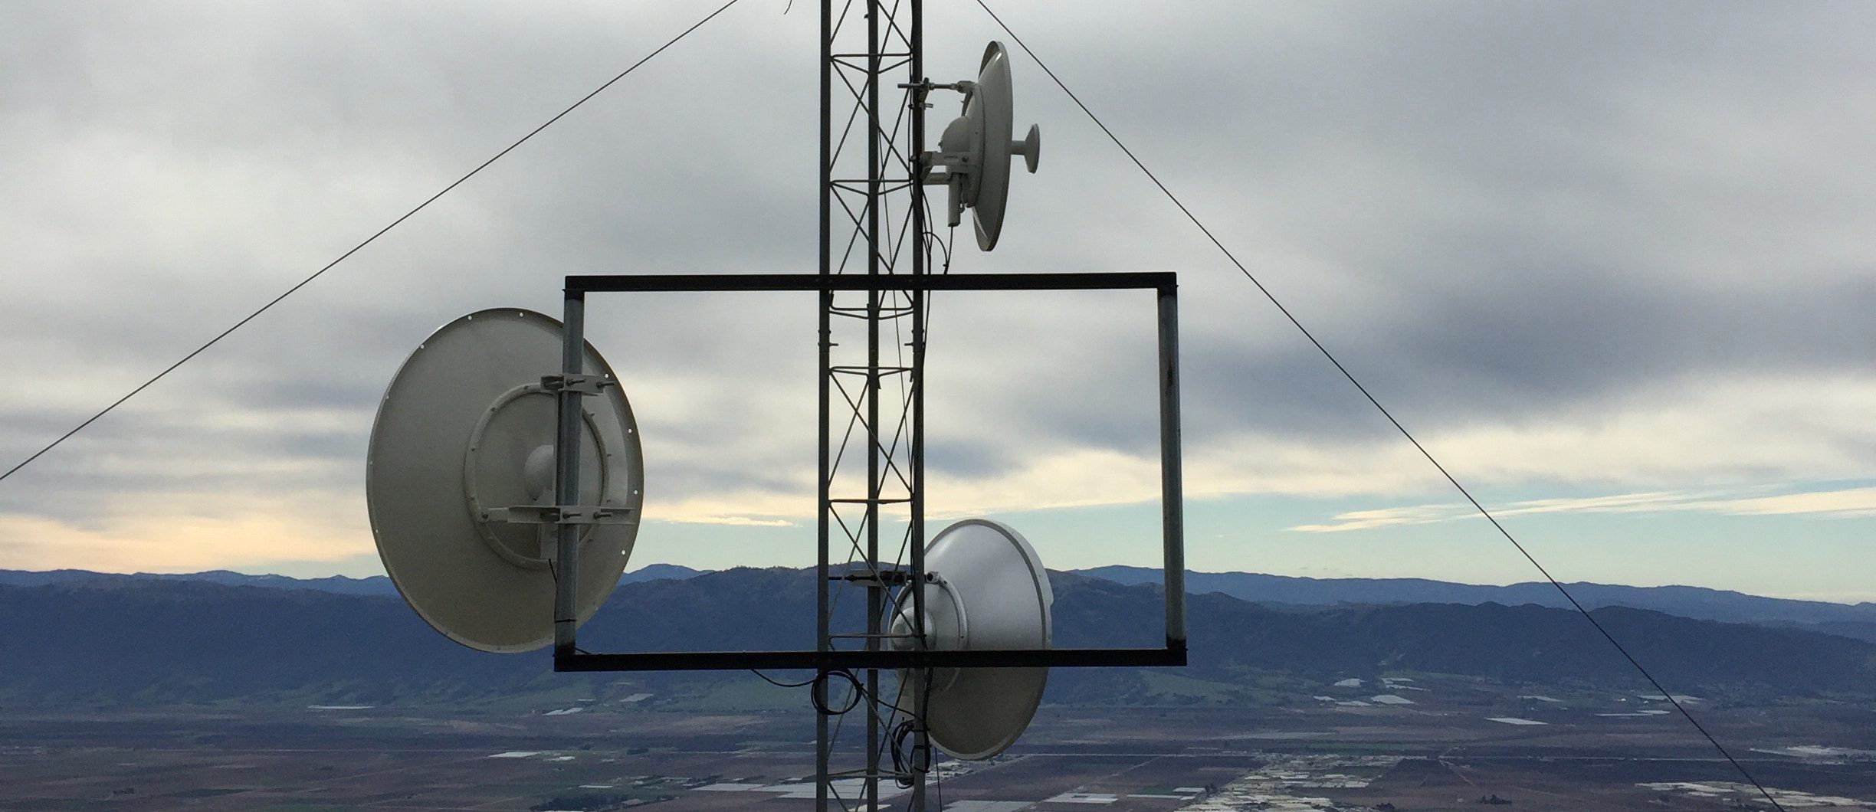

Coming back down from those rarified frequency realms, remember that a Technician can also use digital voice modes. These are the protocols with names like “DMR,” “System Fusion,” and “D-Star” which each take your voice, convert it to a digital signal, transmits the digital signal (usually in the VHF/UHF bands), and then decodes that signal for the person on the other side.
Have you read about hams reflecting their signals off meteors, the moon, or using the mysterious “Sporadic-E” or “Tropospheric Tunneling?” All those are available to the Technician.
Yep; there’s lots to do with your Technician license.

Understanding the Band Chart
So, there’s a 100+ year history of amateur radio and we have a pretty good relationship with the U.S. government (the FCC). Much of that is because we understand that we are privileged to be able to use all these sections of the radio spectrum. By the way, that wasn’t always the case. There were a couple of times when the government shut down amateur radio and we had to make a case to get those privileges back. One of the reasons we have that good relationship is because we are self-policing. We learn the rules and do our best to obey them. There is so much that we can do with our radios that wasting time flouting the law seems a foolish thing.
One of the things we work very hard at is making sure that the signals we transmit are firmly within our allocated frequency bands. Transmitting outside our bands means that we are interfering with air traffic control, emergency medical responders, marine and aviation navigation, space exploration, and so forth. Nobody really wants that. So, it’s important to understand the allocation for your class of license. That means you need to understand the Band Chart.
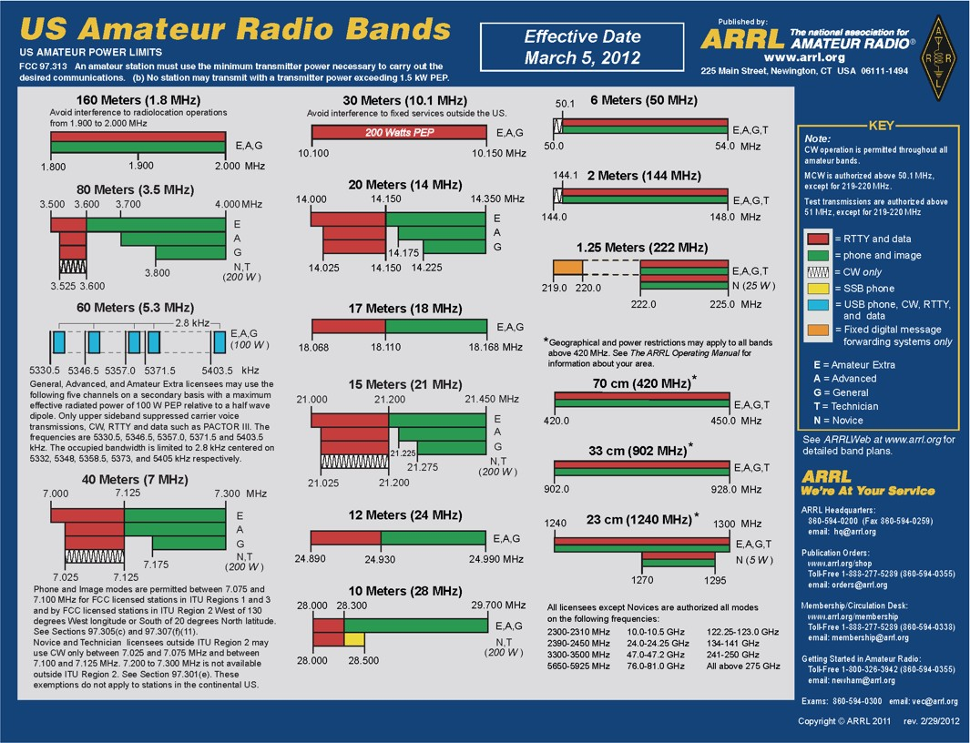
We’ve included one with this package. If you have a station at home, put the chart up on the wall over your desk or bench so you can quickly see where you are and make sure you are not where you don’t belong, radio-wise. The chart shows all the amateur bands we get to play in, depending on the class of license you have. The kind of transmission is represented by color (green is voice, for example) and then, to the right of each color band, are the classes of license that are allowed to transmit in those radio
areas. The “A” and “N” license classes are hold-overs from how licenses were granted about 30 years ago. What you are interested in are the rows that are marked with a “T” to the right – “T” is for Technician.
Now, you might be wondering, “Hey, I’ve got this radio and surely it’s not going to let me transmit outside of the ham bands. So, I’ve got nothing to worry about!”
Well, if only that were true. Some of those cheap Chinese radios (yep, this is a controversy with the FCC) will allow you to transmit outside of your legal bounds. If you do that you are responsible, not the manufacturer. Don’t get in trouble with the FCC – your time in the hobby could be very short.
OK, so let’s look at the Band chart. Lots of colors, lines, boxes and words - but you can make sense of it.
For example, there are three columns of bands. The one on the right has the allocation for 6 Meters (50 MHz). On that band, most hams (E,A,G,T – but not N) have the same privileges: CW from 50.0 to 50.1 MHz; and then data or voice from 50.1 to 54.0MHz.
Now, if you go to the left column and look at the block titled 80 Meters (3.5MHz), the situation gets more complicated. In that case, no matter what your license, you can only use data between 3.5 and 3.6MHz; but only if you are an E-class (“Extra”), everyone else is limited to
3.525 to 3.6. Those Extras get .025 of bandwidth for themselves! For the N-class (called “Novice,” back in the day) and Technicians, you can only use CW, as we mentioned before. Then each class has more or less voice privileges from 3.6 to 4.0MHz: for E-class (“Extra”) they get the whole spread; A-class (“Advanced”) don’t get the lower 100kHz of that; and G-class (“General”) only have 200kHz of voice privileges to work with.
The band privileges can seem a bit complicated, but as you study the chart some things become more apparent: digital tends to the lower frequencies. The farther a signal can usually go the higher the license you need to use that frequency neighborhood, and so forth.
So, read the chart and study how each of the bands work.

How to Get On The Air (“GOTA”)
Repeater Basics
The “Big Idea” of repeaters is to take your limited signal and amplify it so lots more hams can hear it. The repeater (hamspeak: “machine”) does a lot of sophisticated work to pick out your weak signal and then simultaneously re-transmits it much stronger.
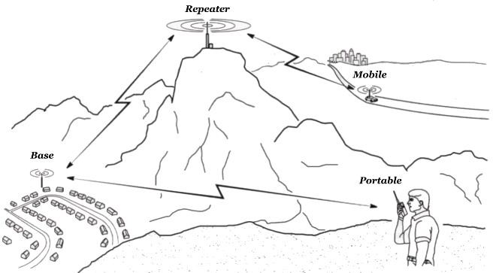
Your signal may be limited because it is relatively low powered. Say you’re using a handheld that only puts out five watts. The repeater uses its sophisticated receiver and picks up your signal out from the noise,
cleans it up a bit, and then more powerfully re- transmits it on a slightly different frequency to everyone else in the region. Another reason your signal may be limited is because of geography. Remember
2m and 70cm usually use FM, which is a line-of-sight mode. If there’s a significant hill between you and your ham buddy, even though you’re merely a half-mile away, you are going to be silent to each other. The answer is to put a repeater on a high point in the region (here we use a couple of hills and mountains). That means the repeater can ‘see’ your signal and retransmit it to anyone else ‘visible’ to the repeater.

Offsets and CTCSS Tones
While a repeater is some very clever engineering, it isn’t magic. It must be able to receive and transmit simultaneously. It does that by listening on one frequency and then transmitting on a slightly different frequency. As you remember from your testing, this difference is called “the offset.” You’ll need to program your rig to have the proper offset for that particular repeater. All of the repeaters in this area follow the same standard offset rules (but outside the area, there can be some exceptions). You’ll see a + or – with a frequency value (e.g.: “-0.6 MHz” or “+5 MHz”). The number is the amount of the offset; the “+” or “–“ is the direction of the offset – you need to have both correct to access the repeater. So, the frequency of the repeater is given as the frequency that it transmits, and you will receive. The offset is the value above (+) or below (-) your receive frequency that you will be transmitting on.
There’s another feature that most repeaters have to improve the signal quality: a “tone squelch.” The problem is that some static can trigger the repeater and then static gets retransmitted. That’s annoying. So, many repeaters have a ‘squelch tone.’ This is a sub-audible (below our ability to hear) tone that is injected into the signal by the ham’s rig: handheld, mobile, or base station. When the repeater hears that tone, it then instantaneously recognizes that tone and then transmits what it receives. Additionally, a repeater itself can insert that tone into its transmission to tell your rig that it should pick up that signal and send it through the speaker. You will program in a value like “100.0” or “114.8”.
Once you get all these values right and saved to your rig’s memory (that is, “programmed”), you should not need to change them again for that repeater.
Now, how do you find out these values? Well, in this case, the Internet is your friend. There is a great website sponsored by The Repeater Book: www.repeaterbook.com . You’ll find nearly every repeater on the planet in there – not only for hams, but also GMRS and other services.
Take a look, browse around, see what’s nearby!

How to Make a Basic Call – Script Included!
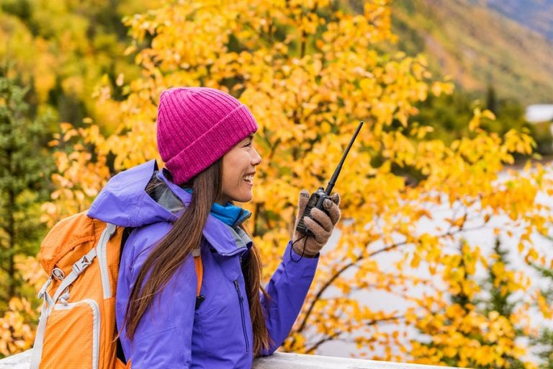
Talking to someone else on the radio is relatively easy – but also can be intimidating. What we call, “Mike Fright” is a very real thing. This is why we encourage you to listen. Learn to hear the cadence, how people talk, what the ‘procedure’ is like, what confident operators sound like, et cetera. Nearly every new ham’s first
contact is supervised by another ham coaching them along right next to them – especially in the Old Days.
Speaking of the Good Ol’ Days, remember that The Hobby is over 100 years old. The on-air practices we now know have been developed and hammered out over the last century from Morse Code through AM voice, to FM repeaters, to digital modes.
Your ham life will likely start in the VHF/UHF part of the ham world. There are many similarities between the VHF/UHF and ‘classic HF’ ham worlds, but also some differences. We’ll discuss those in this section.
But before we get to why; let’s dive into what. Here’s a typical conversation between two hams using a local repeater…
- “Whiskey Eight Echo Sierra Mike, monitoring … Whiskey Eight Echo Sierra Mike.” (waits a bit)
- “Hey, Eric! How’re you doing? Kilo Seven Tango Alpha Mike.”
- “Morning, Ken – good to hear you. I’m out running errands by the mall and thought I’d see if I could catch a cue-soo (QSO) on the way back home…”
- [Ken and Eric engage in chit-chat – hamspeak is “rag chewing.” About nine minutes into the conversation, suddenly K7TAG says out of the blue …]
- “This is Kilo Seven Tango Alpha Golf for the ID.”
- “Right – this is Whiskey Eight Echo Sierra Mike.”
- [The two hams continue their conversation]
- “OK, I’ve arrived home, so I’ll be saying good-bye.”
- “Great chatting with you. 73’s.”
- “This is Whiskey Eight Echo Sierra Mike out.”
- “This is Kilo Seven Tango Alpha Golf clear and monitoring.” Let’s break down this conversation…

The call signs. So, the first ham gives out his call sign and uses the International Phonetic Alphabet. This makes it easier for people to make out the letters. Notice that he repeats his call sign to make sure that it is understood.
Why did he start out saying, “Monitoring?” You may remember from your testing that if you want to initiate a radio contact, you say “Sea-cue, See-cue …” (CQ) which is from the old days where the hams would transmit Morse Code (“CQ” … “Seek You;” get it?) and then the practice just carried over to voice.
But your Technician world is different. You usually don’t operate in the HF bands where calling “CQ” is normal practice. In the repeater world, you let people know you’re there by saying that you are “Monitoring.” This is a rather more passive posture: you are ‘monitoring the traffic’ on the repeater soooooo … ‘If somebody wants to talk with me, sure, that’ll be OK with me. Because we all be very cool and laid back when we be on the repeaters.’
The Acknowlegement. K7TAG (Ken) comes back and addresses the first ham, Eric, with his own call sign, also using the phonetic alphabet. Eric recognizes Ken’s voice and his call sign and refers to him by his first name.
Hams, over the air, are primarily interested in your call sign. Your call sign is your radio identity. Secondarily, hams are interested in your first name (hamspeak, “handle”). Hams are not very interested in your last name. If they need it, they can look it up later.
What’s a “QSO?” (pronounced, “cue-soe”) You’ll remember from your testing that hams have developed several “Q-signs” as abbreviations. Again, these date from the Morse Code days and are very much used today. There are several, but most hams use just a few. A QSO is a radio contact, QTH is your location (like a police “10-20”), etc. Hams use these all the time in casual conversation (BTW, if hams are involved in emergency communications, they are actively discouraged from using special codes – plain language is required). So, Eric is telling Ken that as he’s headed home. He thought he would attempt to chat with someone (QSO) and Ken was right there to chat with.
What do they talk about? If you’re looking for culturally significant, profound, or momentous oratory … well, not so much in most ham conversations. Hams chat about some of the most trivial, mundane, and inconsequential things. But in doing so, they are not doing trivial or inconsequential things. More on that later. Here are some examples of what hams will chat about:

- A new piece of gear or equipment they are trying out: “Hey; I put up this antenna that I’m experimenting with. How’s my signal sounding like from over there?”
- What they did, or will be doing, that day: “Well, I’ll be heading over to my doctor to have a lump checked out – gotten to that age when stuff like that is important.”
- Check-ins during “nets” (hamspeak for on-air meetings) - more on that, below.
Really, hams will talk about their cars, a trip they took in 1991, how they got an amplifier to tune up, nearly anything.
But. There are some things hams do NOT talk about. See “Best Practices,” below and sheet, included.
Rules About Call Signs. There are rules about using your call sign, as you’ll remember. Here’s something we forget: you do NOT have to use your call sign when you begin a conversation – even though that is good practice in casual radio conversations. However, you must identify yourself at least once each ten minutes and when you conclude your conversation. You see that Eric and Ken stop their conversation very briefly to make the legal identification (“for the ID”) because it’s been about ten minutes and then they continue.
I hear “73” all the time – what’s that about? 73 has become the abbreviation for ‘best regards,’ or a similar sentiment. Again, another tradition brought forward from the Morse Code days.
Some hams might sign off with a, “See you down the log;” which implies that they are logging each contact (which is rare these days) and hope to see your callsign in that log – that is, contact you in the future.
Is there a difference between “Over,” “Out,” “Clear,” and “Monitoring?” Yep – there is! Here’s what these terms mean:
- “Over” means you’re done talking and are looking for a response from the other ham. It’s a shortened phrase, “Over to you.”
- “Out” means you’re done talking and are about to go off the air. In our example above, Eric (W8ESM) had arrived home and was going to turn off his mobile radio to go inside. So, he signals to Ken (K7TAG) by saying, “Out”
  - OK, this leads to one of the things that hams laugh about. In the movies or TV, you’ll hear people on the radio say, “Over and Out.” Well, that’s just silly because if you say “over,” you’re expecting a reply. But then you also said, “Out” meaning you’re turning off your radio or otherwise ceasing radio operations – which is it?!?

  - Occasionally, you’ll hear two hams closing up a QSO and one says they’re “Out” and then a third ham chimes in, “W8ESM, this is W7SLT, are you still there?” So, Eric feels compelled to answer the new ham and has a new brief QSO. We can imagine Eric sitting in his car or truck wanting to go inside but other hams still want to talk to him. While it may seem nice to be popular like Eric, we might wonder that what he *really* wants to do is get inside and visit the bathroom.
- “Clear” means you are done with the conversation but are still listening. Here, Ken says that he’s “clear” and “monitoring;” letting anyone else know that he’s done rag-chewing with Eric and is up for another QSO.

Talking to Other Stations – Some Best Practices
We’ve attached a sheet on “Do’s and Don’ts.” Some of these are aimed at the HF ham world, but most are easily applicable to the VHF/UHF arena. Read through the sheet, but we want to emphasize a couple of things …
- Listen before you transmit. Spend time just listening to experienced hams do the hobby. As you’ve heard before, ‘You have two ears and one mouth. So, spend twice as much time listening as you do talking.’ In the ham world, that really works out to be about 90% listening.
- Take care to speak clearly and more slowly than you do in normal conversation. Even using FM, there’s static and such and it takes just a little more effort to hear a message clearly. Make it easy for others to understand you. Hold the microphone about 2 inches from your mouth and speak in a normal voice. If you speak too softly, it will be difficult to hear you; if you speak too loudly, your signal will be distorted.
- Be ready to be helpful in an emergency situation. This implies getting some additional training (locally, we have an Amateur Radio Emergency Service organization that serves the Thurston County Emergency Operations Center). It is frequently said that ham radio works, “when everything else doesn’t.” If something bad happens, your community will need your help, so be prepared!
- Ham radio has a long tradition of ‘gentlemanly’ or ‘lady-like’ conduct. Every so often, somebody writes to one of the magazines about some rude behavior they’ve witnessed, and that complaint gets traction because (for the most part) hams are pretty good about keeping it civil. In that vein, there are three things hams generally do not allow in their QSOs -

  - Profanity – hams tend to keep their language clean … on the air. No comment regarding how we speak off the air (!)
  - Topics of politics, religion, sexuality. There are some powerful opinions and people can start yelling which gets us to …
  - Loud speech (to avoid an ‘over-modulated’ signal) – even a loud laugh is frowned upon by the old hands. A soft chuckle is the norm.
Gaining Experience
“Well, all that’s great, but I really don’t know anyone to talk to on the radio – all of my friends are non-hams. How do I get experience??” That’s a great question and there are several ways to get on-the-air practice. Let’s discuss a few options:
- Just press the button and start talking. Some people can do that, but it’s pretty intimidating for most. Being a ham is a somewhat demanding hobby. It takes knowledge to pass the test (as you well know!) and a certain skillset to do well. Just pressing the button and blathering is somewhat disrespectful of the hams out there who have worked hard to do the radio thing well.
Better is to …
- Get onto a Repeater and say you’re monitoring. This is the equivalent of getting on the air in the HF world and ‘calling CQ.’ A LOT of old hams will tell you to just do that. This is not a bad option, but it is true that for some people pressing that mic is Very Intimidating. Another great way to get started is to …
- Participate in a Net. This is really one of the best ways to get on the air regularly. There are several that are local (there’s a list below) and most are “directed,” meaning they are structured and under the guidance of a “Net Control Station” (NCS). An NCS is an experienced ham who directs the conversation. These directed nets are great because, at the minimum, they don’t require a lot from you. As you listen to the nets, you’ll start to hear how they work. Here’s some generalization of how they go:
  - The NCS starts out the net with a Preamble (a short script that informs hams what the net is about and some basic instructions).
  - The NCS then asks for “check-ins.” Now, here’s where some nets differ …
    - Some nets are club or organization based, so the NCS will first ask for members to check in; visitors will get their chance later.

    - Some nets are in the ‘whomsoever will come’ variety – they take regulars and visitors all the same.
    - Many NCS operators will ask for the regulars by city or county, and then ask for visitors.
  - For a roll-call type of net, the NCS will call out the call sign of the member (usually in call sign suffix order, sometimes by location) and wait for a response. If the ham gets through, then the NCS acknowledges the ham briefly and then moves on.
    - NCS: “WA7BAM [using phonetic alphabet]” (silence; Bruce isn’t on tonight. So the NCS just moves right along …)
    - NCS: “W8ESM”
    - W8ESM: “Net control, this is W8ESM; over”
    - NCS: “W8ESM; Good evening, Eric.”
    - NCS: “KF7HXV”
    - And it goes on until everyone’s callsign has been called …
  - You’ll notice right away that there’s nothing more vocally demanded than just giving your call sign. It may not seem like much, but there’s a lot that goes into that moment: getting your radio ready, getting it programmed correctly; having an antenna that will be effective; getting the timing right to jump in and be heard; etc.
  - After the members are checked in, the NCS will then make a call to “any missed or late check ins.” The NCS is looking for any members who, for whatever reason, missed their slot and want to check in now. Personally, there have been a couple of times when I was ready to check into a net, I’ve turned on my rig and … something goes wrong. I scramble to get it fixed and then by the time the normal roll is finished, I make a late check-in.
  - After the Late or Missed, the NCS will usually call for any visiting stations. The first time you participate in a net, that is You! There may be some experienced hams who’ll jump in right away. That’s OK, wait for a chance to jump in yourself. Then give your call sign phonetically and include your first name: “Net control, this is Kilo Mike Four Papa Oscar Papa, name is Bob.” Hopefully, the NCS will come back with something like, “KM4POP – thanks, Bob, for joining us.” If the NCS doesn’t hear you the first time, keep trying.

  - If two or more hams talk on a repeater at the same time, the sound is pretty unmistakable. The NCS will hear that and say something like, “Sounds like a couple of you ‘doubled’ (hamspeak for two signals trying to get the repeater’s attention at the same time); would the station ending with Romeo Oscar Zulu come back?” Duane, WB7ROZ, will reply with his full call sign. Then the NCS will say, “Alright, will the other station try again?” If you were the other station, give your call sign.
  - And there you go! You’ve made a QSO by merely checking into a net.
  - Nets usually meet, at the least, every week. Plan accordingly and check in each week – it’s great practice
  - Here are some local nets you might consider visiting:
    - OARS Information net – each Tuesday evening at 7:30pm at one of these two linked repeaters (the OARS repeater system):
      - 147.360 (normal offset; tone: 103.5)
      - 441.400 (normal offset; tone 103.5)
    - TC-ARES net – each Tuesday evening at 7:00 PM on the OARS repeater system
    - ARES District 3 net – each Sunday evening at 7:15 on the Capital Peak Repeater;
145.470 (normal offset, tone 100.0)
- Why Participate Regularly in a Net? Remember what we said before about how those trivial and inconsequential conversations are more important than they seem? Well, the reasons are several:
  - Hams just like talking to other hams – obvious
  - But less obvious is that hams have a strong ethos of community service and emergency preparedness. Those are not things a ham needs to do,1 but if you want to be helpful when things fall apart, you need to be prepared and practiced -
    - Hams talk to other hams to develop relationships, get to know each other, recognize voices and operating styles. In terms of emergency preparedness, that’s a huge help and makes you more effective.

¹ However, there’s a whole Subpart (47 CFR Part 97; Subpart E §§ 97.401-97.407) of the regulations about Amateur Radio that deals with Emergency Communications. Those regulations strongly imply that hams should be prepared to render community service in the case of an emergency.

    - Hams like to ensure their equipment is working as best it can. This is an important realization: hams work with electronics and mechanics – those things break or otherwise go wonky. The time you want to learn something is wrong with your gear is while you’re talking about your inflamed toe, not when there’s a wildfire in Capitol Forest that’s just taken down the power grid. So, every couple of days you get on the air to make sure everything is working reliably; and, if things go wrong, you know quickly how to troubleshoot and get back on the air.
    - Hams need to get practice on the rhythms, procedures, and over-all ‘feel’ of radio communication. You get better at any skill when you practice – everyone knows this. When hams rag-chew, they are practicing the art of radio communication. Again, being in the middle of an emergency is not the time to get confused about the call-sign rules or forget the International Phonetic Alphabet. Be practiced, be comfortable, keep your skills fresh even if all you’re talking about are automotive carburetor troubles.
    - Essentially, participating in a few nets allows you to practice and hone your skills so you can develop confidence as a radio operator.

Where do I go from here? Upgrading Your License and Privileges
Upgrading Your License
Sure, you could stay at the Technician level for the rest of your ham career and be content with the opportunities available in that world. But we don’t endorse that – we want you to go as far in The Hobby as you can! There are A Lot of very engaging and exciting things that are only available to the General and Extra class license holders. HF privileges, becoming a Volunteer Examiner, and leadership roles in local amateur radio organizations are just a few of the most obvious prospects available to you as an experienced ham radio operator.
The hobby and its technology are changing every day. The only way to keep up with that change is to constantly use and improve your capabilities.
License classes are available through a variety of sources. The OARS club provides both classes and testing.

It Takes A Net To Raise A Ham
First, A Word About The ARRL
We would like to encourage you join the national organization, the American Radio Relay League. The ARRL has an interesting history as the preeminent organization for hams in the United States. Additionally, the ARRL acts as the hobby’s lobbyist with the FCC and the relevant international governing bodies. The ARRL maintains a good web presence and publishing arm.
Let’s get practical: membership with the ARRL comes with a default print subscription to one of their four magazines. The magazines are:
- QST – a generally oriented magazine that has a little bit of everything for everyone. If you are going to choose one print magazine, this one is it. You may not understand everything at first – but save those issues and come back to them. After a year or so in the hobby, a lot of those articles will make more sense.
- QEX – this magazine is oriented to the experimenter and articles can get quite technical, but they will usually include a couple of articles that are more accessible to us non-engineering types.

- NCJ – the National Contest Journal; as the name suggests this magazine covers every contest that they can possibly be aware of, as well as operating hints and equipment that are useful in a contesting environment. Occasionally, some intriguing general-interest articles for those who want to sharpen their operating chops.
- On The Air - OK; now we get to THE magazine that will be the most helpful to you. This one is specifically oriented to people like you who want to know The Next Thing as you get started in the hobby. So, for the people reading this pamphlet, the “On The Air” magazine is directed specifically at you.
OK, so all that is great, but here’s the Big Deal: as a member of the ARRL, you have access to all of these magazines. The option is to get one as a print version mailed to your home, and then all the others are available digitally (that digital benefit extends to their extensive magazine archives). My recommendation is to get “QST” as the print version mailed to your home and then read the “On The Air” magazine online through the ARRL’s magazine reading app.

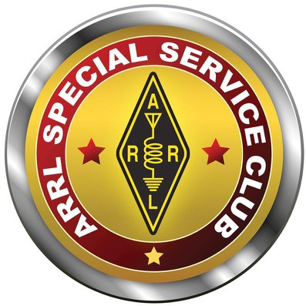
A Shout-Out to OARS!
Getting back to our club, the Olympia Amateur Radio Society is a nationally recognized, ‘special services club.’ This means we do more than occasionally meet and eat pancakes at the local breakfast place. Actually, we don’t do the pancakes thing. Though, that might be a good idea. After all, who doesn’t like pancakes?
Anyway, along with those regular meetings, we engage in license classes as well as testing; we do a lot of public service by providing radio support for local and regional events, we mount a serious Field Day presence, etc. Those monthly meetings always contain an educational component and we’ve been able to attract several regional and nationally known speakers for those times.
The OARS club also sponsors three linked repeaters, NT7H, on the 2m, 220, and 440 bands…
- 147.360 +.6, 103.5
- 224.460 -1.6, 103.5
- 441.400 +5, 103.5
The rest of the time we’re just having fun “playing radio” by honing skills and pursuing our own particular interests.

Again, we would greatly appreciate it if you would join us and we’ll sweeten the deal: your dues during your first year as a ham are waived for OARS. What a deal!! Fill out the application and welcome!
Check us out:
- olyham.org
- facebook.com/ARRLOARS

Conclusion
That is our introduction and welcome. As we just got through saying, there’s a lot out there in radio-land. It may sound silly, but it is also true: the ham radio hobby can be quite an adventure. Why not join us as we do the journey together?

Included in this packet:
- U.S. Amateur Radio Band Plan
- Best Practices article
- International Phonetic Alphabet
- O.A.R.S. membership application
- A beginner’s map to a life-time of Adventure radio! (this document)

