February, 2018

Are the Whatleys still in Peru? Are they still on the planet? Yes we are! But we are losing count of the many blessings we would like to share with you, so let’s get started.

In November, 2017 Barbara and Caleb joined Tim for a Bible conference in the village of Manguriari. The church in Manguriari is one of 16 works and churches Tim is assisting, using the town of Kiteni as a hub. The little church building was packed with men as Tim taught them for 10 hours with a power point he had prepared from the book of Jude. Barbara taught the ladies for 6 hours while Caleb and our co-worker Joy Akkermann had teaching and activities for the children. Tim makes many of these ministry trips by himself, putting up a tent to stay in. We are excited to see greater faithfulness and spiritual maturity among the congregations and pastors as Tim is able to clarify issues as diverse as eternal security and what will happen to unborn babies when Christ comes to rapture the church.

December was an exciting time for us since after six years we tried to unite our 7 children for Christmas. Only Cesar could not be with us as we all went to Pilcopata to spend time together and do ministry in the church plants in Pilcopata and Salvación. It was wonderful to harvest manioc root, help with music and Bible teaching and speak on the radio. We spent time at the river and visited the Bass and Melinc families. We praise the Lord for souls saved in the church plants there.

In January our annual Pastors’ Camp enjoyed fabulous teaching and harmonious fellowship. The spiritual maturity of our many lay pastors and their wives is becoming more evident. A special emphasis was to the children of our pastors. This is a key area since most of our country churches have no Sunday School or youth ministries. This year at Pastors’ Camp there were decisions for Christ among the young people, and 8 of them decided to take a vow of purity after receiving a week of Biblical teaching.

Opportunities to witness, distribute tracts and start new works continue to abound no matter where we are. By the same token, it is urgent to help our lay pastors and leaders become more grounded in their faith. In March Tim plans to gather 30-40 key individuals and teach classes all day for five days. They will concentrate on the doctrine of God, fitting in counselling and advice during breaks and meals.

Another area that demands time and consideration is our upcoming furlough, scheduled for the end of May of this year. We are thankful that Abundant Life Baptist Church in Arín continues to do well under the leadership of Pastor Saul. Our Peruvian co-laborers, Rolando and Gladys Arias are able to keep the Kiteni church plant afloat. This means that the major ministry needs here in Peru seem to be covered during our absence. Our greatest prayer needs at this time include the sale of our house in Arin and accelerated learning for us. Each furlough involves reverse culture shock as life in the USA seems to be done more quickly and technologically. We need wisdom and diligence to develop materials, do scheduling, and be effective communicators of the message God wants us to share. For the first time we are planning to base out of South Carolina since Cesar, Briana and Sonia continue studying at Bob Jones University. We hope to be able to spend more time with them and prepare Caleb to be responsible for himself when we return to Peru in 2019.

Before the Throne:
- Thank God for Tim’s stable health in the jungle and the reliability of a good vehicle to get him to the isolated works and churches.
- God has given us $15,687.00 for a property in Kiteni! That is enough to make the purchase BUT pray that the owners would actually come to town and do the paperwork.
- Please pray for the sale of the house in Arin. To us, this seems urgent.
- The Bible School, SEBIC, is going through a transition as our fellow missionaries, Ken and Sharon Loveall, have to move to the coast of Peru due to health reasons. We ask God for special wisdom and provision for SEBIC and the Loveall family during this time of testing and stretching.

Tim, Barbara and Caleb Whatley
Church Planting and Pastoral Training in the south central jungle of Peru

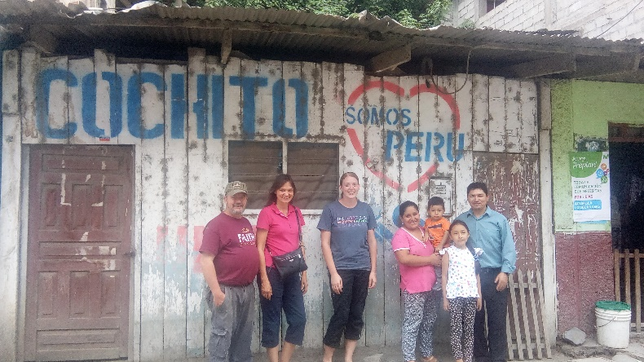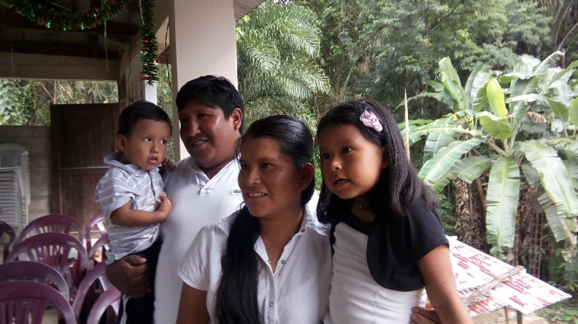 Tim & Barbara Whatley, Joy Akkermann and the Alex & Flora Herrera, Melody and Caleb – Church planting in
Arias Family. Church Planting Team in Kiteni Pilcopata

