Infographic Poster

Nadine K. Thola
School of Education, Liberty University

Author Note
Nadine K. Thola
I have no known conflict of interest to disclose.
Correspondence concerning this article should be addressed to Nadine K. Thola
Email: nthola@liberty.edu

Infographic Poster
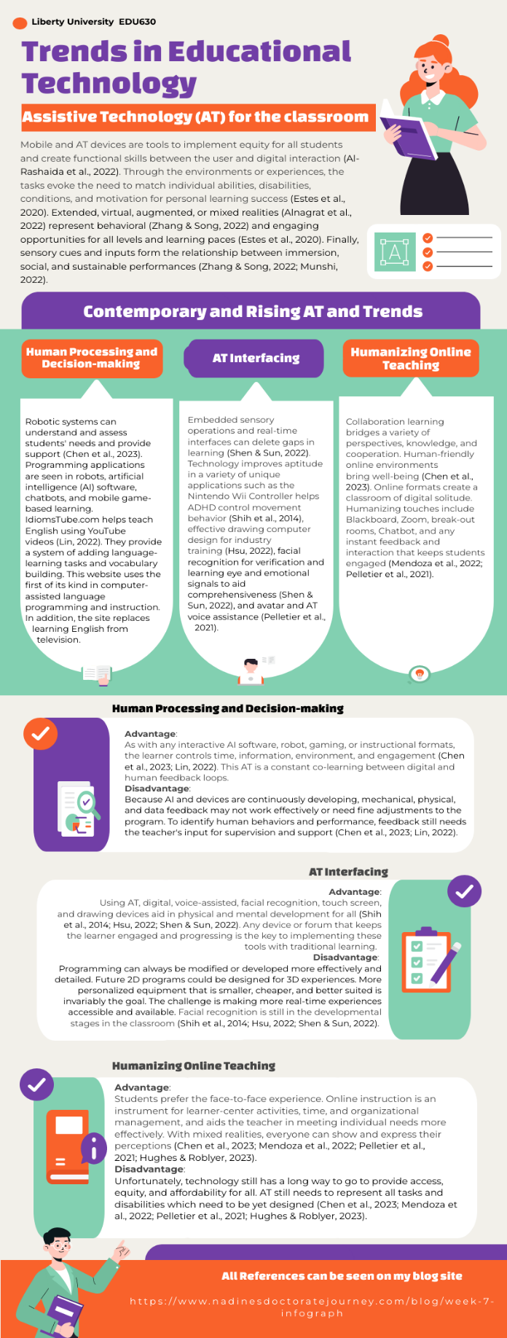
References
Al-Rashaida, M., Amayra, I., Lopez-Paz, J. F., Martinez, O., Lazaro, E., Berrocoso, S., Garcia, M., Perez, M., Rodriguez, A. A., Luna, P. M., Perez-Nunez, P., & Caballero, P. (2022). Studying the effectsof mobile devices on young children with Autism Spectrum Disorder: A systeatic literature review. Review Journal of Autism and Developmental Disorders, 9, 400-415. https://doi.org/10.1007/s40489-021-00264-9
Alnagrat, A. J. A., Ismail, R. C., Idrus, S. Z. S., & Alfaqi, R. M. A. (2022). A review of Extended Reality (XR) technologies in the future of human education: Current trend and future opportunity. Journal of Human Centered Technology, 1(2), 81-96. https://doi.org/10.11113/humentech.v1n2.27
Chen, X., Cheng, G., Zou, D., Zhong, B., & Xie, H. (2023). Artificial intelligent robot for precision education: A topic modeling-based biblimetric analysis. Educational Technology and Society, 26(1), 171-186. https://doi.org/10.30191/ETS.202301_26(1).0013
Estes, M. D., Beverly, C. L., & Castillo, M. (2020). Designing for accessibility: The intersection of instructional design and disability (M. J. Bishop, E. Boling, J. Elen, & V. Svihla, Eds.). Springer. https://doi.org/10.1007/978-3-030-36119-8_8
Hsu, H.-H. (2022). How facial symmetry influences the learning effectiveness of computer graphic design in makeup design. Symmetry, 14, 1982. https://doi.org/10.3390/sym14101982
Hughes, J. E., & Roblyer, M. D. (2023). Integrating educational technology into teaching:Transforming learning across disciplines (9th ed.). Pearson.
Lin, P. (2022). Developing an intelligent tool for computer-assisted formulaic language learning from YouTube videos. ReCALL, 34(2), 185-200. https://doi.org/10.1017/S0958344021000252
Mendoza, S., Sanchez-Adame, L. M., Urquiza-Yllescas, J. F., Gonzalex-Beltran, B. A., & Decouchant, D. (2022). A model to develop Chatbots for assisting the teaching and learning process. Sensors, 25(5532). https://doi.org/10.3390/s22155532
Munshi, G. M. (2022). Assisting Autistic children through virtual reality systems. Contemporary Issues in Education Research (CIER), 15(1). clutejournals.com/index.php/CIER/article/view/10402
Pelletier, K., Brown, M., Brooks, D. C., McCormack, M., Reeves, J., Arbino, N., Bozkurt, A., Crawford, S., Czerniewicz, L., Gibson, R., Linder, K., Mason, J., & Mondelli, V. (2021). 2021 EDUCAUSE Horizon Report, Teaching and learning edition. EDUCAUSE. http://library.educause.edu/resources/2021/4/2021-educause-horizon-report-teaching-and-learning-edition
Shen, Y., & Sun, S. (2022). Design of international Chinese education promotion platform based on artificial intelligence and facial recognition technology. Computational Intelligence and Neuroscience, 2022, 6424984. https://doi.org/10.1155/2022/6424984
Shih, C.-H., Wang, S.-H., & Wang, Y.-T. (2014). Assisting children with Attention Deficit Hyperactivity Disorder to reduce the hyperactive behavior of arbitraty standing in class with a Nintendo Wii remote controller through an active reminder and preferred reward stimulation. Research in Developmental Disabilities, 35(9), 2069-2076. https://doi.org/10.1016/j.ridd.2014.05.007
Zhang, Y., & Song, Y. (2022). The effects of sensory cues on immersive experiences for fostering technology-assisted sustainable behavior: A systematic review. Behavioral Sciences, 12, 361. https://doi.org/10.3390/bs12100361

