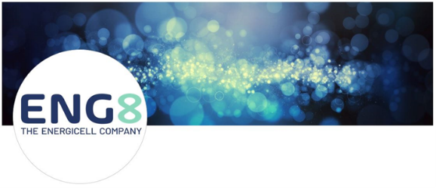
Dear All,

Update ENG8 International 01/08/2023.

The company valuation for ENG8 International per 01/08/2023 is set at £40 M. after the recent report from the University of Cambridge. (Materials Science and Metallurgy Department) and the recent X-ray spectrometer analysis of the electrodes with UL.com confirming Nuclear Fusion (LENR) has take place again and showing a Q factor (CoP) for direct electricity in to out of 2.
The next validation is scheduled for September, when UL.com would then do that with ENG8 at Culham Innovation Centre and the University of Cambridge, both with Prof Brian Josephson as the “observer”, were a Q5 (CoP5) is expected, both electrical as thermal out.

Meanwhile, more members of the ENG8 team are being re-located to Portugal, thanks to your support.

Things are going well as planned at ENG8 International and keep in mind:
The expected company valuation of ENG8, once commercial production is in place, is over £1 B. So, plenty of growth of the share-value is still to come before the end of next year.
By investing now, you support the Company, your Portfolio AND the Environment.

For more information and full reports, visit practitech.com/ ENG8 International (UK or NL flag) or contact me at the details below.

Kind regards,
Paul Dopierala
350 PPM LTD
Tel.: +44 (0)203 582 2970 (direct)
Email: pauld@350ppm.co.uk
Web: www.350ppm.co.uk

Registered Address: 350 PPM Ltd, 8 Terminal House, Station Approach, Shepperton, Middlesex, TW17 8, England.

--
Is this email not relevant to you? Click here

