Serenity Care Children’s Home
Statement of Purpose

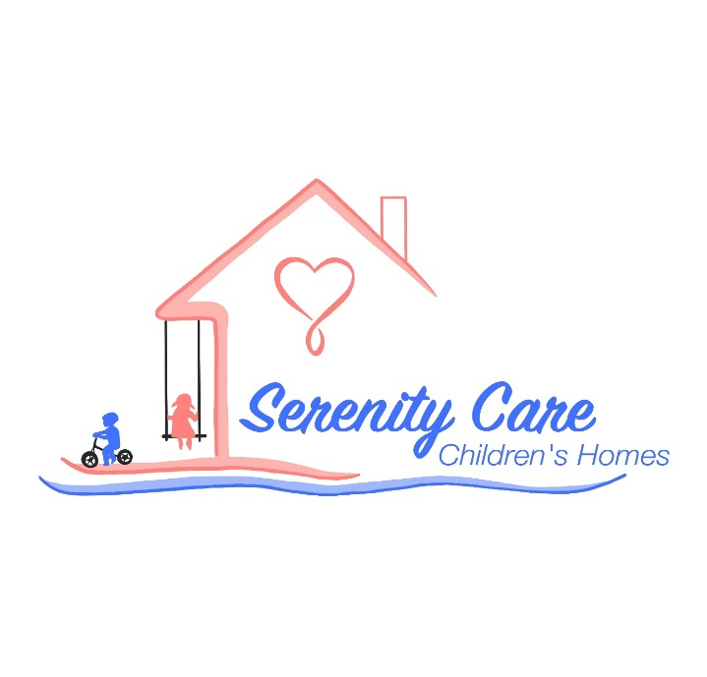

March 2024
This document fulfils the requirements of Children’s Homes Regulations and the Quality Standards April 2015

The Registered Manager Alexander David Hayward.
The Deputy Care Manager Reece Scifo
Email info@serenitychildren.co.uk
Quality and purpose of care
1. A statement of the range of needs of the children for whom it is intended that the home is to care and provide for.
2. Details of the ethos of the children’s home, the outcomes that the home seeks to achieve it and its approach to achieving them.
3. A description of the accommodation offered by the home including:
(a) How the accommodation has been adapted to meet the needs of the children,
(b) The age range, sex and number of children for whom it is intended that the accommodation is to be provided, and
(c) The type of accommodation including the sleeping arrangements.
4. A description of the home.
5. The arrangements for supporting the cultural, linguistic, and religious needs of the children.
6. Details of who to contact if a person has a complaint about the home and how that person can access the complaint policy.
7. Details of how a person, body or organisation involved in the care and protection of a child can access the home’s child protection policies and the behaviour management policy.

Views, wishes and feelings
8. A description of the policy and approach to consulting children about the quality of their care.
9. A description of the policy and approach in relation to children’s rights and anti-discriminatory practice in respect of children and their families.

Education
10. Details of the provision to support children with special educational needs.

Enjoyment and Achievement
11. The arrangements for enabling children to take part in and benefit from a variety of activities that meet their needs, to develop and reflect their creative, intellectual, physical and social interests and skills

Health
12. Details of any healthcare or therapy provided:
(a) Details of the qualifications of staff and professional supervision of the staff involved in providing any healthcare or therapy, and
(b) Information about how the effectiveness of any healthcare or therapy provided is measured, the evidence demonstrating its effectiveness and details of how the information, or the evidence can be assessed.

Positive Relationships
13. The arrangements for promoting contact between children and their families and friends.

Protection of children
14. A description of the approach to the monitoring and surveillance of children.
15. Details of the home’s strategy towards behavioural support, including information about:
(a) Approach to restraint in relation to the children; and
(b) How persons working within the home are trained in restraint, and how their competence is assessed.

Leadership and Management
16. The name and work address of:
(a) The registered provider
(b) The responsible individual (if one is nominated); and
(c) The registered manager (if one is appointed)
17. Details of the experience and qualifications of the staff, including details of the management and staffing structure of the home, including staff that provide education or healthcare.
18. Details of the management and staffing structure of the home, including arrangements for the professional supervision of staff, including staff that provide education or healthcare.
19. If staff are all of one sex or a majority of one sex, a description of how the home promotes appropriate role models of both sexes.

Care Planning
20. Any criteria used for the admission of children to the home, including any policies and procedures for emergency admission

Quality and Purpose of Care
- A statement of the range of care needs of the children for whom it is intended that the children’s home is to provide care.
Serenity care children’s home is a registered children’s home providing care, accommodation, and education for a total of three children, male and female gender, aged 6- 17 years. This is made up of three registered beds.
Serenity Care is a therapeutic, warm, and friendly environment, which cultivates children hopes for their future. Children will be provided opportunities through their education, therapy and daily care and support, to plan for a better future. Children can heal and move forward from previously damaging and traumatic experiences, which the staff at Serenity care will support, whilst maintaining the child’s identity, and where possible encouraging their continuing bonds with family.
We are a positive choice for children for whom residential care is the preferred option, as most placements are offered on a long-term basis and therefore provide stability for the children and we can support children towards independent living, return to family and move towards foster placements.
Serenity care is one of few children’s homes in the country offering on-site equine supported therapy, a therapy designed to help children and adolescents who struggle to manage and understand their emotions and behaviours. Emotional dysregulation often contributes to difficulties in establishing a stable sense of self and forming and fulfilling stable relationships with peers and family members. Often, children who come from chaotic or traumatic backgrounds can having trouble coping with present emotional overload, and we believe that they need to develop strategies to manage this for the future.
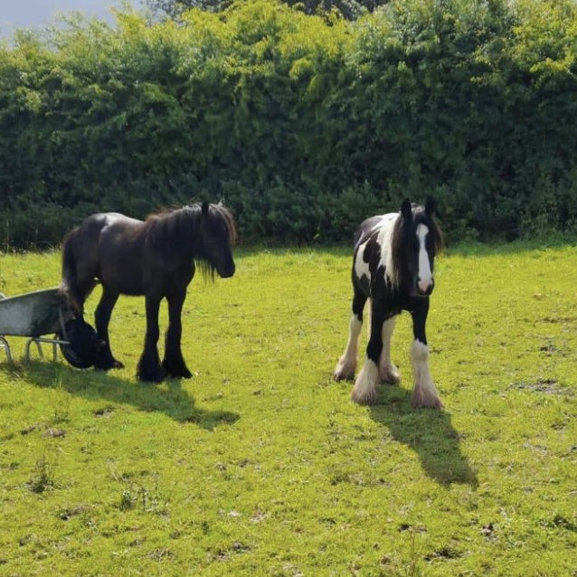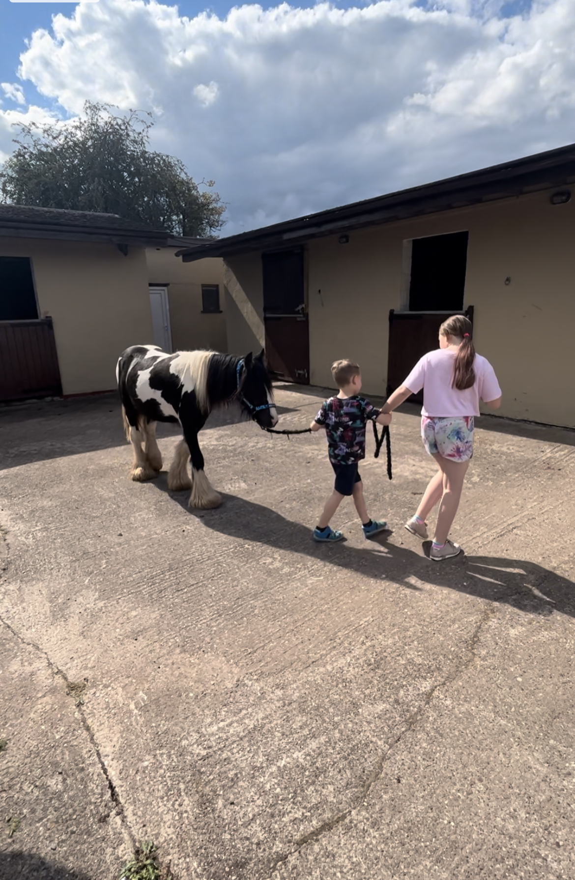

Monthly consultation sessions are available with The Child Psychology Services (TCPS). Following consultation, staff receive a written report the following day to read to provide guidance of working as a team and supporting the young people.
The staffing team are trained to apply PACE –Playfulness, Acceptance, Curiosity and Empathy.
A holistic care plan addresses individual needs which are developed, encompassing educational planning, identifying therapy goals, recreational activities, direct work required, group work, and supporting contact with families and friends.
Our routines ensure safety, consistency, and boundaries, whilst promoting positive experiences, new achievable challenges, success, positive reinforcement and building and maintain relationships for each child in our care.
Prior to moving on, each child will receive help and support to prepare them for this transition as we recognise this can be a difficult time.
We treat all the children in our care with dignity and respect, and value their individuality, promoting privacy, freedom, and choices. We encourage and assist the children to express themselves appropriately, nurturing the skills to assess and understand their own situation and take the lead in planning their own futures. In our work with young people, we can provide the basis for supporting them into independent living. We actively encourage and support children in developing their potential through education, providing the opportunity to gain the qualifications and experiences to progress to higher education.
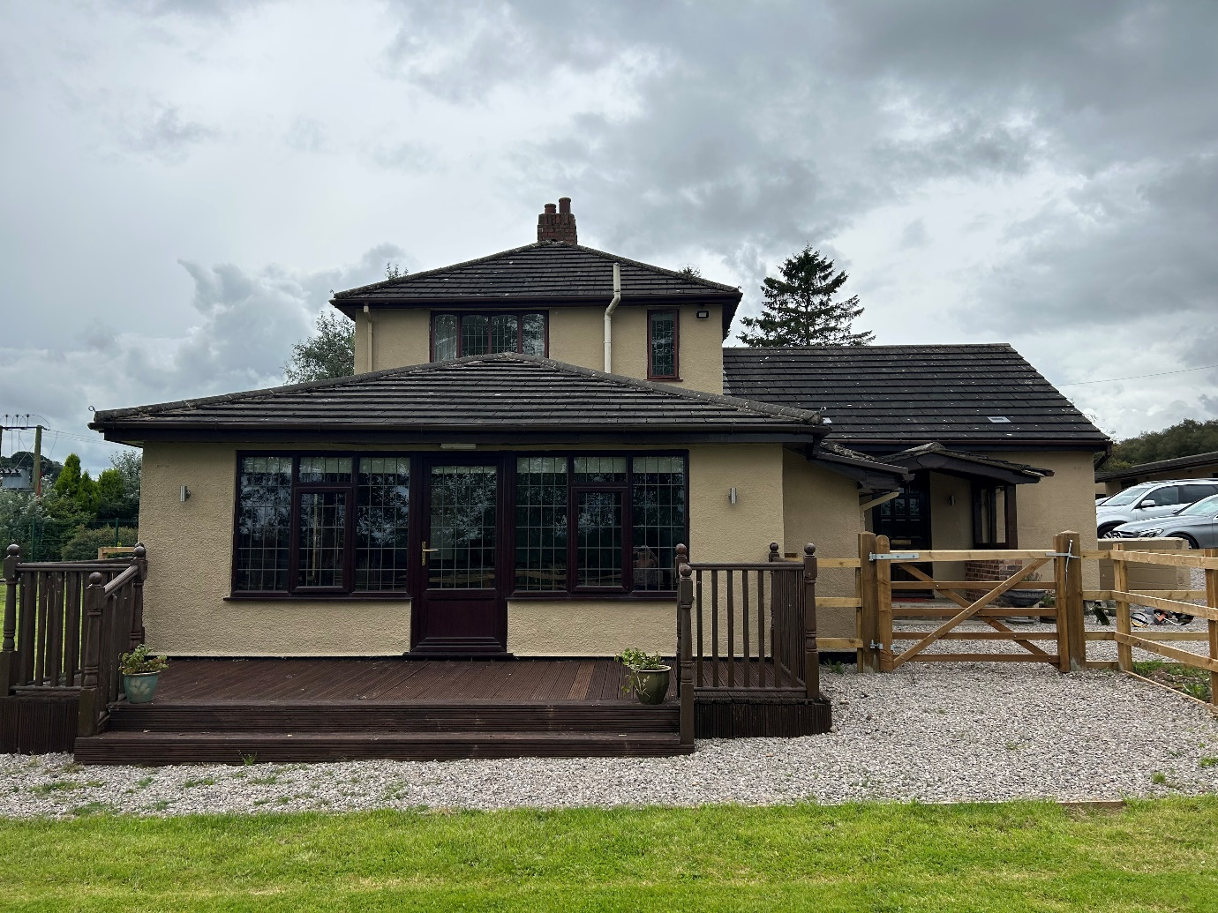

Facilities and services
Serenity Care is a newly opened registered children’s home registered with Ofsted in 2023.
Serenity care provides care for children 365 days per year, 24 hours per day. A structured program of education, activities, therapeutic support, and basic life skills is tailored and responsive to the needs of each child. We are passionate about empowering children and young people to exercise choice and control over their lives and encourage choice of preferred activities as their program progresses. We recognise that for some children residential care is a positive choice.
All staff are trained in PPR –Preventing, Protecting and Restoring range of behaviour support techniques and interventions. These principles will be deployed as required throughout the day.
In preparation for moving on, Pathway plans can be devised where appropriate, and young people helped through that process.
An End of placement report will be completed at the end of each child’s stay along with memorabilia to commemorate their stay along with a gift from everyone at the home. Follow up work can be offered and undertaken as necessary.
The children will be offered opportunities to go on holiday and have short breaks away from the home.
2. Details of the children’s home ethos, and the outcomes that the home seeks to achieve and its approach to achieving them.
At Serenity care we believe that each child needs a sense of routine, consistency and boundaries in their life, and a caring and nurturing system of support to encourage, develop and maintain pride, self-discipline, self-esteem, confidence to establish trust and respect for themselves and others.
Our staff team are motivated, experienced, and committed to working with children and young people. Staff will encourage children to self-express positively, assisting them in overcoming emotional expressions of past trauma, positively impacting well-being and nurturing resilience.
Purpose
Our purpose is to provide high quality residential care to children and young people aged six to eighteen. Our home provides stability and care for up to three children/young people. The home offers a chance for everyone, to be assisted and supported with changing times, promote confidence and individuality, and encourage them to express themselves and live together in a happy environment.
The placement is for the young people who have come from a variety of backgrounds and have complexed emotional/ behavioural difficulties and display this through challenging behaviours, mental health complications.
We provide individual care packages tailored to meet the needs and requirements of each child. We accept planned placement with a transition plan is preferred.

Our Ethos
Our ethos at Serenity care is that we provide legacy of excellence and a voice that will be listened to advocate for the needs. We endeavour to promote a culture based on empowerment, acceptance, and learning.
This will be achieved by utilising a child-centred approach, putting the child’s needs, wishes and feelings at the centre of everything we do. All staff are supported to work together to translate these core principles into practice, assisted by high quality training. We believe that every young person should have a sense of hope, achievement, and aspiration for their future, as they may not have experienced this during early life. With a therapeutic and nurturing approach from the dedicated staffing team, we strive to reach positive outcomes and bring out the best in our children and young people.
We believe that for some children residential care can be a positive choice, as some find biological family or foster placement difficult to cope with and cannot reach their full potential in these environments. In some instances, it may be more supportive to maintain family links from a residential base than from a foster home, and we will always promote family contact where this is beneficial for the child. Sibling placements together can be considered dependent on capacity and the best interests of the children and as stipulated in their social care plan.
Serenity care can help break links with negative networks of previous abuse and neglect, whilst preserving, improving, and maintaining positive family links. Where children are placed away from their home area, we take particular care to ensure that they are made to feel safe and are supported.
Prevent Protect Restore (PPR)
As discussed earlier in the facilities and services section, our staff use PPR strategies to promote positive boundaries within the home. PPR embodies a range of techniques and strategies drawn from several approaches, both behavioural and interactional, providing a framework for helping children and young people through times of crisis, teaching them better ways to cope.
Crisis as opportunity
The key element of our ethos is that we treat crisis as an opportunity to effect lasting, positive change for our children and young people.
"During the period of crisis, a person is more susceptible to being influenced by others than at any other times of relative psychological equilibrium…this is a matter of supreme importance because by deploying helping services to deal with individuals in crisis, a small amount of effort leads to a maximum amount of lasting response.”
Gerald Caplan in “Prevention of Mental Health Disorders in young people”
Crisis is an opportunity for growth, and we endeavour to make the most of that opportunity to help the children and young people develop better, more constructive, effective coping skills and strategies.
The Caring Environment
We are striving for a safe and welcoming environment within which there is ample care and affection for children to grow. Our children need to feel treated with care, and so need to have their physical, psychological, emotional, and spiritual comforts met.
“The children must get plenty of love and affection whether they deserve it or not they must be assured of the basic quota of happy, recreational experiences whether they seem to have it coming or not. In short, love and affection, as well as the granting of gratifying life situations, cannot be made the bargaining tools of educational or therapeutic motivation, but must be kept tax free, as minimal parts of the youngster’s diet, irrespectively of the problems of deservedness.”
Fritz Redl 1952
At Serenity Care we are proactive in emphasising our caring message to young people.
“No attempts at influencing behaviour pathology can be successful if, at the same time, every pertly of the environment is not kept scrupulously ‘clean’ from the point of view of the psychological hygiene”.
Fritz Redl 1951
Friendship with influence-the adult as a role model
The relationship between staff and children/young people plays a crucial role in the effectiveness of our work. At all times staff are engaged in their efforts to help children to explore and understand their experiences and feelings, and then to move forward. This involves breaking the momentum of the crisis cycle, modelling alternative ways of reacting, rather than allowing cycles of maladaptive coping to manifest. Our staff will not negatively react to children/young people’s destructive behaviours in a way that the young person fears and expects. Our practice encourages mature strength, teaching the child better ways of coping with difficult feelings and situations.
The Aware Culture and the Arena of Safety
Serenity Care must be a safe, non-abusive environment for children and staff. All staff are supervised, supported, and trained to ensure they always operate with in the arena of safety. Creating and maintaining a safe environment and emotional safe base for children and young people is of upmost importance. This is the starting point for all staff recruitment and operational practices and engenders our policies and procedures.
Positive Outcomes
At Serenity Care we strive to achieve positive outcomes for all of our children and young people, with an anti-discriminatory motto of being equal treatment for all.

3. A description of the accommodation offered includes:
(a) How the accommodation has been adapted to meet the needs of the children;
(b) The age range, number, and sex of children for whom the home is intended to accommodate; and
(c) The type of sleeping accommodation provided
Serenity Care is a converted detached farmhouse which has been specifically selected and adapted to meet the requirements for a residential children’s home. The home is decorated to a high standard and displays a comfortable and friendly atmosphere.
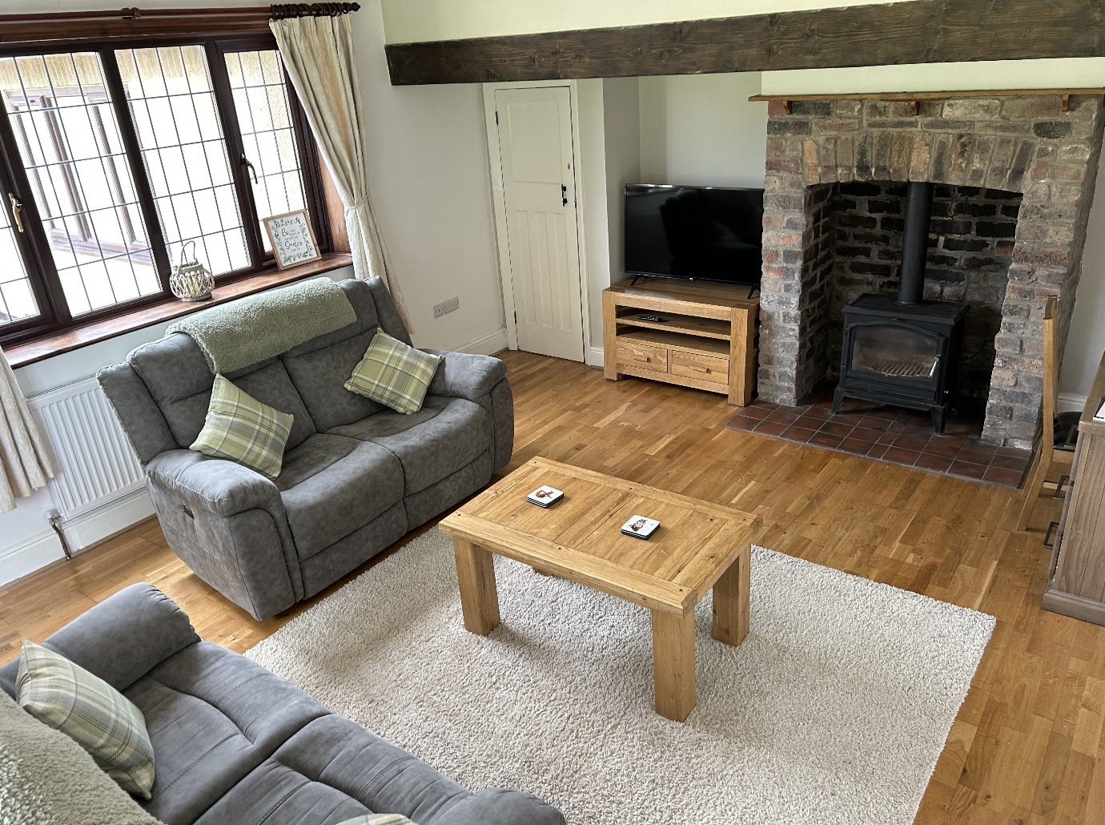
Children will be encouraged to have an input into decisions regarding décor and lay out of the home, with photographs of the children placed around the home to help to provide a sense of belonging, should they feel comfortable with their image being on display.
Children will be able to choose the layout of their bedroom and will be provided a personal budget for decorating the room, to support own personal identity, individuality personal and choice. The budget may be spent on individual items such as pictures, posters, personal possessions such as bedding etc.
All bedrooms are single occupancy and have comfortable furnishings, they are decorated to a high standard and include a television for each child if suitable for the child. Each child will be provided with a key to their room where age and need appropriate.
We recognise each child has a need for both companionship and privacy. We have two communal lounges which are cosy and comfortable and equipped with televisions.
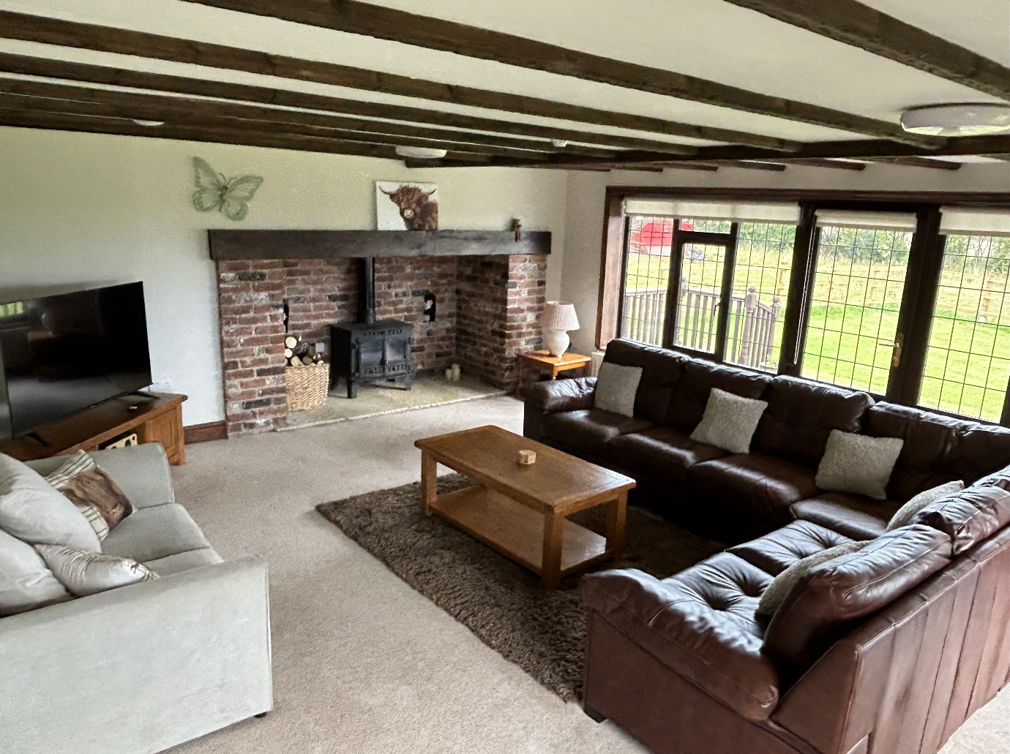
Our home has a dining area with a large dining table where children and staff can enjoy a family feel when eating together, maintaining, and encouraging sociability, building and maintaining relationships and encouraging reflective conversations on the day. The home has a large, fully fitted kitchen with modern appliances.
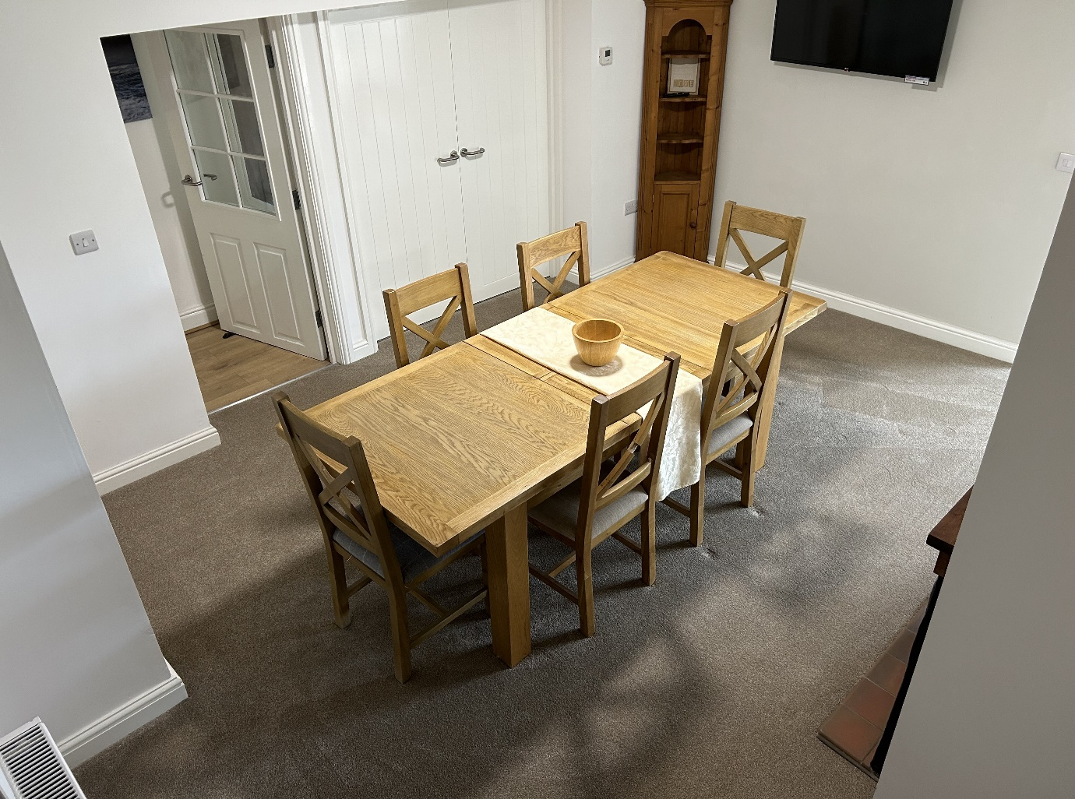

The home is situated in its own grounds where there are swings, slides, football goals and a decking area.
There is a pond that is full of fish such as goldfish, Coye carp, ducks with ducklings which we can feed. The pond has restricted access however it will be made accessible on request as the pond can be useful for quiet time and assisting with a heathy mind using mindfulness.
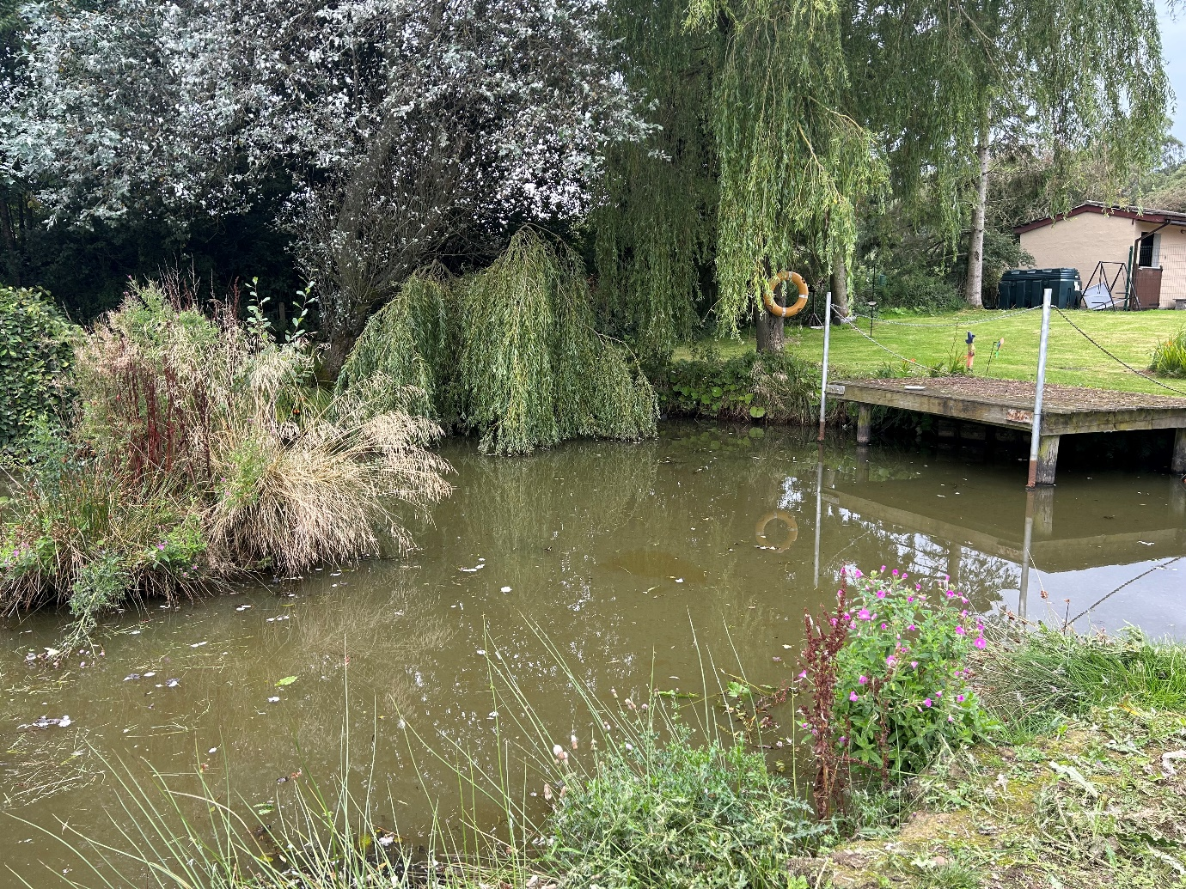

High staff ratios ensure that all our children and young people receive the level of support and direction they require to benefit fully from their experiences of being looked after at Serenity Care.
The staffing team consists of a Registered Manager, Deputy Manager, Senior Residential Childrens Practitioners and Residential Childrens Practitioners, all of whom are qualified or working towards a minimum of Diploma Level 3-4 (QCF/NVQ) following completion of their probation period.

4. A description of the location of the children’s home
Serenity Care home is in a rural setting, in Staffordshire. It is situated down a single-track lane with sole access to the home and grounds. The local area has a range of cultural and recreational facilities including local parks, sports and club facilities, libraries, religious and cultural centres. All the children will be encouraged to enjoy positive and friendly relationships with the local community.
Serenity Care will liaise closely and proactively with the local police and encourage them to visit the home and speak with the children and young people to build positive relationships.
There are local shops and residential properties situated along the main road at the end of the lane along with a bus stop which will help the young people progressing to semi-independency, using public transport, and travelling independently.
Due to the location of our home, there is access to a wide range of educational and entertainment facilities including cinemas, shopping centres, pool and snooker halls, go karting, swimming baths and leisure centres. The staff team work hard to build strong and effective working relationships with local social networks, ensuring the same ethos is maintained when working with parents, relatives, and professionals.
The staff team will work hard to build strong links between the local police, community support officers and the safeguarding team.
These positive working relationships are made possible by our attitude towards safeguarding and not criminalising children and young people, ensuring that they are appropriately matched to our provision, and by encouraging engagement in lawful behaviours when away from the home.
Missing from care protocols have been adapted specific to our care home, and they incorporate robust risk management and proportionate responses to missing from home incidents.
We will work hard to effectively liaise with external agencies such as the Youth Offending Team (YOT), Child and Adolescent Mental Health Services (CAMHS) and the Looked after children’s (LAC) team and other relevant health professionals.
Our well-staffed team and approach to risk management will reflect the child/young person’s ability and understanding of how to keep themselves safe. Therefore, our children/young people are kept safe, but also able to build trust through their behaviour, young people are also where it is appropriate encouraged to take therapeutic risk-taking behaviours. The staff team ensures there is a high level of consultation work done with the young people on how to keep themselves safe.
Our team have cultivated strong links with the local area, we are aware of local hot spots where children and young people could be at risk, via our liaison with the local police. The children and young people in our care are therefore able to develop an understanding of the risks that they will face in the community when living independently as opposed to risk adverse measures.
Robust risk assessments and risk management plans are in place and reviewed and updated regularly to ensure that risk of all aspects are minimised, and remain at safe, manageable levels.
There is also a business continuity plan and an Incident management plan in place should there be an emergency at the home to give staff guidance and support to make swift decisions and actions to keep everyone safe and notified.
5. The arrangements for supporting the cultural, linguistic and religious needs of children accommodated in the home.
If a young person has cultural or linguistic needs or religious beliefs, and they wish to practice their beliefs or customs, it is important that they feel freely able to do so. The staff team will always actively support young people in pursuit of their beliefs, whether that is the provision of culturally appropriate of foods or assisting with traditional preparation of foods, or by ensuring that the young person has correct information and choice of attending their place of worship.
We encourage all children to form appropriate and safe connections with people with similar backgrounds via local amenities such as social groups or churches, mosques, temples etc. Further information regarding the diversity of faiths followed in the Staffordshire area can be obtained from the local council (www.staffordshire.gov.uk), which contains a directory of faith groups in the locality.
To meet the needs of our children and young people from diverse ethnic backgrounds, and to champion anti-racism within the home, will create a stable, accepting, caring environment, which will help to:
- Enhance the child/young person’s self-esteem.
- Create a climate where cultural and religious differences are acknowledged and valued, and discussion is actively encouraged to create better understanding and reduce prejudice.
- Allow visiting parents, relatives, and friends to feel comfortable in the home environment, and to be supported within contact with the child/young person, regardless of race, religion, or class differences.
- Provide a range of multi-cultural books, pictures, and magazines. Also, attention will be paid to meet choices of food, taste, and its preparation.
- Provide appropriate health and hygiene support and care when necessary.
- Young people will be supported to practice any religious faith or cultural norms they choose.
- Encourage acceptance of the child/young people’s race in a positive way and not to dismiss their race or cultural background as insignificant.
- Challenge racism in whatever form presented.

6. Details of who to contact if a person has a complaint about the home and how that person can access the home’s complaint policy.
Serenity Care recognises the vulnerability of children living away from home and how difficult it can be for them to make complaints, especially against those caring for them. The atmosphere in the home is conducive to children expressing their concerns, and staff validating their perspective, and they are committed to solving problems as they arise. If the child/young person agrees, comments and complaints can be made on their behalf, for instance by their independent visitor, Advocate, or via family members.
Serenity Care has a full written complaints procedure and representation procedure, which are shown and explained to every child on their admission; they are subsequently reminded of their right to complain periodically during a child’s Children meeting and following any incidents. In most cases individual concerns can be resolved informally and so we would try to work to achieve the best outcome with the child/young person.
However, we support and encourage children to seek impartial support through the following means if they feel this is required; outside support from their families, referring social services department, the Ofsted inspector, Regulation 44 visitor, advocates or services such as ‘Childline’ if they have concerns, they wish to discuss.
There are child friendly comments and complaints forms. All staff have training on how to deal with a complaint and who to report the complaint to. Staff are aware of the role of Ofsted and the Regulation 44 visitor.
There are procedures in place for addressing complaints made about the Manager or the owners. A log is kept for all complaints made and is available for inspection by Ofsted, the Regulation 44 visitor and the children’s Social Workers. Our home manager reviews all complaints and records all outcomes. The child’s voice is always included, and they are kept updated throughout the process, and informed of the outcome.
A child can also make a complaint or raise any concerns with their Social Worker should they wish to do so. A Children’s Rights Officer can also be contacted if the child/young person feel that they have not been listened to. The nominated officer would then visit and speak to the young person and follow up with any subsequent actions.
Child line also offer support and advice to children and young people choosing to use this service, the telephone number is 0800 1111. In addition, any child/young person, parent or member of the public can make a complaint to: Ofsted, Piccadilly Gate, Store Street, Manchester, M1 2WD. Ofsted’s telephone number is 0300 123 1231. All complaints are taken very seriously, and we will resolve them internally, within recognised time scales when and where appropriate.
Any person wishing to complain about the home should contact in the first instance the homes manager; Alex Hayward or the RI Sandra Oulsnam.
Serenity care home’s complaints policy is made available to all children, parents (where appropriate) and the children’s social worker at the point of placement, and additionally on request.

7. Details of how a person, body or organisation involved in the care or protection of a child can access the homes child protection policies or behaviour management policy.
Serenity Care gives the highest priority to ensuring that the children and young people in our care are safe. We operate within the ‘arena of Safety’ and rigorous safer recruitment procedures are followed.
Staff are supervised, supported, and monitored accordingly. One to one working is controlled, there are clear lines of communication should any staff have any objections about any aspects of practice.
There is provision for ‘no blame’ suspension of staff following the guidance in ‘Choosing with Care’.
There is also a Whistleblowing policy stating lines of communication if any staff have misgiving concerns. Failing to report abuse or suspicions of abuse amounts to gross misconduct under our staff disciplinary procedure.
All of our staff receive training in child protection procedures and whistleblowing upon induction. There is a copy of the Staffordshire SCB procedures within the home, the most up to date copy of Working Together to Safeguard Children, and Serenity Cares Child Protection and Safeguarding Policy and Procedures.
We aim to have all staff trained by Staffordshire Safeguarding Children’s Board on Safeguarding children. Staff are advised of the importance of not asking leading questions to a child.
Child protection concerns are reported to the Registered Manager, or the member of the management team that is on-call, if the Manager is not available. It is the Manager’s responsibility to make a referral to Staffordshire’s child protection team. The child’s Social Worker will also be informed, and a log is kept of any child protection referrals.
Our Safeguarding policy is available within the home, it is also sent out to professionals on commencement of placement, and during consultation over potential placements.

Preventing Protecting and Restoring (PPR)
Serenity Care follows the Preventing, Protecting, and Restoring (PPR) intervention by BTC. This is a Crisis Prevention and management system that uses ‘reasonable force’ in ‘last resort’ with an ‘honest held belief’ circumstances to prevent crime, danger and injury. Situations of ‘last resort’ are often misunderstood. PPR believes it may be necessary to intervene at the start to prevent a “greater harm from occurring” PPR is a crisis prevention and management strategy, designed to reduce the need to rely on high-risk interventions. The program provides a structure to help make sense of a child’s difficult behaviour. Staff are taught specific techniques to prevent and manage crisis situations, this includes understanding situational and maturational crisis and the use of a variety of intervention approaches and specific behaviour management techniques (e.g. caring gesture, prompting, active listening, planned ignoring, and positive attention).
PPR also teaches a range of safety interventions, including release and physical restraint.
Physical interventions rest on the principles of a maximum number of caring gestures, with a minimum amount of force, and the goal of de-escalating the situation by reducing stimulation. Staff are continually observed and assessed on the course and in practice. All parties play an active role in including reflective practice in real life situations, this ensures that staff remain vigilant and can analyse their own skills and practice and appraise the staffing wider team on how best to manage conflict situations.
Staff also employ the Life Space Interview (LSI) a therapeutic verbal strategy for intervening with young people that was developed by Redl and Wineman in the 1950’s. This is an intervention that occurs in the child’s own life space, it uses their own reactions to a difficult situation as a vehicle to change their behaviour and expand their understanding and insight into their own, and others, behaviour, and feelings. The LSI can be used after any crisis event. It does not solve the problem but can be used as an ongoing strategy to help teach the child better coping skills.

Supervision and monitoring arrangements for PPR.
Written records are made of all LSI’s and physical interventions. The Manger countersigns all incident reports involving a physical intervention being required.
All staff are trained in PPR techniques and receive regular refresher courses. Any concerns about practice are initially overseen and addressed by the homes Manager or the Deputy Manager.
The Behaviour Management policy is made available to professionals, and young people on commencement of their placement, and is regularly consulted upon. This policy is also available on request.
Views Wishes and Feelings
8. A description of Serenity care’s approach to consulting children about the quality of their care.
The staff at Serenity Care are expected to work in partnership with children and young people to develop an ethos which balances each individual rights and needs, with the collective needs of the group. We believe that the more involved young people are in influencing the day to day running of the home, the more they will feel heard and respected, and experience greater benefits from their time at Serenity Care.
Each child/young person is allocated a Key Worker and a Co-Key Worker and will receive a key working session each week to review their placement plan. It provides opportunity for the child/young person to speak openly, in a private 1-1 setting, to discuss their views on how they are cared for.
There are further opportunities throughout regular care provision for example Children’s meetings, to speak openly regarding any issues they may have including any bullying issues or concerns in a confidential manner.
Link sessions will be completed planned or unplanned, where discussions will be held with any staff member relating to each child’s individual needs as required at that specific time.
A plan of link sessions will be completed ahead as guidance for staff to follow however the topics are adaptable, to prioritise the need of the child at that present time. A minimum amount of four link sessions per month will be completed.
In addition, children/young people will have monthly meetings with staff where there is an open agenda, and any issues can be raised. Minutes are taken for the meeting, and staff encourage the child/young people to chair their own meetings if they wish.
All children and young people are involved and consulted in relation to all aspects of their lives, their community, their future and their role within family and society through;
- Involvement in all meetings.
- Placement plans and Key work sessions.
- Regular child/young people’s meetings.
- Menus and activity planning.
- Encouragement and support to have regular visits to their GP, dentist, opticians.
- Promotion of their right to follow their own religious beliefs and to attend a worship of their faith/practice.
- Each young person will have an individually focused Education Plan tailored to meet their academic needs.
- Each young person will be supported to contact the Children’s Rights Officer, IRO, Advocate or their social worker, as required.
- Young people will be encouraged to safely explore their own gender identity and sexual orientation.
As part of their arrival to our home and welcoming process, each child is given the contact details of the Children’s Commissioner, and a copy of the Serenity care’s complaints policy child friendly version, will be provided and explained to them. They are encouraged to share any concerns which they may have within the home.
Young people in our care can have access to a phone to make private calls as required subject to their individual risk assessment and care plan.
Written consent is sought by the young people we support to ensure they give permission for any external visitors to inspect and access their care plans and care records as part of the Regulation 44 visiting process.

9. A description of Serenity care’s policy and approach with regards to:
(a) Anti-discriminatory practice in respect of children and their families.
(b) Children’s Rights
We are committed to providing a living environment in which children, young people and staff can realise their full potential, and make an equal contribution within our home, irrespective of their gender, race, disability, sexual orientation, marital status, age, religion or belief.
We value the differences that diversity brings to our home. All children and young people will be treated equally and with respect. In return, the staff group expect to be treated in the same way. We are an organisation that is committed to equal opportunities and anti-discriminatory practice, both in terms of the staff we employ and the children/young people we care for.
All our staff have equal access to training, supervision, support, and promotional opportunities. Prejudice attitudes and opinions in relation to age, gender, sexual orientation, and disability status will be actively challenged. Issues of individual difference will not affect an individual’s position within the home or their access to achievement.
Similarly, all children/young people within our care will have equal access to the benefits and opportunities available. We recognise that on occasions, children/young people will behave in a way that attracts consequences. When this happens, appropriate consequences will be applied consistently and fairly. Staff are clear that the purpose of consequences with children/young people is to promote change rather than to punish. Should restorative justice be an option we feel this is a better route to follow along with reparation work completed if able to do so.
We believe that all colleagues, children, young people, and visitors should be treated with respect. Disruptive or offensive behaviour will not be tolerated and will always be challenged. When children/young people perpetrate such incidents, this will be managed in a way that promotes better understanding and encourages a change in attitude and behaviour. If children are subjected to discrimination, they will be offered protection, comfort and support.
We believe that all children are equally entitled to have their needs met and to be free from abuse and exploitation.
Each child/young person will have a key working team who will explain to them their rights as a looked after child and will consistently ensure that these are being met. There will be regular meetings between staff and children/young people where the issue of the children’s rights will be addressed to ensure that they feel consulted and treated equally.

Education
10. Details of provision to support children with special educational needs.
All children and young people of school age are required to attend school. All of the staff at Serenity Care are committed to preparing children and young people for a successful life, by promoting and making the most of the opportunities available for them.
If there is a situation where the educational needs and /or abilities of a child coming to Serenity Care have not been fully assessed or have previously been afforded a lesser priority due to their life experiences.
We aim to provide each individual child or young person with the specific help and encouragement they require to achieve their full educational potential, equipping them with the essential skills needed for adult life.
We understand that children and young people in care have often suffered from lack of continuity in their education, and the difficulties and disruptions in their earlier life make them vulnerable to underachievement.
They often suffer from low self-esteem and may have struggled academically. It is our aim to give every child/young person as many opportunities to succeed as possible.
Our staff team can offer a wide range of skills and opportunities to the children we care for. Every child/young person’s Placement and Education Plan is developed from learning experiences that reflect that individual’s needs.
The children will be encouraged to form links with the local community by joining local clubs and libraries and helping with local community projects. The opportunity to pursue personal hobbies and interests is actively encouraged.
The resources available at Serenity Care aim to help a child who does not attend school for whatever reason as an interim measure using alternative educational services. We aim to maximize the use of our own resources and those available locally.
There are a variety of schools in the local vicinity along with specialised schools to meet special educational needs. Should tuition at our home be required, we can also provide this service by having an experienced person enrolled within the company or sort externally if required and the opportunity made available for quiet time study with the support of the staffing team at hand.
There are educational visits to museums and galleries within the local areas within Staffordshire and Stoke-on-Trent.
If the home is not registered as a school, the arrangements for children to attend local schools and the provision made by the home to promote children’s education achievement.
We have access to two ponies which are linked to EAL (Equine Assisted Learning) with available staff daily that have completed EAL and courses.

Enjoyment and Achievement
11. The arrangements for enabling children to take part in and benefit from a variety of activities that meet their needs, and develop and reflect their creative, intellectual, physical and social interests and skills.
Activities are provided as an integral part of our educational program as well as provided during leisure time.
There are lots of community resources in the local area for activities including leisure centres, activity clubs and classes, youth clubs and volunteer organisations. Other activities that are available include swimming, badminton, squash, tennis, football, cycling, walking, local parks and countryside, Alton Towers theme park, Go Ape, Segway, ice skating, horse riding, water sports, gym sessions, climbing clubs and dance lessons. Children and young people are encouraged to join in community activities such as Army and Navy Cadets, Scouts, Brownies and Girl Guides and other interest/social groups.
There are a variety of in-house activities made available by the staffing team for the young people to partake in and experience group living and social interaction where they can have pamper nights, games nights, have their hair styled and style each other’s, film night, play board games, bake, make up applied and generally chill and chat together.
The young people have daily access to the ponies, to enjoy and experience the benefits to life that the ponies can bring. They can enjoy them as part of an activity and complete tasks that involve looking after the ponies such as grooming, feeding, walking and petting.
Risk Assessments are carried out for high-risk activities. We have stringent procedures in place relating to safety arrangements for children, young people and staff which includes staff leaving details of whereabouts, intended destinations and locations, times of return, amendments to any change of plans and reporting in and after activity.
Health
12. The details of any health care or therapy provided including-
(a) Details of the qualifications and professional supervision of the staff involved in providing any healthcare or therapy.
(b) Information about the effectiveness of any healthcare or therapy provided is measured, the evidence demonstrating its effectiveness and details of how the information or evidence can be accessed.

Residential Psychology Input
Serenity Care Children’s Home Ltd (The Grange)

TCPS is a Social Enterprise based in the Midlands and are mostly made up of Clinical/Counselling Psychologists, Therapists and two Specialist Occupational Therapists. We have expertise working with children and families who have experienced developmental trauma and all our work is grounded in attachment theory, to aid the understanding and support of young people who present with trauma-related behaviours.

Our Ethos and Approach:
Children who have experienced abuse and neglect have a complex range of difficulties which inhibit their ability to capitalise on the love and care provided by their carers. They are likely to have deep-seated difficulties with trust which can make it hard for them to see their carers’ positive intentions. These issues with trust are also likely to manifest in other relationships with adults including relatives, teachers and professionals.

Ultimately, as residential staff will be having more regular contact with the young people, we want to be able to strengthen this relationship and scaffold a trusting relationship with them and individual work with a therapist is often not the best way to facilitate this. Therefore, our relational approach is about working with the systems around the young people, this is done via training and psychological consultations, and working with the network around a child. We primarily draw upon the Empathic Behaviour Management (EBM) and Dyadic Developmental Psychotherapy (DDP) models.

Serenity Care works with a qualified Psychologist who supports The Grange. This professional has completed an undergraduate degree in psychology and further studies at doctorate level, which involves working clinically across placements and completing a research thesis to build theory-practice links. Each clinician is registered with the Health and Care Professions Council (HCPC), is DBS checked and has completed Level 1 and Level 2 training in DDP. They also have access to high quality supervision.

The qualified Psychologist has facilitated EBM training with The Grange which focuses on the impact of developmental trauma on identity, cognitive, social and emotional development. The residential team learn about therapeutic re-parenting approaches and to further embed these ideas, staff consultations are offered on a monthly basis. These meetings provide psychological insight into children’s needs and allow a reflective space for the team.

What are Psychological Consultations?
Consultations aim to support residential staff to understand and connect emotionally with the young people in their care using a psychologically informed approach. We work together to develop knowledge, skills and confidence in therapeutic care, to define the features of a care environment that allow a child to feel safe enough to begin to heal, and to help the team respond to specific challenges the young people may be facing.

What type of things can we talk about?
- The emotional impact of supporting traumatised young people and staff well-being.
- Updates on the young people, including risky and complex behaviours that feel challenging to manage.
- Creating psychological and trauma-informed explanations to understand behaviours.
- Exploring what these behaviours might be communicating.
- Attachment/relationship issues.
- Exploring ideas for key work sessions.
- Highlighting progress and celebrating successes.
- Team dynamics.
- Ways in which we can improve communication and consistency in the team.
- The impact of organisational changes.

What are the benefits for the team and for the young people?
- Increased consistency in the staff team’s approach and reflective practice.
- Opportunities to embed therapeutic care principles at the heart of the work.
- Helping the team to be empathic and understanding when faced with behaviours that challenge.
- Improving team cohesion, resilience and work satisfaction to increase staff retention. This in turn, improves containment and consistency for the young people.
- Developing a deeper understanding of attachment and the impact of trauma.
- Improved connections with young people.
- To continue to nurture a thriving and therapeutic team environment built upon PACE (playfulness, acceptance, curiosity and empathy).

In addition to the TCPS we use the ponies to complete weekly EAT (Equine Assisted Therapy) with trained staff members.

Positive Relationships
13. The arrangements for promoting contact between children and their family and friends.
The importance of contact between children and their parents, relatives, friends, and significant others is acknowledged, and maintained by working in partnership with relevant parties. Serenity Care supports the principles within the Children’s Act 1989 that such contact should be promoted. These principles are further endorsed by the Patterns & Outcomes in the Child Placement which says:
“Policies and practice need to take seriously the now well-established research finding that visiting is the key to discharge. Contact enhances the welfare of placed children and does not increase the risk of breakdown”.
Within the legislative framework, decisions about contact will be made by the placing authority, subject of course to any order of the court.
Nevertheless, Serenity Care has a significant role to play in making contact arrangements work; in assisting the Local Authority to come to informed decisions about contact; and in facilitating informal contact between the child and significant others.
Where the child is placed outside of their home area, there is specific focus on practical arrangements that need to be put in place to ensure that they maintain supportive contact with their social workers, their families and friends, and connection to their home area.
Arrangements for contact, and any restrictions in contact, will be agreed with the Local Authority prior to admission. We will record details of the contact visit in accordance with the regulations; these will form part of the case record and be available to the local authority. We will keep the Local Authority updated of our views on the contact arrangements.
Where restrictions have been agreed (e.g that contact should be supervised), Serenity Care will provide the necessary staff and facilities if suitable to do so after appropriate risk management.
There are ample facilities within the home to make contact arrangements work, ranging from accommodating private contact within the child’s own space to supervised contact. Parents, family, and friends etc are welcome to share meals provided that it does not conflict with contact arrangements or impede the smooth running of the home.
Serenity Care aims to ensure a welcoming and friendly setting is available for all.
The home has a landline where the children can make and receive calls in private. The names and numbers of Childline, Children’s Commissioner and Ofsted are printed in the Children’s welcome brochure and displayed by the telephone.
There are facilities to monitor the calls however this is only done with the prior approval of the child’s social worker and as part of the child’s agreed Placement Plan, and the children/young people are always informed.
If the child has a mobile phone a contract will be drawn up regarding its use; if the child is unable to adhere to the agreement the details may be changed, or the phone withdrawn, or its use supervised according to need.
Serenity Care has a significant role to play in making contact arrangements work; In assisting the Local Authority to come to informed decisions about contact, and in facilitating informal contact between the child and significant others.
Where a young person refuses contact, we will discuss this with them and offer counselling support, and we will not facilitate contact against their expressed wishes. The placing authority will always be informed of this.
Protection of Children
14. A description of the children’s home approach to monitoring and surveillance.
Sections of the premises may be protected by security sensors and alarms. The intention is to deter intruders, or alert to their presence. Staff vehicles on the premises may also be protected by alarms.
Children’s bedroom doors may be fitted with sensors that alert staff if the door is opened if there is an express need for this to be the case, this will always be discussed with the placing authority before these are fitted or used.
Reasons for use include:
- A non-instructive way of monitoring that no-one (staff or child) enters the child’s bedroom at night (this removes the need for visual checks by staff which can be disturbing for the child).
- The child feels safer: staff will know if anyone enters their bedroom.
- The child will not need to approach staff sleep-in accommodation if they need assistance at night. Staff will automatically be alerted by the sensor and will get dressed and attend to the child’s needs.

15. Details of the homes approach to behavioural support, including information about-
(a) Approach to restraint in relation to children: and
(b) How staff working in the home are trained in restraint and how their competence is assessed.
Serenity Care gives the highest priority to ensuring that the children and young people in our care are safe. We operate within the Arena of Safety and Aware Culture and rigorous recruitment procedures are followed. Staff are supervised, supported, and monitored. One to one working is controlled. There are clear lines of communication should staff have any misgivings about any aspects of practice.
There is provision for ‘no fault’ suspension of staff following the guidance ‘Choosing with Care’.
There is also a ‘Whistleblowing policy stating lines of communication if any staff have misgivings concerning any aspect of practice. Failing to report abuse or suspicions of abuse amounts to gross misconduct under our staff disciplinary procedures.
All staff receive training in child protection procedures and whistleblowing upon induction. There is a copy of Staffordshire LSCB procedures within the home, the most up to date copy of Working Together to Safeguard Children and the homes own Child Protection Policy and Procedures.
We aim to have all staff trained by Staffordshire Safeguarding Children’s Board on safeguarding children. All staff are advised of the importance of not asking what might be interpreted as leading questions from the child.
Concerns about child protection issues are reported to the Manager or member of the management team that is on call, if the manager is not available. It is the on call Manager’s responsibility to make any referral to the Child Protection Team. The child’s Social Worker will also be informed. A log is kept of any child protection referrals.
The safeguarding/child protection policy is available within the home, sent out to parents and professionals on commencement of placement and for consultation.

Involving the Children
Children are encouraged to speak to management about staff. They have free access to their Social Worker and are encouraged to raise any concerns with the Regulation 44 Visitor. Risk assessments (both generally and for the child) specifically address the risk of abuse, bullying, and risk management plans are followed. Young people are educated on how to keep themselves safe, both inside and outside of the home. Maintaining control and discipline is of highest importance. Our aim is to provide a safe, happy, warmth, and caring therapeutic environment for the children placed at Serenity Care.
Positive behaviours occur in situations with a high-quality care provision, with good relationships between staff and children. This includes creating a pleasant physical environment, providing structure, discipline, and supervision, and creating opportunities for experiential learning and success.
Reasonable and appropriate boundaries and expectations of conduct are set and adhered to. Good behaviour and achievements are given positive reinforcements. There is a behaviour reward chart where children can work towards specific goals. Children can earn additional rewards through positive behaviours to encourage future positive behaviours occurring.
At Serenity Care we recognise that moments of crisis provide both danger and opportunity. By appropriately managing the danger we create an opportunity for growth. We help the child through the crisis in a way that restores the status quo, balance or order and we teach the child more constructive, effective ways of dealing with stress or painful feelings.
We define crisis as a time when a child/young person has run out of or has never learned effective, rational, constructive ways of coping with interpersonal problems and difficulties.
Unacceptable behaviours are discouraged. In most circumstances verbal disapproval or reprimands are sufficient to maintain good order. When consequences are used, they must be appropriate, proportionate, and relevant. For example, if a child deliberately breaks a window, contributing towards the cost of the repair helps them to understand the consequences of their actions along with the cost of items which are to be replaced. Where Restorative practice can be applied reparation will be used to prevent the child from building up a debt of funds along with learning practical skills for independent life. For example, should they break a picture, and it is repairable staff will work with the child to restore it to its original state.
Other consequences could be loss of privileges or treats, restriction of leisure activities, additional chores, or increased supervision. In all cases where consequences are used, they are recorded in the log and approved by the senior member of staff on duty. The Manager frequently reviews the consequences log.
Physical restraint is applied only to increase safety if there is an ‘honest held belief’ of danger to people or property. All staff are trained in Preventing, Protecting and Restoring, de-escalation techniques, behaviour management and restraint, to maintain the safety and dignity of all involved. There are regular refresher courses so that staff may refresh their knowledge. In the event of a physical restraint full support is given to all those involved in the incident and a full written report is completed. The report includes the views of the child if the child is willing to engage with staff following the restraint during a Life Space Interview (LSI). We believe returning the connection between staff and the child is of upmost important. Should the child not be ready to connect or complete the LSI with the staff members involved, then an alternative staff member will support the child and allow them a chance to speak freely and encourage them to say what might prevent future occurrences including how staff can help them to regulate more effectively.
There are detailed recording requirements that must be followed whenever a consequence is imposed or there is a safety intervention involving a physical restraint. There will always be management overview of the effectiveness of the measure, and whether alternative techniques could have been used. We also monitor overall use of safety intervention within the home, and regular guidance is given to staff in debriefings, supervisions, team meetings and in training.

Supervision and monitoring arrangements for Preventing, Protecting, Restoring (PPR)
Written records are made of all Life Space Interviews and Physical Interventions. The Manager countersigns restraint forms. All staff are trained in PPR techniques. Any concerns about bad practice are initially overseen and addressed by the Manager or Deputy Manager.
The Behaviour Management policy is made clear to parents, professionals, and children/young people on commencement of their placement.

Leadership and Management
16. The registered providers are:
Owners Christopher Heaton and Louise Fresson.
The Responsible Individual is Sandra Oulsnam
The Registered Manager is Alex Hayward
Serenity Care Children’s Home Ltd
The Registered Provider is Serenity Care Children’s Home Ltd. The Directors are Christopher Heaton and Louise Fresson, Steven Oulsnam and Sandra Oulsnam, and Deborah Scifo and Reece Scifo. Sandra Oulsnam is the responsible Individual of the home, Reece Scifo is the Deputy Care Manager.
The Directors will take an active role in helping to run Serenity Care. Chris Heaton has many years in the building trade and running his own business. Deborah Scifo is the Senior Practitioner and Louise Fresson is a Senior and will play an active role in the staffing team.

17. Details of the experience and qualifications of staff working at the children’s home, including any staff working at the education and health care.

Responsible Individual
Sandra Oulsnam
Sandra has worked with a large range of children with complex needs such as Learning Disabilities, Sexually Harmful Behaviours, Autism, Emotional and Behavioural Difficulties, Self-Harm and Suicidal Ideation working with both male and females for 14 years and has gained a wealth of knowledge and experience in these sectors. Sandra has completed Level 3 in Health and Social Care Working with Children and Young People in 20 10 and Level 4 in Health and Social Care Working with Children and Young People in 2012 along with completing a Leadership and Management Level 2 course in 2013 and again in 2022. During this time Sandra has completed a vast amount and variety of training. Sandra has had numerous positions and experiences in Key Working, Lead Mentoring, Senior Practitioner and Deputy Care Manger. Sandra has completed courses in EBM and PACE therapeutic training. Sandra has enjoyed working with the young people and supporting them through their daily challenges.
Sandra is the DDSL (Deputy Designated Safeguarding Lead) for our home.
Registered Manager
Alex Hayward
Alex has level 5 Diploma in Leadership for Health and social care children and young people’s services Residential Manager. Level 3 CCYP, NCFE Level 2, Equality and Diversity, NCFE Level 2 Mental Health, Key skills level 2 application of number, Key skills level 2 communications, Key skills level 2 IT, Level 2 Multi-Agency working together to safeguard children, Level 3 advanced Diploma IT practitioners (software development), Level 4 DSL Safeguarding lead Multi-Agency Training, Multi-Agency Level 4 managing allegations against staff, BSC health and safety at work, Learning mentor apprenticeship-Distinction Level.
Alex has 16 years’ experience supporting children with EBD, SEMH, CSE, SHB, early years trauma and neglect, therapeutic support and trauma led responses, MAPPA 1,2,3. Throughout this time I have worked in all roles within a registered provision inclusive of 6 years’ experience as Deputy Manager and worked in solo placements as well as multi- bedded arrangements for up to 6 children.
Alex has previously worked as a registered manager for solo provisions as well as dual registrations for 6 years over 2 provisions inclusive of solo and multi bedded registrations.
Alex is the DSL (Designated Safeguarding Lead) for our home.
Deputy Manager
Reece Scifo
Reece has experience in residential care working with children and young people for 2 years. Reece has acquired the relevant skills and knowledge to give young people the best start in life as well as being an effective team leader. Reece has a Degree in Criminology where he has learned not only practical and analytic skills, but also completed research on children’s psychology which has fuelled his ambition in wanting to help children and young people. Following university Reece pursued his careers in the residential setting where he completed Level 4 Diploma in Children and young people’s family practitioner. Reece is currently working towards the Level 5 Diploma Children and Young people’s Family Practitioner qualification.
Senior Practitioner
Debbie Scifo
Debbie has worked in children’s residential care for over two years. Debbie started as an RCW and progressed quickly to a senior position. Debbie had completed Level 4 Diploma Children and Young People’s family Practitioner. Debbie has experience in working with children as a child minder in a school setting at Key Stage 1 where Debbie gained a Foundation Degree in Early Years and a BA Hons in Education. Debbie also has Level 3 in Counselling and acquired a range of training whilst working as a volunteer for Victim Support for 2 years. Debbie has completed a Leadership and Management course in 2022. Debbie works with the homes manager Alex ensuring staff complete the mandatory and necessary training requirements.

18. Details of the Management and staffing structure of the children’s home, including arrangements for professional supervisions of staff employed at the children’s home, including staff that provide education or health care.
Chris Heaton and Louise Fresson are the directors of Serenity Care and carry on the business of the home. Sandra Oulsnam is a Director and the Responsible Individual who holds several qualifications. Alex Hayward is the Manager of the home and holds numerous qualifications and is accountable to them.
Alex Hayward has responsibility of the day to day running of the home and has line management responsibility for the staff employed at the home who comprise a deputy manager, Reece Scifo, and a team of Residential Care Workers.
There are relief staff to cover absence or to provide extra cover if necessary. The relief staff are trained and supervised in the same way as other staff.
In the absence of the manager: the responsible individual Sandra Oulsnam takes charge of the home along with a senior worker.
There are two designated key workers for each child/young person, they are responsible for tracking the individual needs of the child/young person in line with their Care Plan.
Supervisions are conducted in accordance with the Children’s home regulations. Therapeutic staff have the opportunity for professional supervision, specific to their roles. The homes supervision structure sees the manager supervising the deputy, the deputy supervising the seniors and the seniors supervising the Residential staff and relief staff.
The Therapist is supervised by the Clinical Psychologist, whom in turn receives professional supervision independently.
Regulation 44 visits
Regulation 44 visits are carried out by an external independent person that is impartial and independent of the organisation. The reports are available for reading by all staff, social workers, and inspectors. The inspector has extensive residential experience and aims to at every visit; interview with their consent and in private, children accommodated at the home, their parents, relatives, and staff working within the home along with any other people they feel relevant such as social workers or advocates.
The premises are also inspected on every visit along with records of the home apart from any case recordings, unless it has been agreed by the child or the placing authority.

19. If the staff working at the children’s home are all of one sex, or mainly one sex, a description of how the children’s home promotes appropriate roles models of both sexes.
The home has both male and female staff although the gender is balanced there may be times where it is predominantly female. There are male directors along with a male deputy manager working daily at the home. We believe there are also sufficient male staff working at the home to provide the children with positive role models.

Care Planning
20. Any criteria used for the admission of children to the children’s home, including and policies and procedures for emergency admission.
When considering the admission of a child, attention will be paid both to their needs and to those of the children already residing within the home. Children and young people of any ethnic origin or religious persuasion may be admitted to the home.
Children and young people may either be accommodated by a Local Authority under section 20 of the Children’s Act 1989 or subject to a full care order (FCO) section 31. There may be times where an interim care order is applied. Young people can be placed by Voluntary Organisations and others.
- The Placing authority must be supportive of the objectives of Serenity Care.
- The Placing authority must be supportive of Preventing Protecting and Restoring.
- The child (and parents where appropriate) must be consulted about the placement.
- Emergency unplanned admissions are not accepted to the home as this is not believed to be conducive to the child or others residing within the home.
- All consents and agreements inclusive of admission documentation must be received before the placement of the child commences, if this is not the case the placement will not commence in line with organisational admission policies.

Revised date March 2024

