Taunton Deane & South Sedgemoor
Methodist Circuit

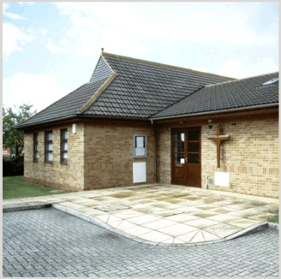
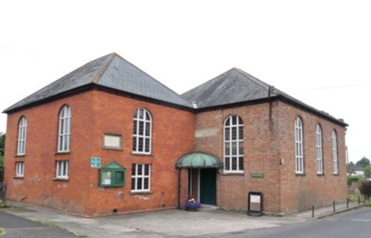
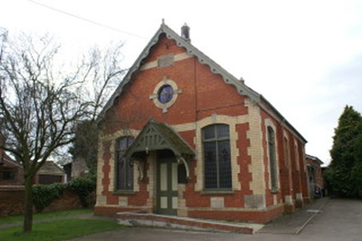
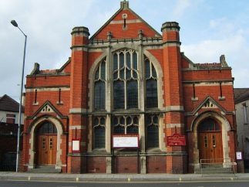
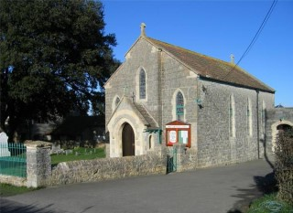
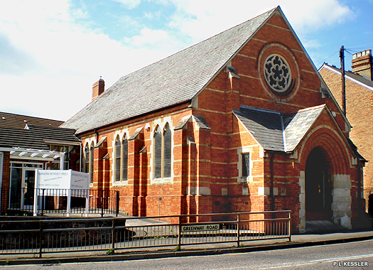
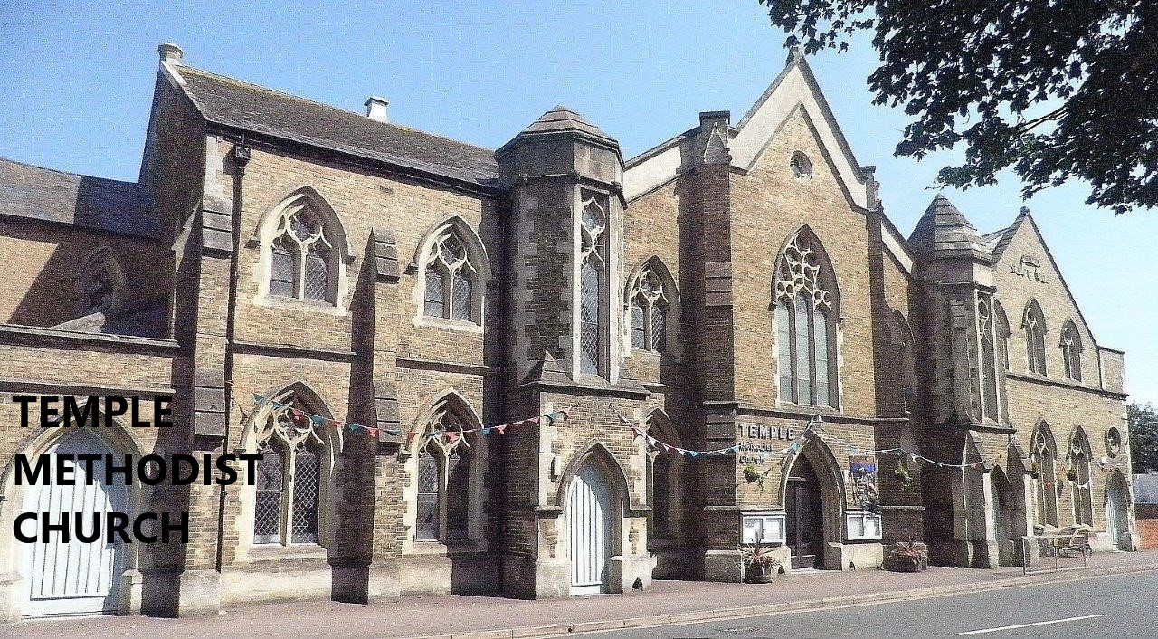


Churches Reports for the
Circuit Meeting

March 2023

A Pilgrim People…

Thank you to those who have compiled these reports. The styles used have varied, but each gives an indication of the work and ministry of the church.

Such reports will always be incomplete, and there will always be more to add or adjustments to be made, but perhaps reading through the joys and opportunities identified by churches will encourage you.

Similarly the challenges we face in our churches, large and small, are much alike.

I hope that it has been useful to take a snapshot of our churches’ life at this time of rebuilding and reassessing our local community needs, and that we can use these reports to work on developing our church and Circuit mission plans.

We are like those who move in a procession on a march through the darkness.
The lights we carry are much alike, although each is individually our own. And when they are blown out in spite of our efforts to protect them from sudden winds, we need each other in order to continue the procession, to see the way ahead.

So we move on, our flickering light joining other lights in a communion of community that is indeed awesome and beautiful."
Albert Schweitzer

TEMPLE

Like churches everywhere, Temple is rebuilding its contacts, congregation and community work following the Covid lockdowns from spring 2020 until May 2021. During this difficult time the role of pastoral care became particularly important and members maintained close contact with one another via the telephone or internet. The period significantly impacted our older members. Our ministers and lay preachers in the Circuit provided a valuable outreach with weekly services on Youtube which reached many more people than would regularly have attended worship in church. These services via Youtube continue and are appreciated by many.

Sunday worship services restarted in the church in May 2021. The congregation has not returned to pre-pandemic numbers, but is gradually growing and 60+ members usually now attend Sunday worship. New people continue to join the congregation. There is a monthly Communion service at 9am which is followed by breakfast. An afternoon cake and conversation' – a ‘Transforming Conversations’ initiative, open to all the Circuit has recently started.

Temple continues to enjoy joint services with the URC approximately 6 times a year and, together with St John’s, share study sessions in Advent and Lent.

Temple plays an increasingly important role as a community centre, largely thanks to the dedication and hard work of Joanna Rossiter, our Church & Community Worker. There are currently 20+ U3A groups, four choirs, a Pilates class and Pop-In who use the premises every week. Pop-In meets every Wednesday morning and is followed by a short mid-week service in the chapel attended by an average of 15-20 people who appreciate this opportunity. Temple is also proving to be an appropriate venue for family conferences run by social services, which take place most weeks. There was considerable discussion as to when and how Temple could provide a 'warm space' for people finding it hard to afford heating at home and Wednesday is the one day when Temple can regularly offer this facility. There has not been a noticeable take up.

Several church groups meet on a regular basis: Quest (a small group of ladies who sing), Thursday Afternoon Group (formerly Vivary and Men's Forum) and SaltPlus who organise mainly social events open to all the congregation. At a recent planning session people were asked to think about our strengths, weaknesses, opportunities and threats. Although this probably did not reveal anything particularly new, it was a useful exercise.

Strengths:
Well established community/gathered congregation with many gifted people
Town centre location
Size and facilities of building
We belong to a flexible/versatile denomination in Methodism
Welcoming church providing 'Intentional hospitality' and good pastoral care
Strong committed ministerial team from varying backgrounds
Variety of music provided by different organists/pianists/Quest
Good technical set up for services and concerts
Great community links

Weaknesses
Are we too wedded to the building?
Lack of mid-week parking
Lack of diversity among the membership
Failure to embrace 21st century technology opportunities
Ageing congregation, hence limited volunteer core to fill roles, especially technical team
Too much dependence on our Church and Community Worker

Opportunities
the developing relationship with Parkfield School
for more involvement with Citizens Somerset
for greater involvement with our increasingly diverse community - several young families now attend regularly
for more use of Inna Tideswell's music teaching groups
for links with new friends, especially those from the MPH working community
large seating capacity and source of revenue through its size and location
to become an Eco Church
our closer/renewed links with Queen's College
working ecumenically with URC and St John's as ‘inclusive church’ partners

Threats
Responsibility and cost of maintaining large, old building
Shortage of ministers (and thus heavy workload of our two presbyters)
Declining membership and age of membership
Declining perceived relevance of Christianity in UK
BRIDGWATER

Since lockdown, we have had to face some real challenges. Some of our regular attenders have not returned to worship, our Junior Church no longer functions as it did and we have had to cope with the deaths of some of our most loved members and friends both during and since lockdown. This is on top of the challenges of functioning as a Church during lockdown itself. Not worshipping in our Church building for many months, took its toll on our building and we are now having to face the worries of increased energy bills, which for us have increased 1000%. As a result of the energy costs, we are using the hall for Sunday morning worship. We are getting used to this, the atmosphere is lovely and our preachers seem to approve. We have managed to set up the technical equipment, so can still project the orders of service. Due to a generous donation, in memory of a former member, we have been able to acquire new projectors and a laptop and will soon have Wi-Fi connected.

Our biggest threats are financial and our ageing congregation. These place limits on what we are capable of doing, but it doesn't stop us dreaming and praying. Our situation can sound very dismal, but happily we are now beginning to see some green shoots and are pleased to be working with our new Minister, Rev. Annie Deche, who joined us last September after we said farewell to Rev. Chris Brown. Our Sunday congregations are growing and we have welcomed some new people to our Church, including a family of friends from the hotel at Junction 24, who we are getting to know and are helping to support.

We are pleased to report that Messy Church continued monthly during lockdown by way of zoom and we kept in touch with the Messy Church families all through the pandemic. We have been meeting monthly, in person, for over a year now and continue to welcome new families, alongside those we have known for a while. These are on Saturdays from 1.30pm-3pm. We have also held parties for the Messy Church families. We are grateful for the support and help we get from our own congregation and are hoping to expand our Messy Church through the coming year by creating special activities for our older children.

Outreach to the community in the Bridgwater area includes our Friday Coffee/Playbreak for toddlers and their parents, allowing parents to chat whilst their toddlers play together. This has recently restarted after a long break.
Sadly, our lay worker, who we employed part time, gave in her notice during lockdown and she was not replaced. We are disappointed that, for various reasons, we did not reap much benefit from the appointment and are now trying to work out what our mission should be and what community we should focus on. We shall be seeking help for this in the near future.

Business meetings and groups held are:
Council Meetings, Finance and Property Committee, Planning Committee, Stewards Meetings and a Pastoral Meeting and some of our members participate in the zoom Bible study group set up in lockdown. We hope to plan an Annual Away Day for a time of Bible Study and fellowship and have just arranged a series of Lent Discussion Groups to be held at the manse on the Mondays of Lent, to be led by Annie.

We have continued to hold our annual Christmas Tree Festival and after a break of three years opened our premises to the Carnival crowds last November. This raised much needed funds, but also provided a very welcome and much appreciated service at the same time.

Social events include: Annual outing, weekly Coffee and Chat started on zoom in lockdown, but now held face to face and meals, either bring and share, catered for by congregation members or enjoyed at local restaurants. A group now regularly has Sunday lunch together after the morning service.

We donate to Methodist and other charities, including Christian Aid and annually, we have a Christmas collection of toys and gifts for local or national charities. We hold an annual quiz to which other members of the Circuit are invited and all proceeds are donated to Christian Aid.

The Church Hall continues to be available for hire, but due to some building problems, we lost our regular bookings from the dancing school which used the premises. In the near future, we will start to intensify our efforts to obtain new users and maximise income.

We still have very good ecumenical links within Bridgwater with the Baptist Church and St John’s Church, but, sadly our links with Eastover School have diminished, although many of our Messy Church children attend that school. We are also making links with the Northgate School in Bridgwater.

We sponsor a child, to help with schooling, through funds donated for coffee and tea following Sunday morning services, through the charity Embrace.

We have 40 members with an ave weekly attendance on Sundays of 25.
ROWBARTON
STRENGTHS
As a congregation we love each other showing an inclusive, friendly welcome to all. This spreads into our supportive pastoral network.
Our membership and attendees are loyal with a good group of church and property stewards. We have some very generous members and attenders, so we have been able to cover essential expenditure.
Deaf Church 3rd Sunday afternoon each month
Our accommodation rooms are warm, light, and airy, thus supporting activities such as “The Mix”. The buildings are well maintained.
We are willing to try new ventures within the community including developing The Pantry Hub.
We support the circuit, work with the North Taunton Churches, joint services with St Andrew’s, “Messy Church”, “Easter Cracked” and “Nativity on the Green”.
We actively support RAfT, TWR, the annual church charity and our Methodist funds
We have a dedicated excellent organist for services.
OPPORTUNITIES
We are a neighbourhood church with a growing multicultural community.
Working together with other North Taunton Churches.
We have the ability to vary our worship using YouTube clips.
Providing the Pantry Hub presents opportunities to engage more fully with the community.
Good social space for more events, groups, and meetings.
We are relatively well placed for transport links giving opportunity for wider attendance

WEAKNESSES
Our age range is unbalanced with a predominantly elderly congregation and no regular children. We do not have a Junior Church.
We lack a large car park.
Our geographical location is both a strength and weakness.
An aging membership makes completing tasks harder and falls onto fewer hands.
The Methodist “system” can mean it takes a long time before some decisions can be made.
Attenders are often not willing to become actual members.
THREATS
The gradual lessening of the congregation due to age and ill health.
A lack of people willing to undertake roles and tasks.
The potential loss of Kilkenny Car Park.
There is some apathy – volunteers can be difficult to find.
A smaller, increasingly elderly congregation could impact on the upkeep of the premises and on ministry within the community.
Risk of burn-out for some members having to do too much individually.

       

LISIEUX WAY

We Commit Ourselves to : Great Worship + Loving Fellowship + Mature Discipleship
+ Using our gifts in Service + Sharing Jesus Christ
We are a small church, Membership is 28 and average attendance on Sunday mornings is around 22. We welcomed two new members this year.

Strengths
Local Arrangement services, led by our Worship Enabler, are valued by the congregation; and we have ‘local’ musicians who occasionally lead the singing with gusto.

While we are always appreciative of the organists who come to play for us, we are also getting used to using the StF cds and hymns via the computer.

The following are regular events:
Bible Study Group; Prayer Group; Come and Sing [now back on a more casual
basis]. Recently a Women’s Fellowship has been formed, and this is drawing in a consistent membership.
We continue to share regular Quizzes; the Jubilee event drew in members of the community
we supported ‘Christmas Sparkle’ for children’s gifts and ‘Open Door’ for adults gifts before Christmas, as part of the MWiB drive.

Regular reports of our services etc go into the Link magazine, courtesy of our members.

We have held the first in a series of meetings [suggested by Citizens Somerset] called ‘Faith in Action’, and these will continue, and hopefully will strengthen our commitment to our community.

This year we have appointed two Home Communion Stewards.

The premises are not as well-used as before the pandemic, but we continue to gain an income and serve the community in this way.

By the end of this month, we are pleased that all invited members of our congregation will have completed Foundation Training for Safeguarding, and within a few months all those requiring Advanced training will have completed the course.

The forms for the Registration of same sex marriages have been lodged with the Registrar, but no response [except to ask for forms that had actually been included] yet, so we are in limbo here.

Weaknesses
It is difficult to man the church for Sunday services lately [stewards, door stewards, IT helpers], but we get by on a wing and a lot of prayer. Likewise, we seem to be continually looking for officers, but always mange to find someone – though at times the situation seems stressful.

We were unable to share Christmas events this winter with the school and the YMCA, after many years of co-operation. We are hopeful for next year! The
proposed Easter Cracked has been shelved due to lack of personnel, and we will support Rowbarton instead.

Like most organisations, we have been adversely affected by covid; but we feel we are recovering slowly, and beginning to get back to our usual strengths – eg - our input into school assemblies locally has been ‘on hold’, but it seems we may shortly again be involved with Blackbrook School assemblies.

Threats
Finances are barely adequate – although we are hoping to install a new front door shortly, other works needed are held over at present.

Opportunities
This year we said goodbye to our Minister Rev Chris Brown and welcomed our new Minister, Rev Annie Deche.

We continue to appreciate the variety of preachers who come to us, and especially those who take on the challenge of our monthly Praise Service. Latterly, it has been good to see preachers choosing one or two hymns that are more easily accessed by a member of the congregation with learning difficulties - it has been especially appreciated, as we realise that hymn choice is an integral part of the message at a service, and finding alternatives poses challenges.

We have enjoyed a Harvest Supper and an Anniversary Lunch in the last few months.

We continue our support of Action 4 Children and CRY, our donations to Open Door, and also collecting bras and bottle tops .

And……
It’s hard to know where to put this! The garden provides a serene area for the community, and for the odd rough sleeper – it also attracts arsonists and gangs of youths who annoy our neighbours. It is a means of us getting to know our community through working alongside them – but also we have to try and deal with the complaints of the community… This is something we are mulling over in our ‘Faith in action’ talks.
Pawlett

Strengths
Our relationship with our Anglican friends continues to flourish. They join us on the third Sunday each month for morning service followed by tea, coffee and socialising. They enjoy sharing the covenant service with us every year and we will join them for the Lent Supper and the Christian Aid coffee & cake morning in May. We are looking forward to Rev Annie’s Lent Studies in March. A Christmas tea with Carols is planned for December as the carol singing around the village did not really work out that well last year.

We held a very successful Junior Church reunion service for our anniversary last year when we welcomed more than 40 young people and their families. Some former members brought their children and it was good to see them all and share reminiscences over lunch.

‘Churches Together in Pawlett’ are facilitating a weekly ‘Warm Welcome’ on Thursdays in January and February. This takes place from 9.30 until 2.00pm in the Royal British Legion building. Grants have enabled us to provide food and drinks throughout the day for anybody who comes through the doors. Bacon/sausage rolls are cooked to order in the morning and soup is available at lunchtime. Coffee/ tea/ hot chocolate are readily available all day, together with biscuits and cake. If people wish to give money, there is a donation box and the money is divided between the Poppy Appeal and Bridgwater Food Bank.
However, there is no obligation to ‘pay’: there is no charge. We are providing a warm space for anyone who need /wants it, space to meet with other people, to be reheated, refreshed and welcomed. The first sessions have gone well: some people have stayed most of the time, some have come early and then returned for soup at lunch time, some have just come for a breakfast bap or a cup of coffee.

Messy Church – Held at the local primary school as an afternoon club, this venture is continuing to be very successful with 20 children attending. 6 sessions were held between 6th June and 11th July 2022 and 7 sessions from 31 October to the 12 December 2022. Topics included Jesus “as a friend” and the Parables plus singing and activities. The next sessions will be held from 20th February to 27 March 2023 when the topics will be the stories of Jesus and the Miracles. On Palm Sunday, 2nd April, from 3.30pm – 4.30pm there will be a special Easter session in the Village Hall.

Opportunities
We still have the pre-school using the hall during school term and we live in hope that this will encourage families to come and take an interest. As we now advertise that there is a service every week.

Our window displays for Christmas encourage groups to decorate a tree. We have Brownies, Rainbows, Pre-school, and Messy Church but so far their parents have not come to see their handiwork.

Weakness
Sadly, our ever-strong junior church has not re-opened after covid. Many have grown up and started work. Others have moved and joined different schools where there are many activities on a Sunday.

Threats
Aging and gradually diminishing membership numbers.
Cost of maintaining and running an old building.
Reducing numbers to take on roles within the church.

       

NORTH CURRY AND CURLAND

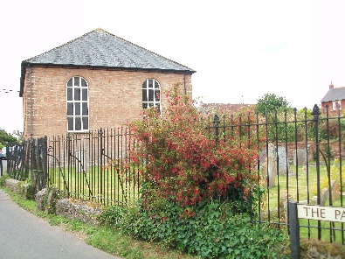
Worship at North Curry Methodist Church:
- Sunday mornings; occasionally afternoon services replace the morning, particularly for 'specials'
- Taize services to mark Advent and Good Friday/Easter Eve
- Ecumenical 'village' and area events to mark the World Day of Prayer, Pentecost, and Remembrance Sunday
- We aim to return to a United Service with Anglican Benefice for Covenant Sunday
- Our worship accompaniment is through the kind services of Andrew Goodwin, Sarah Gilham, and through StF CDs
- Projection and sound facilities are available for leaders of worship, and a pew has been removed (following a long process of obtaining the permissions required for a Grade II building) to accommodate a person using a wheelchair.

Special events and Missional activity:
- Worship which builds on the particular nature of North Curry Chapel,
e.g. traditional, meditative, Taize, favourite hymn evenings
- Involvement in village events, such as Christian Aid, May Fayre, Pentecost Praise, Remembrance Sunday Memorial Service
- Full engagement and support for ‘special Sundays’ through envelope offerings
- Minister takes regular assemblies at the local (CE) primary school
- Building relationships with the Anglican vicar and finding ways to work cooperatively with outreach to the village

Strengths and Opportunities:
- Very committed members, willing to ‘try new things’
- Warm and welcoming – some say ‘special’ atmosphere
- The congregation is always open to new ideas and varied worship styles
- Good working relationships between Anglicans and Methodists
- Good relationship with the primary school through assemblies
- Garden space for outside village activities

- Local musician uses the premises for rehearsals, and for local events - good to have the building used between Sundays
- Useful ‘Upper Room’ space for groups/meetings
- Well placed geographically for Circuit/and Joint Circuit (SP&C) events

Weaknesses and Threats:
- The majority of members/attenders live outside the village, thus there is an associated transport issue
- Declining and aging congregation – the Covid years hit hard
- Building costs and balancing annual budgets are tough challenges

       

THE LEVELS METHODIST CHURCH AT MIDDLEZOY

Worship at Middlezoy
- 1st Sunday of the month, joint morning service. These are held alternately in Holy Cross and the Chapel. In addition, festivals and special events are usually united.
- 3rd Sunday of the month, circuit evening service with Holy Communion
- Flexible worship space encourages worship ‘in the round’ which is generally interactive

Worship at Westonzoyland
- A quarterly united service with CE and Methodist clergy held at the parish church.

Community use of the Chapel at Middlezoy
- Weekly village coffee morning
- Hirings beginning again post-Covid
- Village shop/PO on chapel site
- The Methodist Church was the focus for volunteer help all throughout the Covid lockdowns supporting isolating/elderly people
- One of the two village defibrillators mounted on the Chapel wall

Outreach:
- United ‘Messy Church’ re-formed for seasonal activities post Covid
- Village Nativity and Christingle held at Chapel
- Fundraising lunches
- Involvement in Village events
- School assemblies recommenced
- Our ‘fence gifts’ seasonal outreach for the village and use of new seasonal banners/displays

Strengths and Opportunities:
- Good premises, well situated, and well used by community of all ages
- Very committed members and 'friends of the Chapel' who have good community links
- Two new and active members in the last year
- Wedding and reception in February 2023 – the first for 17 years!
- Good working relationships between Anglicans and Methodists in both villages
- Practical help from Circuit friends for events and activities

Weaknesses and Threats:
- Lack of people to take office or participate in outreach
- Lack of ministerial time for concentrated work – disappointment over the Village Worker position

       

