Friends of Garden Island Creek
Beach Access and Erosion Community Consultation Survey
FOGIC thanks you for taking the time to complete this survey and sharing your thoughts and ideas. We welcome all voices, and the more people who participate the better our understanding of the desires of the community will be.
Surveys due by Feb 15th 2023.
Please return hard copies to the mailbox at 14 Sunset Drive or electronically via email to friendsofgardenislandcreek@gmail.com or via messenger to the Facebook group. Please email or call Kelsie 0472 510 161 with any questions.
This survey may be answered anonymously (if submitted electronically your details will not be stored alongside your survey answers) or please provide your email address at the end if you would like to receive updates specific to these issues.
Q1. Are you a resident/landowner at:
☐ Garden Island Sands, ☐ Garden Island Creek
☐ Another area of the Huon Valley, ☐ Not currently a resident/landowner in the above areas but interested in the issue, ☐ Prefer not to say
Q2. Did you attend the community consultation and discussion about beach access and erosion held at the beach on the 28th January?
☐Yes, ☐ No
Q3. How often do you visit the beach at Garden Island Sands?
☐ Daily ☐ Weekly
☐ Once a month ☐ Frequently but seasonally
☐ Infrequently
Q4. How long have you been visiting the beach at Garden Island Sands
☐ Less than 5 years ☐ 5 to 10 years
☐ More than 10 years
Q5. Have you seen/experienced changes to the beach at Garden Island Sands?
☐ Yes, minor change ☐ Yes, major change
☐ No change ☐ I don’t know
Q6. If visiting the beach at Garden Island Sands in the past 2 years have you found the beach difficult to access since the boat ramp was removed?
☐ Yes ☐ No
Q7. How important do you think it is to address beach access at Garden Island Sands
☐ Very important – urgent action is needed.
☐ Important – action is needed soon.
☐ Not important – no action required.
☐ I don’t know.
Q8. It has been suggested that safe beach access for people/prams/dogs may be easier to establish than boat access, how do you feel about that?
☐ OK. Safe beach access for people is adequate.
☐ Not OK. I feel the replacement of the boat ramp is very important.
Q9. Do you think either a ‘sand ladder/board and chain walkway’ seen at other local beaches, or a set of recycled concrete steps (for which the materials are currently available) are appropriate?
☐ I would be happy with either
☐ I prefer the ‘board and chain walkway’
☐ I prefer the wide concrete steps
☐ I have another idea
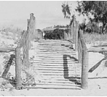
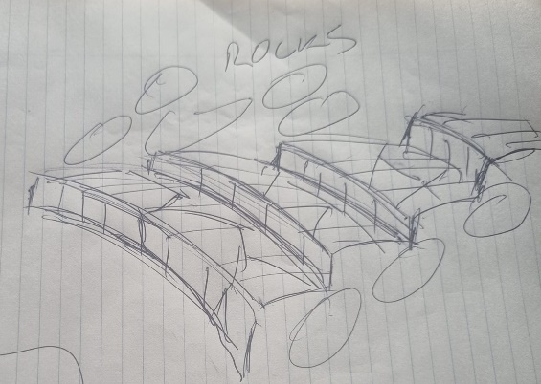
A) ‘Board and chain walkway’. B) concrete steps, a quick sketch by Mick Kelly. Both of these ideas will have to go through engineering to see what’s possible.
Please comment
Click or tap here to enter text.

Q10. How important do you feel it is to take action regarding erosion of the beach at Garden Island Sands
☐ Very important – urgent action is needed
☐ Important – action is needed in the near future
☐ Not important – no action required
☐ I don’t know
Q 11. What do you think are the most important reasons for protecting the beach at Garden Island Sands from erosion? (please rank)
☐ Protect private property
☐ Protect the environment
☐ Ensure safe ongoing use of the beach by the community
☐ Other
Please comment
Click or tap here to enter text.

Q 13. I may like to be involved in the following moving forward
☐ Community meetings to discuss progress and options for beach access and erosion protection.
☐ A group that meets regularly to progress these specific projects (no experience necessary, no commitment required, just participation)
☐ Working bees where I am able to be physically involved in sandbagging etc
☐ Working bees where I can attend and have a less physical role
☐ Joining the Friends of Garden Island Creek group or committee

Please provide your email if you would like to stay informed about these issues:
Email: Click or tap here to enter text.
Other Comments:
Click or tap here to enter text.

