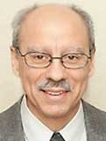 A Note From Deacon Mark
Today is the halfway mark of the Sundays of Lent. This Sunday is known as Laetare Sunday for the first word of the Entrance Antiphon Laetare (rejoice); it is a Sunday of joy! The celebrant has the option to wear rose-colored vestments. Since Lent is half over, now is the time to seek out and practice even more those corporal works of mercy: 1) Feed the hungry. (2) Give drink to the thirsty. (3) Clothe the naked. (4) Shelter the homeless. (5) Visit those in prison. (6) Comfort the sick. (7) Bury the dead. In being merciful to others, we will find God’s mercy for ourselves. Jesus tells us, “Be merciful, just as your Father is merciful” (Luke 6:35). Upon Further Reflection A man was driving down a country road and he noticed that there was a chicken running ahead of his car and keeping pace with it. He looked at his speedometer and he was driving fifty miles an hour. So, he increased his speed to sixty, and then seventy miles an hour. But the chicken just sped up. Outrunning the car, it took a right turn into a small farm and disappeared behind the farmhouse. The man was so astonished by the performance of the chicken that he pulled into the farm and knocked on the farmhouse door. A farmer answered. The man said, “I don’t want to be bold, but do you know that you have a chicken that can run seventy miles per hour?” The farmer said, “Oh I have a lot of chickens who can do that. On this farm we breed three-legged chickens and they are very fast.” “Three-legged chickens,” said the man, “I never heard of that! Why would you want a three-legged chicken?” “For very personal reasons,” said the farmer. “You see, I live here with my wife and my son and we all like drumsticks. And so, when we have a chicken dinner, we are always fighting over who is going to get the drumsticks. But, with a three-legged chicken each one of us has our own drumstick. There is peace in the family.” “That’s amazing!” said the man. “I never heard of a three-legged chicken. Are they good? What do they taste like?” The farmer shrugged his shoulders, “I have no idea. We haven’t been able to catch one yet.”

In His Mercy, Deacon Mark

This weekend we take up our World’s Poor Collection benefiting the Catholic Campaign for Human Development, Catholic Relief Services, Peter’s Pence, and the Solidarity Fund for the Church in Africa. Through this collection, you support programs that address the root causes of poverty and provide a sustainable future for those struggling across the globe. Take this opportunity to be a sign of mercy to our suffering brothers and sisters. Prayerfully consider how you can support this collection.

Sunday Mass with Bishop David Ricken on WFRV Local 5
All who are hospitalized or in an assisted living facility, Incarcerated, or otherwise physically unable to attend Mass in person are welcome to tune in for Sunday Mass with Bishop David Ricken every Sunday at
10:30 am on WFRV Channel 5. You can find and watch archived video of this week's Gospel & Homily from the TV Mass now by visiting.
www.gbdioc.org/SundaytMassHomlly
Rice bowls are at the main entrance, please consider donating.

Faith Formation News:
Thank you, everyone for all the button donations! Stayed tuned for our project! Please keep our students preparing to make their First Reconciliation in a couple of weeks, in your prayers.

God Bless, Faith Formation Team.

Mark Your Calendar!!!
Friday March 22nd @ 6:00 pm – There will be a Reconciliation service at St. Michaels, please join us in our Lenten journey to ask forgiveness form our Father.

Thursday March 28th - Thursday of the Lord’s Supper will be March 28th at 5:00 pm at St. Anthony this year.

Friday March 29th - Passion of the Lord/Good Friday is March 29th at 3:00 pm at St. Michael.

Saturday March 30th - The Easter vigil will be at
St. Anthonys this year on Saturday March 30th
at 4:00 pm.

Sunday June 23rd – St. Michael Church Festival 10:00 am - 3:00 pm. We need volunteers to head sub committees and volunteers in general. Please contact Dee Lyons at 715-584-4683 or the Church office at 715-799-3811. This is our biggest fundraiser for the Parish!

March 10th, 2024
Fourth Sunday of Lent
3/09-5:00 pm………….……Phyllis & Renee Caldwell
3/10-9:00 am……………………………John Orlowski
3/11………….…………….……….…………..No Mass
3/12-8:00 am……………………….……Kelly Lightner
3/13-8:00 am…………………………….Pray for Faith
3/14-8:00 am…………………………Children in need
3/15-8:00 am……………………...…….Richard Vigue
3/16-5:00 pm ………….………….……Jim Kaquatosh
3/17-9:00 am……………...……….…Roger Sanapaw

We are in need of daily Mass intentions. Please turn them in during collection or drop them off at the Parish office.
HELP! ! !
We are still in need of another Eucharistic Minister or two for Sunday 9 AM Mass. We schedule around your availability and try to schedule people only once a month if possible. If you are interested in helping out, please let the Parish office know. We will train you!

Pastoral Parish Council & Trustee Election
The Pastoral Parish Council has three terms opening in May. We are in need of candidates for the Council to serve three-year terms. There are also two Church Trustees opening, one three-year term & one one-year term. Please consider volunteering for one of these positions. Contact the Parish office if interested or want to learn more about these opportunities to serve St. Michael’s Parish.

Thank you to Herb Kohl Philanthropies for a $200.00 donation to St. Michaels Food Pantry.
Deadline for submitting information to the bulletin is 8:00 am Tuesday morning

Eucharistic Ministers
Saturday, March 9th, 5:00 pm
Lector Eucharistic Minister
Kevin Culhane | Kevin Culhane
Sunday March 10th, 9:00 am
Lector Eucharistic Minister
Kathy Tucker | Anne Sulskis
Saturday, March 16th, 5:00 pm
Lector Eucharistic Minister
Pat Gwidt | Jim Gilane
Sunday, March 17th, 9:00 am
Lector Eucharistic Minister
Ellie Sokoly | Pat Gwidt
Saturday, March 23rd, 5:00 pm
Lector Eucharistic Minister
Kevin & Muffy Culhane | Deacon Mark
Sunday, March 24th, 9:00 am
Lector Eucharistic Minister
Kathy Tucker/Ellie Sokoly | Deacon Mark
Financial Blessings March 2nd & 3rd
Envelope/Contributors | $1665.00
Loose Collection | $290.31
Building & Grounds | $10.00
Easter Flowers | $140.77
Votive Candles | $54.00
Bishops Appeal Goal | $5075.00
Bishops Appeal Donations | $475.00
Food Pantry | $210.00
Mass Stipends | $10.00
Fish Fry Sale | $1479.00
Fish Fry Donations | $70.00
Thank you for supporting our Parish
Wish List 2024
Advent Booklets-PD 11/15/2023…………….………….....$75.00
Paschal Candles-PD 11/1/2023……………….…..….....$250.00
Lent Booklets PD 03/07/2024……………..…………........$75.00
Copy Paper………………………………..……….…...….$300.00
Bulletin Paper………………………………..…………..…$300.00
Church Envelopes………………………......................…$400.00
Altar Bread for 1 year……………………..…………….....$500.00
Missals/Song Books………………………..…..............$1,800.00
Copier Expense…………….……………..……….....….$2,250.00
Liturgical Supplies…………………………...….............$1,500.00
Electric….…………………………..………..…............$12,000.00
Heating Cost 1 year………………………..….….……$25,000.00
Hall Roof Replacement…………...…………..............$20,000.00
Rectory Roof Replacement………………...………....$20,000.00
Church Roof Replacement……………...............……$42,000.00

St. Michael Parish

Bishop's Appeal
The Burden of Debt
Life can be challenging. There are times when people feel so lost. They find help through Catholic Charities and the many programs and resources in our Diocese.
Amanda was in an abusive relationship that took a toll on her physically, emotionally, and financially. This relationship left her battered, bruised, and in severe debt. Through God’s grace, Amanda found help from several organizations, including Catholic Charities Financial Health Services Program. With guidance from a Financial Health Counselor at Catholic Charities, Amanda learned to manage her money, prepared a plan to pull herself out of debt, paid her debts on-time, and became self-sufficient.
“Going from $20,000 in debt to no debt…it’s amazing. It feels great,” said Amanda.
Your gift to the Bishop’s Appeal helps people like Amanda. To make a gift today, contact your parish, visit the Bishop’s Appeal website at www.catholicfoundationgb.org/give, or call Tammy at 920-272-8123.

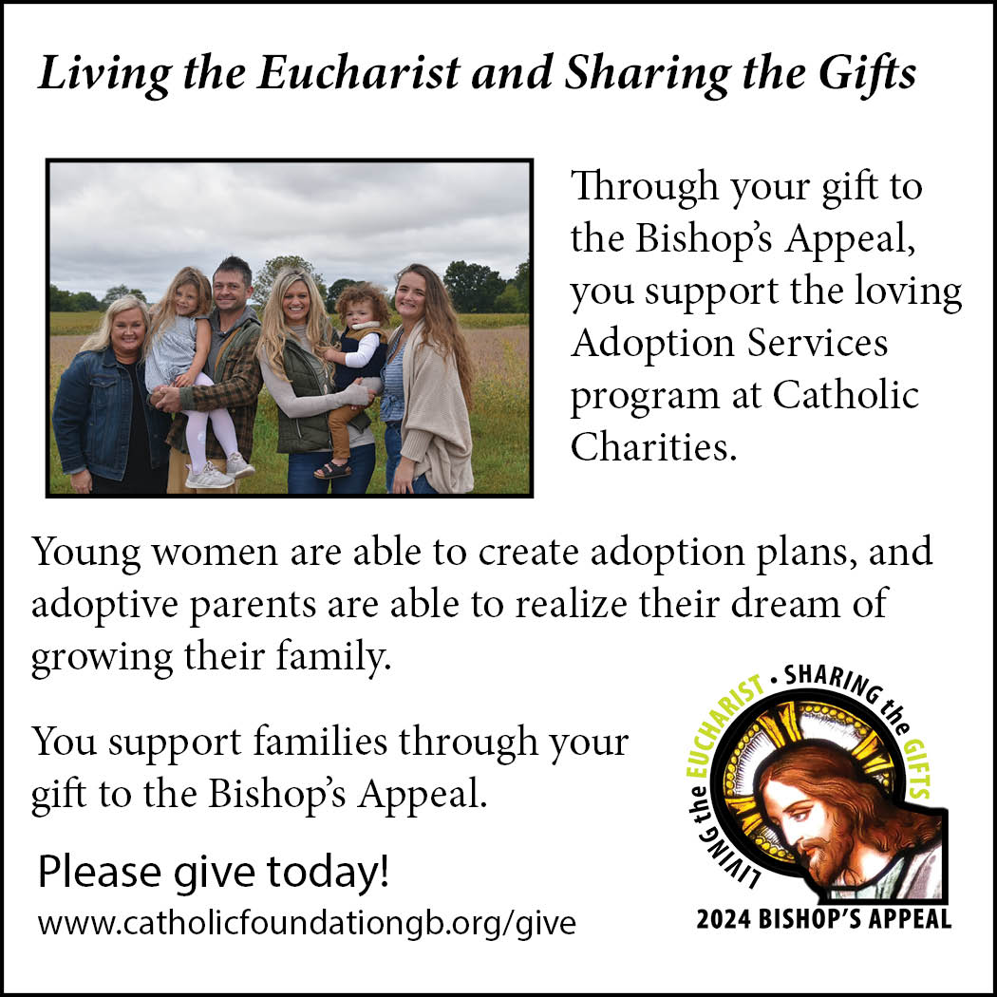

Please pick up your pans, cookie sheets, and miscellaneous items left over from funerals and other church events in the Fr. Barrett Hall.
There will not be a Mass at St. Michael on Holy Saturday, March 26. Easter Vigil will be held at St. Francis in Gresham at 7 pm. Easter Sunday Mass will be at St. Michael and St. Anthony at 10:30 am.

Maintenance. Michael Catholic Parish in Keshena is seeking a part-time maintenance person. Responsible for light maintenance, cleaning the church, etc. Contact the parish office at telephone number 715-799-3811 for an application, and job.

Please pick up your pans, cookie sheets, and miscellaneous items left over from funerals and other church events in the Fr. Barrett Hall.
There will not be a Mass at St. Michael on Holy Saturday, March 26. Easter Vigil will be held at St. Francis in Gresham at 7 pm. Easter Sunday Mass will be at St. Michael and St. Anthony at 10:30 am.
St. Michael’s Calendar
3/09/2024 World’s Poor Second Collection
3/10/2024 World’s Poor Second Collection
3/11/2024 Confirmation Class 7:00 -9:00 pm
3/13/2024 Faith Formation Class 6:00 – 7:30 pm
3/15/2024 Stations of the Cross 5:30 pm
3/22/2024 Stations of the Cross 5:30 pm
3/22/2024 Reconciliation 6:00 pm

MASS TIMES
St. Michael – Saturday: 5:00 pm, Sunday: 9:00 am
Tuesday-Friday: 8:00 am
St. Anthony – Sunday: 10:30 am, First & Third Tuesday: 10:00 am

Book Share
Book Share will be open on Tuesday, March 19th, from 12:30-3:00 pm. Books for all ages and interests! We will happily take any books in good shape that you are
finished with. Please no used textbooks, magazines or encyclopedias.

Food Pantry
Food pantry will be open on Tuesday, March 19th, from 12:30-3:00 pm. There will be drive up service only and food will be placed in your trunk. Please do not get out of your vehicle. Please Recycle large brown paper bags.

Thrift N Gift
Thrift N Gift will be open on Tuesday, March 19th, from 11:00 am to 3:00 pm. We have an abundance of household items, clothes, and great gift items. Shop the Thrift N Gift and Save. We are looking for Volunteers to work Monday & Thursday for approximately 2-4 hours. Please reach out to the Parish Office if you are interested.

We the Knights
We always ask God to bless our community members. If you or a family member need assistance to get to a doctor appointment, we may be able to help. Call Paul at 715-853-2414 or Bob at 920-410-0825.

Kateri Prayer Circle
Never underestimate the power of prayer. Just one small prayer can change your life. If you or your family members need prayers for any reason, please call one of our Kateri Prayer Circle members, who will in turn call members of their group. Soon, many prayers will be offered for your specific prayer request. Please call:

Fay Waupochick 715-799-3437
Jacqueline Braun 715-701-4552

You can also call the Parish Office to leave a request.

Religious Education Calendar Up Coming Events:
Wednesday, November 30th –Classes Resume
Wednesday December 7th
Wednesday December 14th
Wednesday December 21st Birthday Party- Parents
Guardians invited
Wednesday December 28th No Class
Wednesday January 4th No Class
Wednesday January 11 Classes resume
Pastoral Staff:
Fr. Hanz Christian Borbor
Parish Administrator
Parish Office (715) 799-3811
xtian.borbor@gmail.com

Deacon Mark Fuller
(715) 201-2961
mpfull7@gmail.com

Parish Secretary
Rickie Dodge
Parish Office (715) 799-3811
stmichaels@livingwaterslivingfaith.org

Anne Sulskis
Faith Formation
Parish Office (715) 799-3811
Sailkees@yahoo.com
Parish Trustees:
Alicia Wilke, Treasurer
Kitty Gilane, Secretary

Pastoral Council Chair:
Mary Lewellin

Finance Council Chair:
Therese Glauser

Thrift N Gift Coordinator:
Cookie Vigue

Food Pantry Coordinator:
Pat Gwidt

Mass Schedule:
Saturday: 5:00 pm Mass
4:30 pm Rosary & Confession
Sunday: 9:00 am Mass
8:30 am Rosary
Tuesday – Friday: 8:00 am

Parish Office Hours:
Regular hours: Monday-Thursday
8:00 am – 2:00 pm:
Hours may vary, Please call before coming to the office.

SATURDAY MASS: 5:00 pm
SUNDAY MASS: 9:00 am
CONFESSION: Saturday 4:30 - 4:45pm
ROSARY: Saturday 3:40 pm Sunday 8:35 am
DAILY MASS: Chapel Southside of Church

P Parish Administrator, Fr. Nonito Barra - 715-799-3811 - pastor@livingwaterslivingfaith.org
Rectory – 715-994-1337
Parochial Vicar Fr. Joel Jores - 715-787-3377 frj@livingwaterslivingfaith.org
Deacon Mark Fuller 715-201-2961- deaconmark@livingwaterslivingfaith.org
Parish Secretary, Vicki Hermsen - 715-799-3811 - vicki@livingwaterslivingfaith.org
Religious Education Kathy King-Tucker - 715-799-3927 – ltucker@frontiernet.netmailto:maczuzak@frontiernet.net
Wednesday 6 – 7:30 pm September – May
Parish Administrator, Fr. Nonito Barra - 715-799-3811 - pastor@livingwaterslivingfaith.org
Rectory – 715-994-1337
Parochial Vicar Fr. Joel Jores - 715-787-3377 frj@livingwaterslivingfaith.org
Deacon Mark Fuller 715-201-2961- deaconmark@livingwaterslivingfaith.org
Parish Secretary, Vicki Hermsen - 715-799-3811 - vicki@livingwaterslivingfaith.org
Religious Education Kathy King-Tucker - 715-799-3927 – ltucker@frontiernet.netmailto:maczuzak@frontiernet.net
Wednesday 6 – 7:30 pm September – May
Parish Administrator, Fr. Nonito Barra - 715-799-3811 - pastor@livingwaterslivingfaith.org
Rectory – 715-994-1337
Parochial Vicar Fr. Joel Jores - 715-787-3377 frj@livingwaterslivingfaith.org
Deacon Mark Fuller 715-201-2961- deaconmark@livingwaterslivingfaith.org
Parish Secretary, Vicki Hermsen - 715-799-3811 - vicki@livingwaterslivingfaith.org
Religious Education Kathy King-Tucker - 715-799-3927 – ltucker@frontiernet.netmailto:maczuzak@frontiernet.net
Wednesday 6 – 7:30 pm September – May

March 10th, 2024
Fourth Sunday of Lent
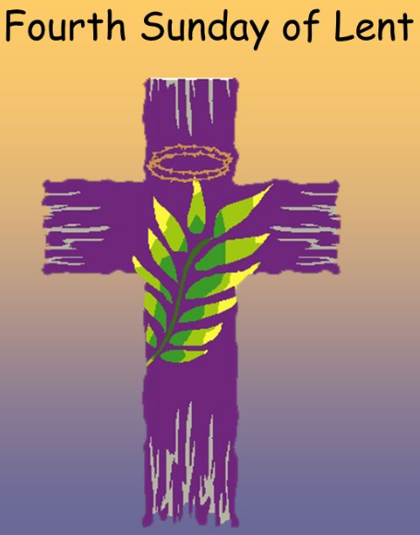
Anamehawikamek Welcome
ST. MICHAEL CATHOLIC CHURCH
PO Box 610, N816 State Highway 47-55,
Keshena, WI 54135 - Phone: 715-799-3811
Email: stmichaels@livingwaterslivingfaith.org
Website: stmichaelkeshena.com
Find us on Facebook: St. Michael’s Church

Mission Statement: St. Michael’s Christian Community,
located on the Menominee Indian Reservation, is a diverse Christian community reaching out to all residents, learning, loving, sharing, and communicating with one another through the teachings and practices celebrated in the Mass & the holy sacraments of the Catholic Church by integrating sacred symbols and spiritual practices of the Menominee.
KNIGHTS OF COLUMBUS: Third Tuesday of each month. The next meeting is March 19th, 2024 at 6:00 pm. Grand Knight Paul Marroquin 715-853-2414.
HOLY HOUR: Holy hour will be Thursday April 4th, from 8:30–9:30 am.
ANOINTING OF THE SICK: Individual arrangements can be made through the Parish Office.
Sacrament of Baptism: Please contact parish office to register and make arrangements.
MARRIAGE: Make arrangements with the Priest, six months prior to desired date.
CONFIRMATION: Contact Anne Sulskis for information via email Sailkees@yahoo.com

