Bio Data of
Prince Ishwar Ramlutchman'Mabheka' Zulu
The Royal Zulu Indian Prince
God-man Born in the Land of the Heavens
By iNduna Phumlani kaMfeka
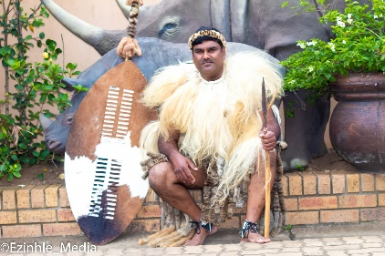

Childhood Days
Born at the KwaDukuza Hospital, in the land which was once a great palace of the legendary King Shaka of the globally renowned Zulu Nation l, Ishwar Ramlutchman was the third of seven children. Growing up in a humble background with his father earning R25 a week whilst his mother, who worked the gardens and laundries earning as little as 50c a day for their sizable family. Ishwar had his first toughest lessons in life when he unexpectedly lost his father who was 39years at the time whilst Ishwar was completing his matric certificate. This left all family responsibilities with his mother, who did not have the means to put Ishwar through tertiary education.This ignited a drive and passion within him to find employment so as to be able to support his mother and the rest of his family. Forty-eight years ago, he came into the life of Seetha and Ramlutchman Kissoon, who named “Ishwar” – in Hinduism meaning “God” – a profound contrast to living and growing up in a weather-beaten, corrugated iron and tin house at the semi-farming communal that produced other high achievers.

Youth Days
Through the grace of the universe, he was able to get himself employed at Tony Motor Spares in Mtubatuba in 1994 and went on to Pipetec in eMpangeni in 1995 and was able to assist his family during this time. His tenacity was tested when he was retrenched in 1998, forcing him to explore new ways of earning a living.
New Business Venture
Ishwar turned to his then spiritual master, the late Sri Swami Sahajananda and spoke to him about his dream of starting his own business that would also serve as a vehicle in which he can help the community of the land of his birth. His master advised him that he "should do everything correctly and success would be his." This motivation saw the birth of AC Industrial in the 1st of June 1998.
Armed with the dream of building AC Industrial into being a reputable private contractor that will service solutions to provincial and local government with a focus on water and sanitation, he however ventured with nothing but the grace of his friends who assisted him to make AC Industrial into a reality. He always states that although it is said "when times are dark, friends are few," he had very loving and caring people in his professional and private life who were there to offer him their wisdom and counsel. Among the greatest anchors in Ishwar's life was his wife Eswari, who stood by him whilst the business took much of his time and focus. She witnessed the trying times which they faced in business but she encourages and motivated him to persevere and refueled his temerity. By the design of the universe, his staff compliment are all spiritually centered people and it is they whom he regards as pillars of AC Industrial to which he pays tribute to whenever he shares his life-story.
Humanitarian and Philanthropist
Ishwar Ramlutchman , Philanthropist and Humanitarian has contributed tremendously to the Indian Diaspora in Africa. His commitment to Gopio has seen the Gopio Convention in Durban a huge success. Ishwar Ramlutchman was the Africa Co- ordinator for two terms and has supported the Indian diaspora in many of His cultural and heritage programmes. He is a business entrepreneur and worked for procurement and implementation of water and sanitation infrastructure projects for local communities. He upholds corporate social responsibility by building schools, feeding and providing health facilities for the poor and disadvantaged in South Africa. From the very beginning he had the policy to serve the disadvantaged. He adopted the social responsibility as a fellow South Africa of India Origin to serve the poorest of the poor .Mr Ishwar Ramlucthman has embarked on a Peace initiative which is supported by all spheres of Government, communities and Amafa Heritage Council in South Africa.

Promoting Unity in Diversity, Social Cohesion amongst all Races
A passionate spiritualist, humanitarian and author who was named 'Ishwar' by his parents which means "Almighty God" in Hindu also being born in the land of the Zulu nation, who are globally renowned as the people of the heavens. Ishwar one day had an epiphany and realized that he was born in a land of a mighty nation and nursed the ambition of meeting the King of the Zulu nation, His Majesty King Zwelithini kaBhekuzulu. In 1994 he embarked on a journey to the Linduzulu Royal Palace where he humbly requested an audience with His Majesty. Ishwar met the King and has since shared a very close relationship with the King and the Prime Minister of the Zulu Nation, INkosi Mangosuthu Buthelezi. This granted him an opportunity to learn intimately more about the Zulu culture and their way of life.
He learnt about ubuntu which is the basic fabric which the Zulu people have as their spirituality as ubuNtu encompasses the teaching which his divine master once taught him "To see God in all names and forms. To serve the poor and needy, seeing God in them. To relieve the pains, sorrows and suffering of others. To share what you have with others. To be a cosmic friend and a cosmic benefactor, a friend of the poor, the forlorn, the helpless and the fallen, is my creed."
His association with the Zulu nation and participation in cultural events and ceremonies is always admired even today by all communities. Ishwar has also met global icon Nelson Mandela to which he recalls the meeting vividly and terms it one of his precious moments in life that he cherishes deeply.
Him being born in the land of the heavens and to live among the people of the heavens and their King, was by divine design which has made Ishwar to be one of a kind that has propelled the history of the Indian community to new heights in the kingdom of KwaZulu. This Peace Pillar demonstrates the universality of all world religions when it comes to promoting peace and harmony in our country.
Adoption as a Son by His Majesty, King Zwelithini Goodwill Ka-BhekuZulu
Ishwar Ramlutchman, adopted son of the late King Goodwill Zwelithini kaBhekazulu and christened by the Zulu monarch as Mabheka Zulu. Move the needle to four decades later. King Goodwill Zwelithini, who comes from a long line of Zulu warrior-kings, adopted him named him Prince Mabheka Zulu: ‘’When I adopted Ishwar Ramlutchman, I gave him a name of Mabheka Zulu. The adoption of dedicated and diligent subjects in the Zulu Kingdom was always done by my predecessors: Kings Shaka, Cetshwayo and Dinuzulu.’’ “The name Mabheka means the one who cares for my people.
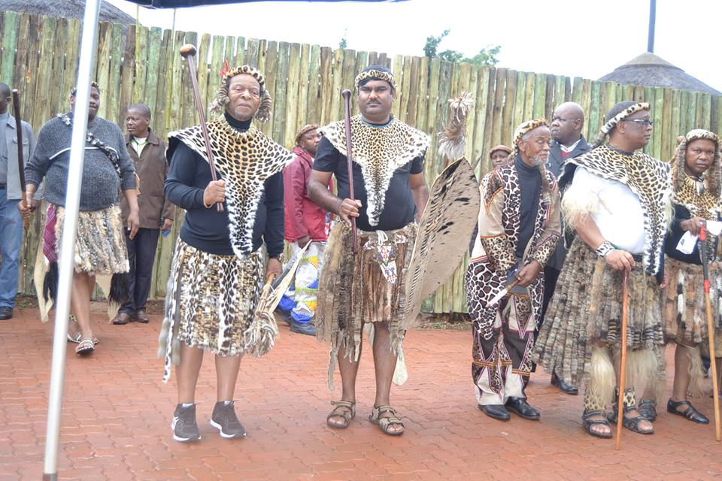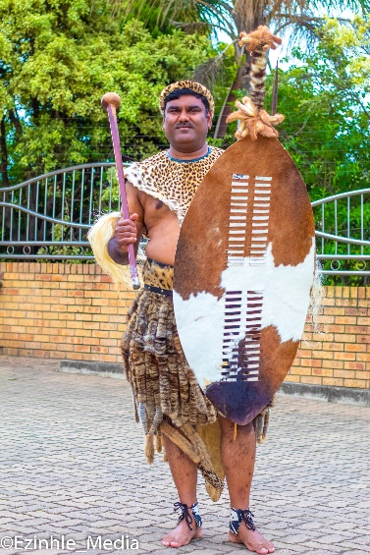
This was done after his heroic dedication and achievements in serving the poorest of the poor in the Kingdom of the Province of KwaZulu-Natal.’’ ‘’Mabheka has become instrumental in rebuilding fractured lives of the poorly served people. Through numerous food, clothing, libraries, community halls, wheelchair distribution programmes, including the sponsorship of bursaries for underprivileged children, Mabheka has made big difference in the lives of my people. In a country with a history of violence, it is commendable that Ramlutchman has erected many temples and churches to promote culture and belief in spirituality. “He has built low cost homes for destitute families, provided water and sanitation for needy communities.’’
“The dictum that people of exceptional leadership, intellectual and spiritual power are ahead of their time rings true for Mabheka’s life’s journey we are celebrating.
“Indeed, over the years Mabheka has become an additional member of our family whom I always refer to as indodana yethu, our son. His commitment and promotion of social cohesion, nature conservation and respect for everyone’s cultural heritage and religion has earned him our respect.’’Ishwar Ramlutchman has championed social Cohesion in South Africa. He is the only Indian that have been adopted as a son by the Royal Zulu Monarch and was the first person of Indian origin to be appointed as trustee of the Royal Household and made part if the Ezinyosi Zulu regiment . He has also been given The Zulu Royal orders and a Zulu Name, Prince Ishwar Ramlutcham Mabheka Zulu.
His spirituality makes him to be an avid environmentalist who is passionate about wildlife conservation and has committed himself to serving as the Ambassador for Ezemvelo Wildlife KZN which grants him the platform to fulfill his divine duty of safeguarding the creations of the Almighty God (Ishwar).
Promotion of Yoga
Ishwar Ramlutchman spear heads the International Day of Yoga programme across KwaZulu Natal together with various communities. He holds many Yoga Classes weekly in various areas and in schools. He is also the secretary for International Yoga Federation in South Africa.Yoga is being used as a tool to promote oneness and unity and diversity.
Promotion of Indian Culture
Many cultural programmes are hosted by Ishwar Ramlutchman such as Indian classical music, religious bhajan programmes , Bollywood and folk dance .
Through his philanthropic and humanitarian eandeavours, Ishwar has received many awards which include the following humanitarian awards :
● Humanitarian Award by South African Government RSA 2004, By Deputy President , Jacob Zuma
● Humanitarian Award by The ProvincialGovernment KZN by Premier JS Ndebele
● Humanitarian Award by The City Of Umhlathuze
● Humanitarian Award by Uthungulu District Municipality
● Humanitarian Award by Umkhayakude District Municipality
● Humanitarian Award by Prince MG Buthelezi, House of Traditional Leaders
● Hindu Business Leadership Award by the South African Hindu Forum
● Ganesha Award by the South African Hindu Forum
● Business Excellence Award by MEC For Finance and Economic Development KZN
● People's Choice Award from Zululand Chamber of Business Foundation - 2007
● People's Choice Award from Zululand Chamber of Business Foundation - 2010
● Award from South African Police Services, Richards Bay -2010
● Heritage Award from Amafa Heritage Council for the Installation of Peace Pillars.
● Amman award by the Mount Edgecombe Temple
● Ambassador for Ezemvelo Wildlife KZN
● Gopio International Community Service Award Kochi – 2013
● Gopio International Community Service Award New Dehli – 2014
● New Global Indian Humanitarian Award
● Humanitarian Award from Break Village Temple Society
And more recently he was;
● Appointed by KwaZulu Natal Parliament as a Trustee of the Royal Zulu Household (2009 to 2018)
● Patron of GOPIO South Africa (Global Organisation of People of Indian Origin)
● Appointed Trustee by Rev Jessie Jackson founder of Rainbow Push Coalition Africa foundation - New York.
● Honorary Patron - Divine Life Society, Rishikesh, India
● Chairperson 1860 Legacy Foundation Northern Zululand.
● Honorary Patron – Clare Estate Hindu Crematorium
● ● Executive Vice President for Gopio International
● President of the Sivananda World Peace Foundation
● Trustee , Prince Mangosuthu Buthelezi Trust
● Ambassador , Bayede Heritage Trust
● In a rare recognition of his unheralded and long-standing community service, philanthropy and bridge-building role-playing – three USA-based institutions – Los Angeles, LADC and IOA – conferred on him the honorary degrees on behalf of the National Congregational School of Theology and the Development Church. Professors and peers presented the triple honours in Doctorate in Humanitarianism and Conflict Resolution, Master’s in Christian Religious Studies and Professorship in Humanitarianism and Community Development from the Los Angeles Development Church and Institute.
● Unsung Heroes Award
● Currently promoting Peace and unity through the Installation of the Sivananda Peace Pillars across South Africa.

