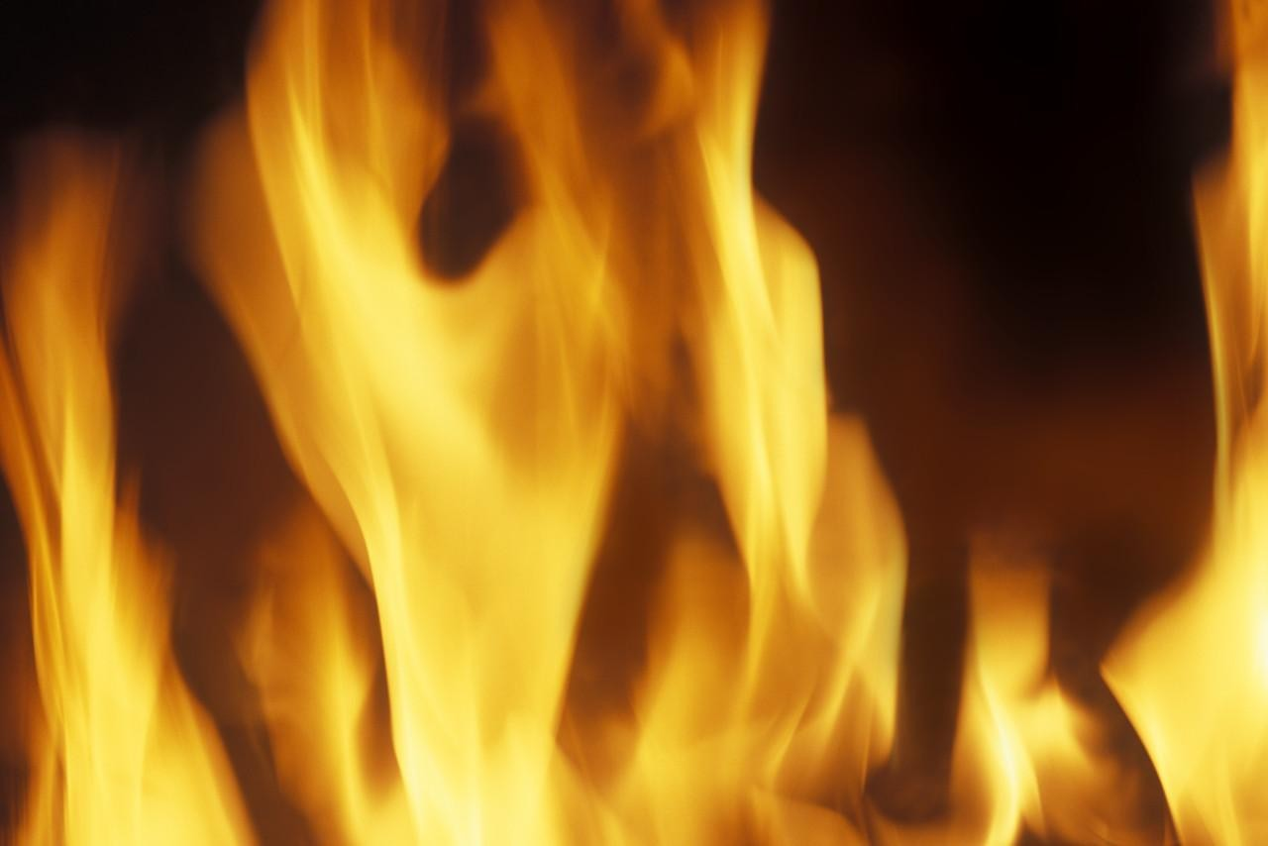

Hell, Gehenna, Hades, Grave, Tartarus, Abraham’s Bosom, Lake Of Fire, Abyss, Bottomless Pit

Understanding The Terms, Times & Places Of Eternal Damnation

One must go to the OT Hebrew & NT Greek in each scripture to understand the terminology and to paint the right picture of eternal damnation.

- There are two different words in the NT, both which were erroneously translated as “hell”. One is the greek word “Hades,” the other is “Gehenna.” But when Jesus and the NT writers spoke using the different terms, they intended a distinction.

- Also the word “hades” in the NT and “sheol” in the OT is sometimes translated as “the grave” which is also misleading.

- Jesus’ story of the “Rich man & Lazarus” in
- Luke 16:19-31 begins to unravel the mystery for us.

Old Testament

“Third Heaven”
OT (The Throne of God – Heaven is a real place)
“Second Heaven”
(The Universe)
2 Corinthians 12:2

The Battleground

People

Old

Angels
“First Heaven” (Our Atmosphere)

“Earth”

satan demons

“Sheol”
(OT Hebrew)
=
“Hades”
(NT Greek)

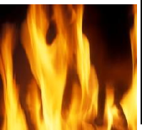Hell
“Gehenna” (NT Greek) “Lake Of Fire”
empty
Testament

Demons that sinned
Saints
Upper Region of Sheol is “Abraham’s Bosom” Place of Comfort For the Righteous (i.g. Lazarus)
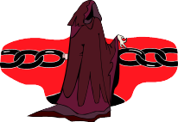by having sexual relations with women that produced giants

Tartarus

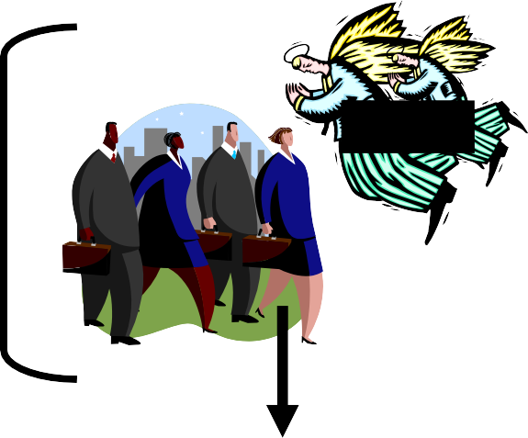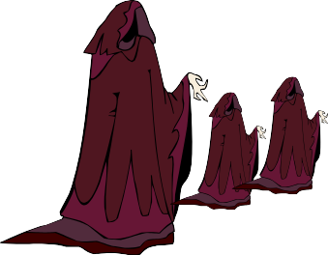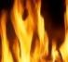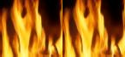
Old Testament Sinners
“Fixed Gulf”
Canyon
(no crossing between upper and lower compartments)
Luke 16:19-31
Lower Region of Sheol is a “Place Of Torment” (i.g. rich man)

Crucifixion & Resurrection Of Jesus

3
Days

“Third Heaven”
(The Right Hand of God’s Throne)
“Second Heaven” (The Universe)

The Battleground
“First Heaven” (Our Atmosphere)

“Today you
“Earth”

“Sheol”
(OT Hebrew)
=
“Hades”
(NT Greek)

Hell
“Gehenna” (NT Greek) “Lake Of Fire”
empty
Shall be with me In Paradise”
“Abraham’s Bosom Place of Comfort
(also called “Paradise”)
“Fixed Gulf”
Canyon
(no crossing between upper and lower compartments)

OT
Saints

Demons that sinned
by having sexual relations with women that produced giants

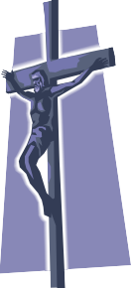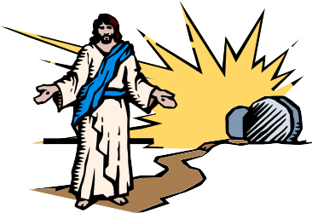
Old Testament Sinners

“Place Of Torment” (i.g. rich man)

Tartarus

New Testament

NT
New Testament
Saints
“Third Heaven” (Heaven is a real place)

“First Heaven”
“Second Heaven”
(The Universe)

The Battleground

People
Angels
(Our Atmosphere)

“Earth”

satan demons

“Sheol”
(OT Hebrew)
=
“Hades”
(NT Greek)

Hell
“Gehenna” (NT Greek) “Lake Of Fire”
empty
No longer an Abraham’s Bosom or Paradise

Demons that sinned
Gulf or Canyon
possibly now the “Bottomless Bit”
by having sexual relations with women that produced giants

Tartarus

New

Testament Sinners

“Place Of Torment”
Old Testament Sinners

End Times

End

0
The

Tribulation
Saints

1 2 3
Jesus
The Immortal Saints
& Angels

Satan Cast into Hell For All

7
All Sinners (OT, NT,
Tribulation) are sentenced
to Hell with their bodies intact
for all Eternity

Battleground

People

Beast & False Prophet
1000 Yr
Reign Of Christ

Rev 20:1-5
Eternity

5

“Sheol”
(OT Hebrew)
=
“Hades”
(NT Greek)

satan

End Of
1000 Yr
Reign Satan Loosed
4
For A Season
All Sinners (OT, NT,
Tribulation)
Ascend to
The Great White Throne Judgment

Hell
“Gehenna”
Gulf possibly now the “Bottomless Bit”

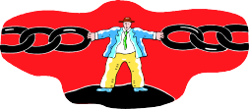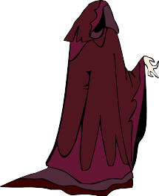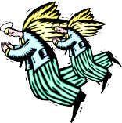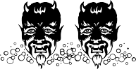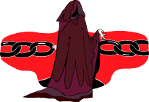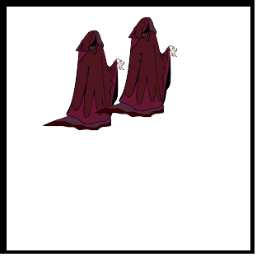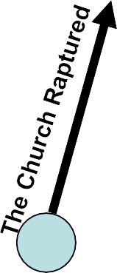(NT Greek)
“Lake Of Fire”
Tribulation Sinners

“Place Of Torment”
OT & NT
Sinners
6

New Heaven & Earth

New Heaven & Earth Now
A Single Place

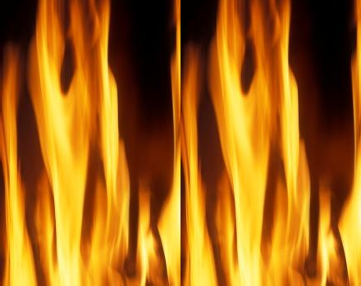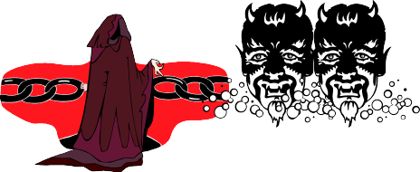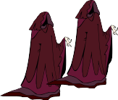Hell “Gehenna” (NT Greek) “Lake
OT, NT
& Tribulation Sinners
satan
demons
demons Beast &
who sinned False prophet with women
Of Fire”

All Saints from
OT, NT & Tribulation

New Jerusalem

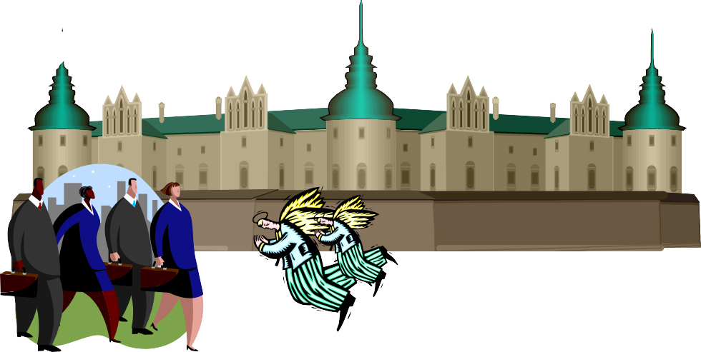ANGELS Jesus & The Father

All Eternity

All Eternity

