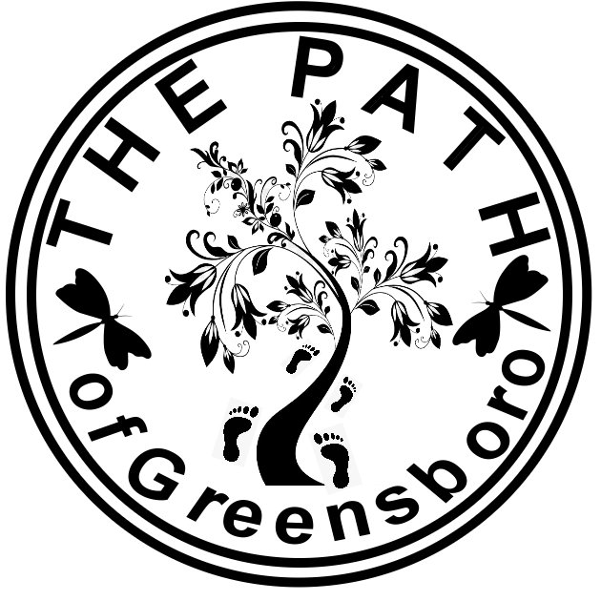
The Path – A Spiritual Gathering of Metaphysical Minds

The Path supports the following principles:
- We believe in one Source and respect however you choose to recognize that Source. IE. God, Goddess, Creator, Higher Power, Infinite Intelligence, etc.
- We affirm the divine right of individuals to seek the truth within their own hearts.
- Life is eternal.
- Spiritual progression is eternal and infinite.
- We believe that communication between all planes of existence is a reality.
- The ultimate expression of a loving God is to “Love Thy Neighbor as Thyself”.
- We believe in personal responsibility and that individuals create their own reality according to natural law.
- We affirm that the innate gifts of mediumship and healing are expressions of God's love.

Please read the above stated principles. Attest that you have done so and are 21 years of age or older, by printing out and completing the below form. Sign and submit with yearly dues payment of $10.00.

Membership Application

*I am 21 years of age or older
*I have read The Path's Principles (as shown above)
*I am submitting my dues of $10.00.

Name: ___________________________________________________

Email Address:_____________________________________________

__________________________________ ________________________
Signature Date

Mail this form with $10.00 (make checks or money orders payable to Donna Grady-Moore) to:

c/o The Path NC
913 Sedge Garden Road
Kernersville, NC
27284

