**13th Annual “Clean Sweep” Wallkill**

*“Come join us for a combined effort to clean up Wallkill’s river* ***and*** *roads.”*

**Volunteer Release and Acknowledgement of Risk**

**Name of Volunteer (please print):**

**Address: City: Zip Code:**

**Home Phone: Cell Phone: Email:**

**Date:**

**Date of Volunteer Activity:** April 15th, 2023 (rain date 4/16/23) **Location of Volunteer Activity:** Hamlet of Wallkill/Wallkill River

This document must be signed by all volunteers. If the volunteer is under the age of 18, this document must be signed by his or her legal guardian.

***Volunteer Activity:***I am donating my time and services without any compensation and shall at no time be considered an employee or independent contractor of the **“Clean Sweep” Wallkill (2023)** event or its organizers. I understand that no organization is providing insurance coverage for me.

***Release from Liability:*** In consideration for being allowed to participate in **“Clean Sweep” Wallkill (2023)** as a volunteer, I, binding my heirs, executors, administrators, and assigns, hereby fully and forever release, waive, discharge, acquit and exonerate the organizers and all sponsors of **“Clean Sweep” Wallkill (2023)** in which I am participating, from any and all claims, actions, causes of action, remedies and complaints of any kind, except for claims for gross negligence or willful misconduct, which I have or may have, whether known or unknown, arising out of or relating to **“Clean Sweep” Wallkill (2023)** or my volunteer work for this event, including specifically all claims for personal injury, paralysis, wrongful death, property damage and any other injury I may sustain.

***Assumption or risk:***  I assume all risks of participating in **“Clean Sweep” Wallkill (2023)** and full responsibility for my conduct and actions, including any injury to myself or others or damage to property that may result while volunteering. I understand the **“Clean Sweep” Wallkill (2023)** organizers and sponsors are not responsible for the conditions I create for myself or created by other volunteers or participants. I am aware that **“Clean Sweep” Wallkill (2023)** activities may be hazardous, involving risk of serious bodily injury, death or property damage. I am voluntarily participating in these activities with knowledge of the risks. These risks include, but are not limited to, slips, falls, and exposure to hazardous materials, objects or persons falling on persons, equipment failure, and injury from sharp equipment, improperly administered first aid, lightning strikes, hypothermia, and/or drowning.

I know of no reason, medical or otherwise, that would prevent me from performing the tasks required to participate in this volunteer activity. I will be personally responsible for my own safety during these activities and assume all risks and accept full and complete responsibility for any and all damages and personal injury of any kind, including death. I recognize **“Clean Sweep” Wallkill (2023)**, its organizers, sponsors and volunteers make no representations whatsoever as to whether the Wallkill River and the roadways of Wallkill are safe or as to whether the safety recommendations provided are comprehensive or adequate.

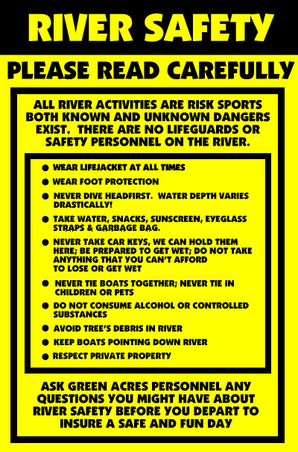**“Clean Sweep” Wallkill (2023)** is not responsible for loss or damage of any personal property. Canoeing, kayaking & boating in general, like all outdoor activities can be dangerous. By participating in **“Clean Sweep” Wallkill (2023)** you will be assuming those risks.

***C:\Users\Jeff\AppData\Local\Microsoft\Windows\Temporary Internet Files\Content.IE5\2U8ZOGY8\MC900014586[1].wmf***

***Please Have Fun, Be Safe and remember to***

***Wear Your Lifejacket At All Times.***

***Thank you for participating in***

***“Clean Sweep” Wallkill (2023)***

My signature below affirms that I have read and understood the above document and that I voluntarily, freely and without duress agree to its terms:

**Participant: __________________________________________________**

**Legal Parent / Guardian : ______________________________________**

**Sign: Sign:**

**Print: Print:**

**Date: Date:**

**Emergency Information:** In case of emergency, please call:

Name: _________________________________________ Phone:________________________________

Relationship:____________________________________ Allergies:______________________________

Current Medications or conditions: ___________________________________________________________