SENSITIZATION OF PFJ 2.0 REPORT
After the district level GhAAP training, the technical officers organized farmer’s fora at the various operational areas to sensitize farmers on PFJ 2.0.
The objective of PFJ 2.0 is to ensure food availability, Promote import substitution, Promote food export, Job creation, and ensure food security and resilience.
The key elements include: Input Credit System which involves Quality Fertilizer, Improved Seeds, Support Services and Secured Credit
The Priority Commodities of PFJ 2.0 Model includes Rice, Maize, Soyabean, Sorghum Tomato, Pepper, Onion, Cassava, Yam, and Plantain
The technical officers further explained how the model will work; they said Each Aggregator will be assigned to a zone. All farmers within the zone interested in joining the programme will be registered biometrically with unique IDs, and farms geo-referenced. Aggregator simultaneously enters into Input credit and service agreement with the farmers. (NB: Inputs would have been pre-selected by Farmers). Aggregator supplies input and services to farmers under a deferred payment term. Aggregator provides inputs and support services to farmers and monitors farmer’s operations until harvest time. At harvest time, Aggregator mobilizes resources to collect portion of harvested produce equivalent to the agreed cost of inputs. Price of produce will be determined at the beginning of the season. The collected produce (repayment produce) is transported by Aggregator to designated warehouses. Produce is sold to offtaker, who then makes payment to the Bank within 24 hours of delivery.

Questions asked by farmers were addressed by the officers’ in-charge. The sensitizations were well organized and a lot of farmers showed interest to partake in the PFJ2.0 program. In all a total of 722 farmers participated comprising 554 Males and 168 Females.
Sensitization of PFJ2.0 was also carried out at Susubiribi FM
Below are pictures during the sensitization radio program.
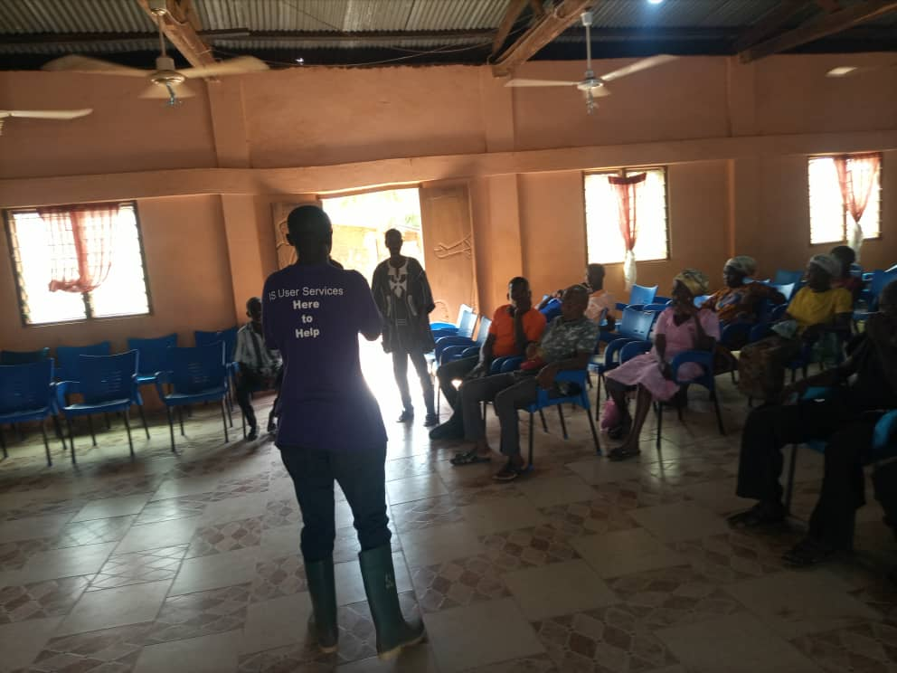
JAMES TOWN

ADJIKPO/MINTA/BOMI
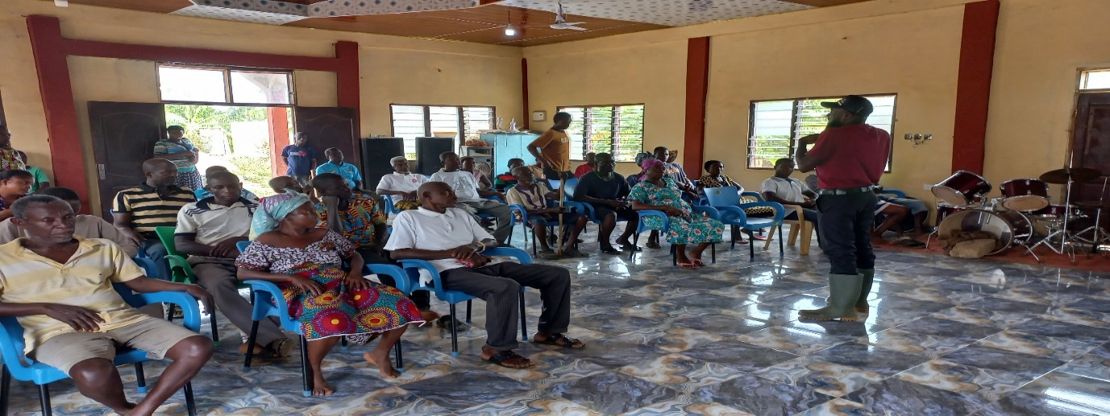
MPEASEM
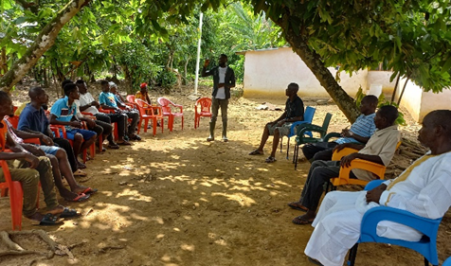
TETEKAASOM
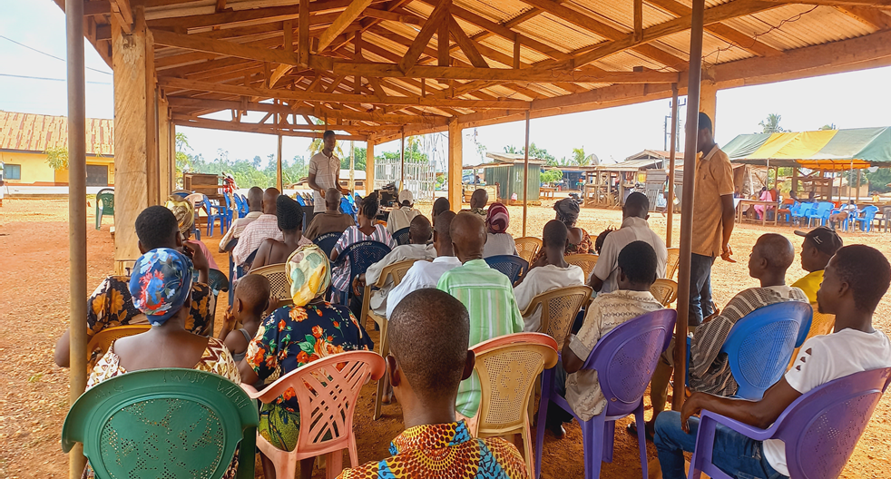
TWUMWUSU
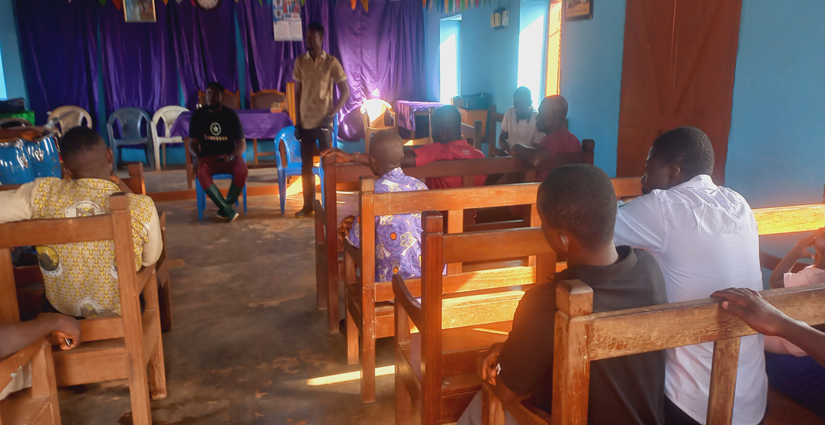
PRAMKESE

NKWANTANANG

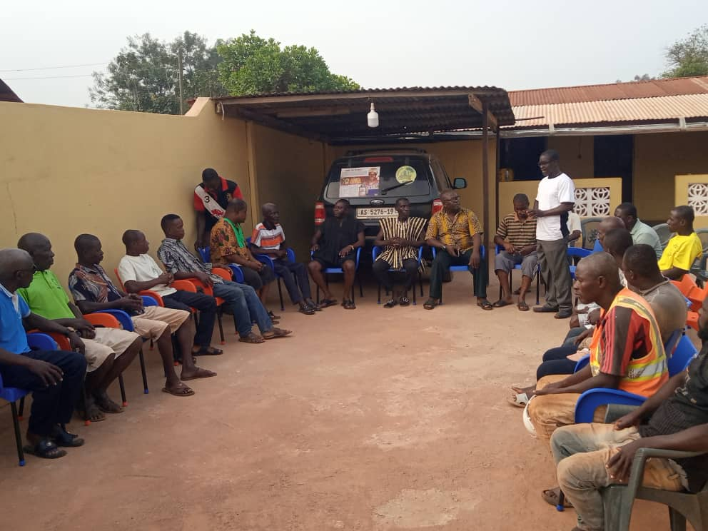
ANWEAM
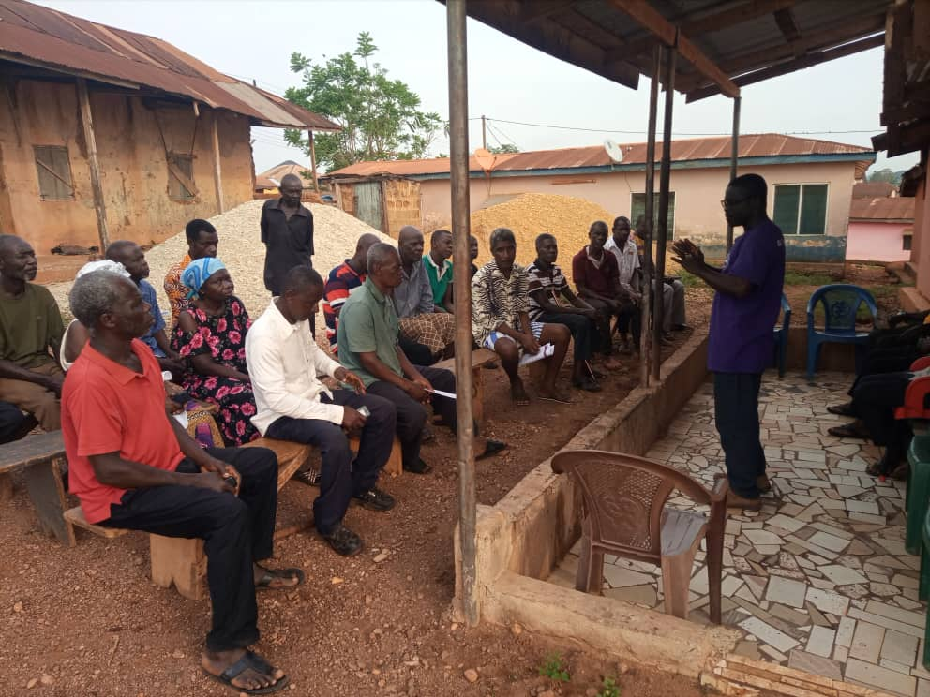
OTUMI


ABODOM
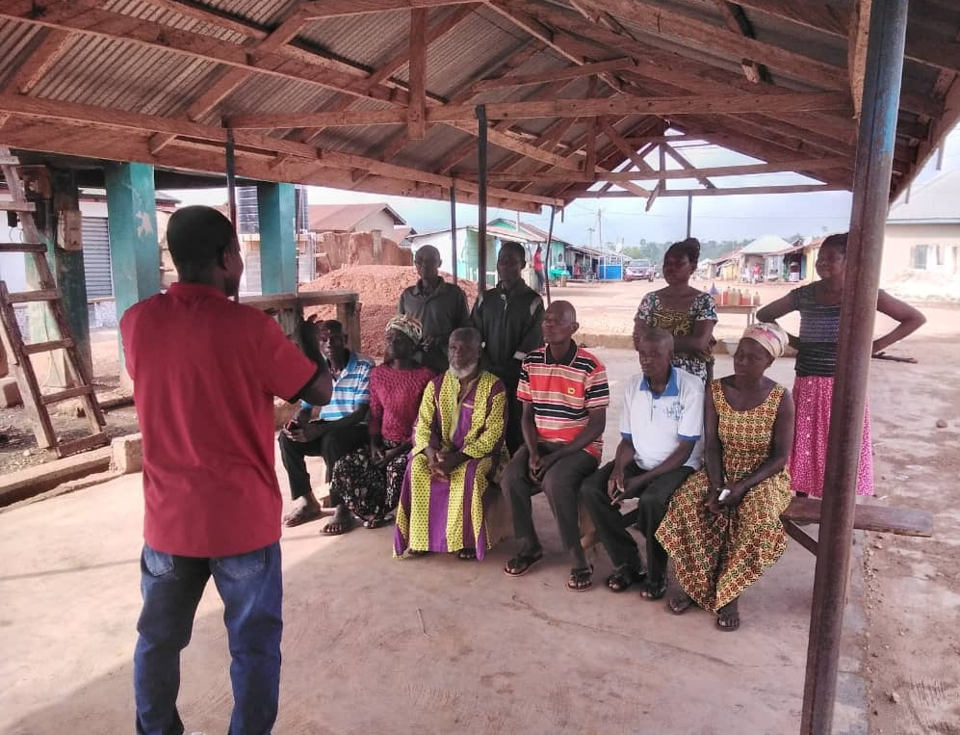
BOMSO
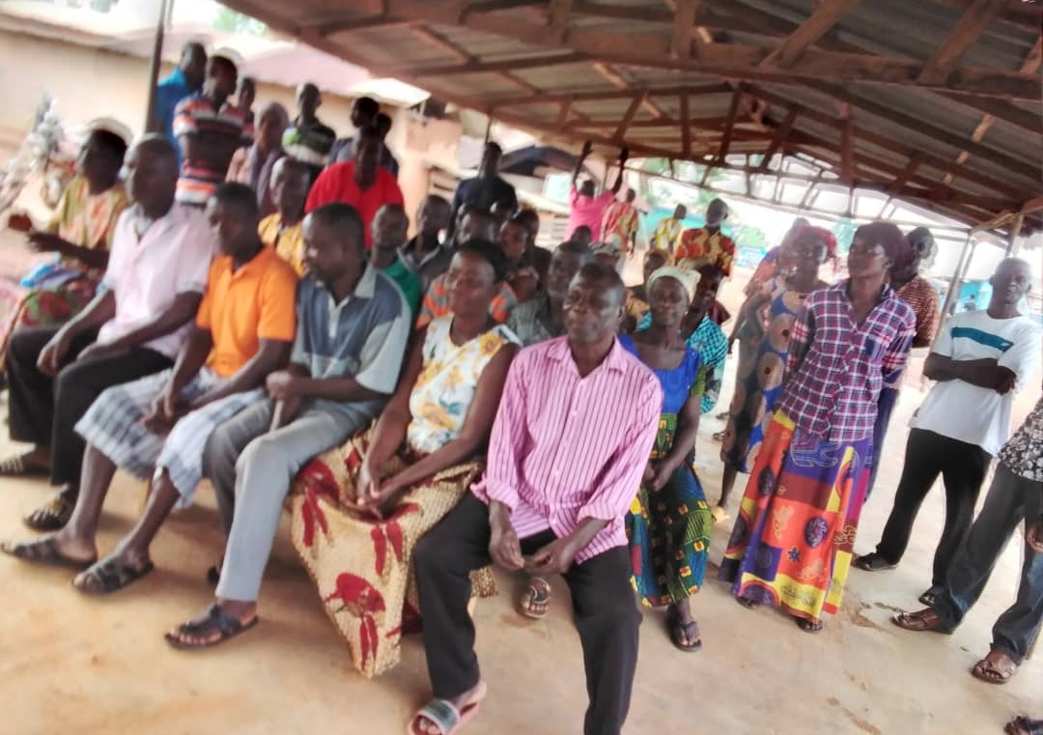
TWEAPEASE
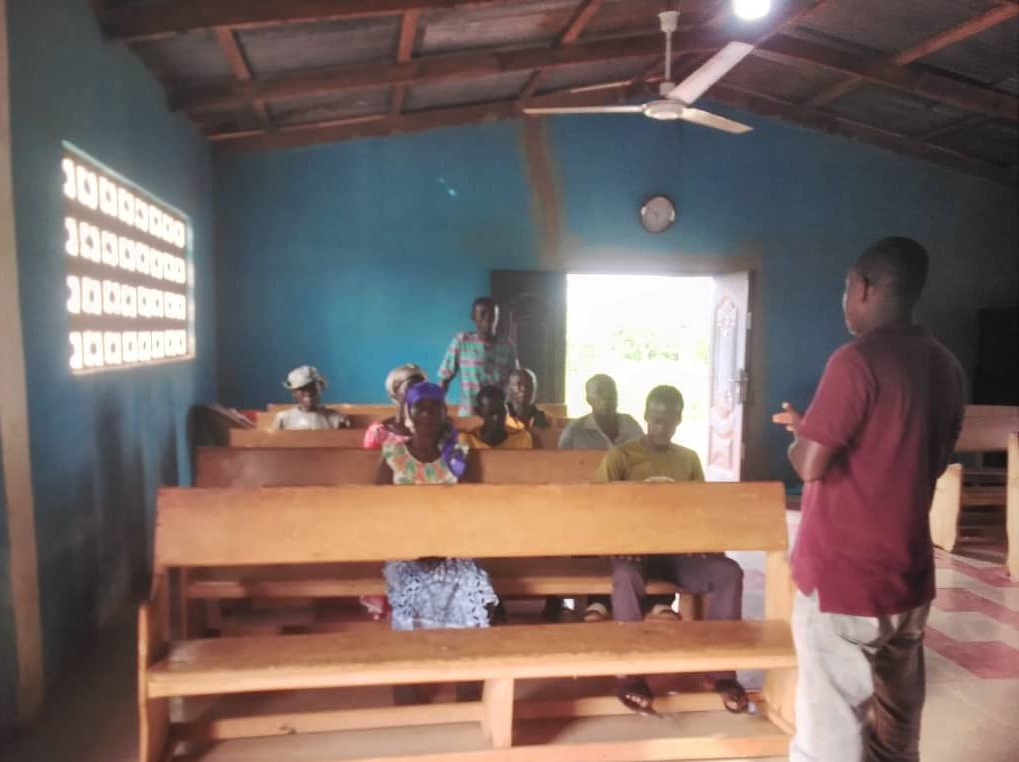
KUKUBI
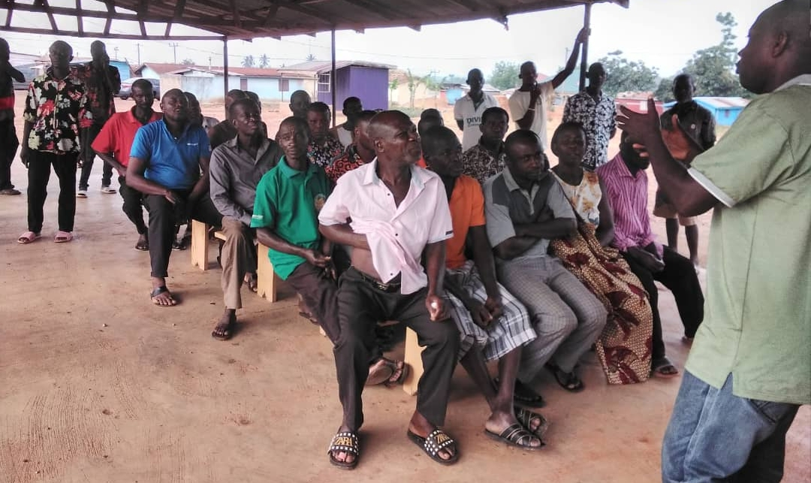
AUOM



SENSITIZATION OF PFJ2.0 AT SUSUBIRIBI FM

