REPORT ON FARMER FIELD ORGANIC DEMONSTRATION
The department in collaboration with CARE-R4D is embarking on organic demonstration in the Municipality. The demonstration plots are established in four communities namely Abodom, Amoako, Twumwusu and Pramkese with eleven treatment plots. The eleven treatments includes basal application of empty fruit bunches, empty fruit bunches with poultry manure, cocoa pod husk, cocoa pod husk with poultry manure, rice husk biochar with poultry manure, broadcasting application of empty fruit bunches, empty fruit bunches with poultry manure, cocoa pod husk, cocoa pod husk with poultry manure, vegetable control and maize control. Plot layout was carried out on the 15th of April, 2024 at the various communities.
We started by using rice husk to prepare biochar as one of the organic fertilizer that will applied to pepper and garden eggs.
The lead farmers in the various communities planted their seed maize on the 19th – 20th April, 2024 with a planting distance of 75cm×25cm one seed per hole. After two weeks the lead farmers applied neemazeal an organic insecticide to control fall armyworm infestation.
On the 13th May, 2024, a field day was organized to apply the various organic fertilizers to the planted maize at Amoaku and Abodom with a total number of 54 farmers comprising 30Males and 24Females with a representation of chief farmers, chief and elders, assembly members etc. The department also carried out monitoring visits and work is in progress.
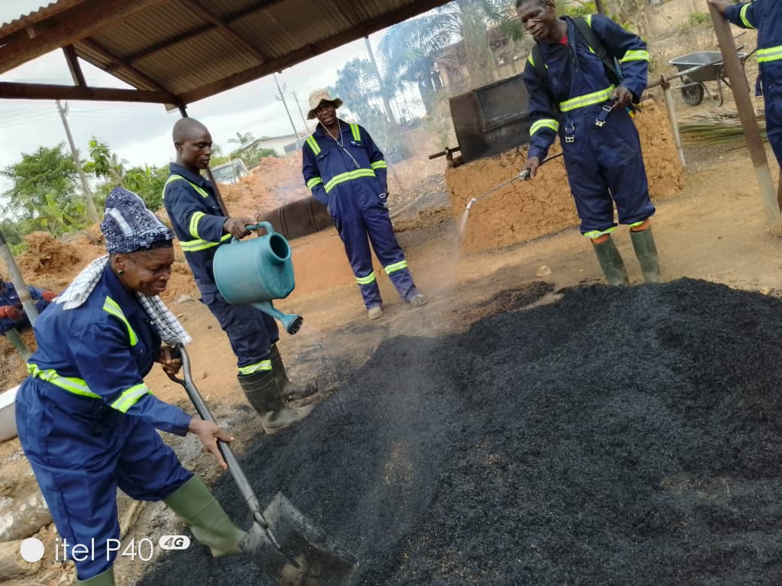
Preparation of rice husk biochar
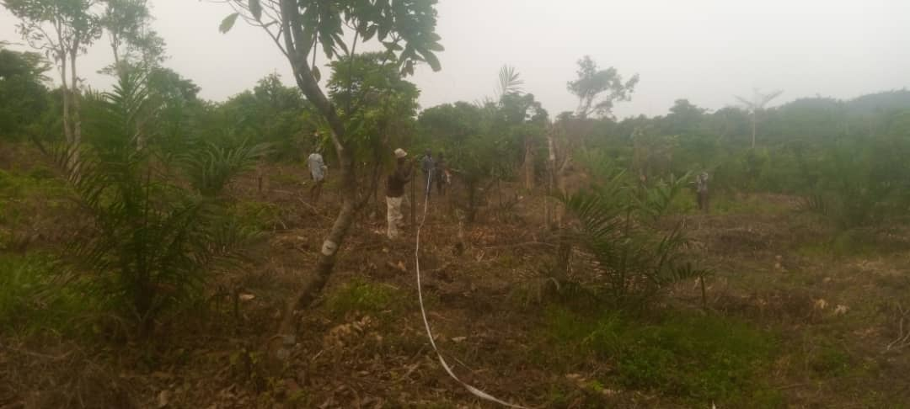
Plot layout
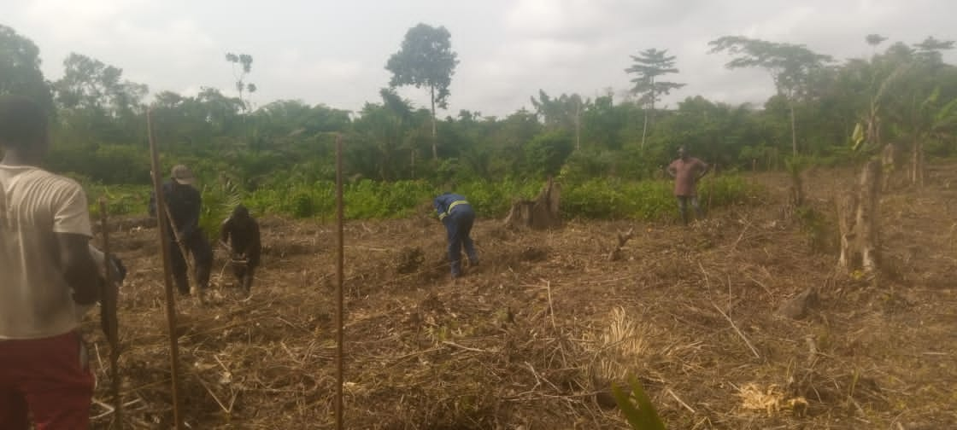
Planting of seed maize
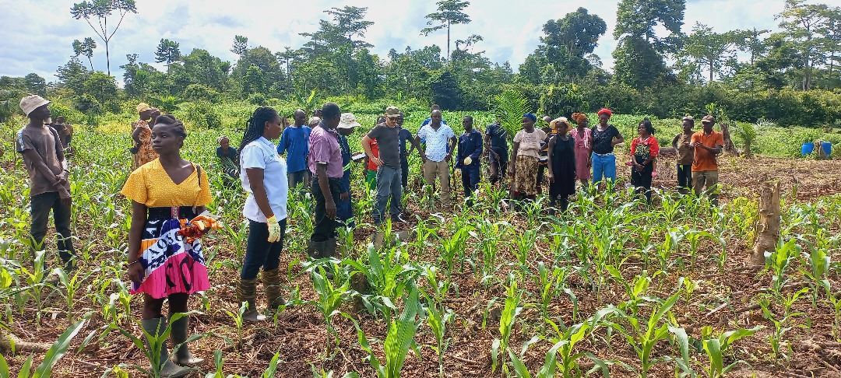
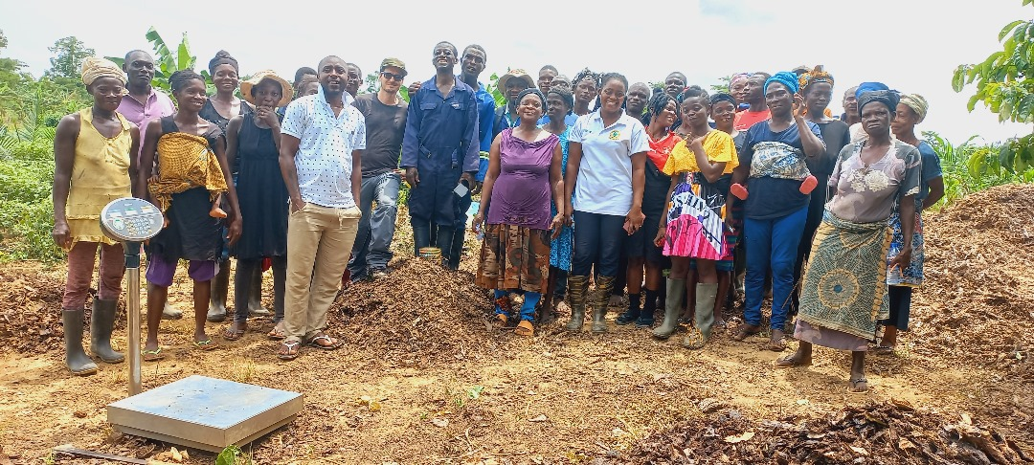
Field day at Amoaku

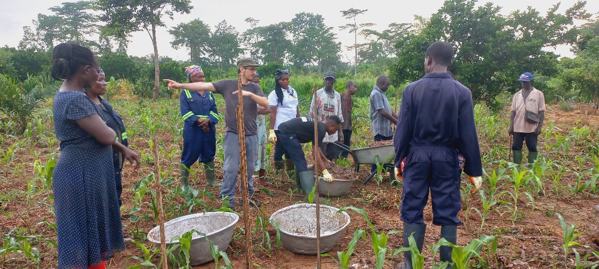
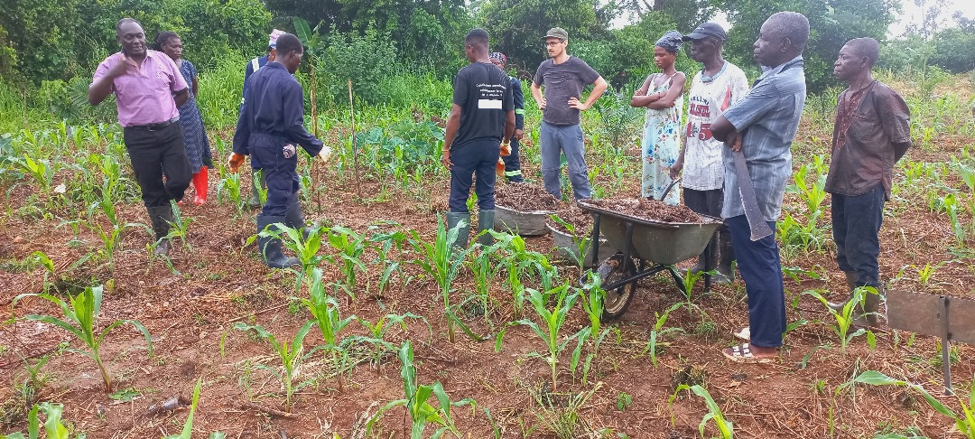
Field day at Abodom
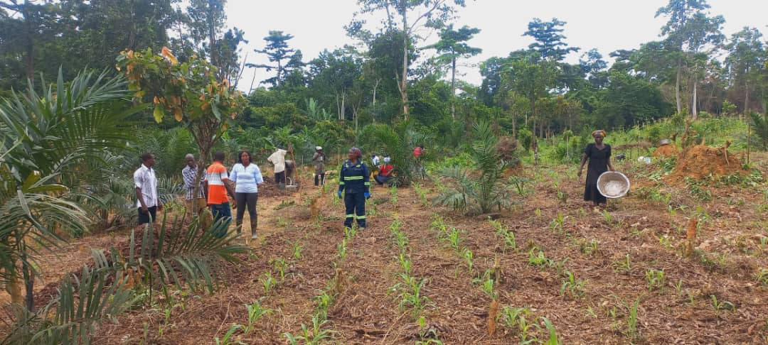
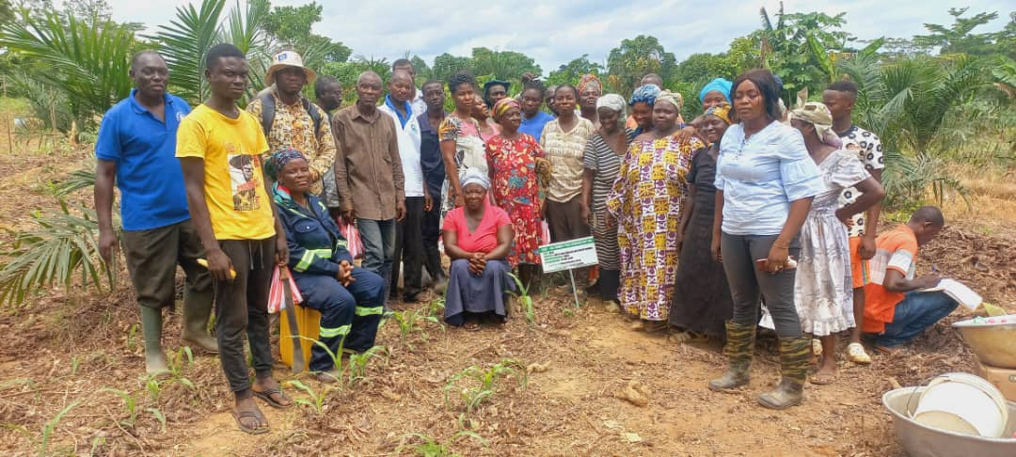
Field day at Twumwusu
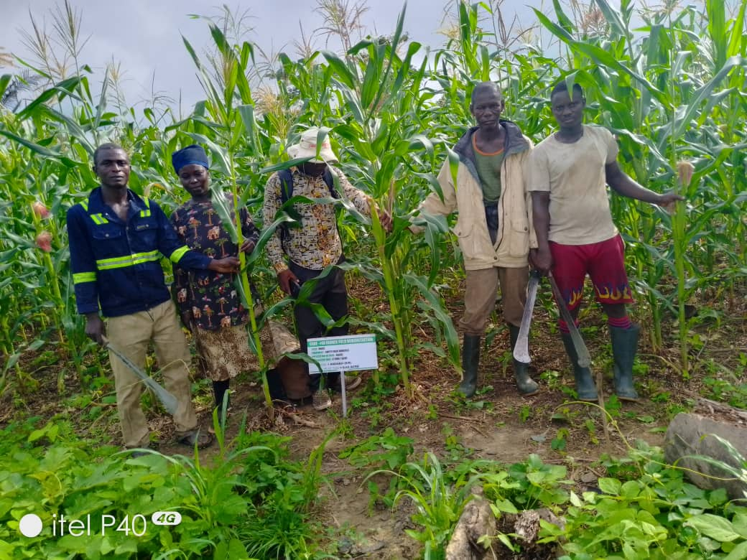
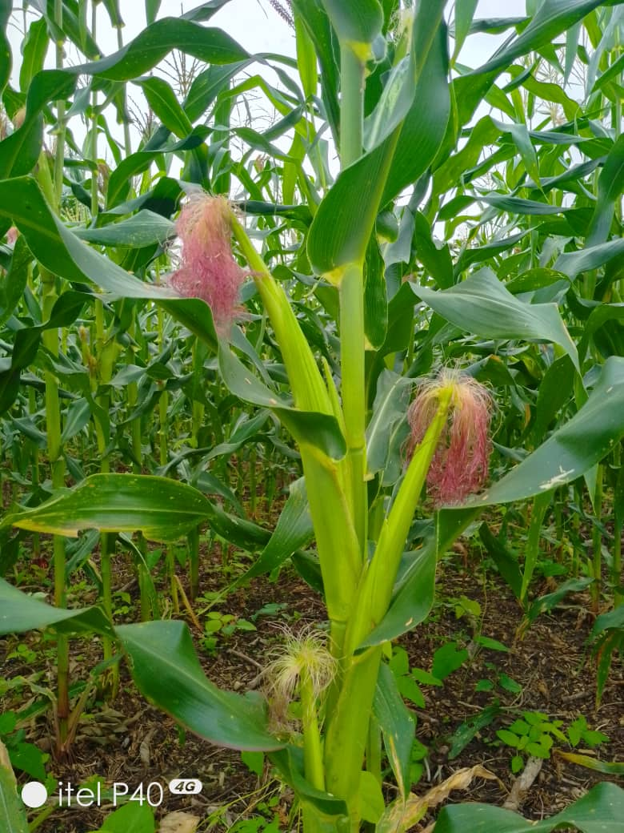
Monitoring visit to demonstration site.

