Chewie’s Pawsibilities
SENIOR PET GROOMING RELEASE FORM

PET’S NAME_________________________________________________ DATE____________________
Your pet is very important to us. Because we care about your pet’s safety and well-being, we want to assure you that every effort will be made to make your pet’s grooming visit as pleasant as possible. Occasionally, grooming can expose a hidden medical problem or aggravate a current one. This can occur during or after grooming. Please be advised about the following risks for your pet’s grooming experience.
SENIOR PET
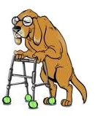  _________  Initials | Some senior pets can be uneasy or apprehensive during their grooming visits. As your pet gets older, they may not tolerate a grooming session like they used to. Senior pets have a greater chance of injury, especially those with pre-existing health problems. Therefore, your senior pet will be groomed in a style that will not add to their excitement, but with cleanliness and comfort kept in mind. Sometimes pre-existing conditions arise unexpectedly, such as skin allergies, moles, warts, bone, and joint sensitivities, mental and behavioral changes and more. For example: Arthritis can be painful and could be aggravated during grooming. Grooming may cause your pet to be a bit sore or uncomfortable after the grooming. We recommend speaking with your vet about pain medications or sedatives that may help keep your senior pet comfortable during or after grooming.
FUZZY PET
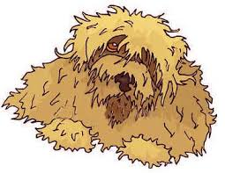  _________  Initials | Because your pet is severely tangled and matted, it is at greater risk of injury, stress, and trauma. All precautions will be taken to provide a safe and comfortable grooming experience. Complications can occasionally arise during or after grooming. Mats left in a pet’s coat only grow tighter, and can prevent air from reaching your pet’s skin, or eventually cause it to tear it open. Heavy matting can also trap moisture and urine near the pet’s skin, allowing mold, fungus, or bacteria to grow, causing skin irritations that existed prior to the grooming process. Matted pets have a greater chance of injury during grooming and need extra attention during their grooming session. Removing a heavily matted coat includes risks of razor burn, nicks, cuts, or abrasions due to warts, moles, or skin folds trapped in the mats that are not easily seen or avoidable. After grooming, your pet’s skin may be itchy, red, and or irritated, and may need to be evaluated and treated by a veterinarian.

I understand the risks and realize that my pet has a greater chance of injury during grooming. I grant permission to obtain emergency veterinary treatment for my pet at my own expense. I will not hold Chewie’s Pawsibilities, their affiliates, groomers, or staff responsible for accident or injury to my pet related to the risks listed above.
Owner Signature_____________________________________ Phone Number__________________
Owner Name (Please Print) ___________________________________________________________

