York/Adams Chapter of PIAA-
Registered Track & Field Officials

Meeting #5 Agenda– April 22, 2024 (7:00 PM)

I. Call to Order

II. Announcements

A. Happy Earth Day and Vote Tomorrow

B. Comments on York High Jr High Meet. Additional comments on Arctic Blast, Pan-Ram, Shippensburg.

C. Golf at South Hills on Wednesday, May 15 before the picnic at Sterners. 12:30 ish. Let Lynn VH know if you want to play. All officials and families are welcome to the Picnic @ Sterner’s Picnic Grove. Social hour @ 5:00. Covered Dish dinner @ 6:00. Wednesday, May 15. Meeting #7 at 7:00. Sign-up sheet for picnic.

D. Please wait until Jon S. portion of the agenda to discuss unusual circumstances/occurrences/questions through first weeks of scrimmages/competition.

E. Email from Bill McHale, PIAA District 3 Male Officials Representative and Cathy Wreski, PIAA District 3 Female Officials Representative regarding Official’s Symposium – June 22, 2024 at CD.

III. Motion to forego reading of April 8, 2024, minutes. Question- any additions/corrections. Motion to accept April 8, 2024, minutes.

IV. Treasurer’s Report

V. Nominations for officers and executive committee members for the 2025 YAIAA Track and Field Officials Chapter. This was forwarded to members with the Agenda.

Chapter By-Laws Addendum 2 - Officers and Duties: Chapter Officers may be elected to serve a second, consecutive one-year term provided the current officer is nominated to serve a second term, the current officer accepts the nomination, and this nomination is approved by the vote of the majority of the chapter membership at the annual Nominations Meeting. If an officer is not elected to a second term by this process, nominations and voting will be conducted as described in Article VII - Chapter By-Laws Addendum 1.

A. Nominations for Rules Interpreter- Jon Seitz,
B. Nominations for Treasurer- Dave Rizzuto,
C. Nominations for Secretary- Lynne VanHouwe,
D. Nominations for Vice-President- Dave Wickenheiser,
E. Nominations for President- Steven Stough,

Chapter By-Laws Addendum 3 - The Executive Committee shall consist of the immediate past-president and two at-large members who shall be elected at the annual voting meeting of the chapter.

A. Nominations for Executive Committee At-Large Member #1- Bill Blank,
B. Nominations for Executive Committee At-Large Member #2- Mike Eisenhart,

V. Old Business

A. Ray Geesey Officials assigned:

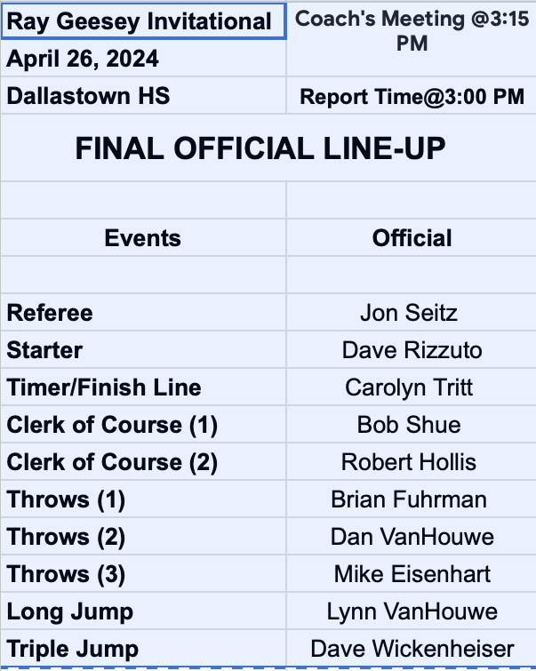
B. Any reports back regarding equipment to purchase- high jump measuring device, headset radio/intercom

VI. New Business

A. Please be sure that you are being properly paid for double duals. Please notify Steve Stough if that does not happen. Steve Stough is trying to straighten things out with Chuck Abbott. Issue with amount of pay if an official works a meet that is really three or more dual meets. How should this be approached? I am not sure we can get this completely solved this year.

B. Thoughts on equipment inventory

VII. Rules Interpretation Portion- Jon Seitz

VIII. Adjournment (motion, second, vote)

Next Meeting- April 22, 2024, 7-8 PM, Room 1011, YCST

