Paint & Sip Workshop
Learn how to paint with Alene Kieser. No experience necessary. A fun session. Participants will receive personalised guidance as the group is limited. All materials supplied.

Cost: $75 per person,  Maximum group size - 10 people  Duration: 4 hour class  Venue: Art as Mania  20 – 22 Emu Bay Road, Deloraine  Dates: Saturday, April 27th  Time: 10 am – 2 pm | 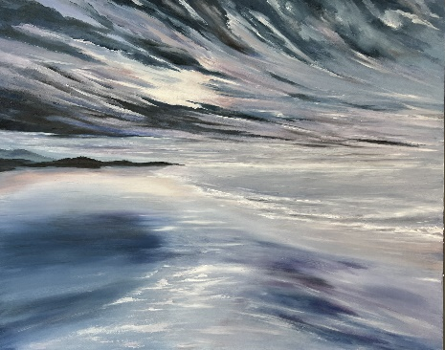
To enrol or for more information contact Art as Mania contact@artasmania.com.au or phone 0488 137 315

Bookings essential

