Inner Child Workshop
Play with colour drawing in a small group. Explore your inner child with Jo Wild. All materials provided. Please wear an apron or worn clothes. Tea and coffee provided.

Cost: $75 per person  Maximum group size - 6 people  Duration: 2 hour class  Venue: Art as Mania,  20 – 22 Emu Bay Road, Deloraine  Dates: Saturday, April 13th  Time: 10:00 - noon | 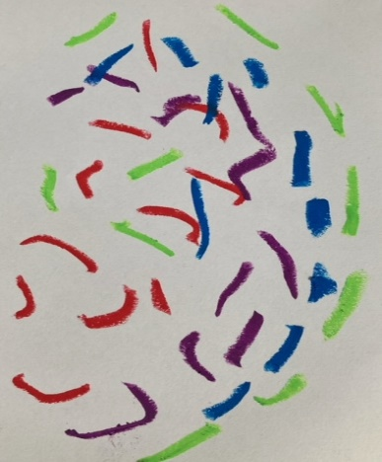
To enrol or for more information contact Art as Mania contact@artasmania.com.au or phone 0488 137 315

Bookings Essential

