Sewing Workshop
This guided workshop teaches you basic sewing techniques. All materials supplied. Bring your own sewing machine if you have one. Class held by Maryhelen Bakes

Cost: $15 per person,  Maximum group size - 6 people  Duration: 2 hour class  Venue: Art as Mania  20 – 22 Emu Bay Road, Deloraine  Dates: Saturday, September 9th  Time: 10 am – 12 pm | 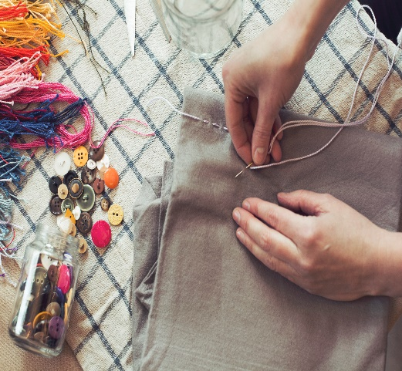
To enrol or for more information contact Art as Mania contact@artasmania.com.au or phone 0488 137 315
Bookings essential
Workshop Fun in Deloraine

