Pottery Workshop – Leaf Bowls
This fun, guided workshop teaches you basic Hand Building techniques and is suitable for beginners. All materials supplied. Class held by Trish Richers. Allow 2 to 3 weeks to pick up fired works.

Cost: $55 per person,  Maximum group size: 6 people  Duration: 2 hour class  Venue: Art as Mania  20 – 22 Emu Bay Rd, Deloraine  Dates: Wednesday, April 12th  Time: 6 pm – 8 pm | 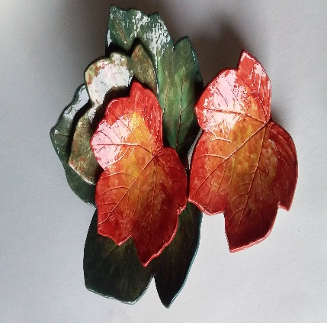
To enrol or for more information contact Art as Mania contact@artasmania.com.au or phone 0488 137 315
Workshop Fun in Deloraine
@ArtistinResidenceTrailTasmania

