Dreamscaping Workshop
This fun, guided workshop shows you techniques using no brushes and only 3 alcohol inks to create abstract landscapes . Different methods shown to create skies, water effects etc. All materials supplied. Class held by Sue Love.

Cost: $55 per person,  Maximum group size - 9 people  Duration: 2 hour class  Venue: Art as Mania  20 – 22 Emu Bay Road, Deloraine  Dates: Saturday, Nov. 26th  Time: 10:30 am – 12:30 pm | 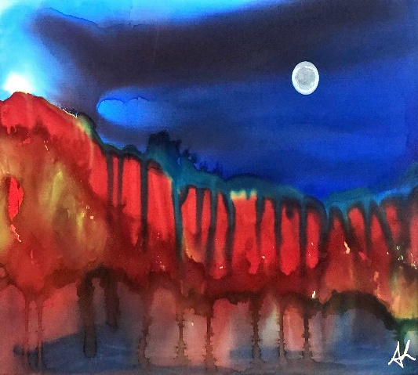
To enrol or for more information contact Art as Mania contact@artasmania.com.au or phone 0488 137 315
Workshop Fun in Deloraine
@ArtistinResidenceTrailTasmania

