Knitted Wire Bracelet Workshop
Learn how to knit jewellery with wire and make a bracelet with beads or buttons. All materials supplied.
Class held by Noelene Hammond

Cost: $55 per person,  Maximum group size - 8 people  Duration: 4 hour class  Venue: Art as Mania  20 – 22 Emu Bay Road, Deloraine  Dates: Thursday, October 13th  Time: 10 am – 2 pm | 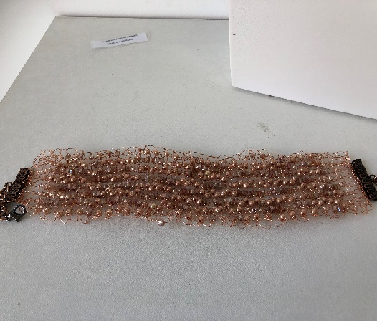
To enrol or for more information contact Art as Mania contact@artasmania.com.au or phone 0488 137 315
Workshop Fun in Deloraine
@ArtistinResidenceTrailTasmania

