NORTH SALEM OLD FASHION DAYS
SUNDAY, SEPTEMBER 3, 2023
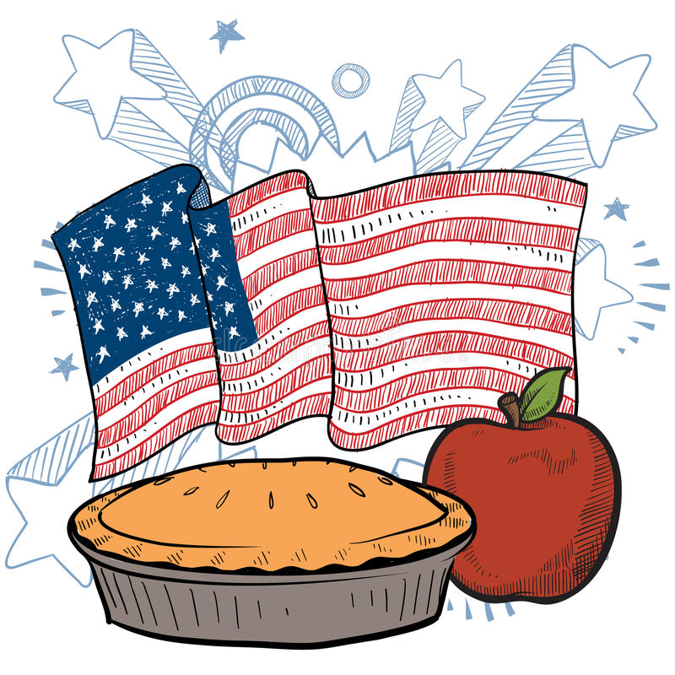
***PIE CONTEST ENTRY FORM***
Only fruit or nut pies are eligible. NO CREAM PIES. Filling and crust must homemade
be the exhibitor and pies must be in an 8” or 9” disposable pie pan.

Registration will be from 11:00am to 11:30am on Sunday, September 3, 2023 at the
Bandstand on North Broadway
You do not need to be a resident of North Salem or Hendricks County to enter the contest.

Judging will begin promptly at 11:30am. Prizes are as follows:

1st place $50
2nd place $30
3rd place $20

All pies will be auctioned off to the public following the presentation of the pies.

Name__________________________________________________________________

Address________________________________________________________________

City:___________________________ State___________________ Zip Code________

Phone #______________________________

**Type of Pie___________________________________________________**

Please contact Rebecca Compton with any questions. Phone #765-676-5297

