Anyone else find it interesting that an outgoing Obama administration undertook this action only days before Trump was sworn into office?
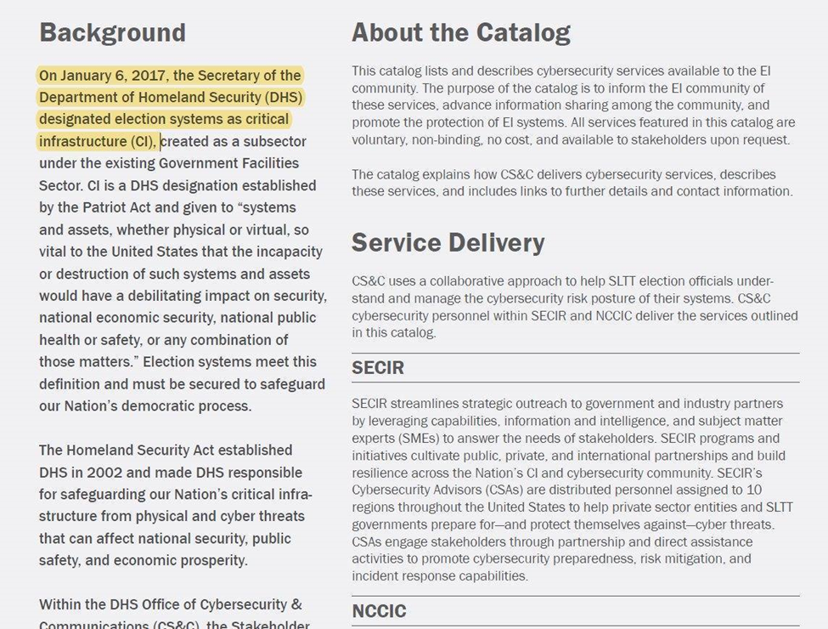
https://www.eac.gov/sites/default/files/eac_assets/1/6/DHS_Cybersecurity_Services_Catalog_for_Election_Infrastructure.pdf

This is the only reply I have ever gotten from Secretary of State Evnen, despite numerous emails to him, received June 18, 2021. He even put it in bold print that our machines do not connect to the internet.
--------------------------------------------

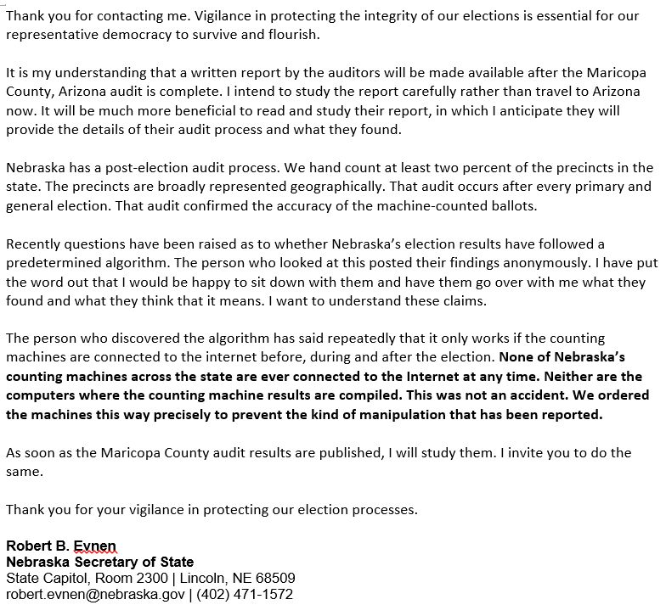

For reference, this is the letter to which Evnen responded. I have sent other letters also and never received any reply.

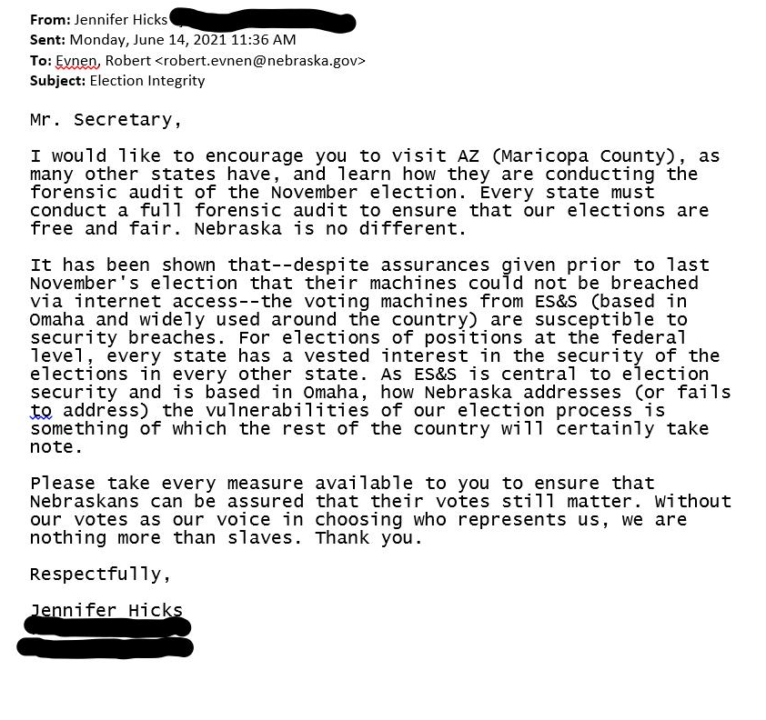

Secretary of State Evnen has been adamant that ES&S machines do not have the capability to connect to the internet. ES&S is headquartered in Omaha and is the nation's top provider of voting machines.

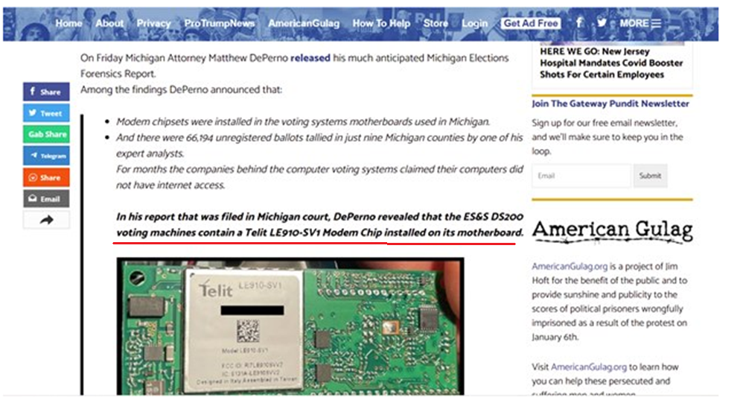
https://www.thegatewaypundit.com/2021/04/exclusive-attorney-matthew-deperno-sits-jim-hoft-patty-mcmurray-first-interview-court-hearing-antrim-county-case-video/

Contact Nebraska Attorney General Doug Peterson and ask him to join other AGs in bringing the case found at this link--https://fix2020first.com/--to the Supreme Court. As you can see, this law suit indicates that ES&S machines suffer “grave issues” and are vulnerable.

https://cdn.michaeljlindell.com/downloads/fix2020first/states-v-us-and-states-compl-2021-11-23.pdf
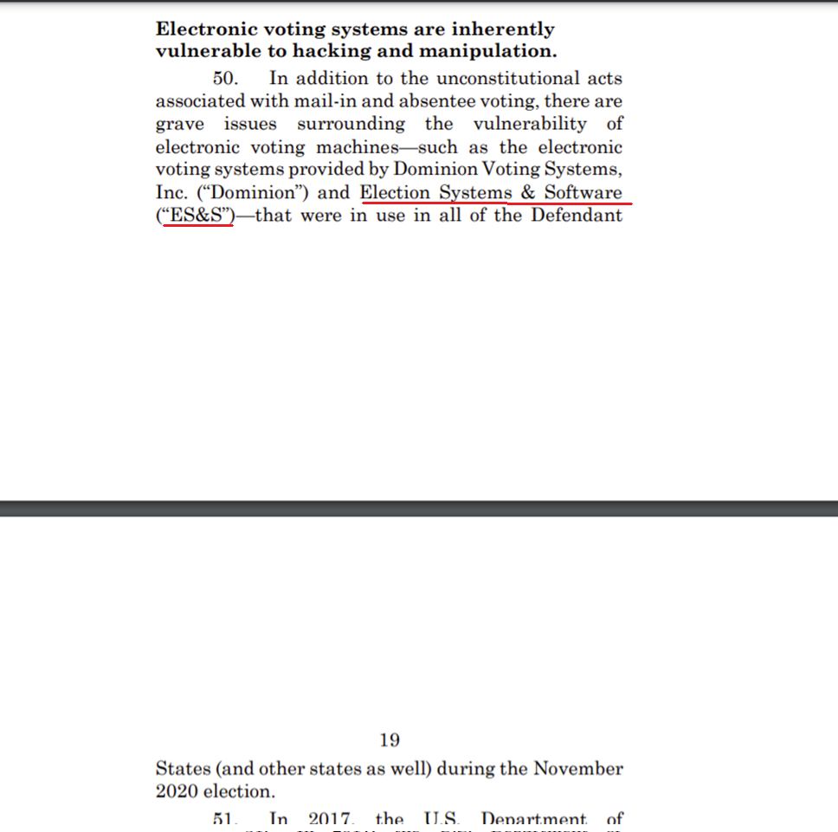

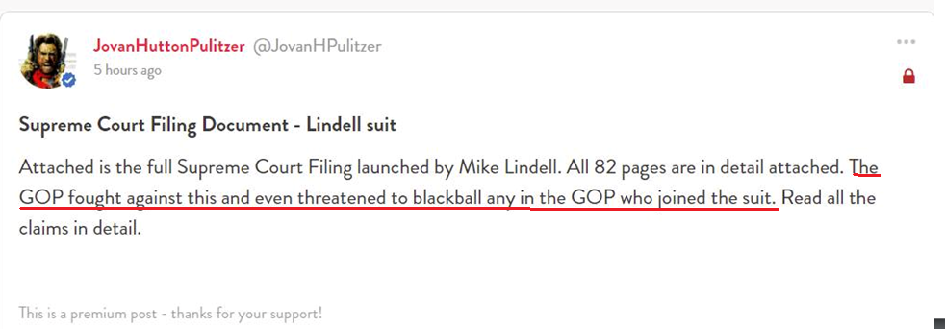
That statement above, from Jovan Hutton Pulitzer, is exactly why Senator Clements deserves our praise for having been the ONLY senator in the Unicameral to have had the courage to call for a full forensic audit in all fifty states. It is also exactly why every elected Republican who has remained silent and failed to speak out against the election fraud in our country SHOULD BE SENT PACKING.

And how is it not a conflict of interest that Crowdstrike software is being used to ensure that our elections are secure?
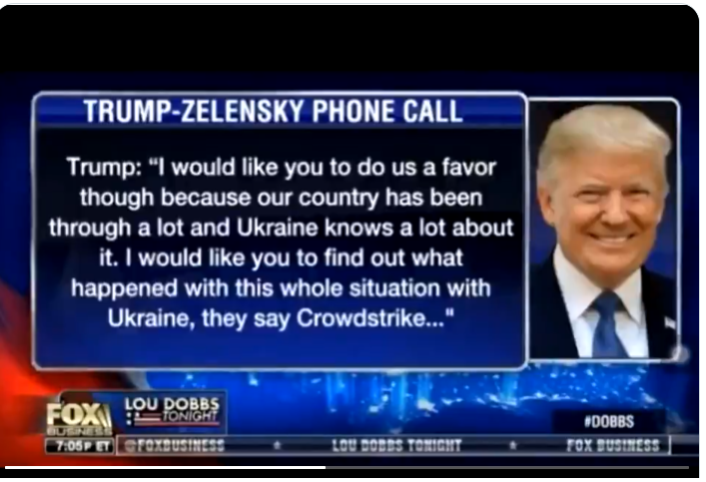

We know that Lancaster County had an agreement with the Center for Internet Security (CIS), and that Crowdstrike provided the software which was used for EDR Services. CIS has an agreement with the federal government to provide EDR Services to certain SLTT (state, local, territorial, tribal) entities. It would be good to know which things were taken into account in determining which SLTT entities the federal government made these agreements with, I think.

Also notable is that ES&S is a member of CIS. Weren't new ES&S voting machines put in place in Nebraska just before last November's election? Secretary of State Evnen seems convinced that our elections were proven to be secure. Was Crowdstrike software used to provide him those assurances? And if our machines in Nebraska are never connected to the internet, as Evnen claims, then why are ES&S (as well as practically every county in Nebraska) members of the CIS Elections Infrastructure Information Sharing and Analysis Center™ (EI-ISAC®)?

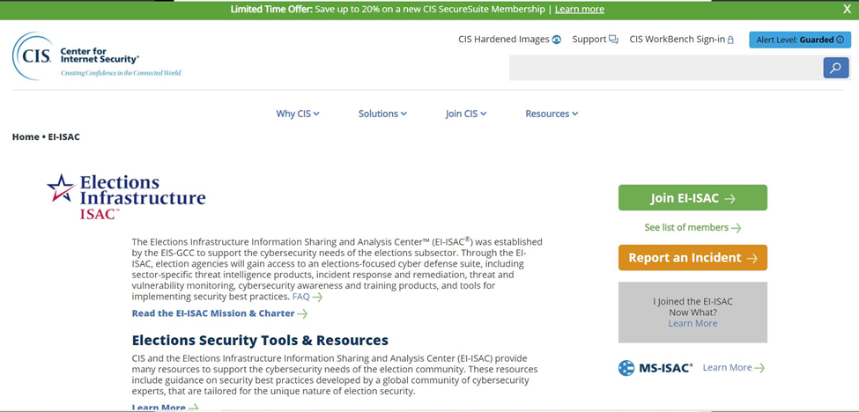
https://www.cisecurity.org/ei-isac/
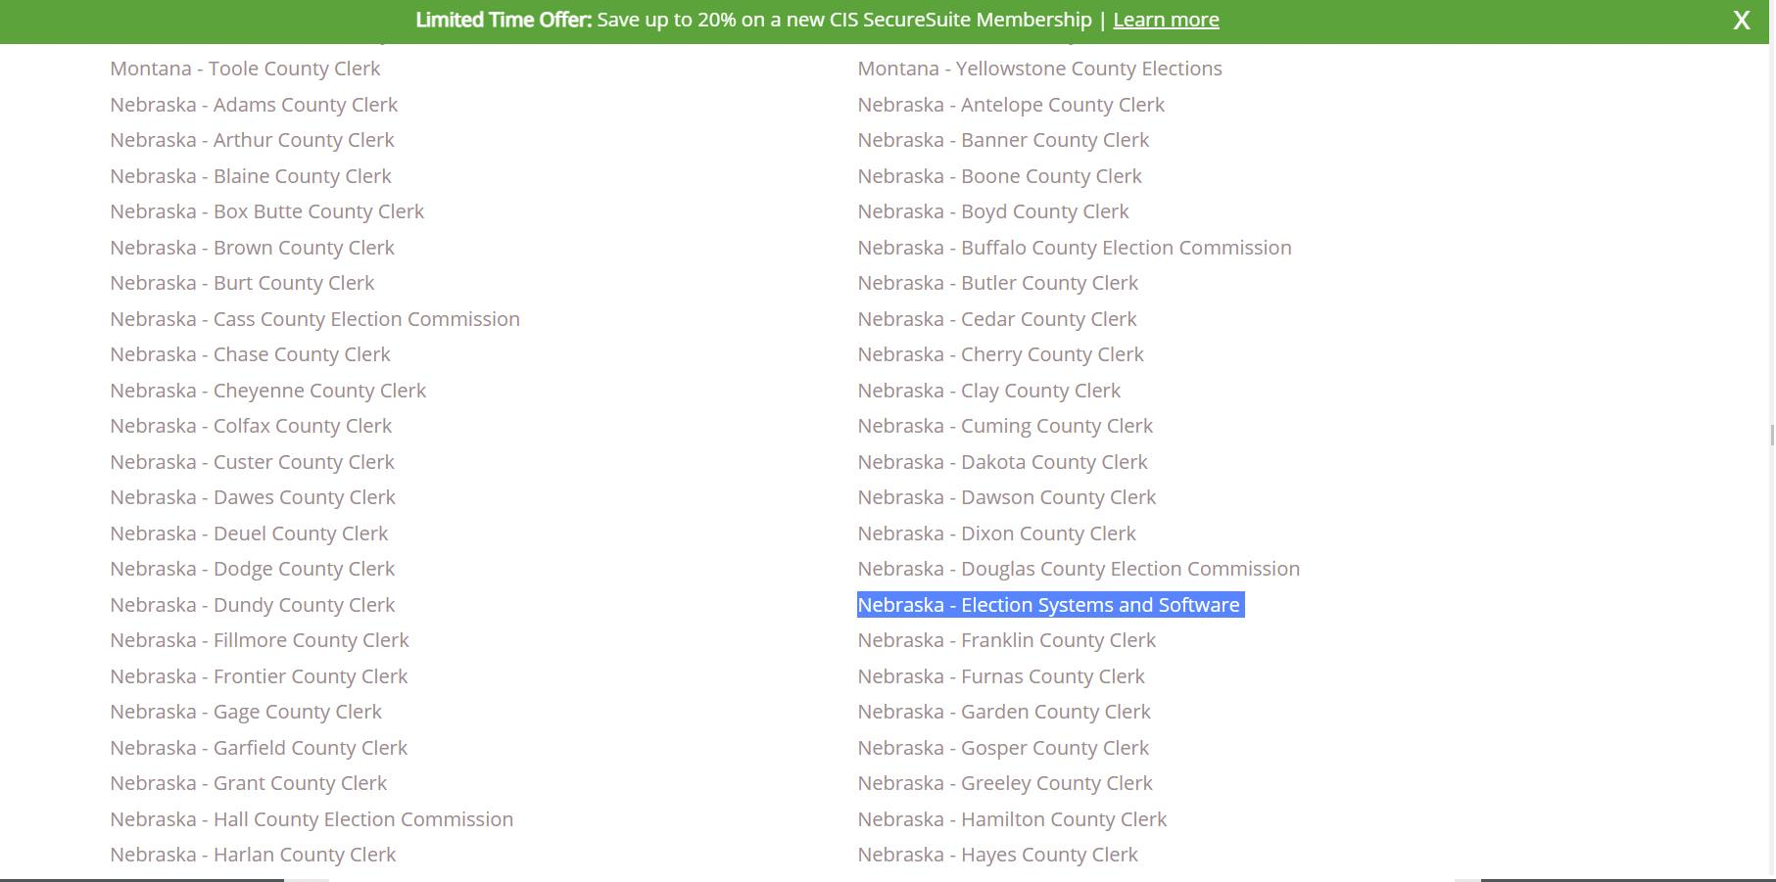
https://www.cisecurity.org/ei-isac/partners-ei-isac/
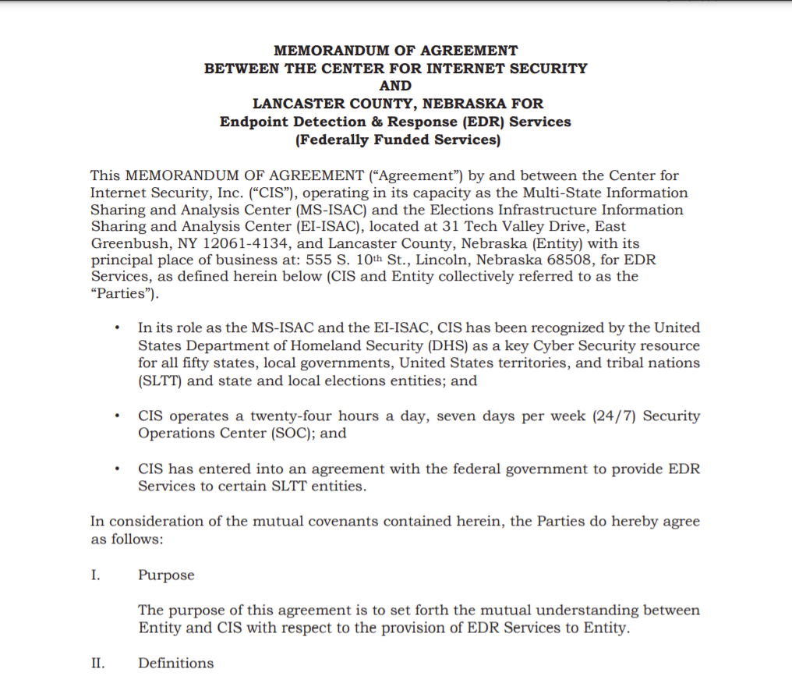

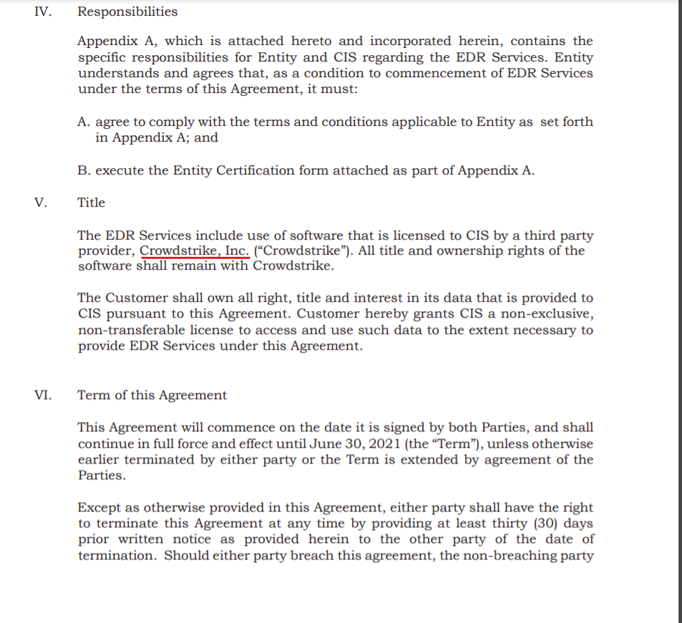https://www.lancaster.ne.gov/DocumentCenter/View/6207/C-20-0552

Should a cybersecurity company with a document outlining their plans for "Reinventing Government" be used to provide the security for our elections? How is this not a conflict of interest? Clearly, Crowdstrike is not approaching our elections from a neutral position. Whether nefarious or not, Crowdstrike is without a doubt seeking to use their role in cybersecurity to manipulate our government. Their involvement in providing election security software used in our state is something that our Secretary of State Evnen should be investigating. We need a full forensic audit. And we need it done before our next primary election so that the people can be assured that our elections are secure from the influence of those who seek to "reinvent" our government in a way that would reflect their own interests.

Secretary of State Evnen should conduct a full forensic audit.

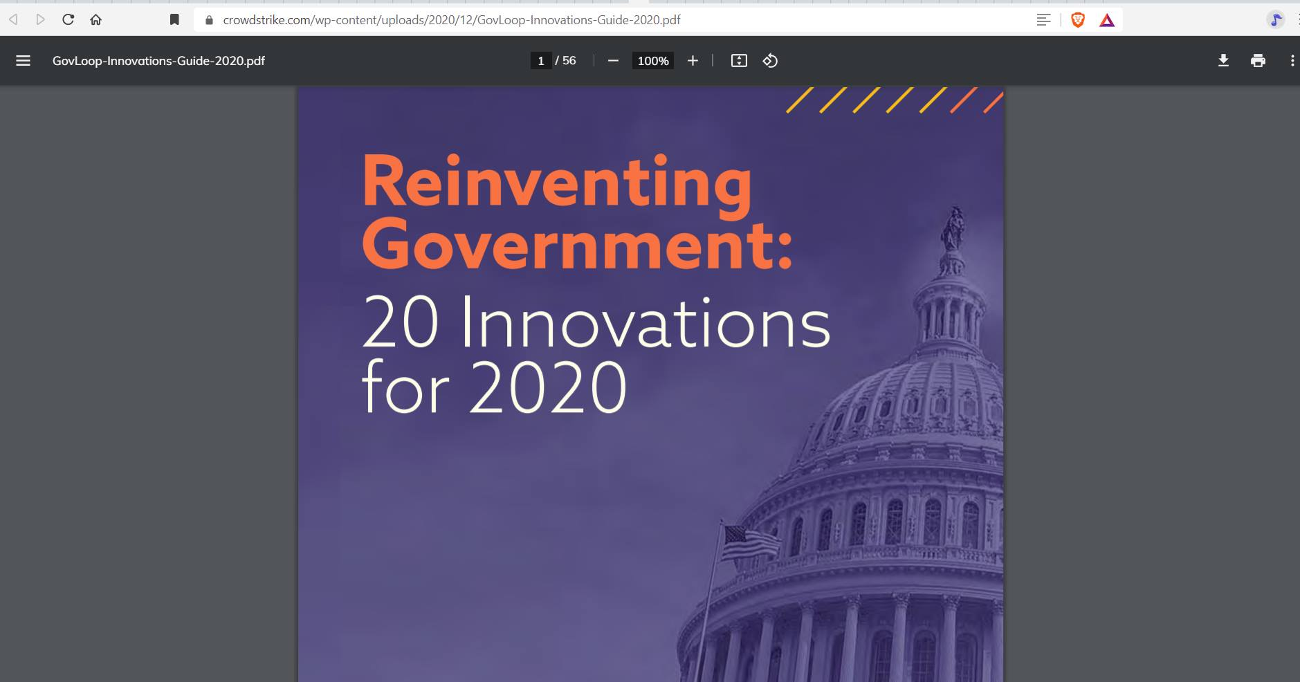
https://www.crowdstrike.com/wp-content/uploads/2020/12/GovLoop-Innovations-Guide-2020.pdf

Crowdstrike, whose software is used as part of the election cybersecurity measures taken in our own state (and likely every other in the nation), clearly has an agenda. Part of their plan for "Reinventing Government" through the use of cybersecurity in our elections involves a plan to "leverage" volunteers. Should Crowdstrike be seeking to "leverage" anything? (The answer is no.)
And if you follow the various links throughout this "Reinventing Government" document from Crowdstrike, you will see how others were also involved in manipulating our elections by exerting efforts to ensure that the database of volunteers used in our elections was made up of people that THEY chose. I find the repeated use of the word "leverage" (in this document and in those that are linked to) to be disturbing.
Tell Secretary of State Evnen that those who seek to “leverage” our election process should not have any access to it at all. We MUST have a full forensic audit before our next primary election.

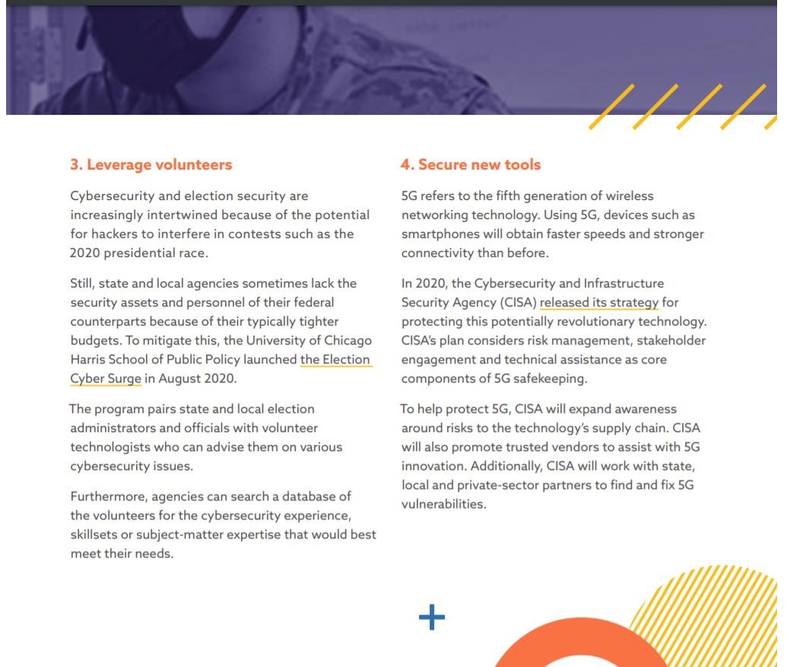

The database of volunteers to work elections was made up of those who had been vetted to meet the requirements of those who have a stated agenda to "reinvent government." This is manipulation of our elections and it should not be permitted. Secretary of State Evnen should conduct a full forensic audit BEFORE our next primary.

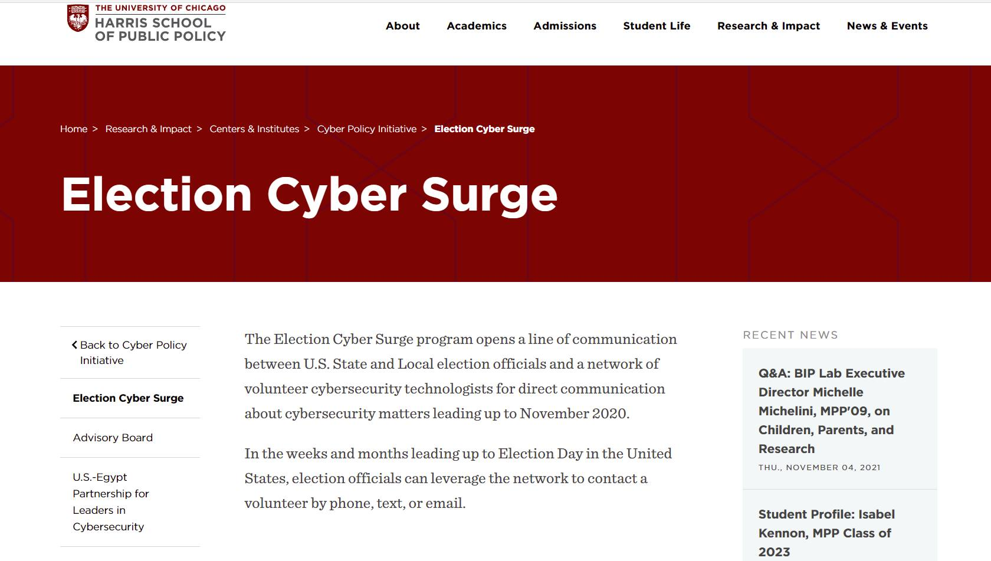
https://harris.uchicago.edu/news-events/news/election-cyber-surge-launches-connecting-local-election-administrators-volunteer

More from the “Reinventing Government” document on the Crowdstrike web site.
Those who have been fighting to keep CRT out of our schools might notice a few buzzwords here. This is more of how Crowdstrike would like to use cybersecurity to “Reinvent Government.” With a heavily left-leaning political agenda and a clearly stated intent to use cybersecurity to transform our culture, Crowdstrike should NOT be providing software to assure us that our elections are secure.
We need to call on Secretary of State Bob Evnen to conduct a full forensic audit to assure us that the outcomes of our elections are free from interference by people who want to transform our government and our culture.

The “Reinventing Government” document on the Crowdstrike web site links to these two pages and gives us more insight into how Crowdstrike would like to see our government reinvented. The Colorado Equity Alliance claims that it “aims to operationalize equity and make sure it is woven into the fabric of state governance.” There are many concerning things in the link to the empathy training as well.
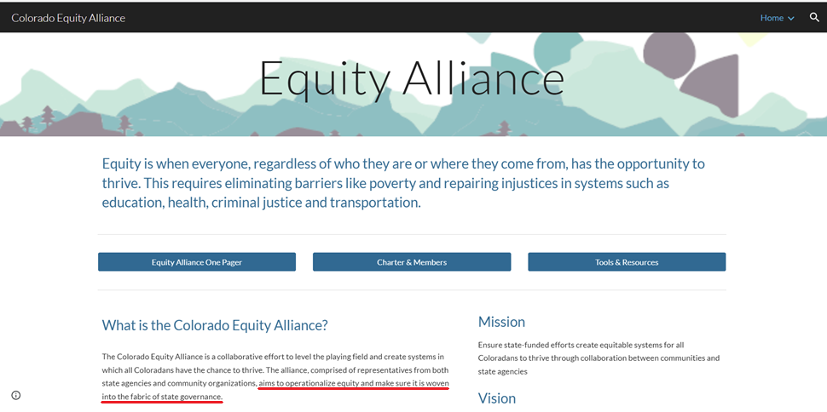

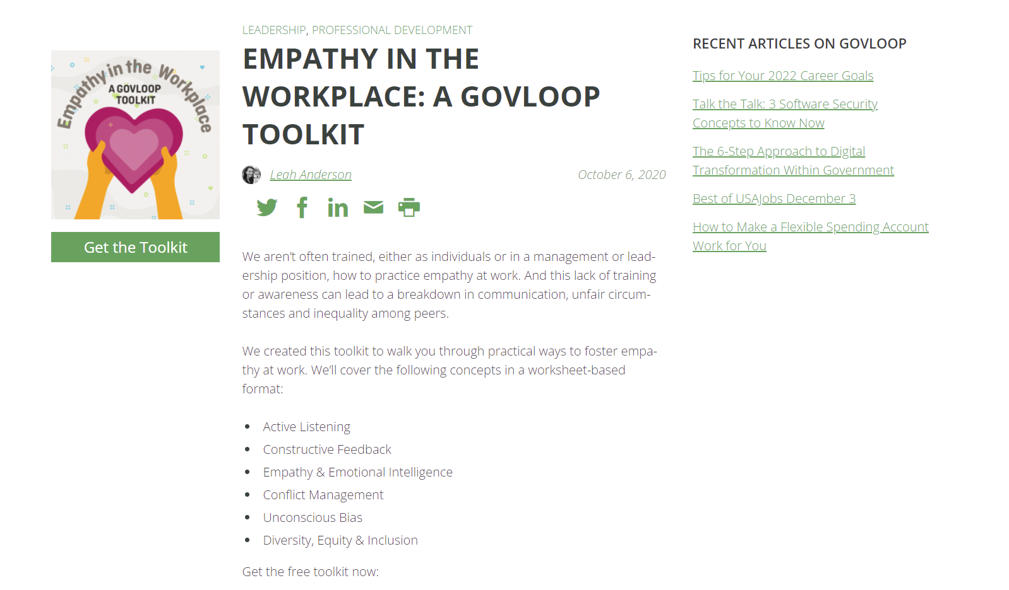

Should we feel comfortable allowing Crowdstrike to provide EDR Services for our elections, knowing that those at Crowdstrike would like to transform our country and our culture?

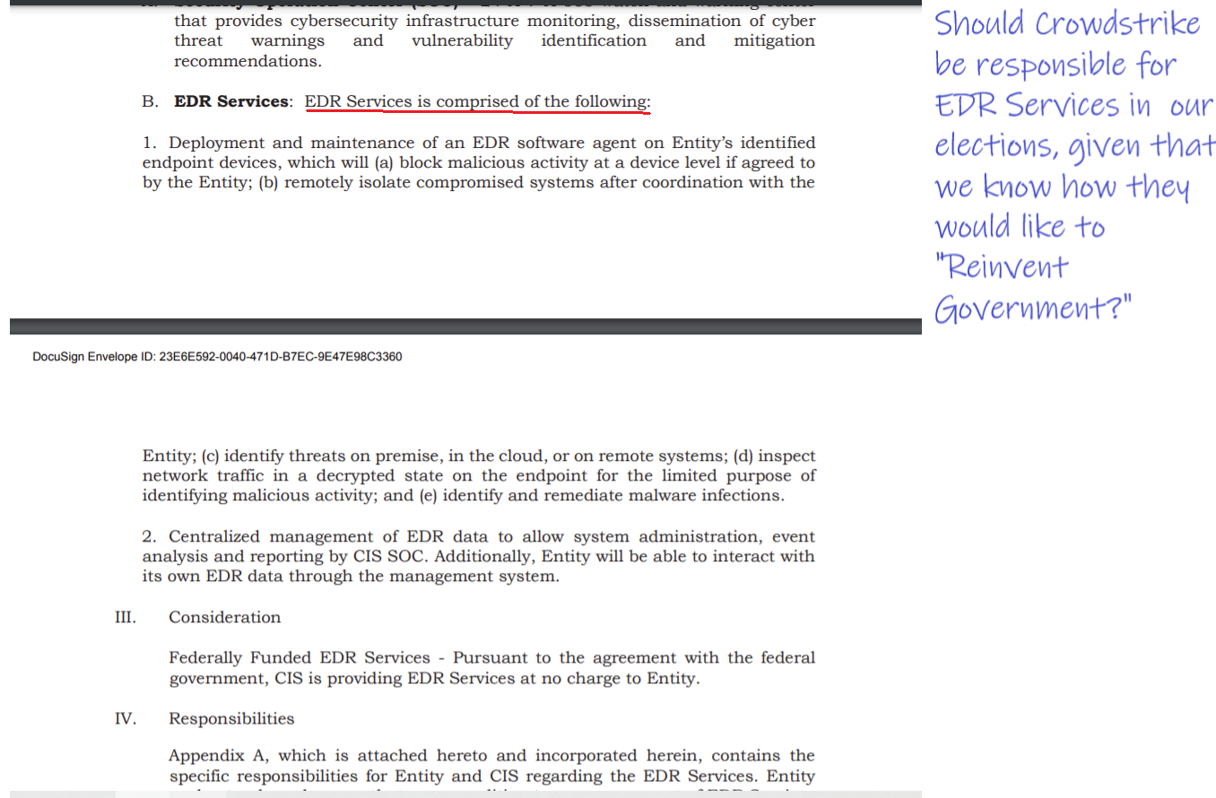

Besides Crowdstrike posting the document on their web site about how they would like to “Reinvent Government,” there are other reasons for us not to want them to have anything to do with providing security for our elections.

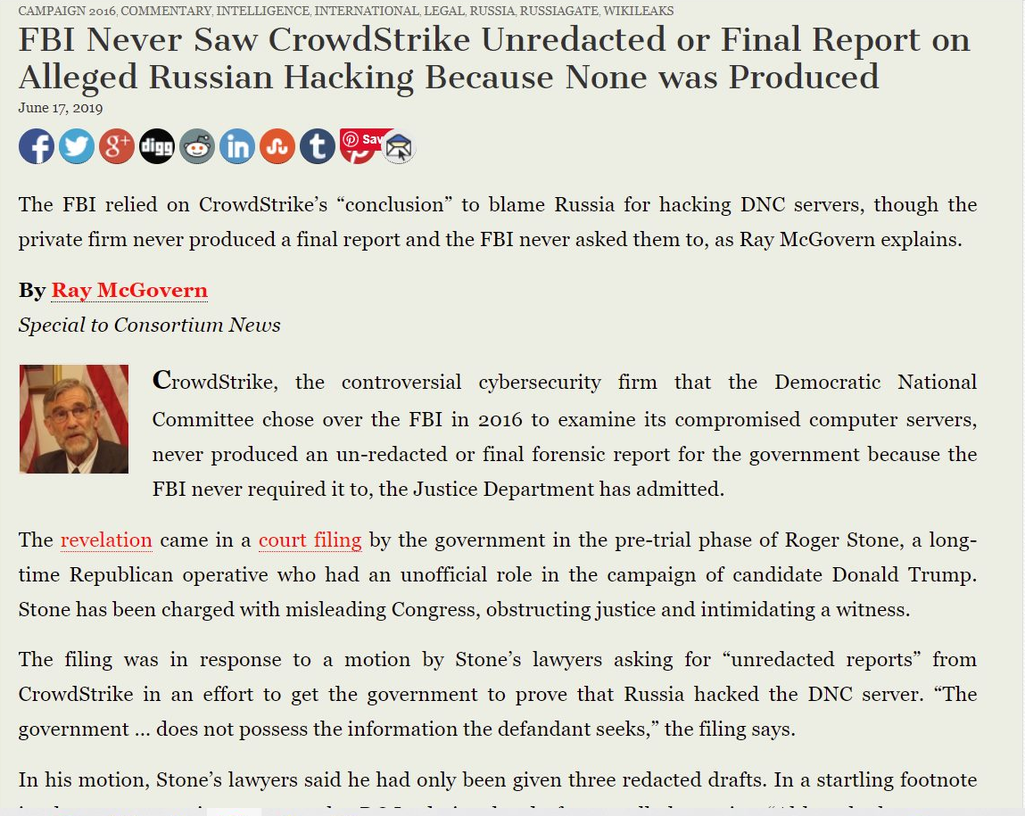https://consortiumnews.com/2019/06/17/fbi-never-saw-crowdstrike-unredacted-or-final-report-on-alleged-russian-hacking-because-none-was-produced/

DNC/Clinton campaign lawyer Michael Sussman (whom Special Counsel John Durham is expected to recommend for indictment for giving false statements) is the one who hired Crowdstrike to examine the "hacked" DNC computers. The computers in question in the investigation were never examined by the FBI.

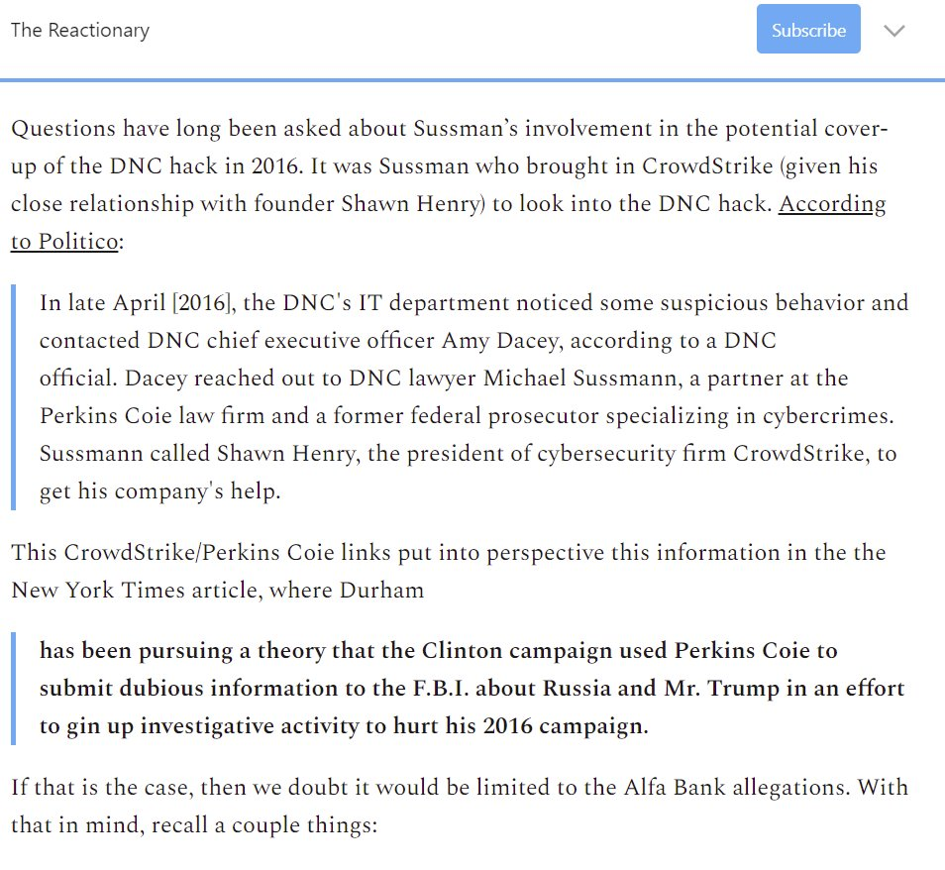https://technofog.substack.com/p/nyt-john-durham-seeks-indictment

Zuckerberg money was dumped into Lancaster County via a grant. This picking and choosing of where large sums of money get infused into our election process unlevel the playing field and give advantages to some areas over other areas in our state. This is yet another way that the left manipulates the outcome of our elections. We need a full forensic audit of our November 2020 general election.
robert.evnen@nebraska.gov
402-471-2554

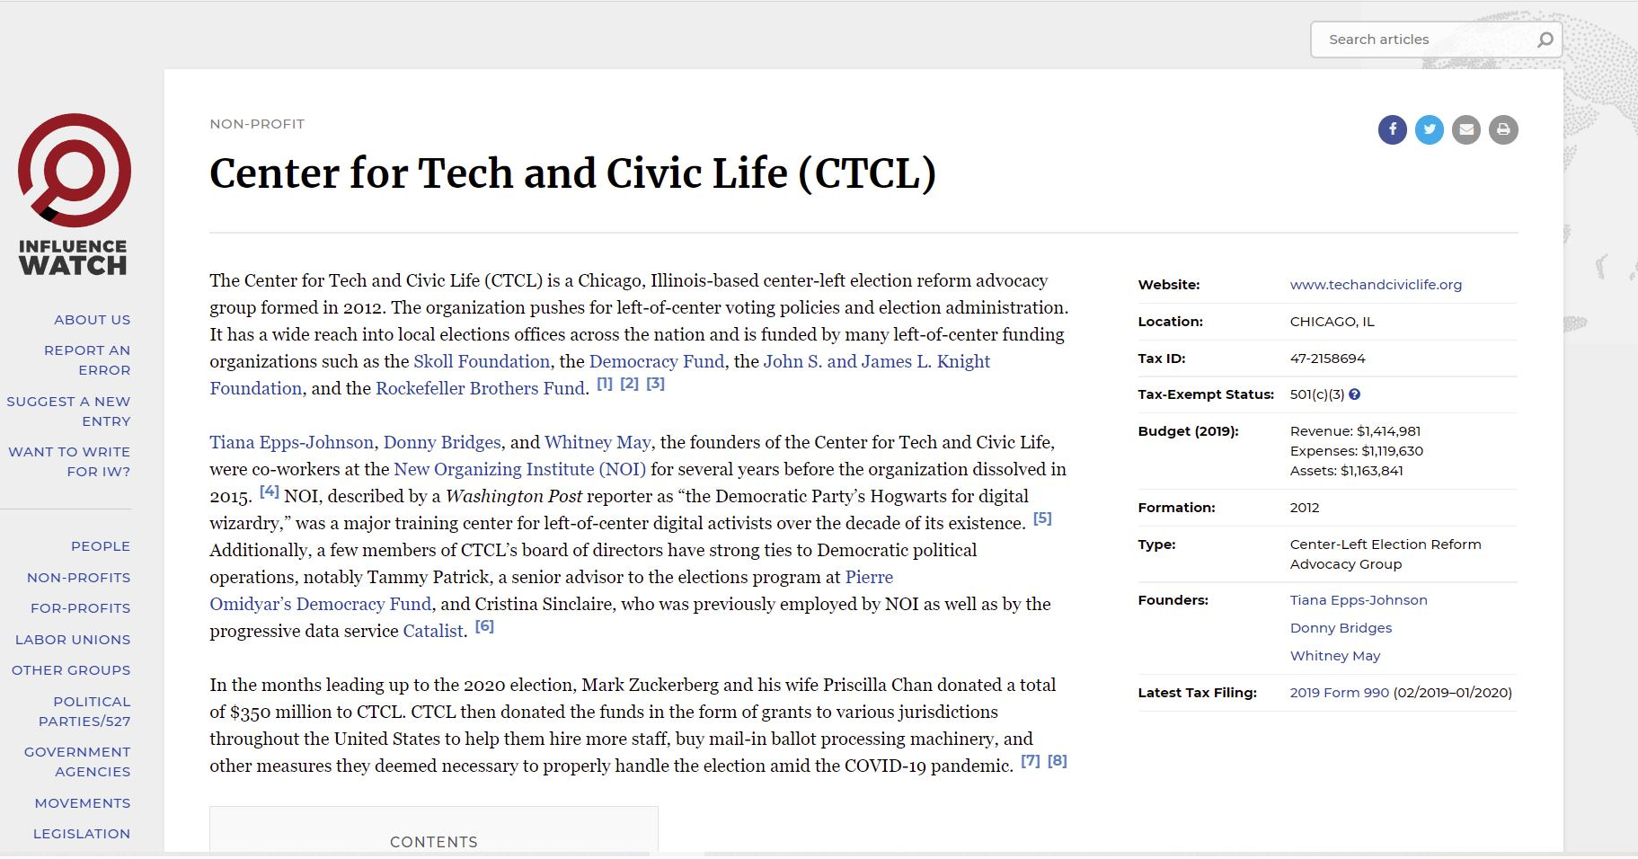
https://www.influencewatch.org/non-profit/center-for-tech-and-civic-life/
--Thanks to Kathy F. for sending me this info.

When Zuckerberg (or anyone else) is permitted to dump money into select areas of our state in order to improve election turnout, this is an interference into and a manipulation of our election process. Secretary of State Evnen should be conducting a full forensic audit.
robert.evnen@nebraska.gov
402-471-2554
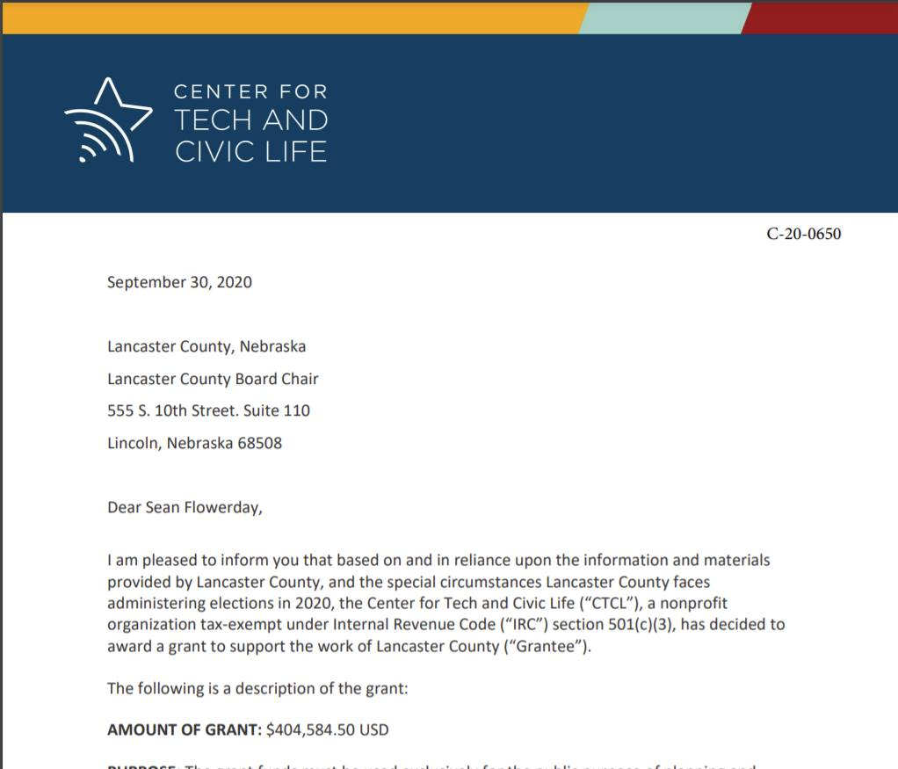
https://www.lancaster.ne.gov/DocumentCenter/View/6716/C-20-0650?bidId

This is the summary that Lancaster County was required to provide to CTCL telling how they spent the grant money. Notice the note at the bottom thanking CTCL (i.e., the Zuckerbergs) for helping them to address COVID issues. Also notice that the bulk of the grant went toward “vote-by-mail,” and not one red cent went toward personal protective equipment (PPE) for staff, poll workers, or voters. Clearly, this money was spent in a way which favored those who voted by mail.
--Thanks to George B. for requesting and obtaining this report.

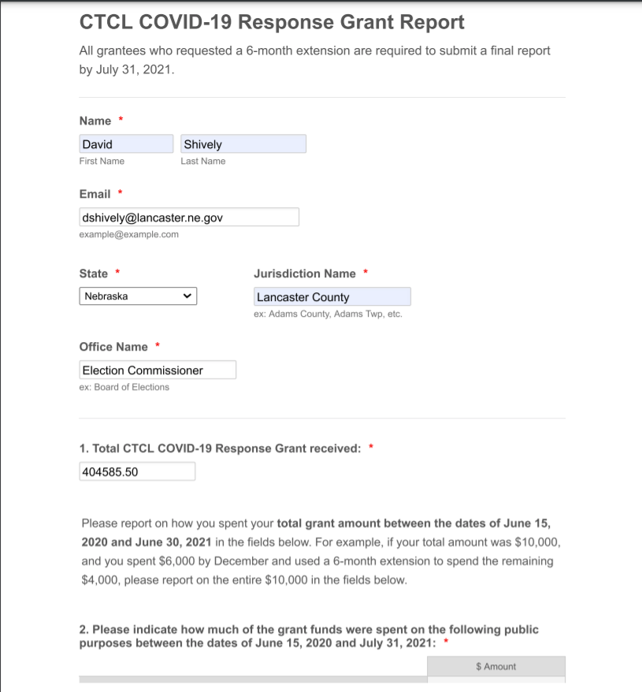
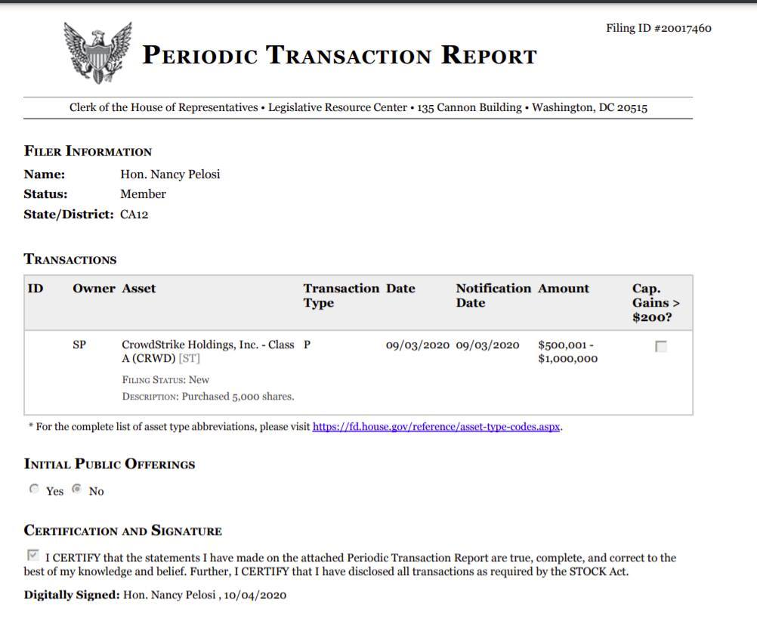
https://disclosures-clerk.house.gov/public_disc/ptr-pdfs/2020/20017460.pdf

