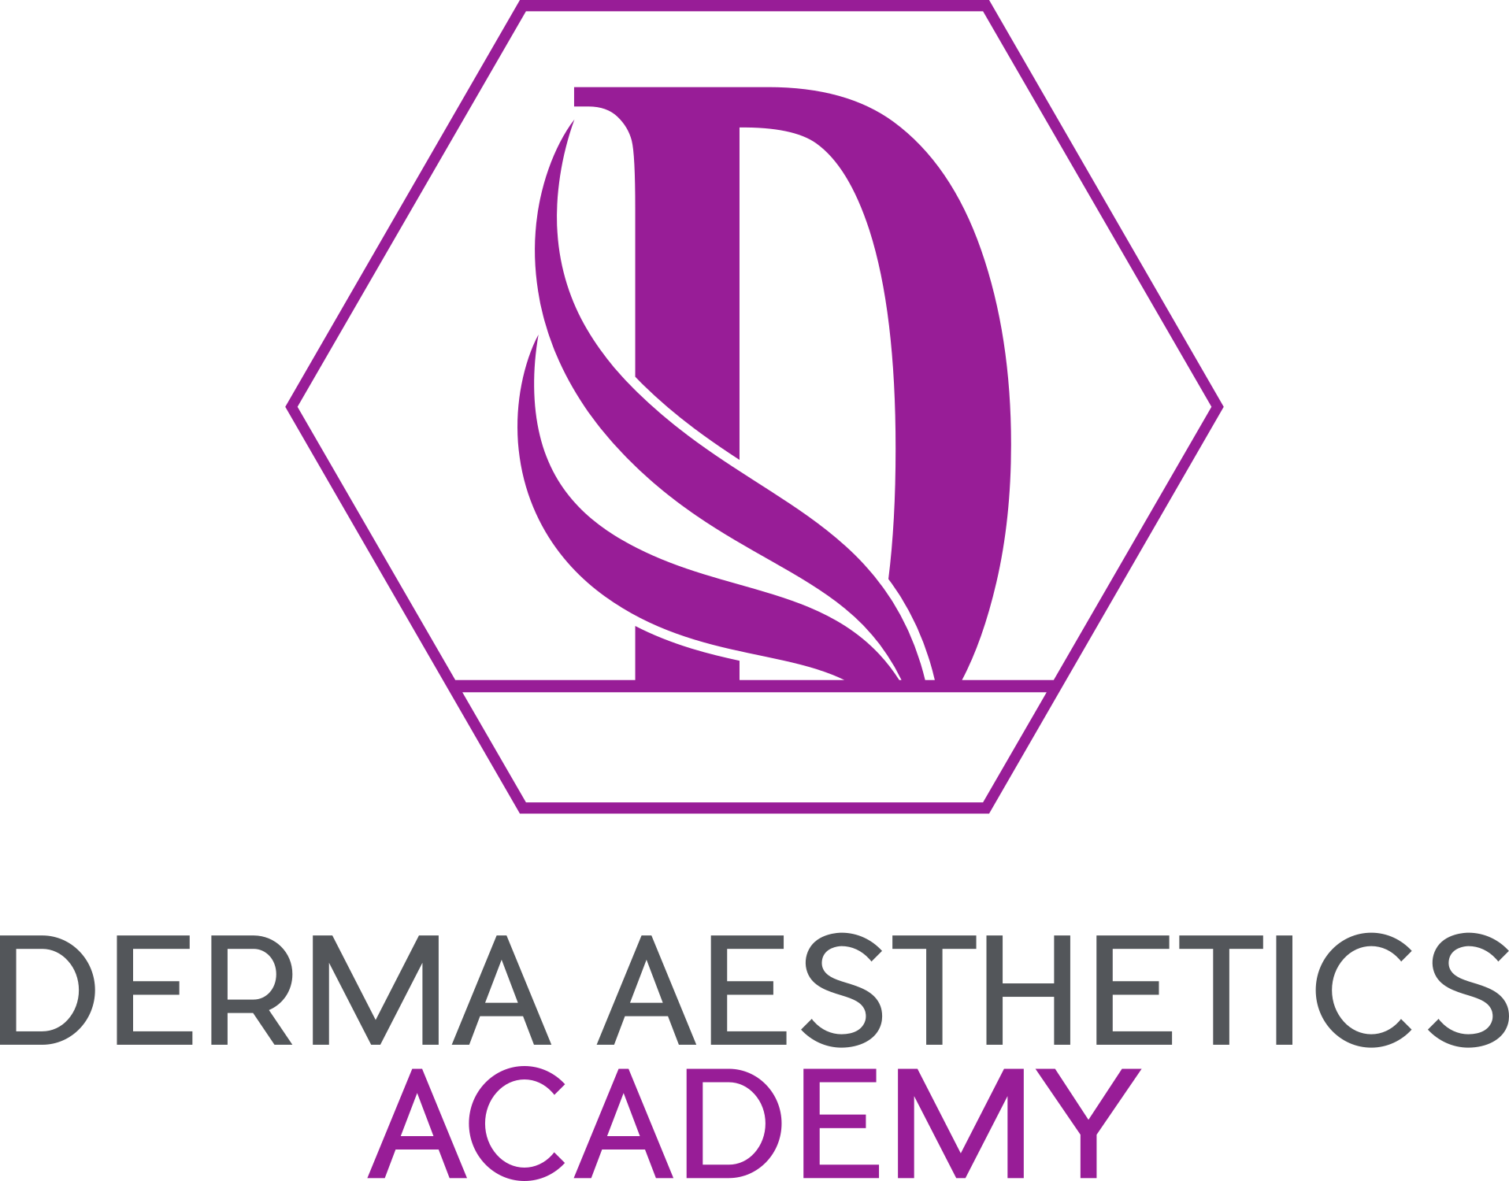

Complaints Procedure

Derma Aesthetics Academy is committed to delivering high quality service and encourages our students to inform us of any causes of concern or areas for improvement.

At the same time, it is expected that in raising possible issues of complaint that students will have observed their obligations as students of Derma Aesthetics Academy, through meeting their course commitments and a level of general behaviour that accords with academy regulations and reasonable consideration for others.

We aim to handle complaints in a way that:
- Is fair and efficient to all
- Treats any complaints with seriousness, sympathy and confidentiality.
- Facilitates early resolution
- Allows Derma Aesthetics Academy or a particular section to benefit from the experience.

How to complain

This procedure outlines a number of simple routes by any student or user depending of the seriousness of the complaint. The following list indicates examples of the type of complaint covered by this procedure:

- Misinformation about your course
- Poor teaching or supervision
- Insufficient facilities
- The behaviour of a member of staff
- The behaviour of another student
- A failing in the academy’s service

Do remember that complaints will not always produce the outcome you are looking for. For instance, policy decisions or resourcing beyond Derma Aesthetics Academy control may affect the level of service provided.

However, whatever the decision, we undertake to inform you of the result of a complaint and the reasons for it.

Sensitive Issues/Complaints

If you have an issue which is not about Derma Aesthetics Academy services or teaching but instead relates to a more sensitive and personal issue such as harassment, you can refer to Derma Aesthetics Academy separate procedures on equal opportunities which sets out what action you can take. Copies of which are available upon request.

Derma Aesthetics Academy Guarantee

If you have a concern, do not hesitate to raise it. We would love to hear from you as early as possible to resolve the problem and to put things right for the future.

We welcome your views and suggestions. We will monitor all comments and complaints treat them seriously and follow our procedures and timescales. We will always endeavour to continuously improve our services.

The Complaints Procedure

Stage 1

Complaints of a minor nature should be raised with the member of staff responsible, or the teacher leading your course, with the aim of resolving the problem directly and informally. It is anticipated that the vast majority of complaints will be resolved in this way. You should raise your concerns within 7 days of the matter in question. Your teacher will fully investigate your concerns and address accordingly. If your complaint is about the teacher then and it would be inappropriate to discuss the matter with them, you may begin with stage 2.

Stage 2

If you are not satisfied with the outcome of stage 1 or if you are no longer on your course please contact Derma Aesthetics Academy on +2347037716046 or email www.dermaaestheticsacademy.org where your concerns will be investigated. A response will be sent to you within 5 working days.

Stage 3

If you are not satisfied with the outcome of stage 2 you will need to complete the complaint/appeals form and forward to the customer services team at the address below. This may be in writing or by email. You are likely at this stage to be requested to substantiate any complaints or allegations with full written factual evidence and/or signed statements from witnesses. This will assist in reaching a speedy conclusion to the complaint.

A response to your appeal will be sent to you within 28 days.

(COMPLAINTS ADDRESS)

Managers Name: Date:

Managers Signature:

Staff Name: Date:

Staff Signature:

