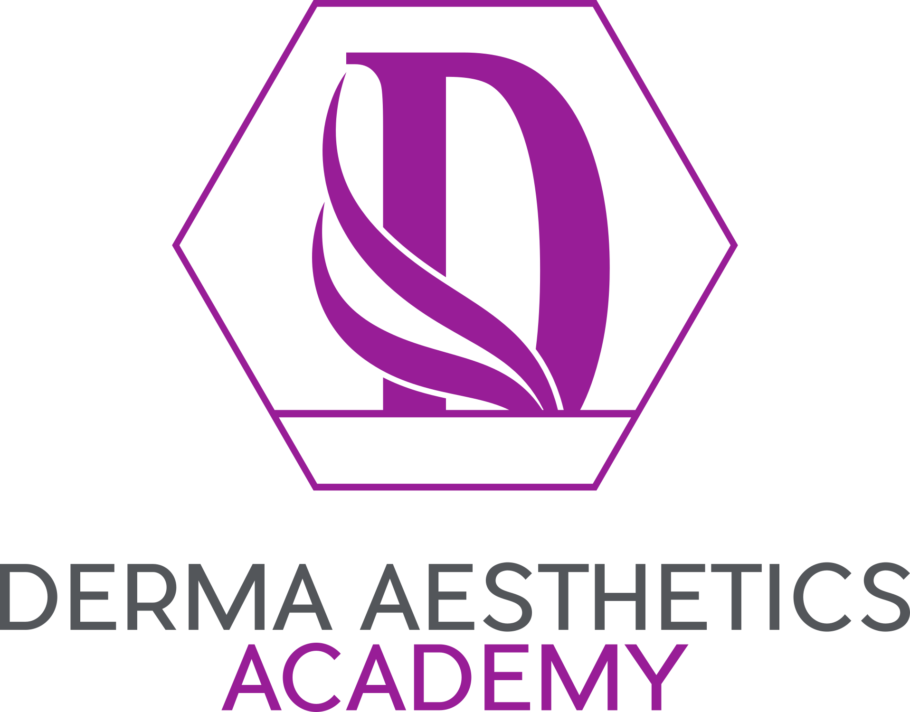

Appeals Procedure

Awarding Qualification Appeals

The Appeals policy is designed to protect the interests of all candidates and also to protect the integrity of the qualification.
Candidates have the right to appeal in the event that they are dissatisfied with the following:
- The assessment decisions made by Derma Aesthetics Academy, where applicable.
- The assessment decisions made by the Awarding Organization.
- The decision by Derma Aesthetics Academy not to support an enquiry or appeal to the Awarding Organization.
A copy of the appeals procedure is available to all students.
There is an informal and formal procedure available. The formal procedure is only to be followed if the informal procedure has failed or is inappropriate for the circumstances. All appeals must be via the formal procedures of the Awarding Organisation and supported by the Centre Manager.
Every attempt will be made to resolve disputes as near as possible to the point of origin, Derma Aesthetics Academy will keep appeals records for inspection by the Awarding Organisation for a minimum of 2 years.

Informal Procedure
- Where a candidate wishes to make an appeal against the quality of provision at the Centre, he/she should first of all attempt to resolve the matter by a direct approach to the Centre Manager.
- If the matter remains unresolved the candidate may require a personal interview with the Centre Manager.
- Before the personal interview, the Centre Manager should have obtained an independent second opinion on the initial decision.
- If, after any action to resolve the dispute taken by the Centre Manager, the matter is not satisfactorily resolved, the complainant may use the formal procedure.

Formal Procedure
Once the informal procedure has been exhausted, of if it is inappropriate to the circumstances, the formal procedure is to be followed.
- The complainant will be required to submit a formal complaint in writing to the Centre Manager.
- Within 10 working days of receiving the written appeal, the decision of the Centre Manager should be communicated to the student/trainee.
- Decisions by the Centre Manager regarding the quality of teaching provision are final.
- If the complainant disagrees with the result of the formal Appeals procedure regarding assessment decisions, they may utilize the Awarding Organizations formal Appeals procedure for which they must be supported by the center. For details of the Awarding Organization Appeals Procedure, please refer to the relevant Awarding Organization website.

Further Appeals
Any learner wishing to appeal against the operation of the Appeals Procedure can do so in writing to the Centre Manager.

Certified Course Appeals Procedure

Derma Aesthetics Academy allows all learners to appeal decisions made in the area of admissions, attendance, assessment, and learner discipline. The Appeals procedure is designed to allow learners to have any decision which they consider unfair, relating to admissions, attendance, assessment, or discipline, reviewed.
All members of staff are responsible for operating and implementing the Appeals policy and procedure by ensuring that the learners have the opportunity to discuss any problems informally. If problems reach the formal stage, staff should ensure that learners have access to the Appeals Policy and Procedure.
Appeals Procedure
- In the first instance, the learner should discuss any potential appeal, with his/her Course Tutor and/or the Centre Manager to try and settle the issue in an informal way.
- If, after discussion, the learner wishes to make a formal appeal against a Centre decision, the appeal should be sent in writing to the Derma Aesthetics Academy within one week of receiving the decision. This can be done by email or letter.
- The letter or email should include any new information that the learner wishes to highlight.
- Learners requiring help to write this letter or email should contact a member of centre staff or another appropriate person.
- Once an appeal has been received, all information concerning the appeal will be logged by the Derma Aesthetics Academy.
- All written requests for an appeal will normally be acknowledged within 7 days of receipt. An appeal hearing will then be held to allow the learner to explain the basis of the appeal.
- The learner may choose to be accompanied by a representative or friend.
- Derma Aesthetics Academy will set up an Appeals Panel which will consist of the Director/Owner plus one member of Staff, and up to a maximum of two other appropriate members of staff or independent experts.
- None of the Appeals Panel will have been involved in the original decision.
- After the Appeal has been heard, the Panel will tell the learner of their decision as soon as possible and confirm this decision in writing to the learner, normally within 7 working days.
- A copy of the written decision of the Panel will be retained by the centre.
- The decision of the Appeals Panel is final.

