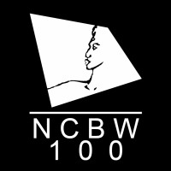
NATIONAL COALITION OF 100 BLACK WOMEN, INC.
PRINCE GEORGE’S COUNTY CHAPTER

PATRON FORM

The National Coalition of 100 Black Women, Inc., will host the 35th Anniversary Gala to Benefit Scholarships & Programs - "Red Carpet Glitz & Glamour" on Friday, April 21st, 2023, at Martin’s Crosswinds in Greenbelt, Maryland. Each year we raise funds to assist our scholarship recipients with their college tuition. We are asking for support by becoming a PATRON at $15.00 per person or $25.00 per couple/partners.

PLEASE PRINT OR TYPE
PATRON’S NAME | AMOUNT  ($15.00 per person) | ($25.00 per couple/partners)
1.
2.
3.
4.
5.
6.
7.
8.
9.
10.

Please return this form and payment no later than March 25, 2023. Checks are to be made payable to “NC100BW-PGC”. Mail form and payment to: Dr. Michelle McKoy, Financial Secretary at P.O. Box 623 Riverdale, MD 20737. Email form to Geneva Williams: lingen@comcast.net.

Member’s Name_____________________________________________________________________
Thank you for your support. All Names will appear in our Gala Souvenir Program Booklet.

