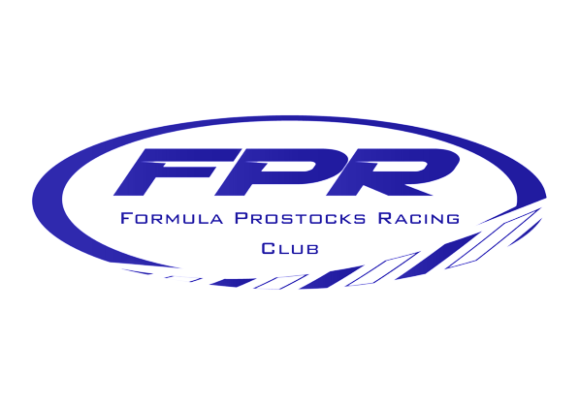
FPR Classic Superbike FP3 Evo Regulations 2024

All riders wishing to enter a race must be a current member of Formula Prostocks Racing Club.
1, Machine Eligibility
This class is open to 1000cc four-cylinder machines which were produced before 1st January 2008. Later machines may be eligible if they are the same model and specification of those available before 1st January 2008. Similar machines or hybrids may be considered on a case-by-case basis and at the discretion of the club / class eligibility officer. If such a machine is given dispensation, this is on a year-by-year basis and will not be automatically excepted the following season.
Examples of motorcycles permitted.
Kawasaki ZX10R C1&C2, D1&D2.
Yamaha R7, R1 4XV, 5JJ, 5PW, 5VY, 4C8.
Honda CBR1000RR SC57.
Suzuki GSXR750 SRAD, K1 – K7, GSX-R1000 K1 - K7.

2. Engine and gearbox.
Engine tuning is free.
Original 1000cc barrels, cylinder head and engine/crank cases must be retained.
Aftermarket Slipper clutches and close ratio gearsets are permitted.

2.2. Cooling system.
Aftermarket or race kit copy radiators may be used.

3. Induction.
Carburettors, Injectors, ECU flashing, EPROM piggyback units are all free. Bellmouths, variable or fixed.
Race kit airboxes may be used. Fuel as per ACU specification.

4. Chassis and Subframes
The chassis and engine must be from the same make and model of the machine entered.
If the original engine is not available, the replacement must be from the same model range of motorcycles.
Subframes are free and frame strengthening permitted.

5. Front Forks
Front forks are free along with yokes.
Lock stops must remain, but aftermarket or race kit units may replace standard. Adjustable offset and angle permitted. Steering dampers may be used.

6. Rear Suspension
Rear suspension and linkages are free.
Swing arm strengthening permitted along with quick release and captive fixings. Race kit swingarms may be used.

7. Wheels
Wheels are free but must be Aluminium and at least the minimum size recommended for the machine.
Carbon fibre wheels are NOT allowed.

8. Tyres
Tyres are free.
Any slick treaded or wet tyre may be used. Tyre warmers are permitted.

9. Brakes.
Brakes are free.
No Ceramic or Carbon Discs permitted.

10. Ignition Systems
Any ignition or ECU unit may be used.
Any form of Launch, Wheelie or Traction Control is forbidden. Use of aftermarket quick shifters and shift lights is permitted. Wheel speed sensors not permitted.

11. Wiring Harness
Any wiring harness may be used. Kit alternators permitted, or stock unit removed. Starter Motors must be fitted and working.
A Tachometer must be fitted for Noise testing and a Rain light for poor conditions. All as per ACU Regulations.

12. Bodywork
Bodywork is free but should be representative of the model and period.
Belly pans or an oil catch tray must be fitted as per ACU regulations and size.

13. Additional Regulations
Apart from the club regulations set out above, all machines must also comply with the ACU regulations. These can be found in the ACU handbook.

14. Additional Club Rules
All riders wishing to enter a race must be a current member of Formula Prostocks Racing Club.
If any riders are unable to set up in the designated FPR paddock, they must make themselves and their location known to the series organiser before morning practice. Failure to do this may surrender any championship points earned at that event.
If the entered machine has any mechanical issues that prevents it starting a race, permission from the series organiser must be obtained before starting the event on another machine. Wet and Dry bikes are allowed but the organisers must be aware of both Specifications. Entering on an Unknown Machine will be considered Cheating!
All participants machines will be made available and promptly upon request from the organisers for technical inspection. All machines in this class will undergo a technical inspection at some point. Failure to follow the technical regulations stipulated above will result in your ineligibility to race within the club. Any dispute from technical inspection will be referred to the series organiser. They will endeavour to find a simple and suitable solution to the issue in question wherever possible. The series organisers decision on the matter will be final.
In the event of a race being cancelled and then rerun later, only those who were on the grid of the original race will be eligible for championship points.
Any changes to race dates, meetings, format, and championship points are at the discretion of the club. The series co-ordinator’s decision is final!
By entering this class, you do so on the understanding that you will abide by all club rules and the regulations set out above. Failing to do so will result in the loss of any championship points accrued. Persistent failure to comply with club rules or regulations will result in being expelled from the series.
If you think you may not be compliant with the rules, just ask us. If there is any doubt, we’ll happily clarify. Our rules are very flexible, so nothing to be concerned about. But the series organisers’ decision will be final.

Series Co-ordinator: Keith Chambers
Email: formulaprostocks@gmail.com Tel: 0844 500 8565

