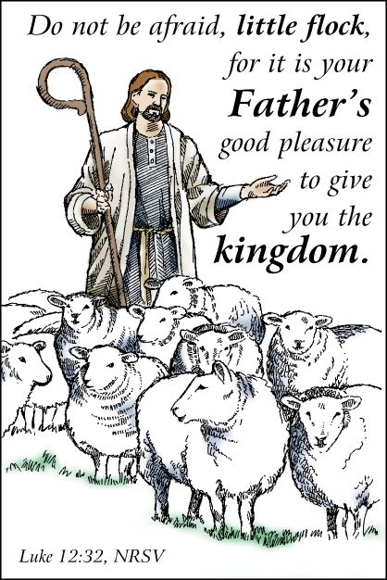
August 2022
The MESSENGER

A publication of Kerkhoven Lutheran Church, Kerkhoven, MN 56252
Security Systems That Don’t Fail
Jesus knows that we worry about a lot of things. Many people who own a lot of possessions live in fear of losing them. Some find that a security system installed with cameras and sensors and smart doorbells can lower their anxiety. But even with internet-of-things technology, these security systems do not stop the risk of theft. We may get a video of someone stealing our stuff, but we still lose the stuff. Anxiety over losing what we have persists and may in fact be ever-present as our cell phones alert us to each passerby at the front door.
Jesus proposes several other security systems that transform our anxiety over losing what we have into a different kind of calm. The first one he offers is probably the least popular: Sell your possessions and give the money to the poor. You don’t have to worry about your belongings being stolen if you get rid of them. It’s a radical option, but an option nonetheless.
Jesus also proposes another kind of security: Place value in the things that can’t be stolen. When we treasure the mercy and love of God as our most prized possession, we have what no one else can take. We have a security system that does not fail. We have deep and abiding peace. Our fears are calmed.
There is one additional security system to which Jesus invites us: Have confidence that it is God’s good pleasure to give us life with God, life in a world where everyone has enough and no one worries about losing it, life where we all know we are equally beloved. When this is our treasure, when it is where we place our hearts, we find the peace that is a secure gift. From sundaysandseasons.com.


Kerkhoven Lutheran Church Council Meeting
The KLC Church Council is scheduled to meet August10, 2022. Church boards are encouraged to meet prior to the council meeting and submit agenda items for the 7:00 pm council meeting by Tuesday, August 9, 2022.
Kerkhoven Lutheran Church Meeting Minutes
The Kerkhoven Lutheran Church Council met on 6/08/2022 at 7:00 pm in the KLC fellowship hall.

President Ted Almen called the meeting to order.
Devotions were read by Scott Mitteness August Devotions: Eric Rudningen
KLC Mission statement was read in unison. Living and trusting in God’s amazing grace we welcome all who worship, learn and serve in celebration of Christ’s love.
The secretary’s report was read and approved (Susan Nelson/Eric Rudningen)
The Financial report was read and accepted as written. (Susan Nelson/Scott Doering)
Ann reported that Grinnell Mutual did renew our property insurance and we have been paid $13,600 for water damage, etc to the parsonage. That money is in our savings for now until the repair is complete. She also reported we are operating within our means.

Board Reports
Worship and Witness - given by Susan Nelson
Communion will be given each Sunday during the summer months. Hymns are chosen to the week’s passage and occaission. Eric R offered to help choose hymns if they want a week off.

Outreach and Evangelism - given by Alison Nelson
Backpack program continues through summer school with about 25 bags being sent home weekly. More funds are needed to maintain the program and it currently costs about $4 per backpack per week. A Noisy Offering will be designated and we will contact other area churches asking for assistance.

The freezer has arrived for the freezer meal program and will be placed once space is cleared out.

There is a 2 person camel costume available. Contact Ann Hanson if interested.

Christian Education - given by Melanie Wirth
The committee has been organizing curriculum into files and reported that the back room by pre-k had been cleaned out. The walls should be cleaned and/or painted and will be used as a teacher prep space.

This fall we will continue on the same curriculum which runs in a three year cycle. Memory work will be added to Sunday School curriculum.

An adult education class will be organized and can be led by anyone.

Stewardship and Finance - given by Lane Carlson
The board has been able to count the offering each Sunday and that is working well. A thank you will be posted on Facebook, KLC Sunday Bulletin and KLC Messenger.

Property and Grounds - given by Scott Doering
Freetly Electric will look at our air conditioning since it does not seem to be keeping up. . Freetly Electric wrote a letter to our insurance stating that the control parts had not been received yet and thus not replaced. Grinnell Mutual did renew our policy. The committee will contact Don’s Building Center to see if they knew of a crew available to shingle the storage shed. The committee is looking into grants and/or rebates to bring down the cost of a potential new AC unit. They will work with Tony Olson on the parking lot project.

WELCA - given by Carmen Maus
Summer brunch is slated for next Sunday.. The group is setting parameters for quilt donations to assist people in need in our community. The green curtain has been removed and will be replaced by an accordion style door. This area will be used for “tree storage” and items used for decoration.

A bus trip is being planned for quilt drop off and consideration given to the St. Cloud area.

Pastor’s report - not present

Old Business
- All items identified by the removal committee will be available for two Sundays (June 12 and 19) before being donated. (motion by Scott MItteness, second by Ted) There will be donation envelopes for people wanting items.
- Library remodel: Library furniture and corner cabinet has been removed
- Cow pie bingo: 400 tickets available at a cost if $20/ticket. Contact a council member to purchase

New Business
- Construction review committee was established (Jessica Carlson, Scott MItteness, Sue Nelson, Lee Meyer) Motion made by Scott D/Eric R
- A reminder to be considerate when contacting and communicating others. Be respectful of frequency and timing of messages. May want to use delay send feature to schedule a message to be sent at a better time.
- Parsonage basement repair from flooding is still not complete. Service Master did a partial job but has not returned for reinstallment. Strandburg Insurance will be contacted to see if we can pay half and hire another crew to finish the job.
- Rugs are not laying flat and are a tripping hazard. Discussed using tape or removal. Lane C offered to remove.

Motion to adjourn made by Ted A/Scott D

Respectfully submitted by Beth Carlson


August
Many people remember people’s birthdays, but we also need to remember the day of our spiritual birth, our baptismal day. Also please take note of who was baptized during this month and wish them a happy baptismal day.

Mallory Carlson – 3rd | Kristy Nystrom – 10th | Melissa Rhoda – 23rd
Kayla Hoffman – 3rd | Victoria Guilemard –11th | Shep Nystrom – 24th
Kelsey Cortez – 3rd | Ross Carlson – 11th | Derrick Henry – 24th
Jackson Ziehl – 4th | Grayson Reinke – 17th | Rick Falk – 24th
Bonnie Carlson – 4th | Julie Jahn – 19th | Ruth Ann Falter – 25th
Clarice Larson – 6th | Charlene Gordon – 19th | Josh Wagner – 28th
Zoe Olson – 7th | Ted Meyer – 21st | Darrell Toutge – 28th
Jared Dokkebakken – 8th | Amber Torkelson – 23rd | Ashllie Hauge – 30th
Loretta Falk – 10th | Kora Klein – 23rd | Arlene Carls – 31st


Larry Lindquist – 2nd | Susan Nelson – 8th | Matthew Zvorak – 20th
Jared Krieger – 3rd | Caleb Grothe – 9th | Eric Lottman – 22nd
Nicholas Meyer – 3rd | Spencer Almen – 10th | Joshua Nelson – 23rd
Sharyl Syverson – 3rd | Brendan Hjelle – 11th | Regan Carlson – 24th
Allison Miller – 3rd | JoLynn Larson – 11th | Katie Guse – 25th
Ryan Carlson – 3rd | Calvin Carls – 11th | Jeremy Winter – 26th
Arlene Carls – 4th | Trinity Torkelson – 12th | Scott Mitteness – 26th
Heidi Winter – 6th | Jeff Holtkamp – 12th | Kalli Forsell – 27th
Laura Worden – 6th | Megan Wenisch – 14th | Dana Wenisch – 28th
Trevor Kelm – 6th | Matthew Molenaar – 15th | Kayla Kelm – 29th
Wylee Lottman – 8th | Juanita Halverson – 16th | Ethan Hauge – 30th
Lane Carlson – 8th | Bailey Petersen – 18th | John Zvorak – 30th
Barbara Norton – 8th | Colton Kinney – 20th | Lilyanna Winter – 30th

If we have missed your birthday please let Ann know in the church office.

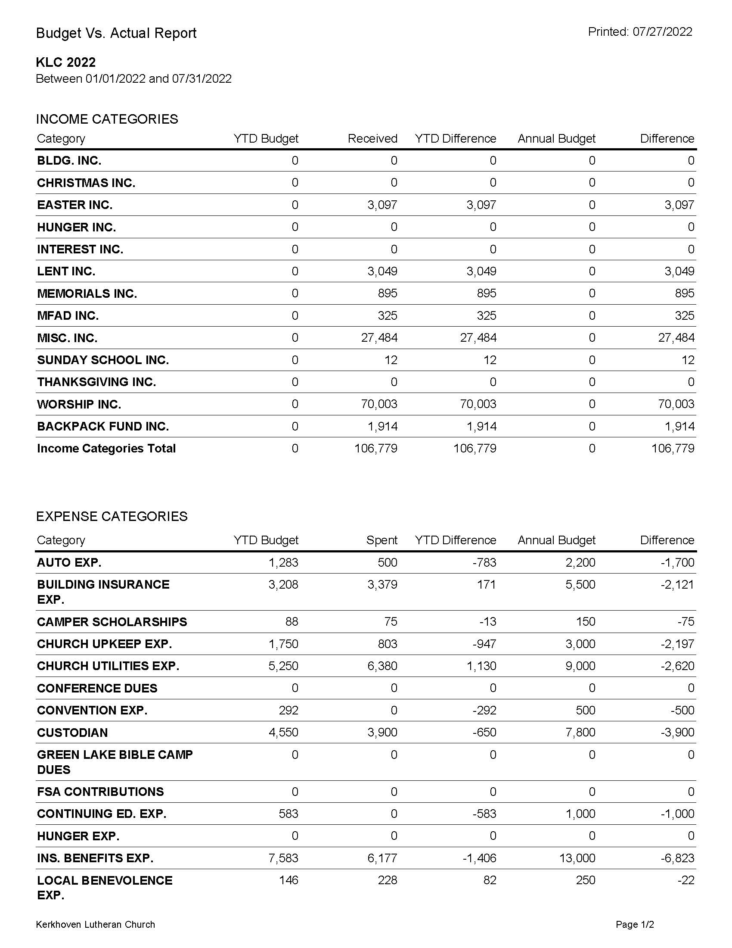
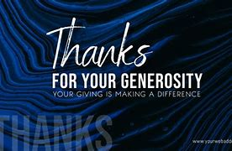
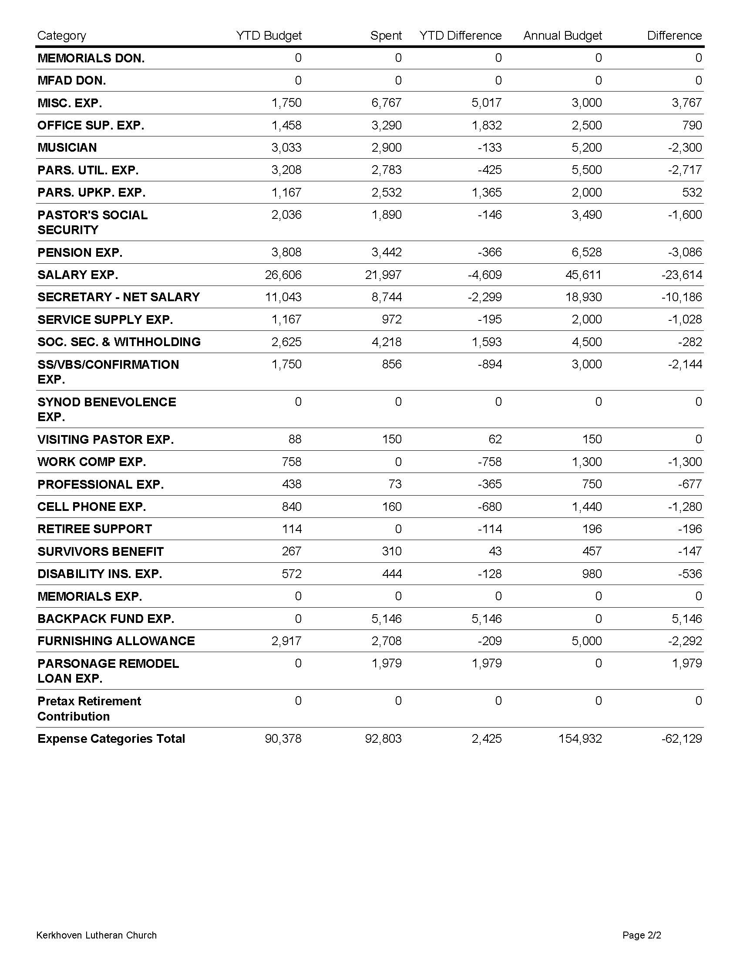

 | July 2022 | YTD
Actual Expenses | 13,168.24 | $92,803.00
Actual Income | $13,634.18 | $94,637.00
Budgeted Incomed | $12,340( $3,084 per week) | $90,378.00

Thank You: The KLC Board of Stewardship and Finance would like to thank everyone for their ongoing generosity with their offerings and donations to the ministry of our church.


We continue to organize and update the education areas and are getting excited for the child and adult fall classes to begin in September. The Little Library has been built and is now in place outside the KLC doors to the Fellowship Hall. There will be books and devotionals added as they become available. If you have books or items to share please feel free to add them to the Little Library.

If you'd like to learn more about how to get involved in Youth and/or Adult Christian Education for next fall please contact any of the board members.

Kerkhoven Lutheran Church Sunday School
2022-2023 School Year Calendar
September 11, 2022 | Rally Sunday - First day of Sunday School
October 23, 2022 | No Sunday School - Fall Break
November 27, 2022 | No Sunday School - Thanksgiving Break
December 11, 2022 | Christmas Program
December 18, 2022 | Christmas Party (contingent program date)
December 25, 2022 | No Sunday School - Christmas Break
January 1, 2023 | No Sunday School - New Year Break
January 15, 2023 | No Sunday School - MLK Day Break
February 19, 2023 | No Sunday School - Presidents Day Break
April 9, 2023 | No Sunday School - Easter Break
May 21, 2023 | Last Day of Sunday School

Pastor Michael Buller: 320-377-9466
Cindy Clasen: 612-747-2878
Amber Doering: 320-295-6762
Jaci Hennes: 320-220-5232
Shelly Lottman: 320-212-0858
Jesse Nelson: 320-905-5730
Kristin Stivers: 952-693-6381
Chris Wenisch: 320-248-6277
Melanie Wirth: 612-670-6719

Where Has Flat Jesus Been

We are not hearing of many Flat Jesus sightings or travel reports. There is still time left before September and Rally Sunday. Let us remember to bring Jesus with us on our summer adventrues.
In September, on Rally Sunday, we will vote and give prizes for things like: Farthest Distance, Best Outfit, Selfies with Most People, Best Summer Vibe, Most Photos taken, Most Guest Appearances
You can find your kit on the Table by Ann’s office.

Farmer’s Market

The Kerkhoven Farmers Market will be held each Tuesday in the months of July and August. Come check out some fresh produce, baked goodies and maybe some fun homemade items. There will be food and fellowship at each market. The Farmer’s Market is held at the shelter by the pool in Pillsbury Park from 3-5:30pm.

Thank you!


Mark Your Calendar

KLC Luther League is planning an intergenerational outing to the Twins game, Sunday, August 7. Cost will include tickets to the 1:10 pm, bus ride, and a sack lunch. Plan is to leave following worship service. The group will be leaving immediately following the worship service on Sunday. There are still seats available and all KLC members and friends are invited to sign up. The cost for non-Luther League members is $30.
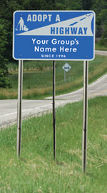
ADOPT A HIGHWAY
Please watch for updates in the bulletins and on Facebook for when the Evangelism and Outreach Board schedules our Fall picking up of litter along our designated 2 mile stretch of Highway 12.

KMS Backpack Program Fundraiser

Tuesday, August 9, KLC is having a booth at the Kerkhoven Farmer’s Market provide information on some of our community outreach ministries. We will be sharing information on the Nutritional Assistance Program for Seniors (NAPS), which is program of USDA and provides self stable groceries for senior citizens over the age of 60. KLC is the distribution site for this program. We will also be providing information on the KMS Backpack program and the soon to begin “Frozen Meal Program”. There will also be having a bake sale that day with the proceeds being designated to help fund these community wide programs. Please sign up to provide items for the bake sale on the sign up sheet on the table between the church offices or drop off items by 2:00 pm the day of the sale at the church or directly to the booth at the Farmer’s Market by 3:00 pm. The KLC Luther League will be serving treats for coffee time at the Farmer’s Market that afternoon also. Stop by and have coffee and support the mission of our church. Thank you.!!!




WELCA Calendar of Events – August

August 10, 2022 6:30 pm WELCA General Board Meeting

Just a reminder during the summer month the Luther does not serve the treats for our coffee fellowship after our worship service. KLC members, both male and female and/or groups are encouraged to sign up to bring treats for one of these Sunday’s. There is a sign up sheet in the kitchen to indicate the Sunday you would like to provide treats and serve the coffee.

Upcoming Dates to Note


Thursday, August 4 – Monday, August 8, 2022
Ann on vacation, KLC office closed
Thursday, August 18 – Wednesday, August 31, 1022
Pastor Michael on vacation. Pastor Joyce Capp will provide on call Pastoral Care and will be leading our worship services during his absence.



Please continue to remember these loved ones and friends in need of prayer during this month.
Gene Halverson | Kaehlen Fernholz | Henry Arends
Wally Loven | Cami Fernholz | Gladys Arends
Dennis Doering | Calvin Carls



MISSIONARY FOR A DAY TO SUPPORT REV. DR. PHILLIP J. AND LOU KNUTSON
MISSIONARY FOR A DAY DONATIONS FOR JULY 2022
July 3, 2022 | In Memory of Jim Arends by Henry and Gladys Arends
July 3, 2022 | In Memory of Moni Welch by Calvin and Arlene Carls
July 9, 2022 | In Memory of Phyllis Loven by Mary Kay Austvold

--------------------------------------CLIP AND PLACE IN OFFERING PLATE------------------------------------

I would like to support Missionary for a Day on the date of ____________________________________
Circle one: In honor of/In Memory of/In Thanks to God for ____________________________________

First Std
U.S. Postage
PAID
City, ST
Permit # 000
Kerkhoven Lutheran Church
402 No. 12th St., PO Box 317
Kerkhoven, MN 56252
320-264-2823
www.kerkhovenlutheranchurch.org

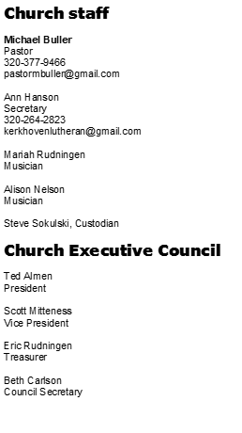


Jesus loves...

