The MESSENGER
March 2022

Living and trusting in God’s amazing grace we welcome all to worship, learn and serve in celebration Christ’s love.

A publication of Kerkhoven Lutheran Church
“The word is near you, on your lips and in your heart” (that is, the word of faith that we proclaim); because if you confess with your lips that Jesus is Lord and believe in your heart that God raised him from the dead, you will be saved. For one believes with the heart and so is justified, and one confesses with the mouth and so is saved. Romans 10:8b-10
In the latter years of his life, the Apostle Paul spent a great deal of time wrestled with God’s revelation of righteousness. This was very different from first part of his life, when Paul (who at that time went by the name Saul) did all he could to live a perfect, “sinless”, life. Before Paul experienced this complete chain of heart, he actually, and completely, believed that his actions would lead to his salvation.
Then Paul encountered God’s symbol of perfection, the Resurrected Christ Jesus, and this experience put everything he thought he knew into question. In nutshell, once Paul encountered Christ Jesus, he very quickly realized no one could ever, or would ever, measure up to such perfection.
What then, he must have wondered, must I now do to be right with God? Paul realized that rather than focusing on being perfect, rising above his personal imperfections, so he would stick out from the crowd, he only needed to look to God’s revelation of perfection who was, and is, and always will be recognized and accepted by God.
In brief, Paul was freed by God’s Grace, after which he was never the same. God’s Grace frees us from the failures of our past, the standards of others, and even fixes our mistakes; God’s Grace makes each day truly new.
My charge to you, my Siblings in Christ, is that during this Lenten season you look to Christ Jesus, God’s symbol of righteousness and perfection, and focus on the freedom this revelation brings to your life, in the here and now. What does this liberate you to do? And who could benefit from such release? Remember, those who believe in their heart that the Resurrection is true find acceptance, and if you if dare to talk about it, will also be saved.
Blessed Journey,

Pr. Michael
Ash Wednesday stewardship
“Remember that you are dust, and to dust you shall return.” -Evangelical Lutheran Worship, p. 254
With these ancient words from Genesis 3:19 and the swipe of a dirty thumb across our foreheads, Ash Wednesday propels us into Lent with the proper context to understand our lives as stewards of the riches God entrusts to us.
The essential teaching of Ash Wednesday – that we are just mortals, after all – crushes our ego, dispels our pretentions, and drives us deep into God’s mysteries. Why are we here? What are our lives all about? What’s really important? Pray over these questions and profound insights emerge.
We are dust. Yes, but we are God’s dust. Our body consists of trillions of atoms, each a speck of “dust” created by of God, billions of years ago. God put us together from the stuff of the universe.
- Therefore, we are quite literally “earthy” beings, made of the same material as air, water, soil and stone. Part of creation, we work to preserve and sustain God’s creation for future generations.
- Therefore, we revere and care for our bodies through healthy living.

We are breath. We are not only dust. Genesis 2:7 describes us as “dust” into which God has “breathed the Holy breath of life.” Our lives are the breath of God in our dust.
- Therefore, every breath we take is holy, a prayer that whispers God’s praise.
- Therefore, we look to God to align our lives with God’s holy reality that arcs towards peace, love, joy, justice, and truth.

Our time is brief. The “dust” that is us will return to the earth. We have a finite number of minutes.
- Therefore, every hour, every second is sacred. There is not a single moment one to waste. We spend our time wisely, carefully, prayerfully.
- Therefore, we do not cling to our possessions, knowing that we will leave it all behind.
- Therefore, we nourish our lives with lasting treasures – relationships, trust, love, joy, service, generosity, and harmony.

This Lent spend time in prayer, with openness and honesty. See how God will transforming you into the person you were created to be. Reflect each day on Ash Wednesday. “Remember you are dust, and to dust you shall return.”
--Rob Blezard
Copyright © 2018, Rev. Robert Blezard. Reprinted by permission. Rev. Blezard serves as pastor of St. Paul’s Lutheran Church and as content editor for www.stewardshipoflife.org.

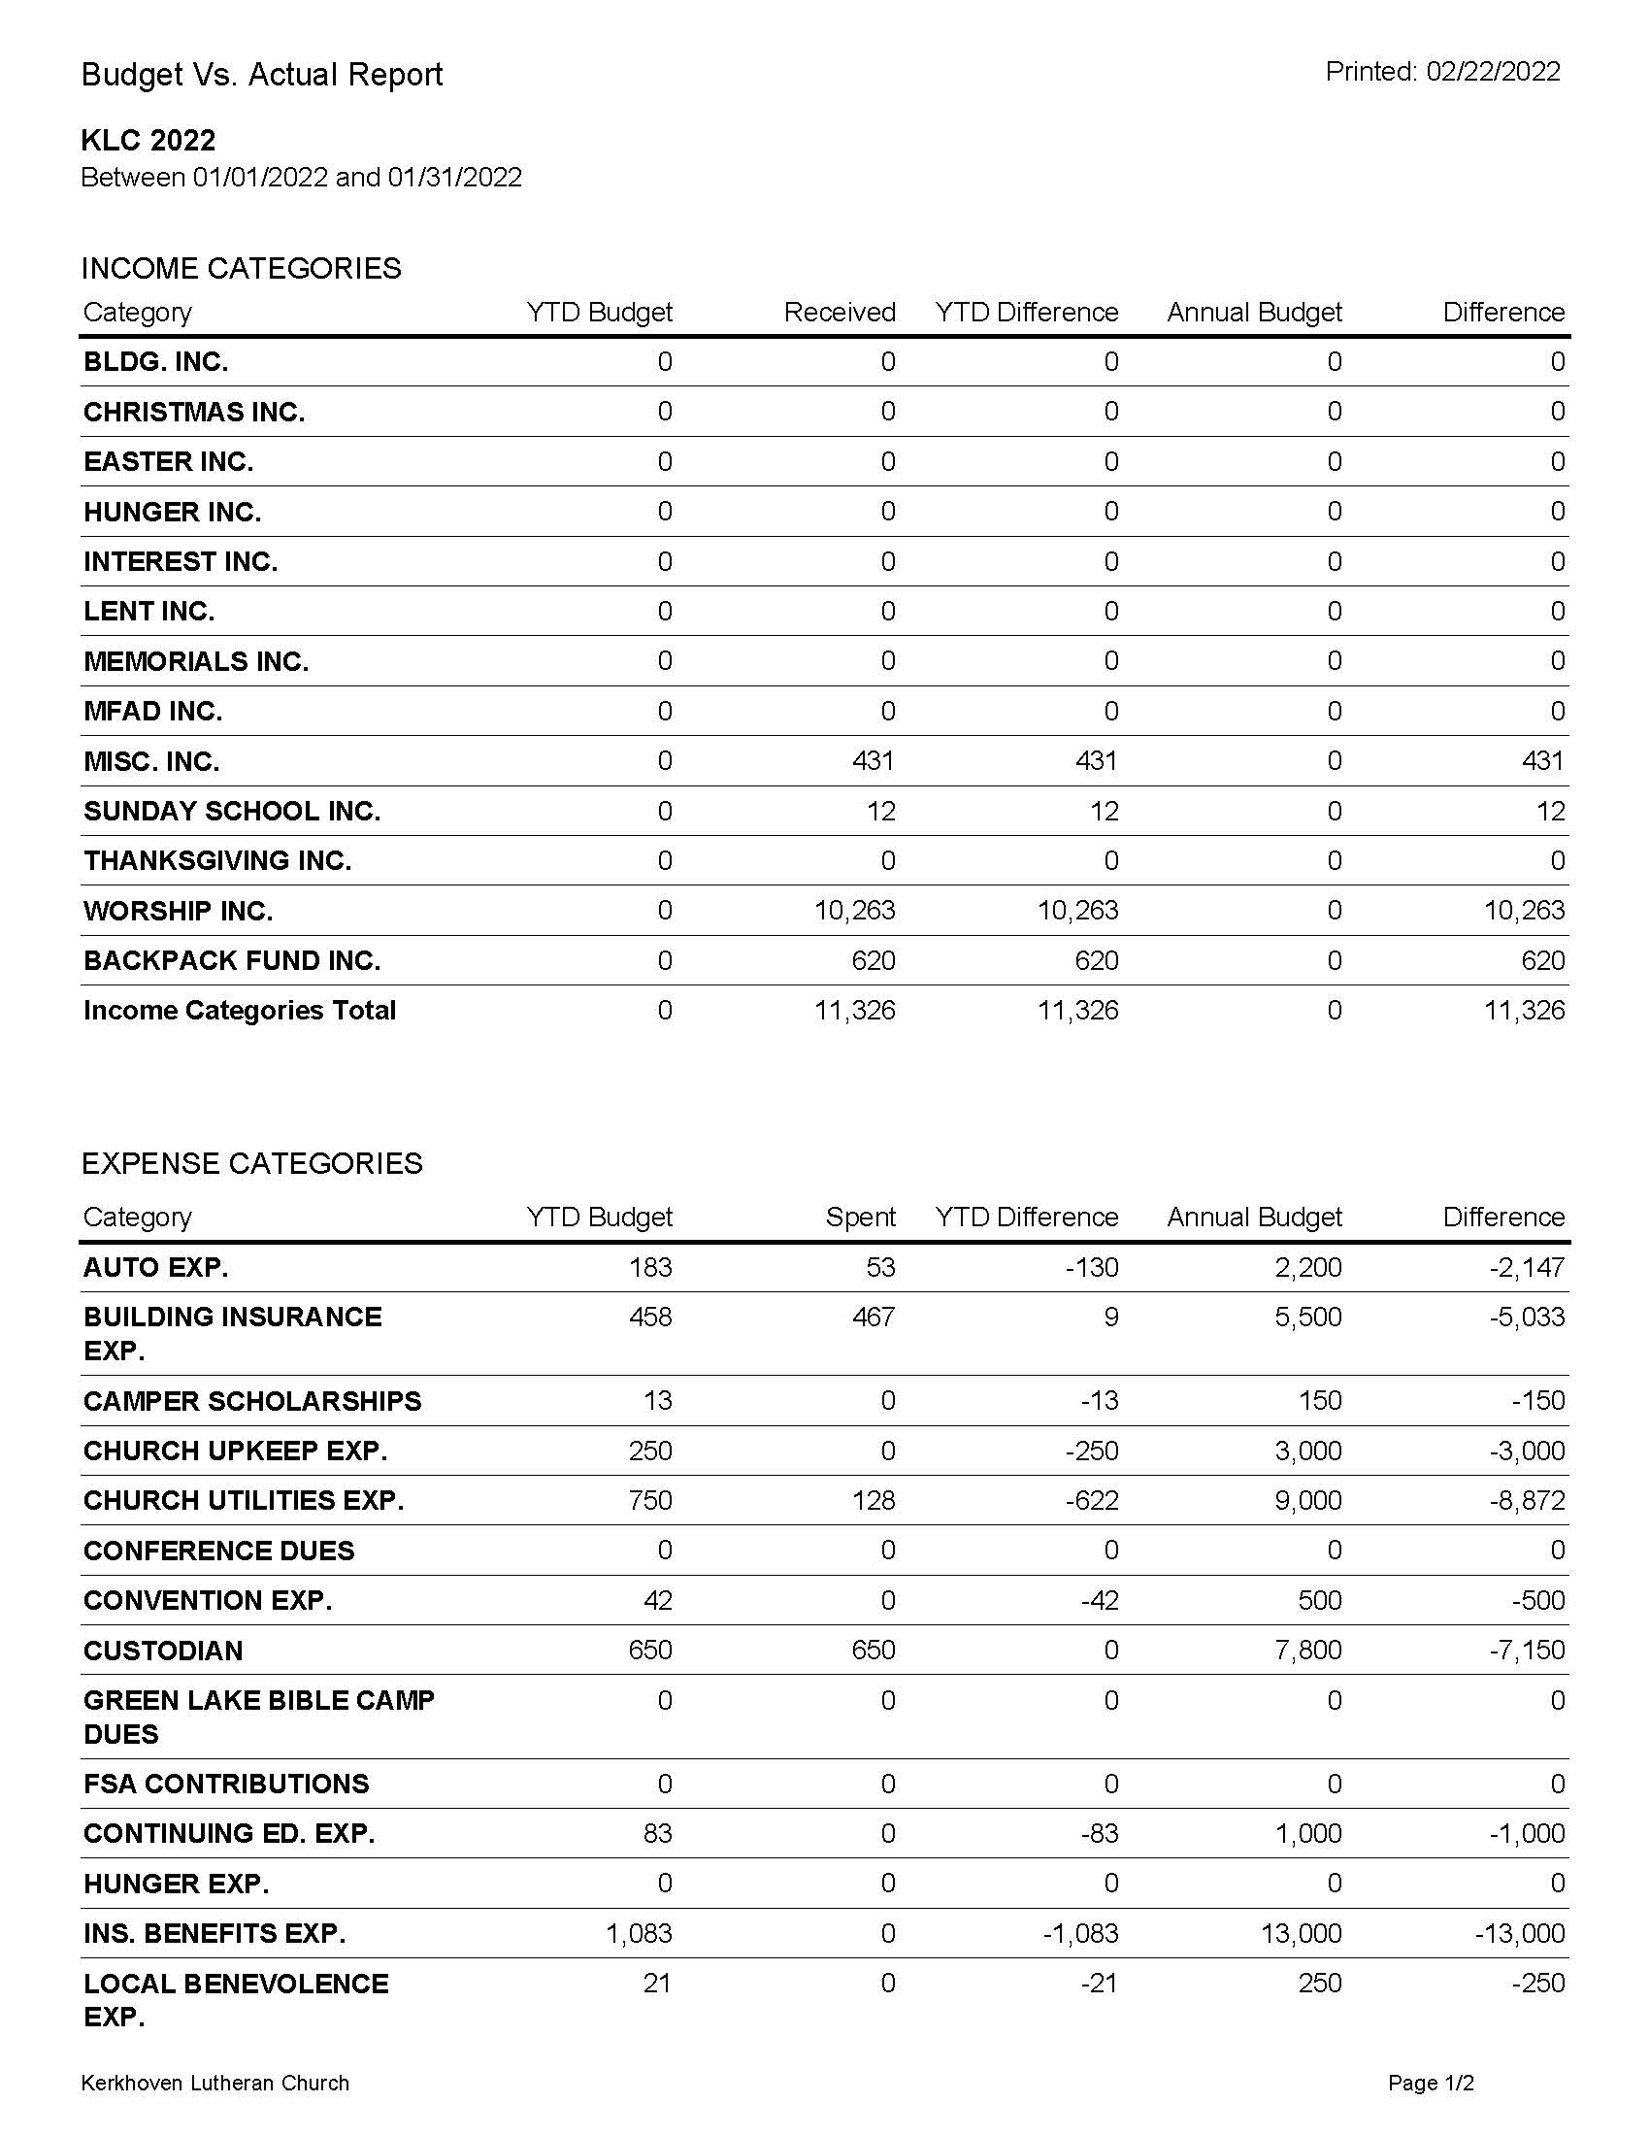
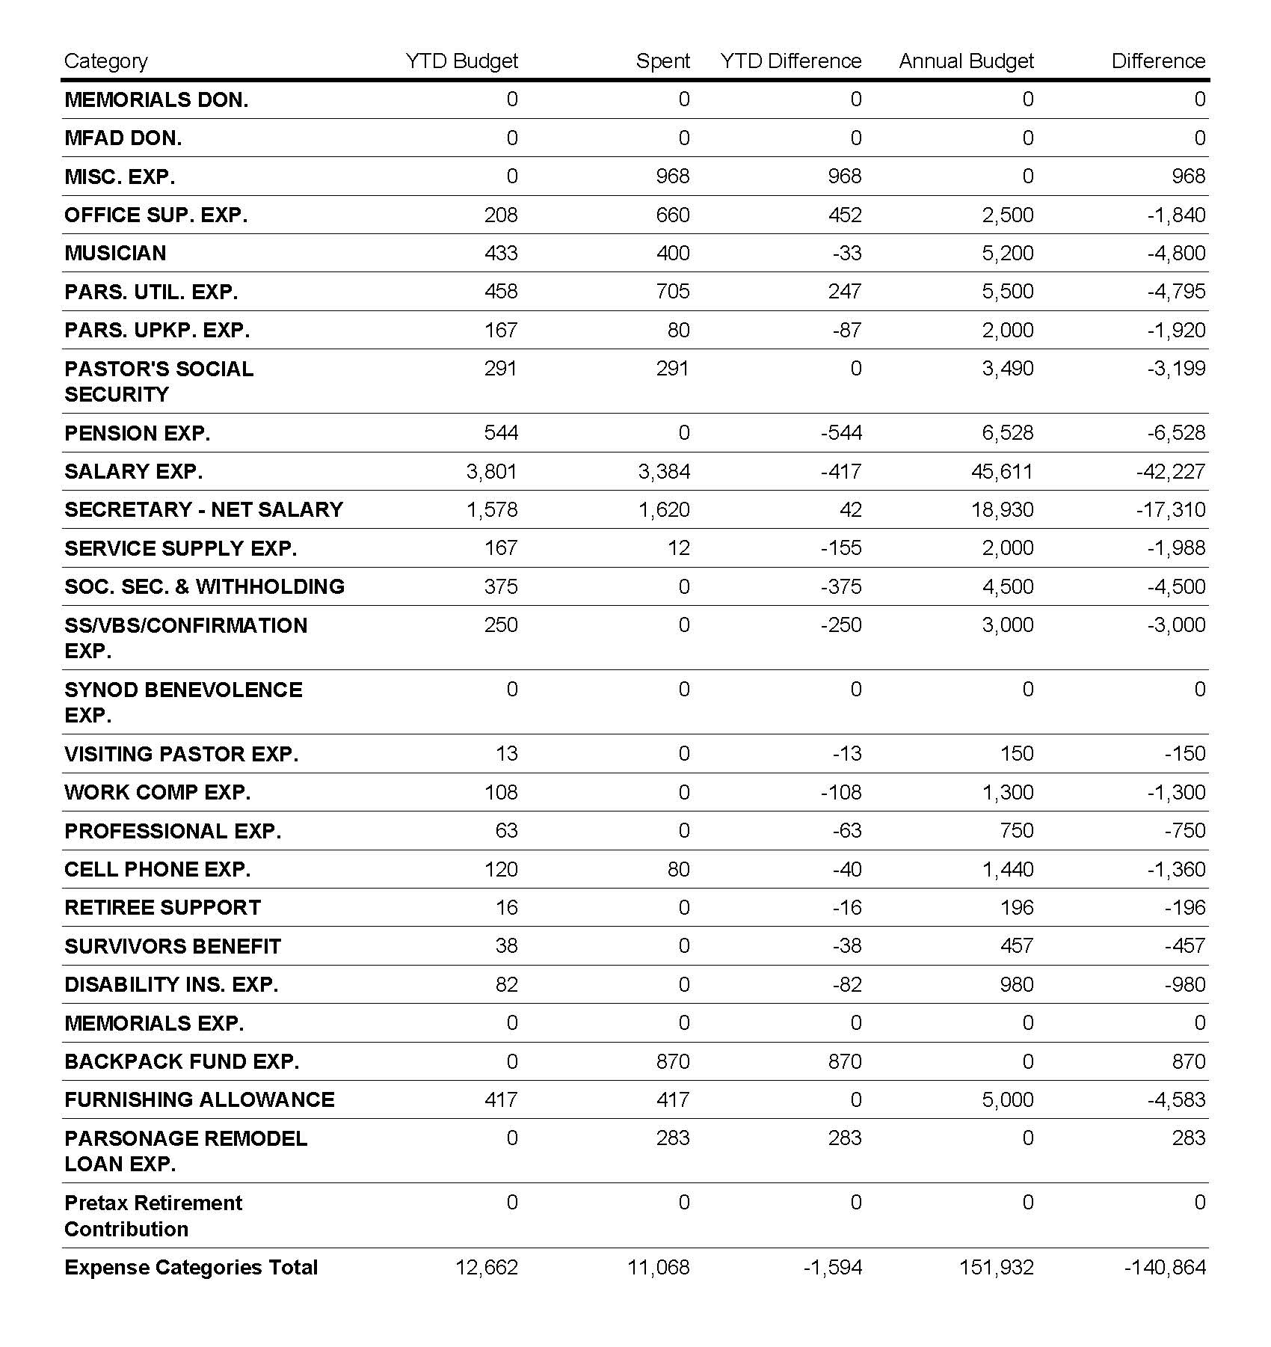

Beverly Henjum – 1st | Adrian Gordon – 9th | Dan Henry – 23rd
Roger Jeseritz – 1st | Katrina Nichols – 10th | Matthew Falk – 23rd
Nicole Muller – 1st | Henry Buller – 11th | Kyle Meyer – 23rd
Sydney Carlson -1st | Sarah Carlson – 12th | Genevieve Berger – 23rd
Boyd Doering -2nd | Terry Petersen – 12th | Becky Spanier – 23rd
Abby Holtkamp – 2nd | Bryce Guse – 15th | Nicholas Baker – 24th
David Amundson – 3rd | Pat Molenaar – 15th | Wyatt Rudningen – 25th
Carol Hjelle – 3rd | Axel Nelson – 16th | Lindsey Henry – 26th
Galen Henjum – 3rd | John Hjelle – 16th | Kelly Hauge – 28th
Cortney Lundberg – 3rd | Kris Wagner – 18th | Hayden Larson – 29th
Pastor Michael Buller – 3rd | Ruth Ann Ashburn – 20th | Jared Kelm – 30th
Ella Molenaar – 5th | Becky Mulder – 21st | Kolbie Nystrom – 30th
Barney Lilly – 5th

BAPTISMS IN MARCH
We remember people’s birthdays, but we also need to remember the day of our spiritual birth, our baptismal day. Please take note of who was baptized during this month and wish them a happy baptismal day.
Roger Jeseritz – 1st | Donna Baker – 9th | Brielle Torkelson = 19th
Jon Rothers – 1st | Courtney Walsh – 14th | Bill Doering – 20th
Olivia Lundberg – 2nd | Ruth Henry – 14th | Dennis Doering – 29th
Gemma Rudningen – 3rd | Kevin Hauge – 16th | Katie Ziehl – 30th
Wayne Nelson – 4th | Michael Holtkamp – 16th | Travis Falk – 30th
Henry Arends – 5th
The KLC Council will be meeting on Wednesday, March 9, 2022, following the Lenten Worship service, approximate time 7:15 pm. If your board has not met please try to have a meeting, or touch base with your members prior to the council meeting and have all items for the agenda to Ann by Tuesday noon. Thank you!

Luther League Youth and Parents: There will be a meeting to discuss the Easter service and breakfast involvement on Sunday, March 13, 2022, immediately after the worship service during coffee hour.

March 6 | March 20
*Lily Winter | *Isaac & Izzy Wirth
Kelsey & Jared Cortez | Junior Hauge
Axel Nelson | Boyd Doering
March 13 | March 27
*Emily & Alex Zurn | *Isaac & Logan Rudningen
Masyn & Jett Olson | Brady Guse
Bailey & Savannah Peterson | Hayden Larson
Quilting will continue into March with sessions scheduled for Wednesday, March 2nd and March 9th at 9:00 am. Decisions will be made as to if anymore sessions will be taking place during March.
Saturday March 12th at 9:00 am is the WELCA Unit meeting in the Fellowship Hall.
WELCA will be serving the Lenten meal on Wednesday evening, March 16th. Serving begins and 5:30 and Lenten worship follows at 6:15 pm.
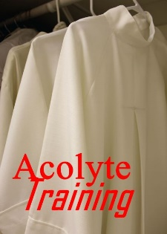
Acolyte Training: The first session of acolyte training took place on Sunday, February 27, following the worship service. However, due to the limited number of youth in attendance for the acolyte training this will be repeated on Sunday, March 6 and again on other Sundays following the worship service until all of the youth have been trained. This is for all youth who are in third grade and older who would like to serve and acolytes.

Meals on Wheels: KLC is responsible for the local delivery of Meals on Wheels for the month of April. The meals are delivered once a week on Wednesdays at 11:00 am. The options of each person ordering the meals is to order as many frozen meals as they would like to receive for the week and they can also order a hot meal for the day of delivery. There are currently approximately 4 local Kerkhoven residents that receive these meal. This varies by week. It takes approximately an hour to deliver the meals. Please sign up on the list on the table between the church offices for the Wednesdays that you would be able to deliver the meals. Thank you.
March 13, 2022
Come and Join the Fun: Tater Tot Hot Dish Challenge/Bingo night:
It's time to settle the debate - what is the best way to make a Tater Tot Hot Dish? Brush up on your skills and bring your best recipe to the challenge. Some basic rules:
- Recipes can be traditional or more unusual/exotic
- Make in a clear glass or aluminum 9 x 13 pan (no personalized or distinct containers, to keep the judging fair and anonymous)
- Must use standard sized tots, Ore-Ida or other brand

Challenge will be Sunday, March 20, at 5:00 p.m. in the fellowship hall. To enter, bring your hot dish ready to eat by 4:45 p.m. Tasting will go on until 6:00 p.m., when votes are tallied, and a winner announced. Bingo to follow.
You don't have to bring a hot dish - everyone is invited to be part of the tasting and judging! There will be a free-will offering collected, which will go toward the new freezer meal ministry.

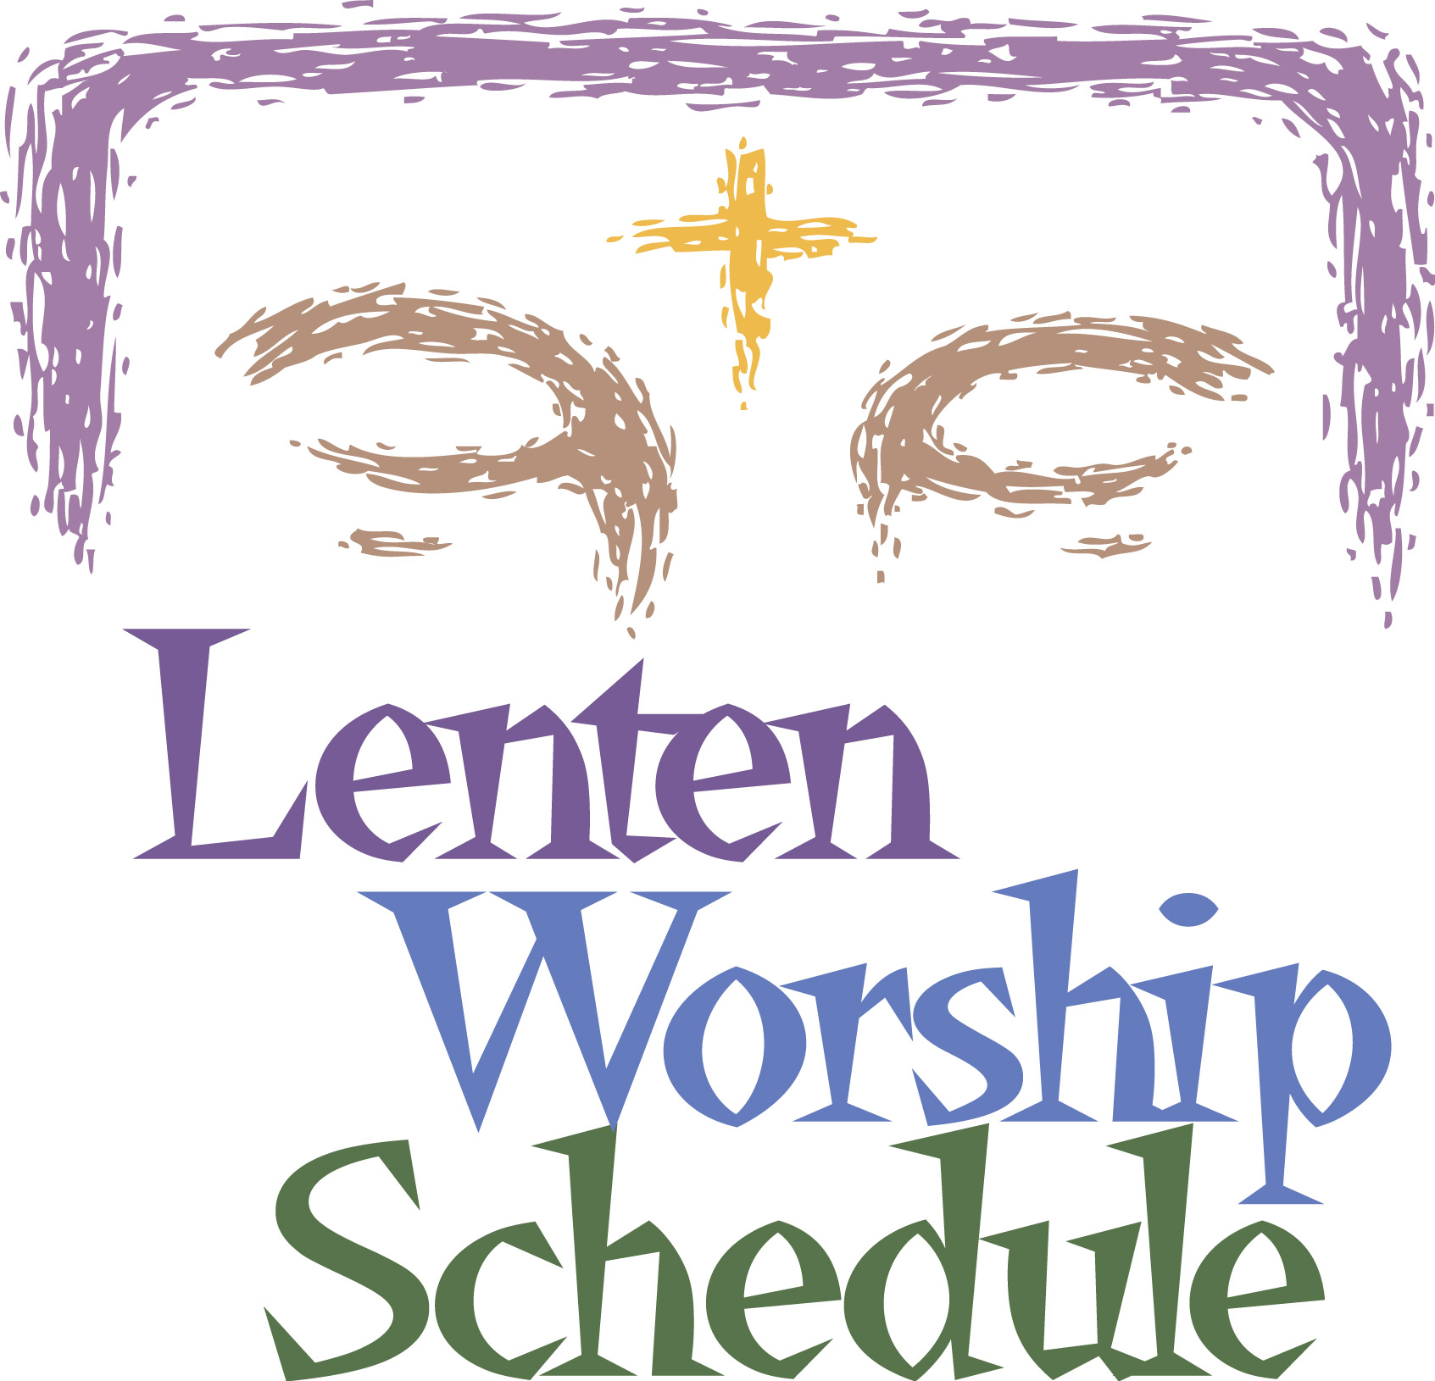
Wednesday, March 2, 2022 5:30 pm Lenten Meal
6:15 pm Ash Wednesday Worship/Imposition of Ashes/Holy Communion
First Sunday in Lent, March 6, 2022 9:00 am Worship/Holy Communion
Wednesday, March 9, 2022 5:30 pm Lenten Meal
6:15 pm Lenten Worship
Second Sunday in Lent, March 13, 2022 9:00 am Worship/Noisy Offering (Food Shelf)
Wednesday, March 16, 2022 5:30 pm Lenten Meal
6:15 pm Lenten Worship
Third Sunday in Lent, March 20, 2022 9:00 am Worship/Holy Communion
Wednesday, March 23, 2022 5:30 pm Lenten MEal
6:15 pm Lenten Worship
Fourth Sunday in Lent, March 27, 2022 9:00 am Worship
Wednesday, March 30, 2022 5:30 pm Lenten Meal
6:15 pm Lenten Worship
Fifth Sunday in Lent, April 3, 2022 9:00 am Worship/Holy Communion
Wednesday, April 6, 2022 5:30 pm Lenten Meal
6:15 pm Lenten Worship
Palm Sunday, April 10, 2022 9:00 am Worship
Maundy Thursday, April 14, 2020 6:00 pm – 7:00 pm Sedar Meal and First Communion in Fellowship Hall
Good Friday, April 15, 2022 6:45 – 7:30 pm Worship Service

LENTEN MEALS
This year the Lenten Meals are being served by the Boards, Committees and organizations of KLC. Service starts each Wednesday evening at 5:30 pm in the Fellowship Hall.
March 2, 2022 Board of Christian Education
March 9, 2022 Board of Worship and Witness
March 16, 2022 WELCA
March 23, 2022 Board of Properties
March 30, 2022 To be determined
April 6, 2022 To be determined

UPDATES AND ANNOUNCEMENTS

Baby Shower: There will be a Baby Shower for the baby of Amanda Sundin and Michael Holtkamp, on Saturday, March 19, 2022, at 1:00 pm at the KLC Fellowship Hall.
The MESSENGER

Bridal Shower: There will be a Bridal Shower for Mallory Carlson on Sunday, April 10, 2022 at 1:00 pm in the KLC Fellowship Hall. Mallory will be married to Ryan Vos at KLC on Saturday, July 23, 2022.
Noisy Offering: March is Food Share Month and the KLC Noisy Offering for this month is designated to go to the Swift County Food Shelf.
Service Opportunity: There is still one position on the Evangelism and Outreach board that is vacant. All confirmed members of KLC are eligible and encouraged to participate in the mission of our church including serving on boards and committees. We would like to encourage all members, youth and adults to pray and consider serving on a board. If you are interested or would like additional information please contact a member of the board.

New Members: We have had some new members that have joined our church family by transfer since our last new member recognition and we are planning a new member recognition on Sunday, May 1, 2022, at our 9:00 am worship service. If you would like to become a member of KLC please make your wishes know to either Pastor Michael or the church office. If you are a currently a member of nother congregation you can request that church to send us a letter of transfer or we can assist you in requesting that.
Noisy Offering: March’s Noisy offering has been designated to the Swift County Food Shelf.

A publication of Kerkhoven Lutheran Church
February 2020
The MESSENGER
February 2020
The MESSENGER
February 2020
The MESSENGER
February 2020
February 2020
The MESSENGER

Please continue to remember these loved ones and friends in need of prayer during this month.

Phyllis Loven | Andrea Rath | Gladys Arends
Gene Halverson | Lee Meyer | Henry Arends
Wally Loven | Phyllis Meyer | Ev Williams

MISSIONARY FOR A DAY TO SUPPORT Rev. Dr. Philip J. and lou Knutson
MISSIONARY FOR A DAY DONATIONS FOR FEBRUARY 2022
February 2, 2022 | In Memory of Lynn Knutson & Doris Bakken by Clarine Beck
February 5, 2022 | In Memory of Doris Bakken by Barney and Jean Lilly
February 6, 2022 | In Memory of Dick Carlson by Barney and Jean Lilly
February 6, 2022 | In Memory of Doris Bakken by Mary Kay Austvold
February 6, 2022 | In Memory of Dick Carlson by Mary Kay Austvold
February 20, 2022 | In Memory of dick Carlson by Clarine Beck

--------------------------------------CLIP AND PLACE IN OFFERING PLATE------------------------------------

I would like to support Missionary for a Day on the date of ____________________________________
Circle one: In honor of/In Memory of/In Thanks to God for ____________________________________

Kerkhoven Lutheran Church
402 North 12th Street, PO Box 317
Kerkhoven, MN 56252
www.kerkhovenlutheranchurch.com
First Std
U.S. Postage
PAID
City, ST
Permit # 000

Jesus loves...

