PRE-READER



**Christmas 1**

Is there a Christmas tree in your worship space?

If so, look at the kinds of ornaments

and draw them on this tree below. If

not, decorate this church Christmas

tree with other Christmas symbols like

angels, candles, and stars.

•

Today is the

**first**

Sunday after

**Christmas**

.

•

The color of the Christmas season is

**white**

.

•

We

**celebrate baby Jesus**

during the

Christmas season.

This manger is missing someone

important! Draw baby Jesus in the

manger. Then color the picture.

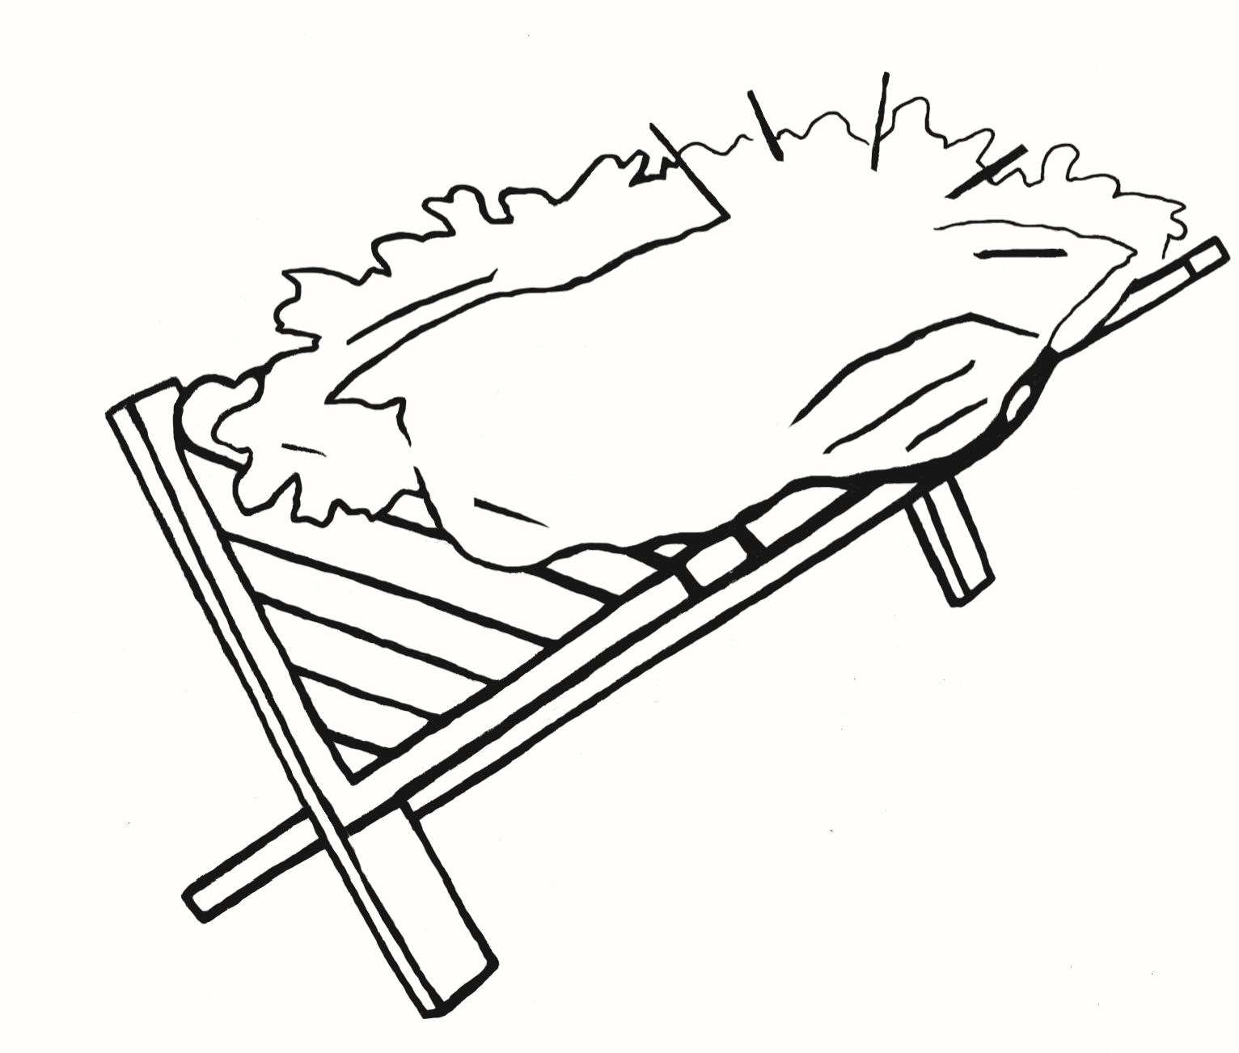

in the temple with the temple teachers.

Spark: Activate Faith Bulletin copyright © 2016 Sparkhouse. All rights reserved.

CHRISTMAS 1

May be reproduced for local use provided every copy carries this notice.

Jesus asked, “Why were you looking for

me? Did you understand that I was in my

Father’s house?”

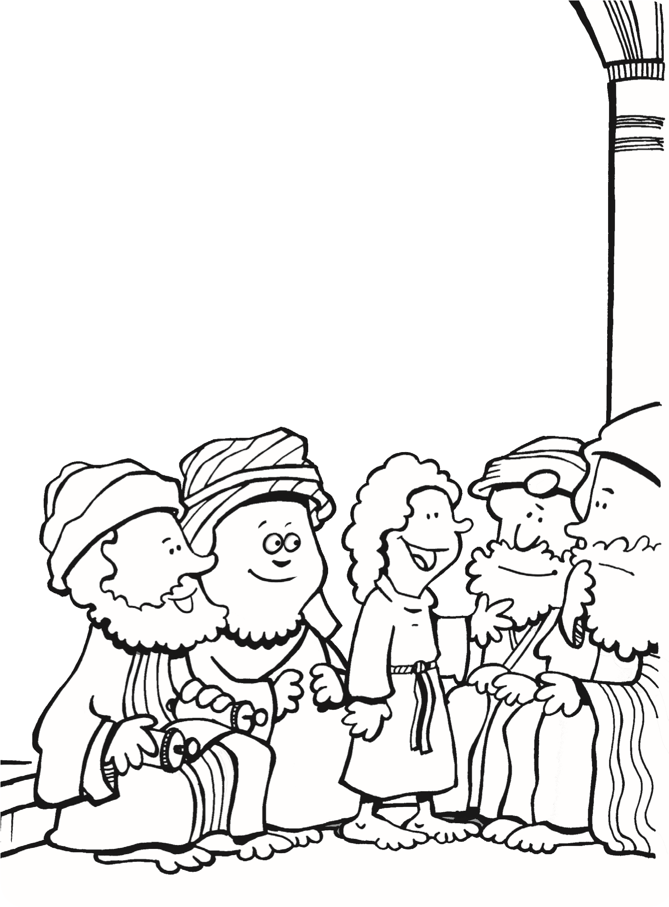

In today’s Bible story, Jesus’ parents were looking for Jesus

and could not find him anywhere! They finally found Jesus



START

END



In the maze below, help Mary and Joseph find Jesus.