Caring for others
F
i
r
s
t
S
u
n
d
a
y
f
C
h
r
i
s
t
m
a
s
o
What a sad day! Ben’s apartment house was ruined . . . and his Christmas presents were all charred by the fire. What can Joe do to help? What would Ben need if his things were ruined by the fire?

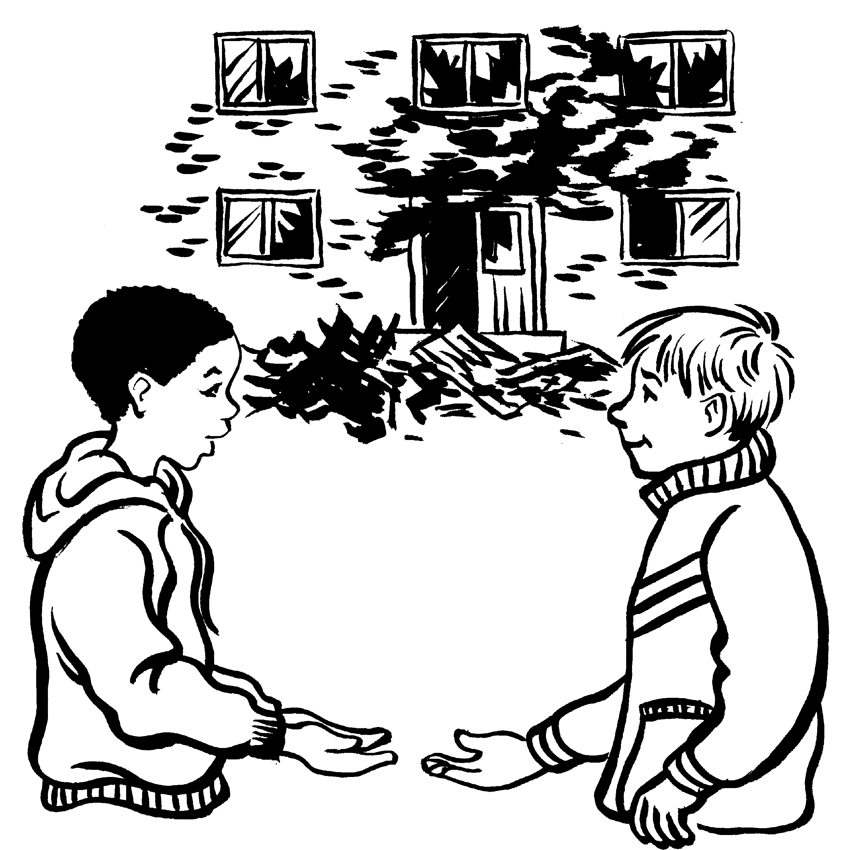
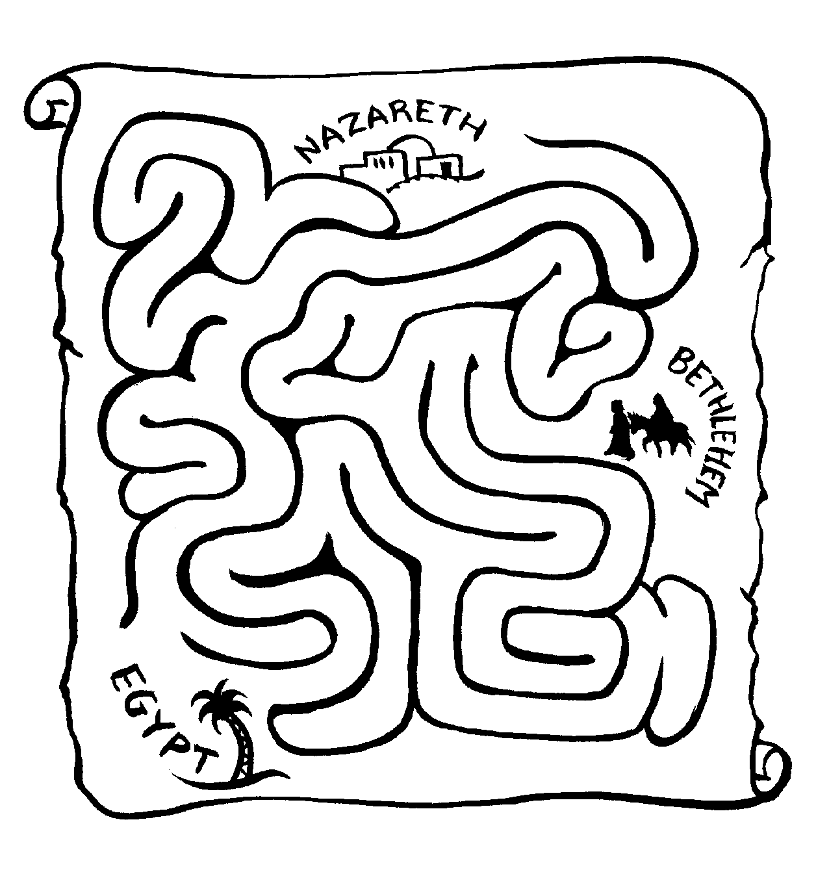
Welcome to worship. Joseph was told in a dream to leave Bethlehem for a safer place. So he took Mary and Jesus on a long journey.
Follow the maze. Print the name of the first stop for Jesus’ family:
_______________________
Draw something Joe could give Ben. What would you do if Ben were your friend? What would you say to him?
Let the youngest child in the family choose an activity to do
Finish the maze. Write the name of their last stop:
together.
_______________________
Kids Celebrate copyright © 2004 Augsburg Fortress.May be reproduced for local use.
All God’s children
Matthew 2:13-23
When Jesus was born
King Herod became
very angry and afraid.
He thought Jesus had
come to take over his
kingdom. Herod killed
many young children
in his anger when he
couldn’t find Jesus.
Mary, Joseph, and Jesus
had already escaped
to Egypt.
God loves all children.
Circle the cross on each
child. Crosses remind us
we are children of God.
Draw a cross here:
All of God’s children are
unique, but there is one
thing in common for the
three children in each row.
Check all rows—up,
down, and diagonal.
Circle the common item
in each row.
Pray for those who are
traveling this week.

Keep all children safe in your care, Lord. Be with us when we care for those who are hurting. Amen

