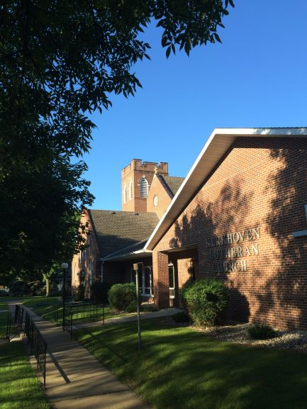
Kerkhoven Lutheran Church
Evangelical Lutheran Church in America

Living and trusting in god’s amazing grace we welcome all to worship, learn and serve in celebration of Christ’s love.

ANNOUNCEMENTS FOR the week of July 25 – July 31
There will be no worship service at Kerkhoven Lutheran Church on Sunday, July 25, 2021. There is a joint Kerkhoven Community Worship Service at 10:00 am at the Lion's shelter at Pillsbury Park. Please plan to attend. Offerings for Kerkhoven Lutheran can be given at the Community Worship by designating in memo line of check - Kerkhoven Lutheran or place in an envelope stating our church. Church or offerings can be mailed or dropped off at the church. Also, you can donate on line through the donate option on our website. Attached are the announcements and also the weekly devotions for the coming week.

PRAYER CONCERNS: (Periodically these prayer concerns will be moved to the prayer concerns list in the newsletter) Donna Baker, Wally and Phyllis Loven, Calvin Carls, Pastor Bill Miller

Stewardship Snippet: The Nineth Sunday after Pentecost , July 25, 2021 Now to him who by the power at work within us is able to accomplish abundantly far more than all we can ask or imagine, to him be glory in the church and in Christ Jesus to all generations, forever and ever. Amen. – Ephesians 3:20-21
Remember that we do not walk alone. Jesus is with us in our efforts to steward our bodies to good health. Scripture abounds with feeding stories—two in this week’s lessons alone—so we can trust that God will provide for our needs if we put forth the effort. Eat well, share what you have, and trust God to help you care for the marvelous gift of your physical body.
--Rob Blezard Copyright © 2021, Rev. Robert Blezard. Reprinted by permission.

Meals on Wheels: KLC is responsible for the local delivery of Meals on Wheels for the month of August. The meals arrive at KLC each Wednesday at 11:00 am. These are the meals for the entire week for each recipient and it takes approximately 1 hour to deliver them. Dates are August 4, 11, 18, and 25. If you can deliver any or all of these Wednesdays, please sign up on the sheet that is on the table between the office doors. Thank you.

Open House Baby Shower: There will be an Open House Baby Shower for the Casey and Jordan Krieger baby at 10:00 am on Saturday, July 31, 2021, in the KLC Fellowship Hall.

Next Sunday, August 1, 2021: The Tenth Sunday after Pentecost

9:00 am Worship Service with Holy Communion.

KLC Office Hours for the Week of July 26 - 31: Church office hour will be Monday - Office closed, Tuesday and Wednesday 8:30 – 3:30 pm, Thursday 9:00-4:00. The church office is closed on Friday. If you have questions or need assistance please call: Ann Hanson – 320-894-4464.

WELCA Quilting: Quilting continues each Wednesday 9:00 am in the Fellowship Hall. Masks and social distancing protocols will be followed. There will be a catered noon luncheon with a free will donation each week.

Grief Support: Carris Health - Rice Hospice will be offering “Healing Hearts” Grief Support Groups for individuals who have experienced the death of a loved one. Our groups meet for a series of 6 weeks as we address a new topic for each week. We have found the series being more effective if a person is able to attend all the sessions. Check with church office or the KLC website for additional information.
KLC Executive Board Board of Christian Education
Ted Almen, President Jesse Nelson Amber Doering
Scott Mitteness, Vice Pres. Shelly Lottman Kris Cortez
Eric Rudningen, Treas. *Heidi Winter Melaine Wirth
Beth Carlson, Secretary Cindy Clasen

Board of Worship & Witness Board of Stewardship and Finance
* Susan Nelson Barb Norton Lane Carlson Mike Wirth
*Arlene Carls Ann Hanson Cliff Nystrom Vacancy
Becky Carlson Tyler Carlson
Board of Evangelism & Outreach Board of Properties & Grounds
Ross Carlson Christy Nystrom Jacob Carlson *Scott Doering
Kristin Schmidt *Alison Nelson * Reid Carlson Ryan Carlson
Ashley Weddington Tony Olson Andrew Forsell

KLC CALL COMMITTEE
Amber Doering, Chairperson Lee Meyer
Kristin Stivers, Secretary Leif Carlson
Tom Baker, Liasion to Council Julia Carlson
Loretta Falk

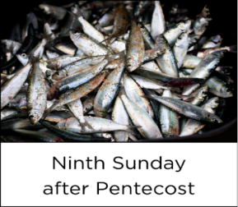
July 25, 2021
John 6:1-21
Use this resource at home to guide your household’s daily devotions.
Pray: Light a candle. Open your devotion with prayer.
Lord of love, with patience you taught your followers to put their trust in you. Give us that same faith which commits all things to your steadfast hands: our resources, our time, and our very lives, in Jesus’ name. Amen.

Read: Read the key verses from Sunday’s reading.
When they had rowed about three or four miles, they saw Jesus walking on the sea and coming near the boat, and they were terrified. But he said to them, “It is I; do not be afraid.” (John 6:19-20)

Reflect: Reflect on the scripture summary.
When Jesus’ followers found themselves hungry with no access to food, Jesus opened their minds to finding a solution. A small boy, acting in faith and generosity, helped make the impossible possible. When Jesus’ followers found themselves stuck in a storm, Jesus opened their minds to a new thing. He walked on the water to guide them ashore. Jesus made the impossible possible, preparing them for the impossible events yet to come.
Connect: Connect in conversation with others in your household or community.
What was a high point of your day? What was a low point?
What miracles have you witnessed? If you haven’t, do you believe in miracles? Why or why not?
For the littles: Do you like to eat fish? How about bread?

Bless: Close your devotion with a blessing.
May God open your mind to the impossible. Amen.
Do: By acting on what we learn, we make God’s word come alive. Do the following activity this week.
Donate food (or better yet, money) to a local food shelf. Then volunteer your time there. (You can volunteer even if you have yourself used a food shelf.)
Go Deeper: Go to bit.ly/daily-devotions-rcl for the daily readings!
Monday, Psalm 37:12-22; 2 Samuel 11:14-21; Philippians 4:10-20
Tuesday, Psalm 37:12-22; 2 Samuel 11:22-27; Romans 15:22-33
Wednesday, Psalm 37:12-22; 2 Chronicles 9:29-31; Mark 6:35-44
Thursday, Psalm 51:1-12; Exodus 32:19-26a; 1 Corinthians 11:17-22
Friday, Psalm 51:1-12; Joshua 23:1-16; 1 Corinthians 11:27-34
Saturday, Psalm 51:1-12; Judges 6:1-10; Matthew 16:5-12

