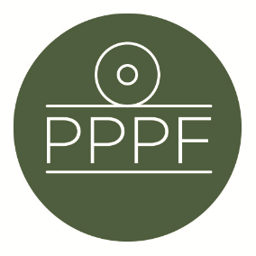
Peak Park Parishes Forum
Working for, and on behalf of, Local Councils within the Peak District National Park
Secretary: Peter Leppard, Sickleholme Cottage, Saltergate Lane, Bamford, Hope Valley, S33 0BE
Tel. 07860 624453 e-mail: secpppf@gmail.com

Meeting of the Management Committee to be held at 2pm on Tuesday 12 March 2024 at Aldern House, Baslow Rd, Bakewell, DE45 1AE

AGENDA

- To receive apologies for absence
.
- To accept the minutes of the meeting of 23 January

- To receive an update on the setting-up of Planning training for Parishes

- To consider a Permitted Development Rights consultation:
https://www.gov.uk/government/consultations/changes-to-various-permitted-development-rights-consultation/changes-to-various-permitted-development-rights-consultation .

- To receive an update on PDNPA Local Plan development

- Secretary’s report

- Finance
- To note the Forum’s FY2023/24 financial position to date
- To approve any payments

- To confirm date of next meeting
Peter Leppard
Secretary, Peak Park Parishes Forum 6 March 2024

