

**Parishes Bulletin 45**

Winter 2023 /24

**Derbyshire Dales District Council offering - ‘Would you like to make your off-gas home warmer and more energy efficient?’**

If we can’t offer you a grant, we may be able to provide other support via MEA's free and impartial energy advice service - Warmer Derby & Derbyshire 

You are an owner-occupier or rent privately.

Your home is not connected to mains gas i.e. you use oil, LPG, coal or electricity for your heating.

Your home has an Energy Performance Certificate (EPC) of D, E, F or G - www.epcregister.com. We can fund an EPC if you do not have one.

And

Your household’s combined annual income is under £31,000 (before tax), or you receive a qualifying means tested benefit

Derbyshire Dales District Council, Town Hall, Bank Rd, Matlock, DE4 3NN Call (01629) 761100

Marches Energy Agency (MEA) https://www.derbyshiredales.gov.uk/environment/energy-advice

**Local Plan Review Update**

We have recently commissioned consultants to undertake a population projection and housing needs assessment to cover the next plan period. This will give us a better understanding of the make-up of our communities and how it might change over time, and will identify the housing issues that planning policy needs to address.

We know that many residents are concerned about second homes, holiday homes and short term rentals, many of which do not need planning permission. The government is currently consulting on whether to introduce a new so-called ‘new use class for short term lets’ which could give local planning authorities more control.

We are on schedule to take our Issues and Options report to Authority Committee in July and will consult with residents and other stakeholders as soon as possible after then.

**Peak District National Park Affordable Housing Scheme Wins National Award**

A newly-completed housing scheme, providing affordable rental homes in the heart of the Peak District National Park, has won national recognition for its contribution to local housing needs and land regeneration in a National Park community.

Bradwell Springs, in Bradwell (Derbyshire), beat off competition from housing developments in London, Hastings and Bridport.

The ‘Beautiful Community-Led Homes’ award has been presented by the Community Land Trust Network to Bradwell Community Land Trust for the Bradwell Springs affordable housing development.

Bradwell Springs is a development of 55 houses, 12 of which are two-bedroom affordable rental houses owned by Bradwell Community Land Trust and managed by Peak District Rural Housing Association. The rest of the houses are open market housing.

The site was formerly an engineering works with various industrial sheds and buildings of no architectural interest in a central village location. The new houses have been sympathetically designed with an appropriate external appearance that reflects local building traditions.

Positive seeds were sown for the success of the development as early as 2015, when National Park planners and the community worked together to identify both the local need for affordable homes and to earmark Bradwell Springs as a site for community development.

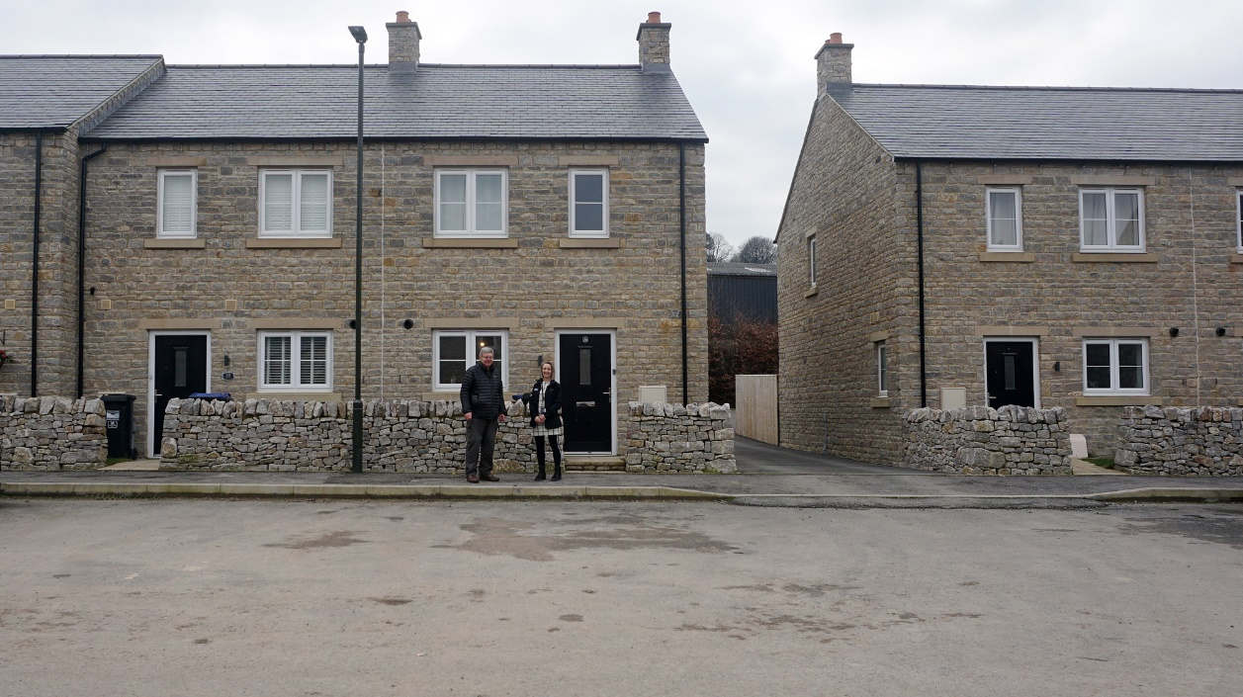

**1** Award winning housing development at Bradwell Springs

**Birds of Prey Initiative Closes**

At the end of April the Authority confirmed it would be closing the Peak District Bird of Prey Initiative after more than a decade of efforts to return ‘raptor’ populations to target levels last seen in the 1990’s.

Although some species have seen a return, the breeding presence of others remains disappointingly low and the years of the Initiative’s existence have continued to see incidents of wildlife crime taking place within the Peak District. These factors have led to some original partners already stepping down from the initiative and others indicating their future intention to do so to the Authority. This recently included those involved in the annual surveying of birds of prey in the Initiative study area, and therefore the Authority as convenors felt the group was no longer viable.

The Authority recognises that some existing partners are disappointed by this decision, however until meaningful change is seen with aspects such as raptor persecution we will be looking to explore alternative means of safeguarding raptors and securing the required population increases. This includes working with the police – as we have done throughout the Initiative – and other partners, more details of which will be shared in the weeks ahead.

Our full statement on the Initiative can be found here: Peak District Bird of Prey Initiative to close as persecution cases continue: Peak District National Park

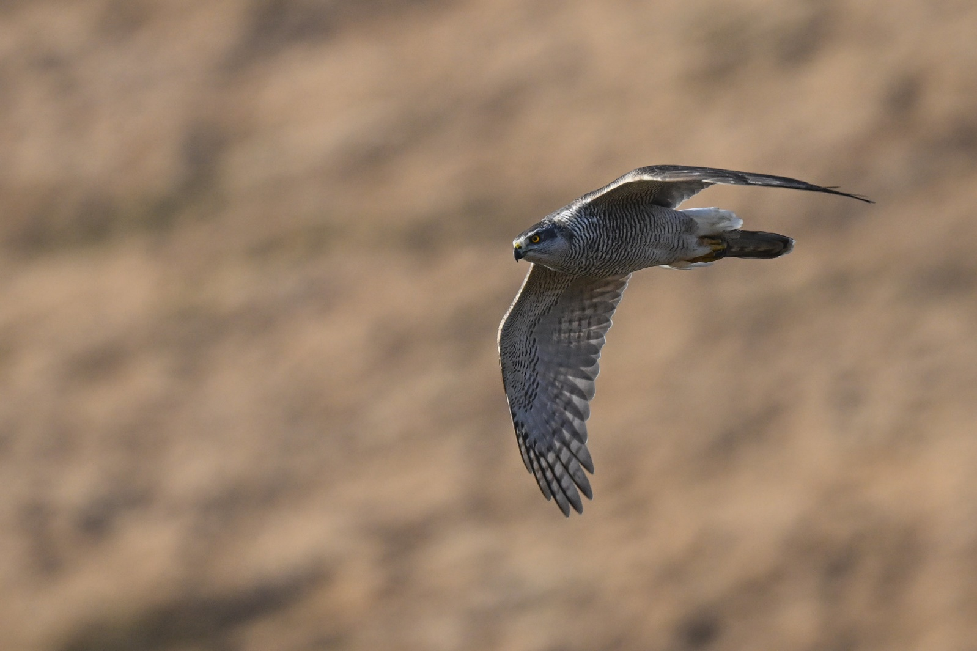

**2** Goshawk

**Stanage North Lees- A Fresh Look for Information**

This summer will see the long-awaited replacement of three large information panels into stone plinths at various locations at Stanage Edge and North Lees Hall.

The new boards have been attractively designed with an array of historical, wildlife and navigation information sharing the story of the estate and current efforts for conservation and climate change. Visitor advice is also included to enable safe and responsible exploring of the estate, along with plenty of photographs.

For the first time, the boards’ content has also been translated into several additional languages which can be accessed instantly via a QR code.

The boards have been funded by the government’s Farming in Protected Landscapes (FiPL) programme.

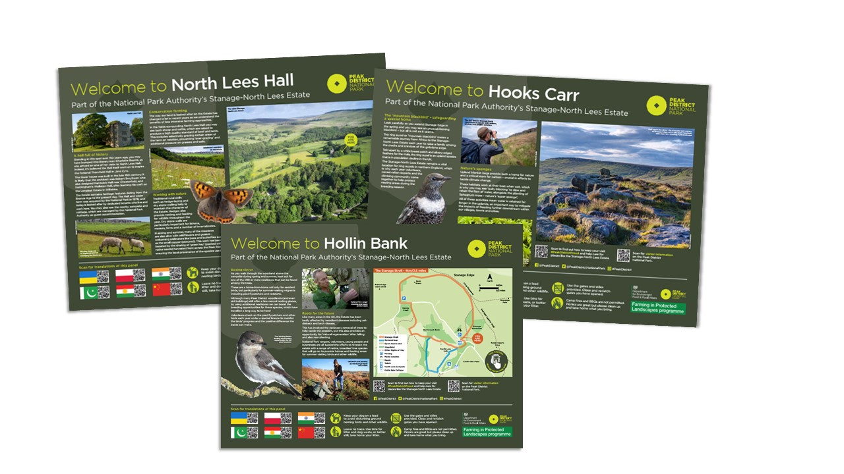

**3** New information boards at Stanage North Lees

**Farming in Protected Landscapes (FiPL)**

Farming in Protected Landscapes is a Defra funded programme for farmers and land managers which has recently been extended to March 2025. It is aimed at delivering benefits for climate, nature, people, and cultural heritage and nature friendly sustainable farm businesses. Grants are based on national Countryside Stewardship payment rates or at a percentage of the costs with the grant rate depending on the degree of economic return.

In the Peak District we now have over 200 agreements varying in size from £1000 to £100,000. https://www.peakdistrict.gov.uk/__data/assets/pdf_file/0022/416083/Projects_Funded_by_FiPL_2023_03.pdf Many are with individual farmers with others being collaborative agreements based on groups of farmers working together, sometimes with another organisation acting as the applicant.

Taddington Parish Council is using the FiPL grant to help restore a site in its ownership at High Well. This includes scrub control and wall restoration to conserve flower-rich grasslands and re-instate grazing, with plans to repair the well itself. The Hope Valley Climate Action is working in partnership with the Hope Valley Farmer Group to plant new hedgerows to benefit nature, landscape and carbon storage. In the South-west Peak farmers are working individually and in partnership with relevant organisations to deliver benefits for water quality and flood control alongside nature. 10 farmers have installed new permissive paths and others have been supported in the costs of opening pop-up campsites and other visitor infrastructure.

With 2 years of funding still remaining the project team are keen to hear from anyone with ideas that meet the themes of the programme and contribute towards the National Park Management Plan. Please contact us at farming@peakdistrict.gov.uk or at 01619 816200. Guidance and further information can be found at Farmers and land managers: Peak District National Park

On the next page are some pictures of a scheme funded through FiPL.

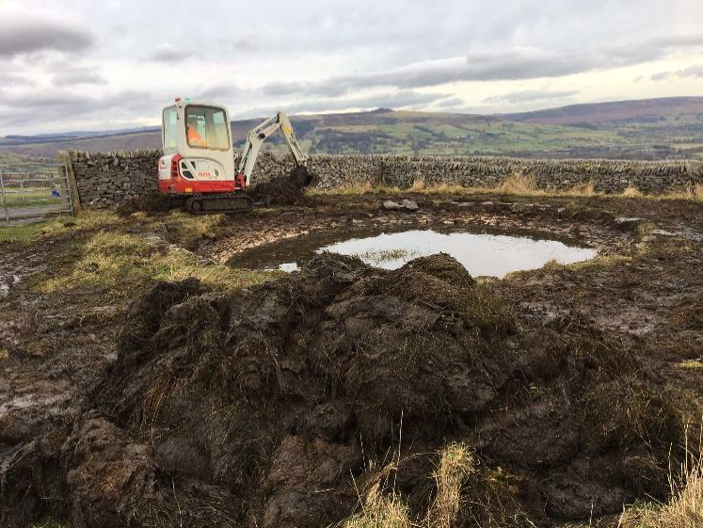

**4** FiPL- Paradise Farm Pond restoration - work in progress

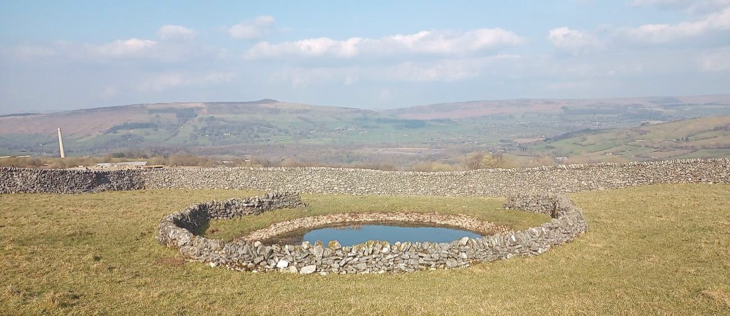

**5** FiPL- Paradise Farm pond restoration- finished scheme

**Rights of Way in the Peak District National Park**

The National Park Authority is continuing to have to make some difficult decisions around the resources we have available and, in this light, we have undertaken a review of our work in relation to public rights of way in the Peak District National Park

The powers, responsibilities and budgets to manage all rights of way within the national park rest with the respective local councils, with the National Park Authority helping them when resources have allowed.

However, there is a need for us to concentrate our reduced resources and we will, in forthcoming years, focus our work on rights of way where our resources will have the greatest impact for the most people. That means focussing on routes such as our Walks Around series, as well as our award-winning Miles Without Stiles routes. We’ll also be working over the next year or so on improving access on the other promoted routes and those rights of way connected with the main visitor hubs. We will review our work year on year to target the routes most in need of our resources. But this approach defines our role better for everyone and enables us to concentrate on where we can have the most impact. Our trails will continue to be maintained and cared for in the same way as always and we will continue to act as the relevant authority for access land under the Countryside and Rights of Way Act 2000

One of the ways you can help us is to send your reports on rights of way issues to those who have the powers and duties to undertake this work – the local councils. Each of the councils that make up the national park area has an online reporting system, enabling customers to easily report problems directly to those who can take action. The links are provided below.

To enable the process to work efficiently we will direct anybody reporting rights of way issues to these online reporting systems and we will not be able to act as intermediaries. We can then target our work on the routes identified as having the maximum impact for our resources in line with our objectives and in agreement with the relevant councils.

Rights of way issues - Derbyshire County Council

Public Rights of Way (staffordshire.gov.uk)

Cheshire East Public Rights of Way - Problem Path details - Your Cheshire East Account

Public footpaths and rights of way (barnsley.gov.uk)

Public rights of way | Kirklees Council

Report a problem - Public Rights of Way - Oldham Council

Public Rights of Way | Sheffield City Council

**Derbyshire Dales UKSPF - grants for businesses and communities**

Business in the Derbyshire Dales are invited to apply for grants to develop or diversify their business. Grants of 40 – 80% of eligible costs are available for projects costing £2,500 - £100,000, depending on business sector and other criteria, through the Rural Innovation Grants sceme

Businesses are also invited to seek free 1:1 advice on issues such as increasing productivity, upskilling a workforce or introducing new technology. Support is available through the new Derbyshire Dales Accelerator programme . Energy audits and grants are also available to help reduce costs and meet decarbonisation targets.

These programmes are funded by the UK Government through the UK Shared Prosperity Fund (UKSPF), part of the Levelling Up programme.

**Grants for Parishes in the Derbyshire Dales**

Derbyshire Dales District Council is currently offering grants to local parishes in their area. The Community Resilience Grants scheme is available for eligible charities, voluntary organisations, social enterprises and town/parish councils. Funding for revenue and capital projects is available, with a maximum of £25,000 being available for capital projects. Grant intervention rate is up to 80% / min grant £4,000 / max grant £25,000.

The programme is being managed by local charity Derbyshire Dales Council for Voluntary Service on behalf of Derbyshire Dales District Council and is part of the UK Shared Prosperity Fund (UKSPF) and Rural England Prosperity Fund (REPF) which was awarded to DDDC.

The fund aims to enable local organisations to deliver projects that maintain key rural services, facilities and community infrastructure; boost community and volunteering capacity to tackle locally identified challenges; enhance social inclusion and resilience; support post-pandemic recovery and help maintain safe and healthy communities; and take local action on climate change to help reduce carbon emissions and promote behaviour change.

See here for **more information and how to apply**

**Listening to locals - Peak District National Park’s chief executive launches new roadshows**

A new series of Peak District roadshows will give local people the chance to share their views with National Park Authority chief executive Phil Mulligan.

The Meet the Chief Executive roadshows are an opportunity to speak to Phil in an informal setting and to share views, ideas, opinions and other feedback about the work of the National Park Authority or the National Park Management Plan.

Events will be held regularly, around once a month, at venues across the National Park.

Read the full press release on our website.

**Planning Liaison Officer**

For any queries about this bulletin, please email sandra.harrop@peakdistrict.gov.uk

**Next Bulletin**

The next bulletin will be out in summer 2024.