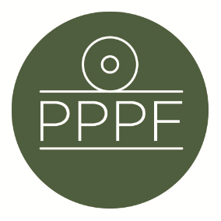
Peak Park Parishes Forum
Working for, and on behalf of, Local Councils within the Peak District National Park
Secretary: Peter Leppard, Sickleholme Cottage, Saltergate Lane, Bamford, Hope Valley, S33 0BE
Tel. 07860 624453 e-mail: secpppf@gmail.com

Meeting of the Management Committee to be held at 2pm on Monday 12 June 2023 at Aldern House, Baslow Rd, Bakewell, DE45 1AE
If requested by any Committee member, there will be an online link to the meeting, details to be advised.

AGENDA

- To receive apologies for absence
.
- To consider co-options of new members to the Committee

- To accept the minutes of the meeting of 17 April

- Matters arising from the minutes not elsewhere on the agenda

- To discuss progress towards, and consultations re, the revised Local Plan
(to include review of Minerals Topic Paper circulated by PDNPA on 21 Apr)

- To discuss any Management Plan issues

7. To note any Parish Members election issues

8. To discuss the emerging shape of Parishes Day, 7 Oct

9. To agree our response to PDNPA consultation (issued 25 May) on revised
Statement of Community Involvement

10. Secretary’s report

- Finance
- To note the Forum’s unaudited FY2022/23 accounts
- To note the Forum’s FY2023/24 financial position to date
- To approve any payments

- To confirm date of next meeting
Peter Leppard
Secretary, Peak Park Parishes Forum 6 June 2023

