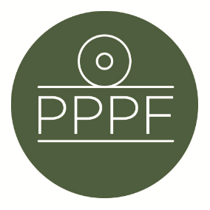
Peak Park Parishes Forum
Working for, and on behalf of, Local Councils within the Peak District National Park
Secretary: Peter Leppard, Sickleholme Cottage, Saltergate Lane, Bamford, Hope Valley, S33 0BE
Tel. 07860 624453 e-mail: secpppf@gmail.com

Meeting of the Management Committee to be held at 2pm on Monday 17 April 2023 at Aldern House, Baslow Rd, Bakewell, DE45 1AE
If requested by any Committee member, there will be an online link to the meeting, details to be advised.
AGENDA

- To receive apologies for absence
.
- To accept the minutes of the meeting of 13 February

- Matters arising from the minutes not elsewhere on the agenda

- To discuss progress towards, and consultations re, the revised Local Plan

- To discuss any Management Plan issues

6. Elections:
a. To discuss any PDNPA Parish Member election issues
b. To discuss any PPPF Management Committee membership issues likely to arise from
May’s Parish Council elections

7. Planning Enforcement: To review collated responses to the Secretary from
Committee members since the Committee’s February meeting.

8. To discuss the implications of the Meeting our Future Water Needs project - see
https://assets.publishing.service.gov.uk/government/uploads/system/uploads/attachment_data/file/873100/National_Framework_for_water_resources_summary.pdf

9. To agree a date(s) to be proposed to PDNPA for 2023’s Parishes Day

- Secretary’s report

- Finance
- To note the unaudited accounts for FY2022/23
- To approve any payments

- To confirm date of next meeting
Peter Leppard
Secretary, Peak Park Parishes Forum 4 April 2023

