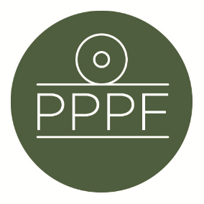
Peak Park Parishes Forum
Working for, and on behalf of, Local Councils within the Peak District National Park
Secretary: Peter Leppard, Sickleholme Cottage, Saltergate Lane, Bamford, Hope Valley, S33 0BE
Tel. 07860 624453 e-mail: secpppf@gmail.com

Meeting of the Management Committee to be held at 2pm on Monday 10 October 2022 at Aldern House, Baslow Rd, Bakewell, DE45 1AE
If requested by any Committee member, there will be an online link to the meeting, details to be advised.

AGENDA

- To elect a Chair for the coming 12 months

- Chair’s opening remarks

- To receive apologies for absence
.
- To accept the minutes of the meeting of 13 June

- Matters arising from the minutes not elsewhere on the agenda

- a. Review of effectiveness of Parishes Day 2022
b. Matters arising from Parishes Day 2022 (including the PPPF AGM)

- To agree our current view on the PDNPA “Planning Service and Parishes Accord”:

- To consider Management Plan developments

- To consider any Local Plan matters, including results from PDNPA’s Parishes survey – see https://www.peakdistrict.gov.uk/__data/assets/pdf_file/0016/440710/Summary-of-Parish-Council-Survey-Autumn-2022.pdf

- Update on Parish Member election arrangements for 2023

- To consider any candidates for co-option to the Management Committee

- Secretary’s report

- Finance
- To note the current financial position
- To approve any payments

- To confirm date of next meeting

Peter Leppard
Secretary, Peak Park Parishes Forum 4 October 2022

