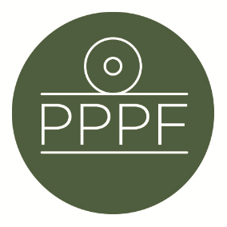
Peak Park Parishes Forum
Working for, and on behalf of, Local Councils within the Peak District National Park
Secretary: Peter Leppard, Sickleholme Cottage, Saltergate Lane, Bamford, Hope Valley, S33 0BE
Tel. 07860 624453 e-mail: secpppf@gmail.com

Meeting of the Management Committee to be held at 2pm on Monday 13 June 2022 at Aldern House, Baslow Rd, Bakewell, DE45 1AE
There will also be an online link to the meeting, details to be advised.

AGENDA

- Chair’s opening remarks

- To receive apologies for absence
.
- To consider a new co-option to the Management Committee

- To accept the minutes of the meeting of 11 April

- Matters arising from the minutes not elsewhere on the agenda

- Permitted floor-areas for self-built homes: To consider PDNPA’s response to the Committee’s comments submitted to them after our April meeting

- To consider Management Plan developments

- To consider any Local Plan issues (inc. the survey recently sent by PDNPA to Parish Councils)

- To discuss the effectiveness of Parish Member election arrangements

- Planning for Parishes Day 2022 (inc. consideration of Parish responses to us re this)

- Secretary’s report

- Finance
- To note the current financial position
- To approve any payments

13.To confirm date of next meeting

Peter Leppard
Secretary, Peak Park Parishes Forum
7 June 2022

