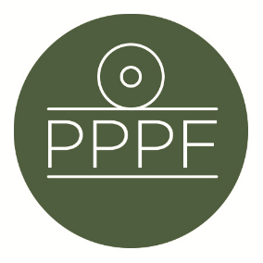
Peak Park Parishes Forum
Working for, and on behalf of, Local Councils within the Peak District National Park
Secretary: Peter Leppard, Sickleholme Cottage, Saltergate Lane, Bamford, Hope Valley, S33 0BE
Tel. 07860 624453 e-mail: secpppf@gmail.com

Meeting of the Management Committee to be held at 2pm on Tuesday 31 August 2021 by Zoom

AGENDA

- Chair’s opening remarks

- To receive apologies for absence .

- To accept the minutes of the meeting of 14 June

- Matters arising from the minutes not elsewhere on the agenda

- To receive an update from M Beer on any recent Management Plan Advisory Group issues

- To start to consider what we would like to see in (a) the new Management Plan and (b) the new Local Plan.

- To decide our comments on PDNPA’s ‘Conversion of Historic Buildings SPD’ consultation

- To make preparations as necessary for the Forum’s AGM and Parishes Day, 18 Sep

- Secretary’s report

- Finance
- To note the successful audit of the FY2020/21 accounts
- To receive a report on the current financial position
- To approve any payments

- To confirm date of next meeting

Peter Leppard
Secretary, Peak Park Parishes Forum
24 August 2021

.

