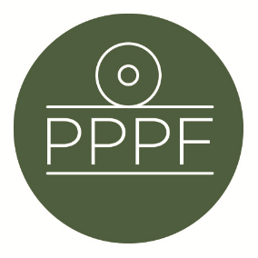
Peak Park Parishes Forum
Working for, and on behalf of, Local Councils within the Peak District National Park
Secretary: Peter Leppard, Sickleholme Cottage, Saltergate Lane, Bamford, Hope Valley, S33 0BE
Tel. 07860 624453 e-mail: secpppf@gmail.com

Meeting of the Management Committee to be held at 1pm on Monday 14 June 2021 at Aldern House, Bakewell

AGENDA

- Chair’s opening remarks (1300)

- To receive apologies for absence .

- Annual discussion with Sarah Fowler and Andrew McCloy, (1305)
to include:
- The new Environment Bill and how it will affect the National Park
- Consequences from Glover - need to maintain local representation at all levels
- role of Landscape Service
- Management Plan & Local Plan and how they knit-in with other developments
- Parishes Day, 18 Sep - theme, organisation, invites
- Enforcement concerns

- To accept the minutes of the meeting of 12 April (1355)

- Matters arising from the minutes not elsewhere on the agenda

- To consider the outcome of our May meeting with Robert Largan MP

- To receive an update from M Beer on recent Management Plan Advisory Group discussions

- To consider affordable-housing policy issues arising from recent correspondence

- Secretary’s report

- Finance
- To accept the (as yet unaudited) FY20/21 accounts
- To receive a report on the current financial position
- To approve any payments

- To confirm date of next meeting

Peter Leppard
Secretary, Peak Park Parishes Forum
9 June 2021

.

