‘Ask for ANI’: Briefing on Domestic Abuse Codeword Scheme for local partners

What is Ask for ANI?
Ask for ANI (Action Needed Immediately) is a codeword scheme developed by the Home Office to provide a discreet way for victims of domestic abuse to signal that they need emergency help from the safety of their local pharmacy.

Why has Ask for ANI been developed?
We know that local areas are already doing great work to support victims of domestic abuse who may be more isolated and finding it more difficult to access help and support as a result of the Covid-19 pandemic. Local areas have worked quickly and innovatively to provide awareness-raising campaigns and initiatives that are already providing vital help to those at risk from domestic abuse.
The ‘Ask for ANI’ scheme is intended to work alongside and build on existing work and provide an additional tool that can be used to help the most vulnerable victims access emergency support in the community.
The scheme has been developed with the help of partners including the domestic abuse sector, pharmacy associations and the police and is being rolled out across the UK from January 2021. It is being independently evaluated by Ipsos MORI and we are keen to work with local areas to assess how the scheme is working and understand how it can be improved and adapted to meet local needs.

How does the scheme work?
Victims of domestic abuse will be able to use the codeword ANI in participating pharmacies (including all Boots stores and participating independent pharmacies) to let staff know that they require an emergency police response or help contacting a helpline or specialist support service.
Participating pharmacies will display posters in their window and around the pharmacy to let customers know that they can approach their staff to seek help. Any information shared will be treated confidentially.
When a victim uses the codeword or asks for help, the member of staff will offer to accompany the individual to the consultation room. They will then check whether the victim wants the police to be called. If so, the staff member will offer the use of a phone to dial 999 or make the call on the victim’s behalf.

If the victim is not in an emergency situation, the staff member will support the victim to contact a national domestic abuse helpline or local support service. They may also contact the police via 101.
Information about how pharmacies can access interpretation services in included in the training guidance and animation.
Which pharmacies will be participating in Ask for ANI?
The scheme is voluntary so not all pharmacies will be participating in Ask for ANI, however participating pharmacies will display posters like this to show that they are operating the scheme:
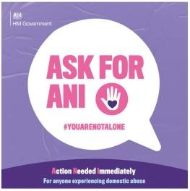
Some pharmacies in your area will already be running the Safe Spaces scheme which enables victims of domestic abuse to use the pharmacy consultation room to access information on domestic abuse support services. The Ask for ANI scheme can work alongside Safe Spaces to support victims who need more immediate assistance to signal that they need help and for pharmacy staff to direct them to the help they need. Safe Spaces pharmacies can also adopt Ask for ANI and can display jointly branded materials like this:
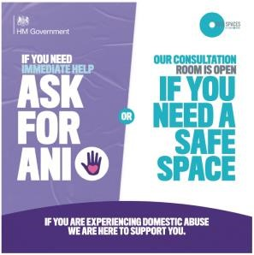
The Home Office will arrange for details of participating pharmacies to be shared with local areas.
It should be noted that all pharmacies have safeguarding policies and procedures and will respond to requests for help from vulnerable members of the community accordingly. We are working with the police and national pharmacy bodies to ensure all pharmacies are aware of the scheme so that staff working in non-participating pharmacies know the codeword and understand that a safeguarding response is required if someone uses the codeword in their pharmacy.
How can local partners support the Ask for ANI scheme?
Ask for ANI has been developed to provide a model for emergency assistance to be provided to victims of domestic abuse in the community, but we recognise that local ownership and commitment to the scheme will be key to its success. We would welcome your help in raising awareness of Ask for ANI across local networks to help ensure that victims and frontline professionals know the codeword and how it can be used to access emergency support. We would also welcome any feedback on how the scheme is being implemented as part of your response to tackling domestic abuse locally.
What should local partners expect on account of the launch of the scheme?
We expect use of the scheme to be at low numbers but local domestic abuse services may receive phone calls from pharmacies assisting a victim. Local services should follow their usual processes in providing help and support. Feedback about the scheme maybe discussed at local partnership meeting and you may wish to integrate Ask for ANI in to your local strategic planning.
Local partners may also see media communications about the scheme around the time that the scheme goes live. We will aim to ensure that these are as refined and targeted as possible so as to keep the codeword itself discreet.
Communication materials and guidance for pharmacies
Pharmacies can sign up to Ask for ANI by completing this online form.
Once registered, pharmacies will be sent a link to posters and training materials which include an animated video explaining how the scheme works.
Get in touch
We’d welcome any questions or feedback on the Ask for ANI scheme and please let us know if there is any additional information or support you need. Please contact the Home Office team at AskforANI@homeoffice.gov.uk

