Appendix 1a - Woolsington Parish Council Area Biodiversity scheme
Community Infrastructure Levy (CIL)

In November 2018 Woolsington Parish Council launched the start of its Area Biodiversity Scheme.
The aims for the Parish Council were to ensure that it manages the natural environment more effectively across all Parish boundaries, to protect its wildlife and natural resources, and to leave a legacy that will benefit present and future generations in the area.
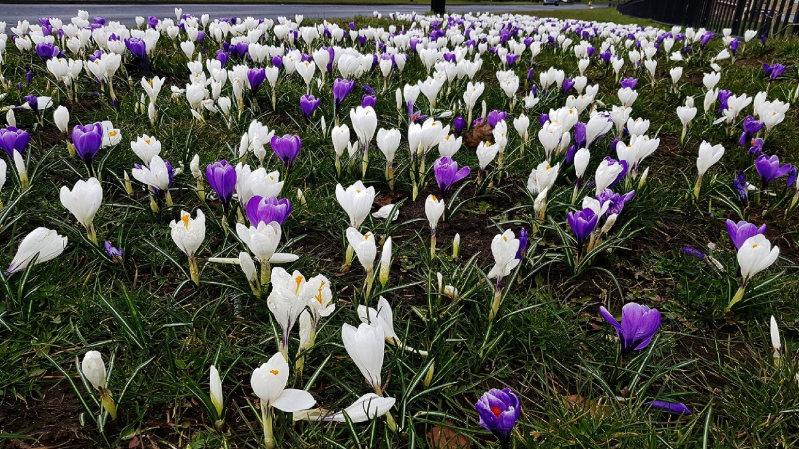
It was almost 100 years to the day, from the launch of this scheme, on 21st November 1918, when the Parliament (Qualification of Women) Act 1918 was passed, allowing women to be elected into Parliament. Therefore, the Parish Council decided to acknowledge the women`s movement with a theme of purple and white crocus, on a green background, the colours of the suffragette flag.
Thousands of these bulbs were planted throughout the Parish, also wildflowers and poppies, together with the installation of bird boxes to encourage birds and increase birdsong. All of these elements maintain the theme of that period.

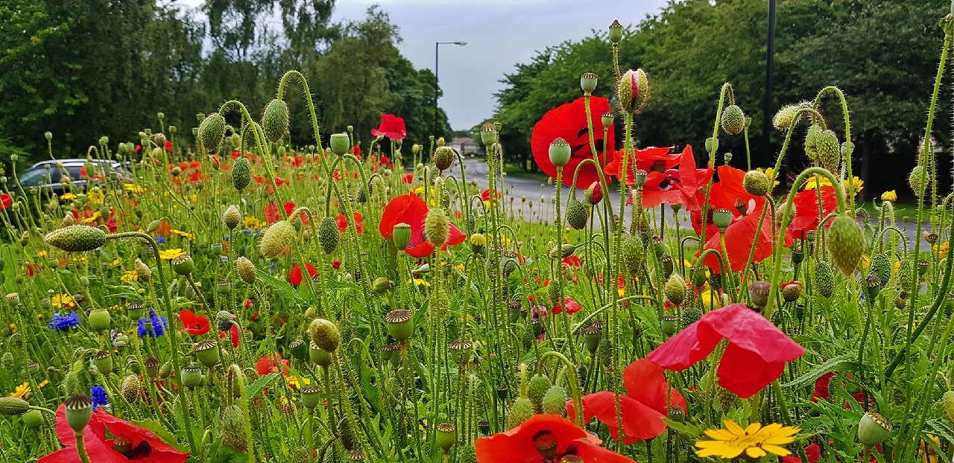
The project began with the creation of a wildflower bed at Sovereign Lodge residential care home.

In November 2019 over 12,000 crocus bulbs were planted at sites on Newbiggin Lane, Gala Field and Etal Lane. Parish Councillors, local volunteers, pupils from Simonside School, together with staff from Groundworks NE & Cumbria and Catherine McKinnell MP all made a tremendous effort. The results are fantastic.
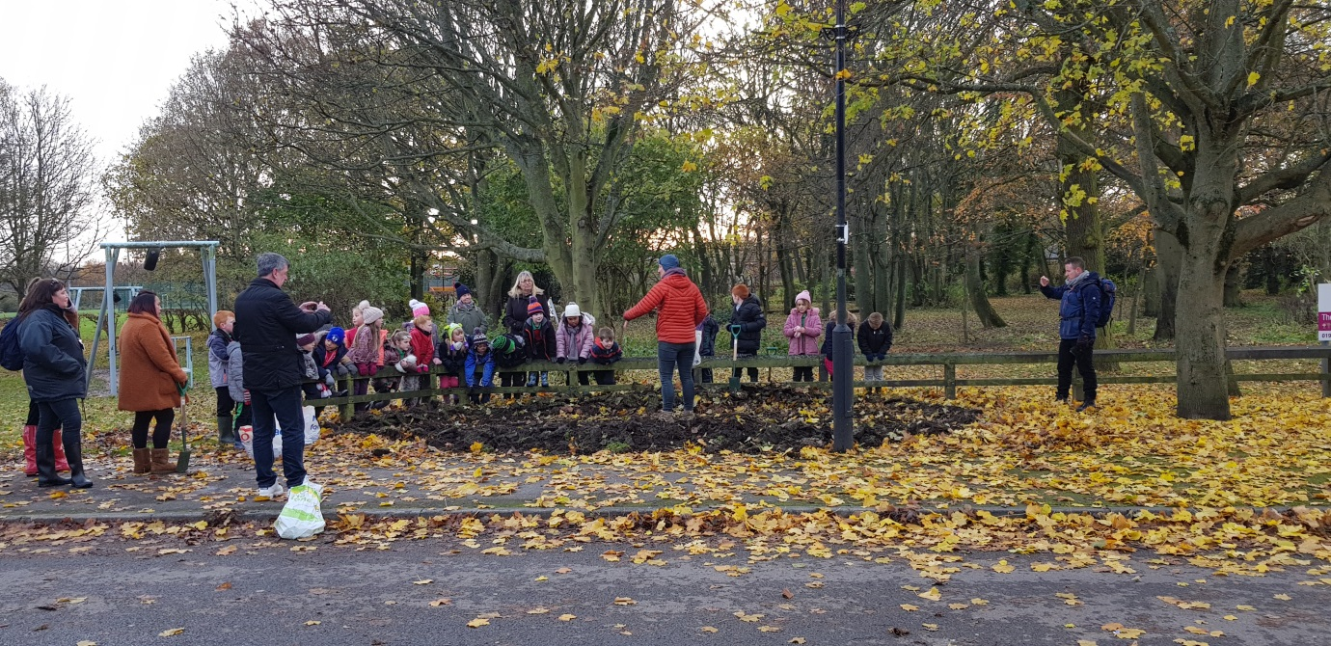
Pupils from Simonside planting the bulbs at Gala Field
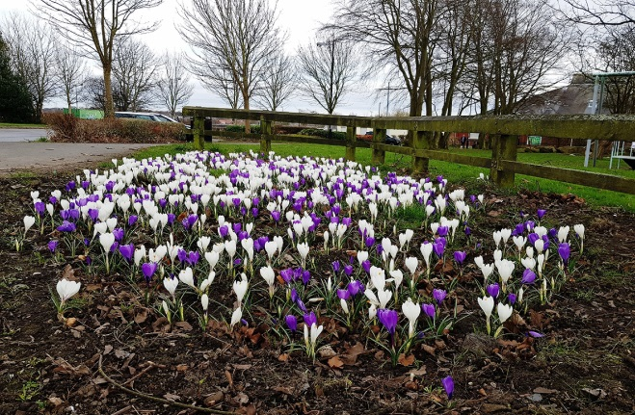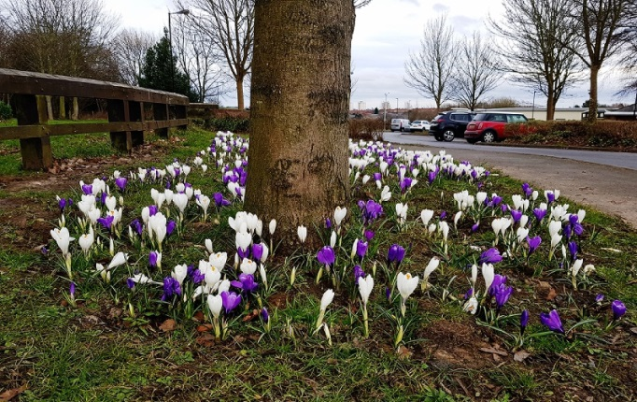
The results for all to see at Gala Field, a most welcoming entrance

Back breaking work.
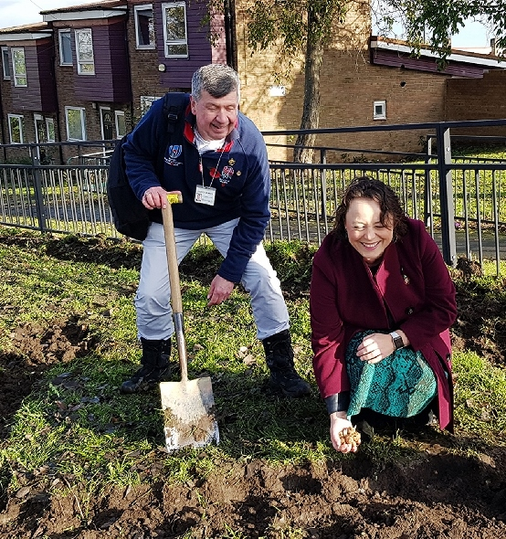
Councillor George Pattison and Catherine McKinnell MP preparing the site at Newbiggin Lane.
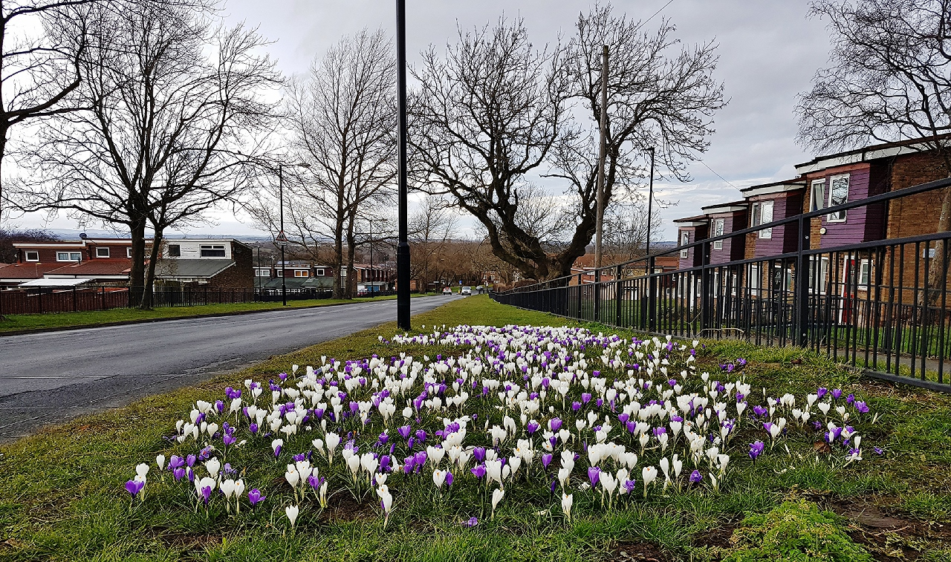
The final outcome a magnificent sight: The Newbiggin Lane Carpet

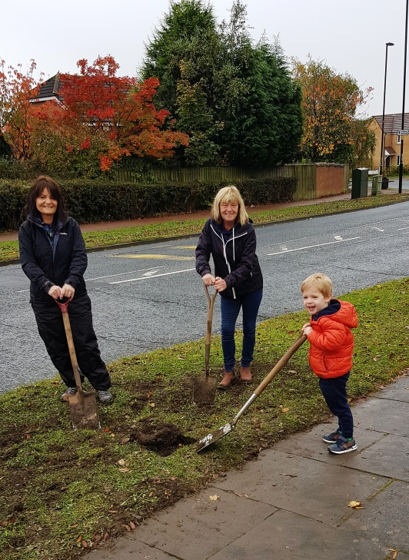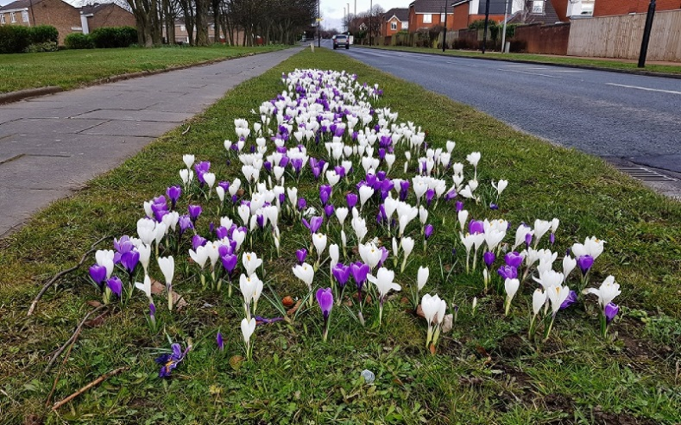
Etal Lane before and after

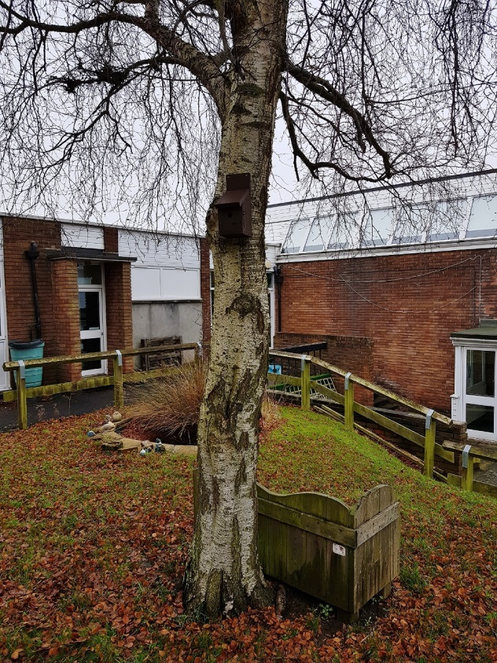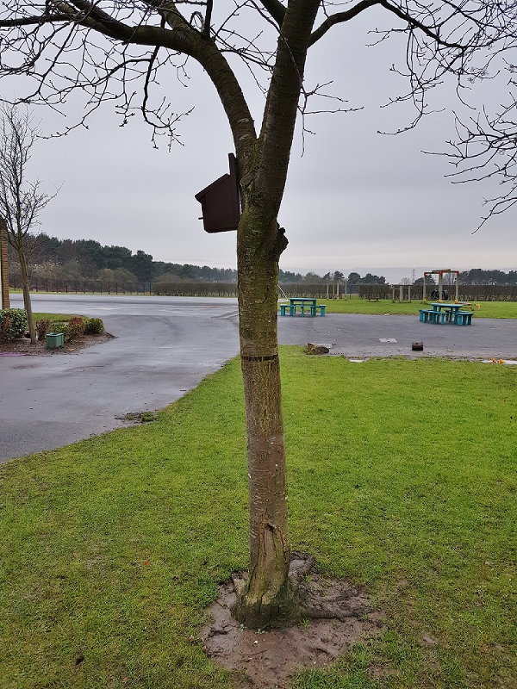
Some of the locally made bird boxes - these ones were located at Simonside School.

In the second phase of the project it is planned to install cameras inside some bird boxes to enable pupils to `Spring Watch` nesting activity from tv screens inside the school.
It is hoped to introduce many more bird and bat boxes throughout the duration of the Biodiversity Scheme.

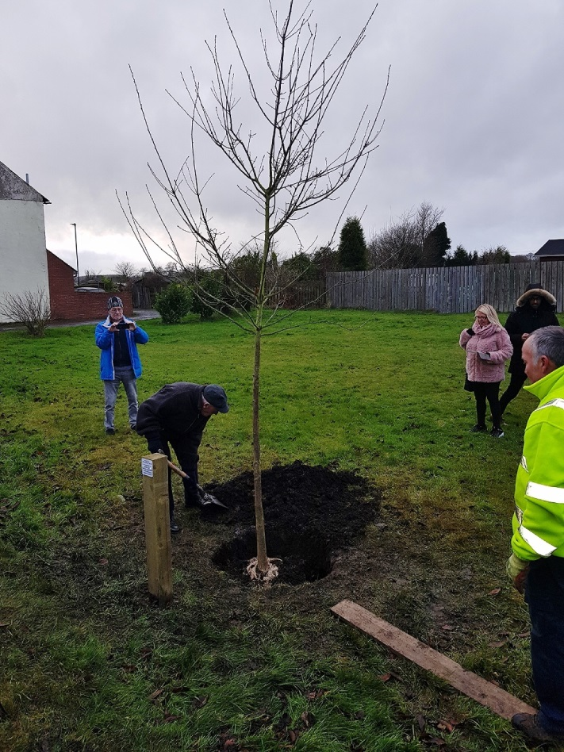

Finally.
The oak tree presented to Archie Cook by Woolsington Parish Council, in recognition of his many many years of tireless voluntary work maintaining the flora and fauna in Callerton village.
Archie’s seen here on left, as always getting his hands dirty and applying the finishing touches himself.

