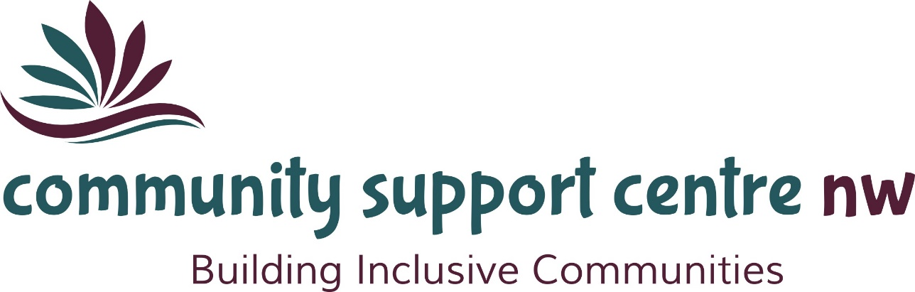

33rd
ANNUAL REPORT

July 17, 2023

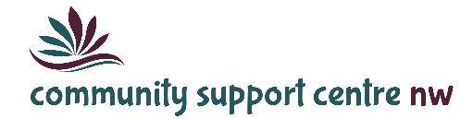

Mission Statement
Providing quality, innovative, client-centred programs and services to enrich the lives the individuals and families we support.

Our Vision
Where everyone feels valued, connected, included and empowered.

Service Principles
Respect
We believe that every individual has the right to their own values, beliefs and individual choices.
Inclusion
We believe that every individual should be accepted and treated equally as a valued member of the community and are entitled to participate fully and enjoy the same quality of life as all community members.
Collaboration
We believe in the importance of working collaboratively with our service partners to achieve the best outcomes for the people we support.
Accountability
We believe in being fiscally responsible and demonstrating transparency and ethical decision-making.
Innovation
We believe in developing an organizational culture that supports opportunities for learning, growth and development and values the contributions of the individuals we support, their families, the staff and the broader community.

Message from the Board Chair and Executive Director

2022-2023
While positive COVID cases lingered throughout the last year, the Community Support Centre-Northwest moved from full on COVID measures to less restrictive approaches and finally, to a return to normal business. The Agency’s commitment to our clients was taken to another level throughout the pandemic. The dedication, adaptability and perseverance of our staff is remarkable. We thank every employee for stepping up to provide safe, quality services throughout this difficult time.
As the pandemic is hopefully coming to a close and we are no longer thinking much about quarantine, masking, distancing and positivity rates, we don’t want to forget about what we have learned through this experience. We learned just how resilient our staff, our clients, their families and our Agency is in times of adversity. Together, we have weathered this uncertain time.
While we’ve endured many challenges, we’ve also had many successes. The goals we set for our Agency are high and any achievements we make are a credit to the collaboration of all staff including front-line, administration and management. Everyone’s contributions keep us inspired and motivated.
The submission of a Business Case to the Ministry of Children, Community and Social Services to address under-funding within the Community Participation and Supports program was approved. This allowed the agency to offer an employer-paid benefit plan as well as an RRSP program. These were implemented through Sun Life Financial beginning in May 2022. We remain hopeful that this employment improvement, coupled with the permanent wage enhancement, will assist us in addressing our staffing predicament.
We also received additional financial support from the Ministry of Children, Community and Social Services in response to our Pressures Identification. One-time funding was received to off-set the projected deficit within the Community Participation and Supports program caused by increased client demand for service and the rising cost of fuel, provider services, etc. For this, we are very appreciative.
In January 2023, the Agency received additional funding in the amount $61,650 through the Canadian Family Justice Fund for the Supervised Access Program. The objective of the funding was to improve the safety of vulnerable children and family members through the COVID-19 pandemic and the recovery phase by modifying or expanding services. Unfortunately, due to the limited time between receipt of the funding and year-end, we were not able to fully expend all of the funds. Unused money will be recovered by the Ministry.
We are grateful that our proposal to the Northern Ontario Heritage Fund under the Rural Enhancement program was successful. As a result, our Dryden building now has new windows, rigid insulation and vinyl siding. These enhancements were necessary to extend the life of our building.
This year the Christmas Cheer Program operated in a modified fashion. While we continued to be unable to accept food or toy donations, we did return to a physical space for handing out the food hampers. We extend a huge thank you to the Dryden and District Agricultural Society who donated the hall for our use. We also thank Peggy Howard, our in-house Christmas Cheer Coordinator, and our many volunteers for their endless work to make this happen. The generosity of local businesses, service clubs, partner agencies and community members was outstanding once again. A total of $59,294 was received toward the program. This allowed us to provide 327 families/individuals with food hampers and 247 children with gifts.
During the year our MCCSS Program Supervisor, Sara Britt, assumed responsibility for another portfolio within the Ministry. She has been replaced by Kaitlin Prezio. We sincerely appreciate both Sara and Kaitlin for their advocacy and support of the Community Support Centre-Northwest.
In closing, we express sincere gratitude to the members of the Board of Directors for their guidance and excellent governance on behalf of the Agency.
Respectfully,

Kim Douglas Debbie Dokuchie
Board Chairperson Executive Director

PROGRAMS AND SERVICES

Community Participation and Supports
The Community Participation and Supports program connects adults with a developmental disability to their community through recreation, leisure and skill building activities. Supports are provided to allow individuals to participate in a wide variety of opportunities. Access to the program is through Developmental Services Ontario – Northern Region.
53
Individuals Served 7254 Service Hours
2100 Episodes of Service

Passport Program
Passport is a funding program to help adults with a developmental disability to live more independently. Families and individuals can choose to purchase services from Community Support Centre-NW with their Passport funding.
We work closely with families and individuals to provide services and supports tailored to their interests and needs. This might include meaningful participation in community events, leisure, recreation, life skills, etc. We promote and encourage healthy living.
We provide administrative and brokerage services for all or part of the individual’s Passport funding.
13

Individuals Served 2374 Service Hours
942 Episodes of Service

Specialized Respite Services
Specialized Respite is a fee-for-service program for children and youth. We provide respite services to families and foster caregivers. Fees can be paid by the family or another involved service provider such as child welfare agencies, children’s mental health or government funded programs such as Special Services at Home.
15

Individuals Served 3548 Service Hours
1038 Episodes of Service

13,176 Total Hours of Support Provided

Supervised Access Program
The Supervised Access Program helps children and their families through difficult periods following a separation or divorce. We provide a safe, child-focused, neutral environment for visits or exchanges to take place between children and their visiting parents or relatives under the supervision of trained staff to ensure that the situation is safe and comfortable for all participants. Visiting sites are located in Dryden, Kenora and Fort Frances.
85
124

Visits Arranged Virtual Visits Arranged
12

Exchanges Arranged
Christmas Cheer
Assisting families in need of assistance due to limited finances. Christmas Cheer is a holiday toy and food distribution program accomplished through a coordinated effort of charities, businesses, service clubs, community members and volunteers.

327
Families/Individuals received food hampers.

247
Children received toys/gifts through the gift card program.

Funding for Dryden Community Support Centre
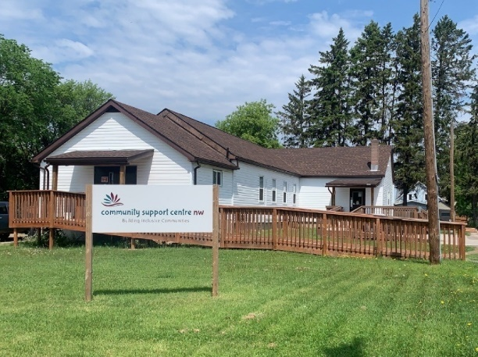
Twenty-two thousand dollars is going towards renovations for Dryden’s Community Support Centre Northwest at 53 Arthur Street.
“Our government is proud to help upgrade the Community Support Centre-Northwest, a hub providing crucial community social services,” said Greg Rickford, Minister of Northern Development and Mines, Natural Resources and Forestry. “These improvements will reduce maintenance and energy costs – money that can be reinvested into programming to better serve clients. Extending the useful life of buildings such as these is another way we are building strong, vibrant communities and improving the overall quality of life for Northern Ontarians.”
FINANCIALS
Funding Sources

Total Revenue: $ 947,691

Expenses

Total Expenses: $ 947,173

Our Board of Directors
2022-2023

Kim Douglas Chairperson
Carlynne Bell Vice-Chair
Shannon Wogenstahl Treasurer
Heather Corner Secretary
Heather Cranney Director

Dryden: 807-223-5995
Fort Frances: 807-274-0110
Toll Free: 1-844-523-8825

www.communitysupportcentre.com

www.communitysupportcentre.com
Community Support Centre-Northwest

