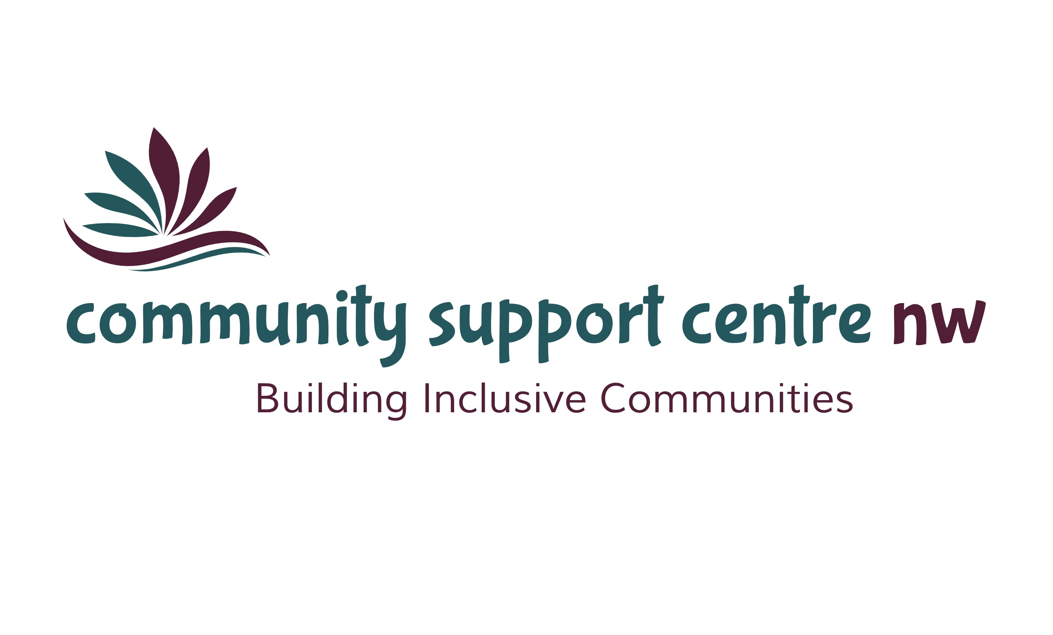  29th  annual report  Over the past year, our new Agency name, logo, Mission, Vision and Service Principals have taken shape and we are excited to share them. | Mission  Providing quality, innovative, client-centred programs and services to enrich the lives of the individuals and families we support.  Vision  A place where everyone feels valued, connected, included and empowered.  Service Principles  Respect: We believe that every individual has the right to their own values, beliefs and individual choices.  Inclusion: We believe that every individual should be accepted and treated equally as a valued member of the community and are entitled to participate fully and enjoy the same quality of life as all community members.  Collaboration: We believe in the importance of working collaboratively with our service partners to achieve the best outcomes for the people we support.  Accountability: We believe in being fiscally responsible and demonstrating transparency and ethical decision-making.  Innovation: We believe in developing an organizational culture that supports opportunities for learning, growth and development and values the contributions of the individuals we support, their families, the staff and the broader community.

Message from the Board Chair and Executive Director
It’s been an exciting year as the Agency experienced significant change and growth as we settled into a very different landscape. The highlight was our name change from the Dryden Volunteer Recruitment and Referral Centre to Community Support Centre – Northwest. We are very proud of our new name which better reflects the diverse programs and services we provide.

The Agency’s proposal under the Developmental Services Investment Strategy was successful and we were granted $25,000 toward the purchase of an accessible vehicle. We launched an “Accessible Vehicle Campaign” to fundraise the remainder of the purchase price. We are extremely grateful for the generous community support we received and in a very short time, we were able to move forward with the purchase of a modified van. The accessible vehicle allows us to provide increased opportunities for community participation for all of our clients.

We have continued to increase the number of people we support through the Passport Program and Fee for Service programs. The number of participants in our Community Integration Services program has remained relatively unchanged from previous years. Our focus is on providing opportunities for community-based activities as well as large group events that promote social interaction. We’ve experienced growing interest in Cooking Class which uses the fun, social aspect of preparing and sharing meals. We introduced a monthly “Drop In” which has attracted approximately twenty participants per evening. In the coming year, will continue to seek new and different experiences where individuals can expand their learning, advance social skills and develop new relationships based on shared interests.

We are pleased to have been provided the opportunity to expand the Supervised Access Program to include the Rainy River District. Through the development of a single point of access, families and referral agents throughout the Kenora and Rainy River districts now have a single contact point for service.

Christmas Cheer was once again an over-whelming success. Each year we find ourselves amazed by the dedication, big-heartedness, support and hard work of our community. It only goes to show that when people come together, amazing things happen.

We would also like to recognize the incredible skills and talents of the staff at Community Support Centre-Northwest. Their passion for improving the lives of the individuals and families we support is commendable and their efforts do not go unnoticed. We also thank the members of the Board of Directors for their excellent governance on behalf of the Agency.

This year we developed a new five-year strategic plan which focuses on four strategic priorities: Service, Employees, Organizational Strength and Financial. Moving forward, the Board of Directors, Managers and Staff will be the driving force in achieving our goals and bringing the plan to life.

Respectfully,

Kim Douglas Debbie Dokuchie
Board Chairperson Executive Director
PROGRAMS and SERVICES

Community Integration Services
Connecting individuals who have a developmental disability to our community through recreation and leisure activities.

Passport
Individualized programs tailored to meet unique needs. Activities may include life skills training, health and fitness and developing social skills through community connections.

Specialized Respite Services
A fee-for-service program for children and youth. Provides respite services to families and foster caregivers involved with the Child and Family Services sector.

Supervised Access Program
Providing a safe and neutral environment for non-custodial parents to visit their children in a supervised setting. Services are provided throughout the Kenora and Rainy River districts.

Healthy Food Box Program
In partnership with the Northwestern Health Unit, the Healthy Food Box program provides affordable access to healthy food options.

Christmas Cheer
Assisting families in need of assistance due to limited finances. Christmas Cheer is a holiday toy and food distribution program accomplished through a coordinated effort of charities, businesses, community members and volunteers to accomplish this annual miracle.

LIVES TOUCHED

Community Integration Services Passport

52 Individuals 7 Individuals
2,879 Days of Service 1,087 Days of Service
6,822 Hours of Service 3,778 Hours of Service

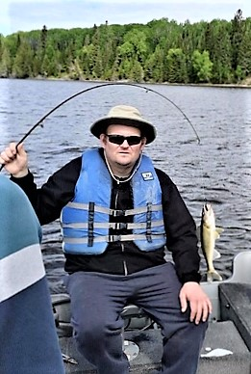
A great day on the lake!
Fee for Service Programs

13 Individuals
1,143 Days of Service
5,281 Hours of Service

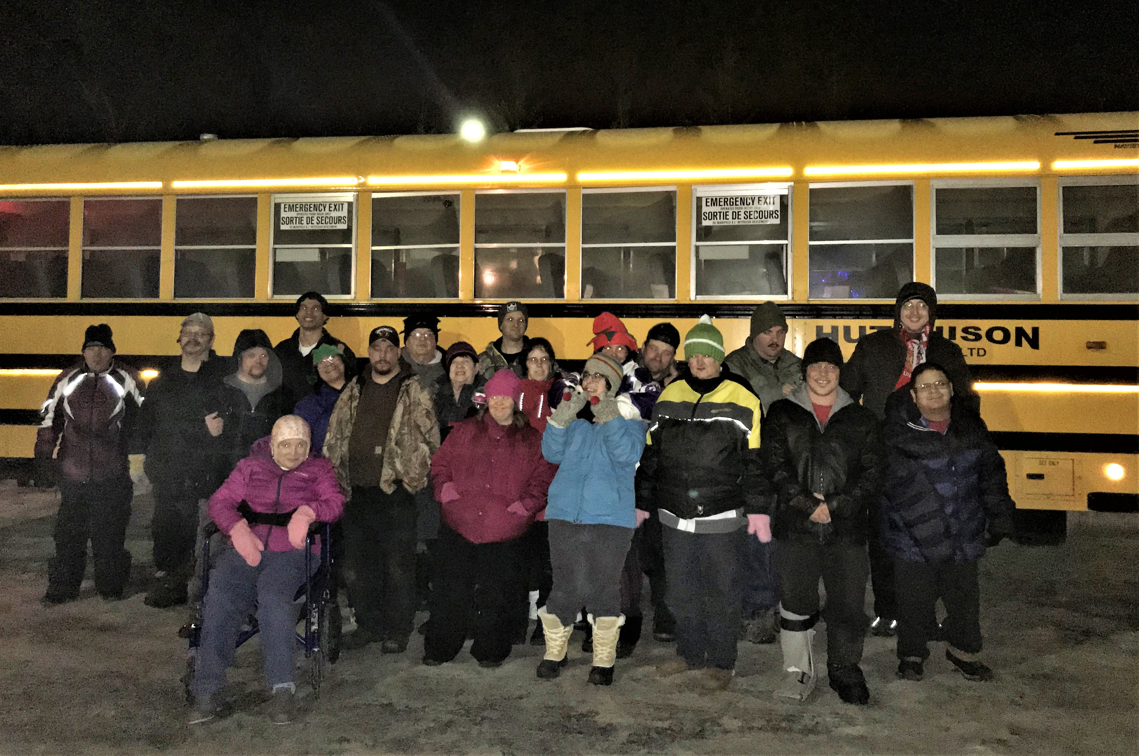
5109
Service Days
Off to view the Christmas Lights in Dryden

21
Front-Line Staff

15,881
Service Hours

SOME REALLY BIG DEALS
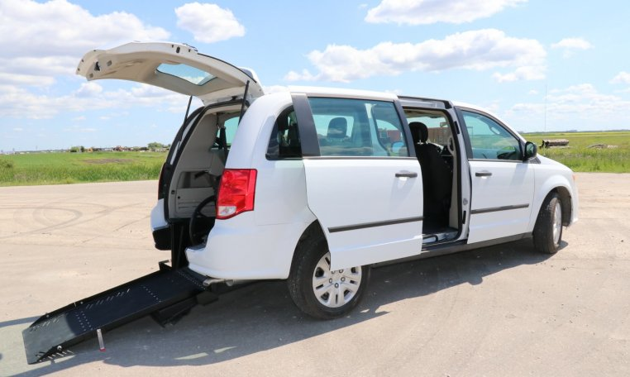
THANK YOU TO OUR DONORS
BDO Dunwoody
Pizza Hut
Royal Canadian Legion
Dryden Lion’s Club
RBC
Domtar
Rotary Club of Dryden
Wal-Mart Canada
Our New Accessible Vehicle

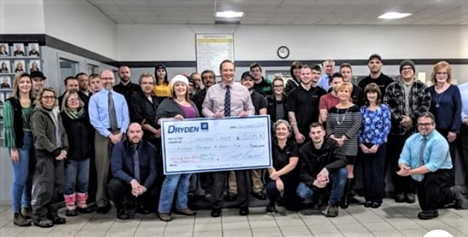

Once again, Dryden GM
matched donations from
individuals and not-for-profit
organizations. An astounding
$15,095.83 was collected
during the Dryden GM
“Double Down” campaign
resulting in a donation of
$30,191.66 for Christmas
Cheer.
Dryden GM Staff make donation to Christmas Cheer

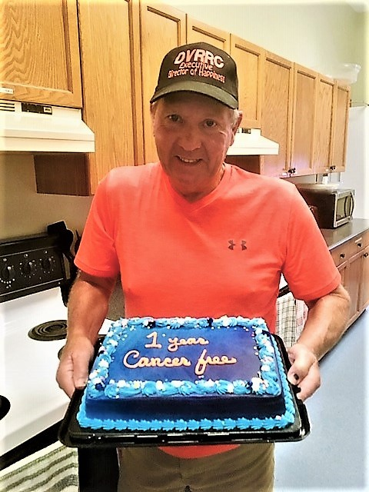
Celebrating with long-time employee, Charlie Barton. One year cancer free!!!
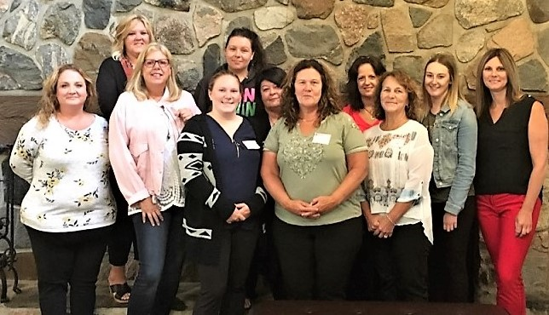
Supervised Access Program Staff

The Supervised Access Program was expanded. The program now provides services throughout the Kenora and Rainy River districts. A transition period occurred during February and March and the Community Support Centre assumed full responsibility for the Rainy River district beginning in April 2019.

104
Visits Arranged

7
Exchanges Arranged

- Stats do not include Rainy River district

FINANCIALS

REVENUE
Fiscal 2018-19
Ministry of Children, Community & Social Services 164,264
Ministry of Attorney General 186,387
Passport One (formerly Lutheran Community Care) 110,100
NEW, MNO, Student Grants, DNFC 24,739
Fee for Service 207,182
Christmas Cheer 57,330
Fundraising (Accessible Vehicle) 11,973
MCCSS (grant through Lutheran Care – accessible vehicle) 25,000
786,975

EXENSES
(in dollars / rounded)

BOARD OF DIRECTORS

Kim Douglas Chairperson
Douglas McMillan Vice-Chair
Shannon Wogenstahl Treasurer
Louise Moody Secretary
Carlynne Bell Member

DRYDEN: 807-223-5995
FORT FRANCES: 807-274-0110
TOLL FREE: 1-844-523-8825

Community Support Centre - Northwest

